Trelawnyd WwTW plan CM0028801
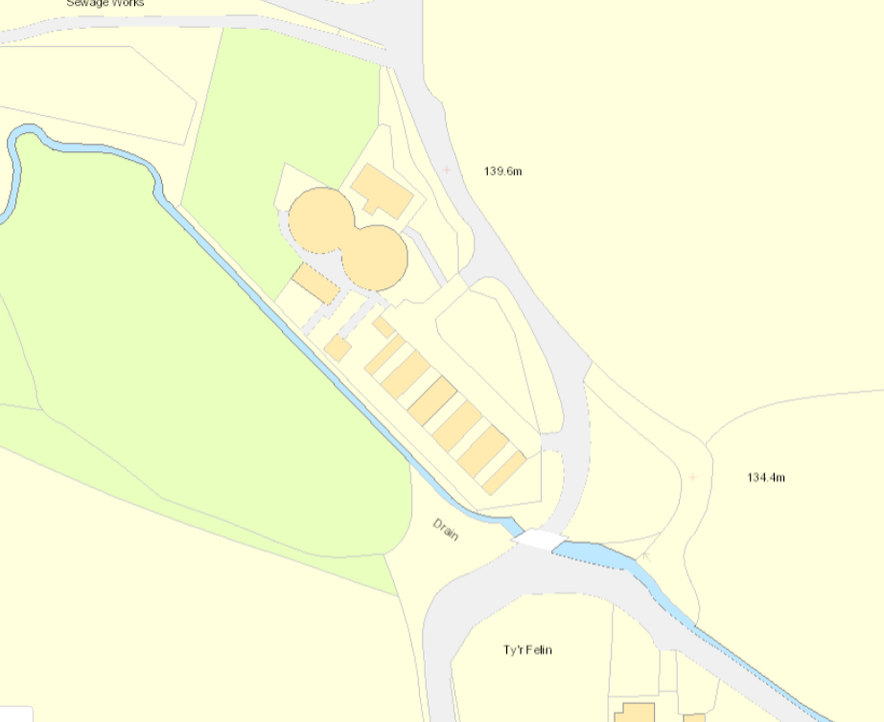
Mcerts Continuous Flow Monitoring point
Final Effluent Sample Point
Final Effluent Discharge Point

