PAN-025469 MyMap Report

surface water courses, well, spring (or issue) or borehole
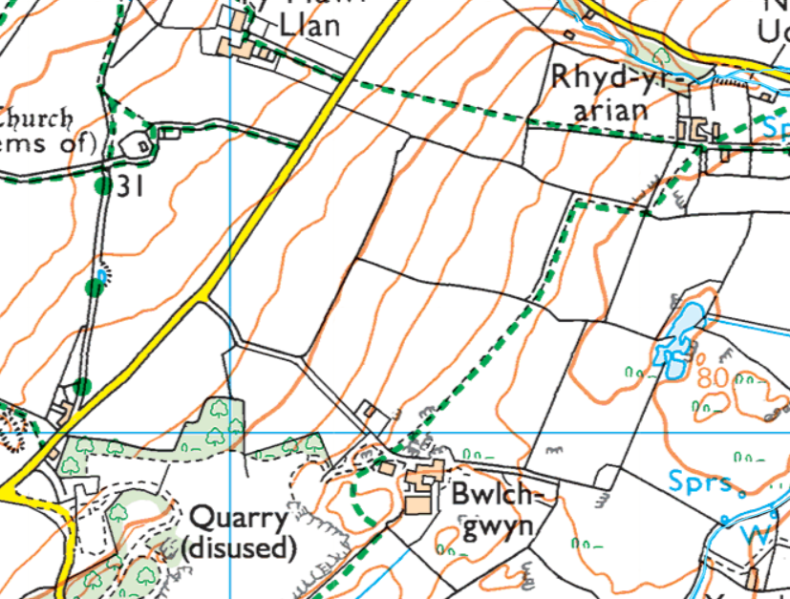
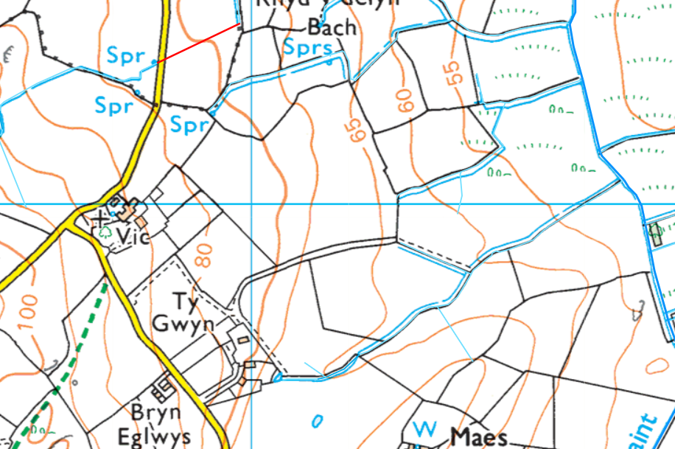
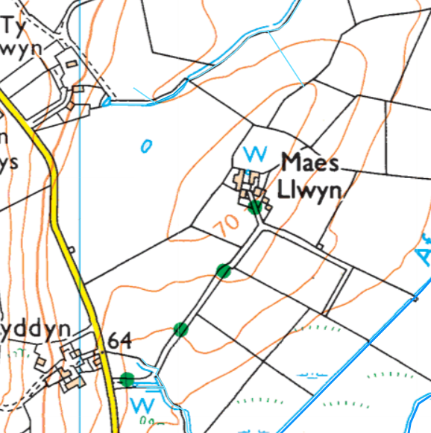
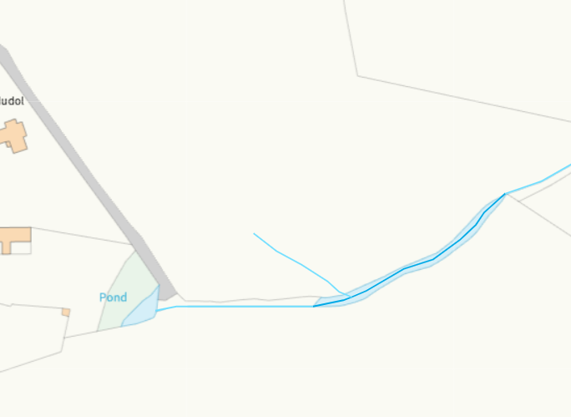 watercourse in south of field 13 needs buffer
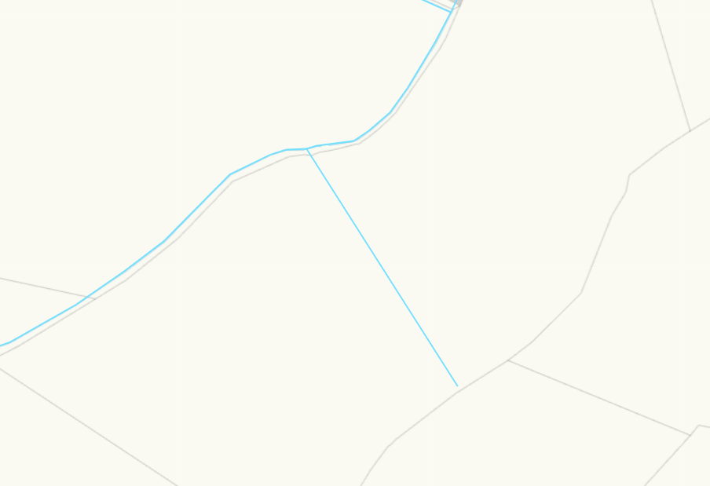
watercourse across field 16 needs a buffer

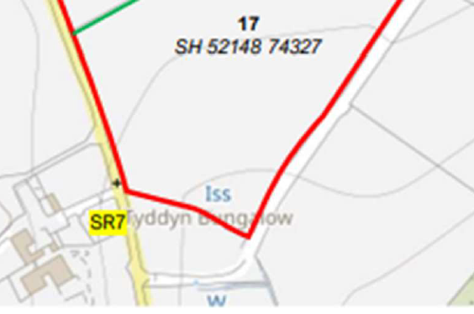 issue in field 17 needs 50 meter buffer
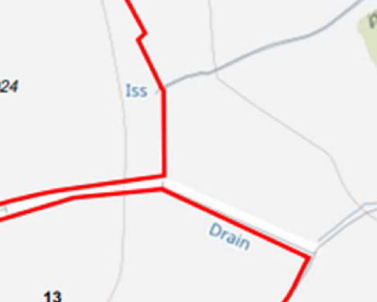 issue on edge of field 14 needs 50 meter buffer

groundwater source protection zones- None
Groundwater Safeguard Zone- None

Natura 2000 (SPA, pSPA, SAC or cSAC) or Ramsar- or SSSI within 500m
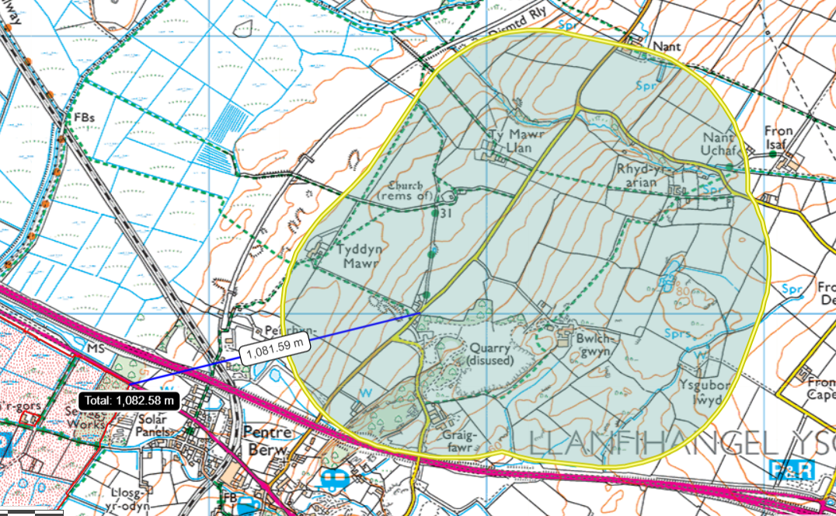
Over 1km from Malltraeth Marsh / Cors Ddyga SSSI
location of any public rights of way
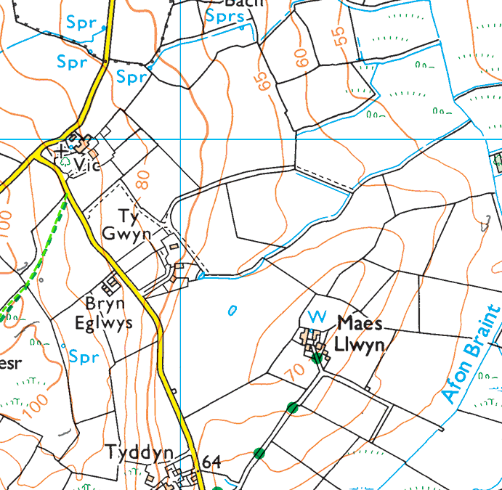
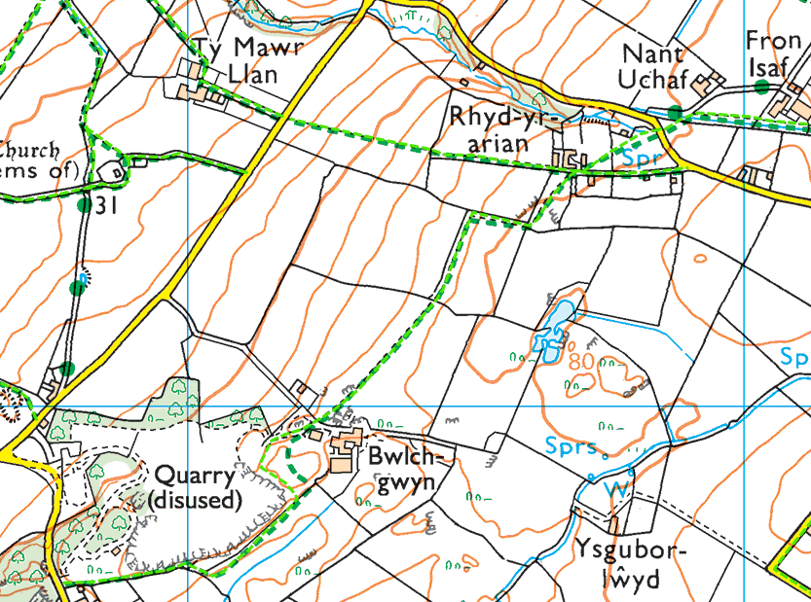

Protected Habitats/ species
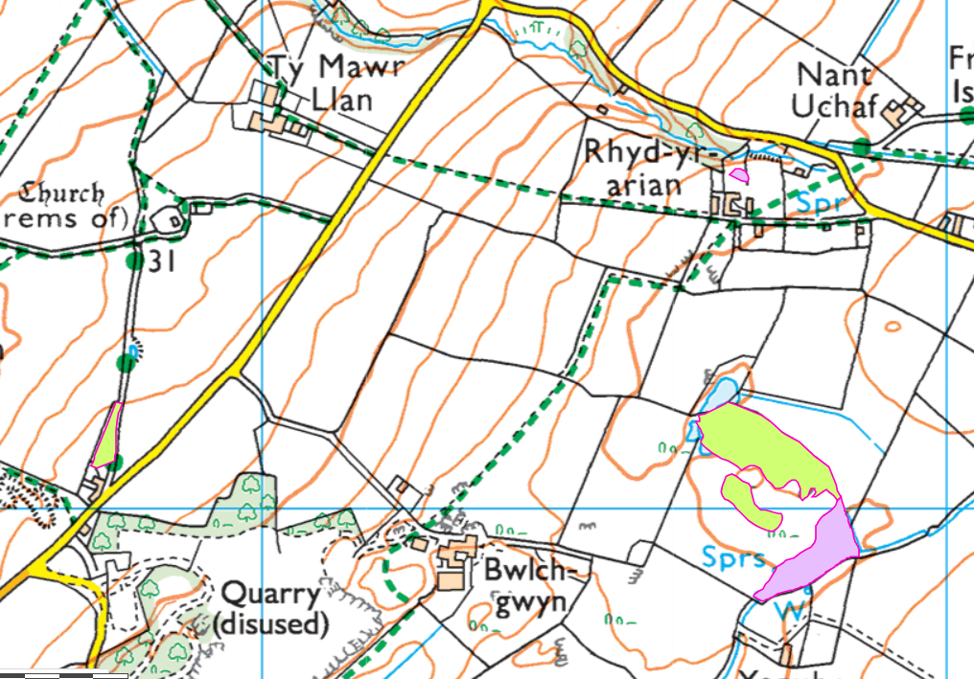
- None within fields
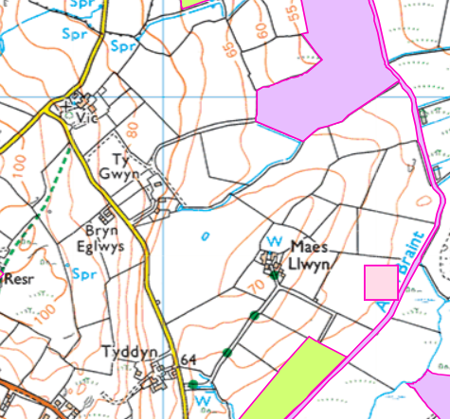
- None within fields

Scheduled Monument/Local Nature Reserve/National Nature Reserve/Ancient Woodlands/Local Wildlife Sites (SINC)/National Park
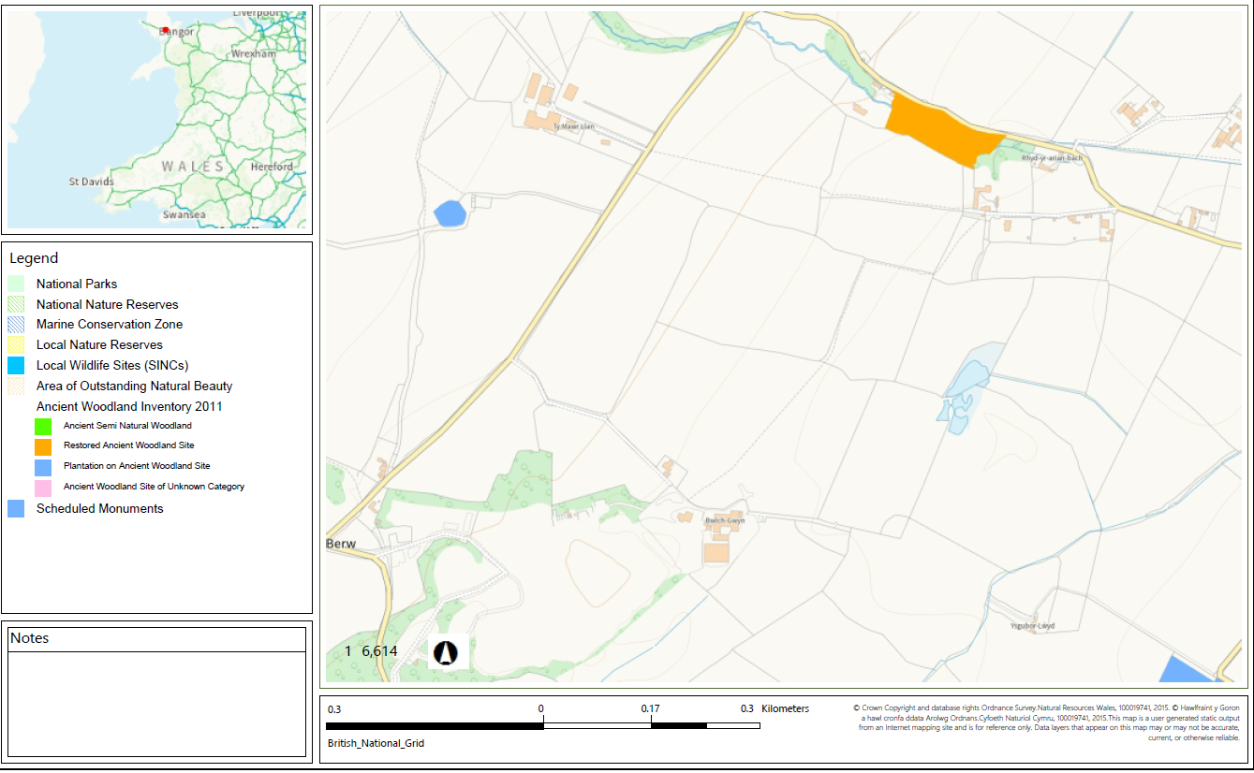
- None within fields
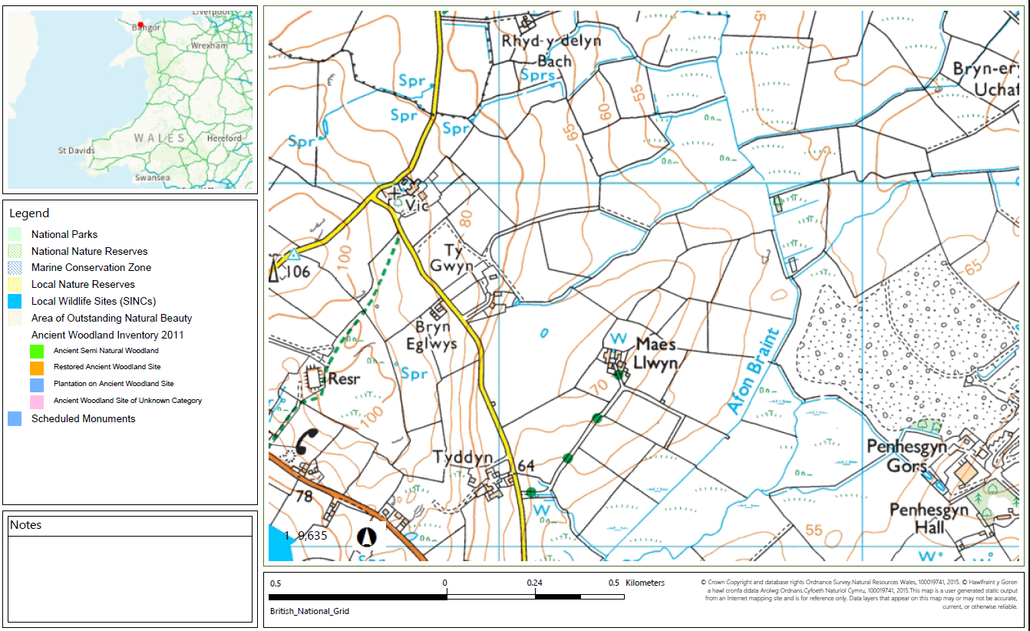
- None within firlds

Flood risk
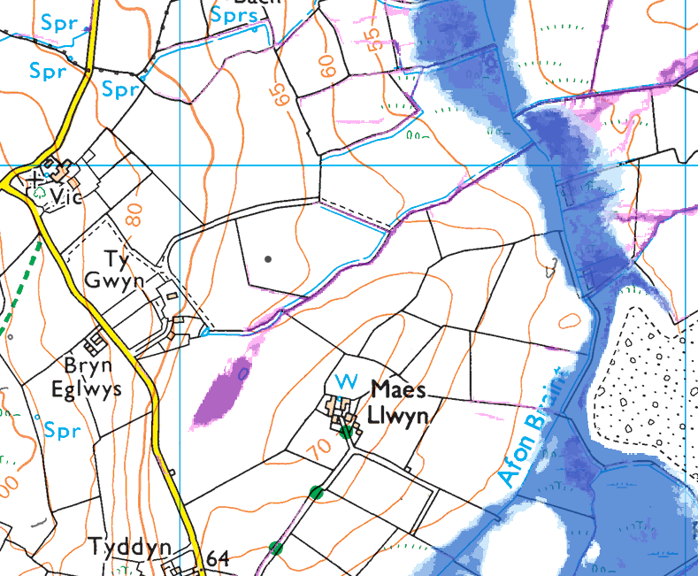
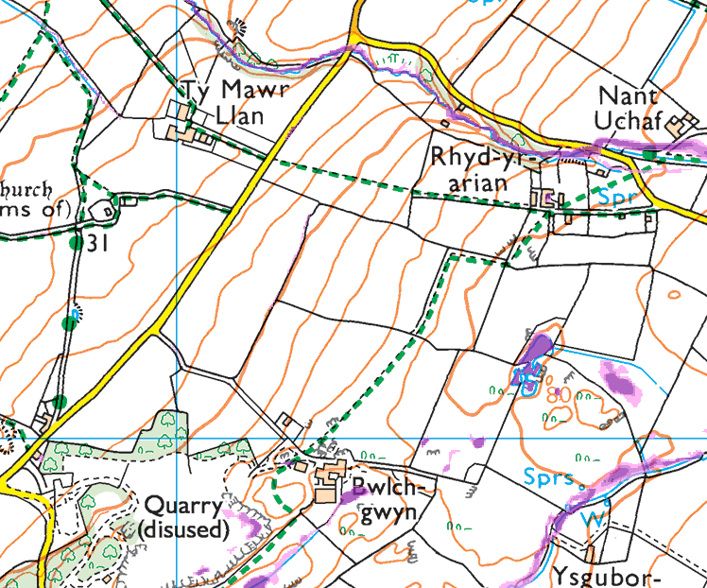

Field Slope


