PAN-025644 My Map Report:
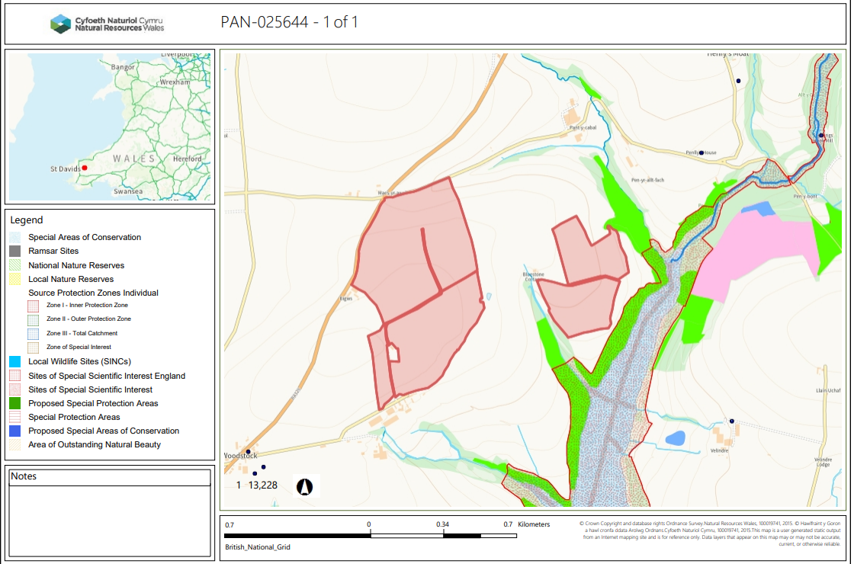
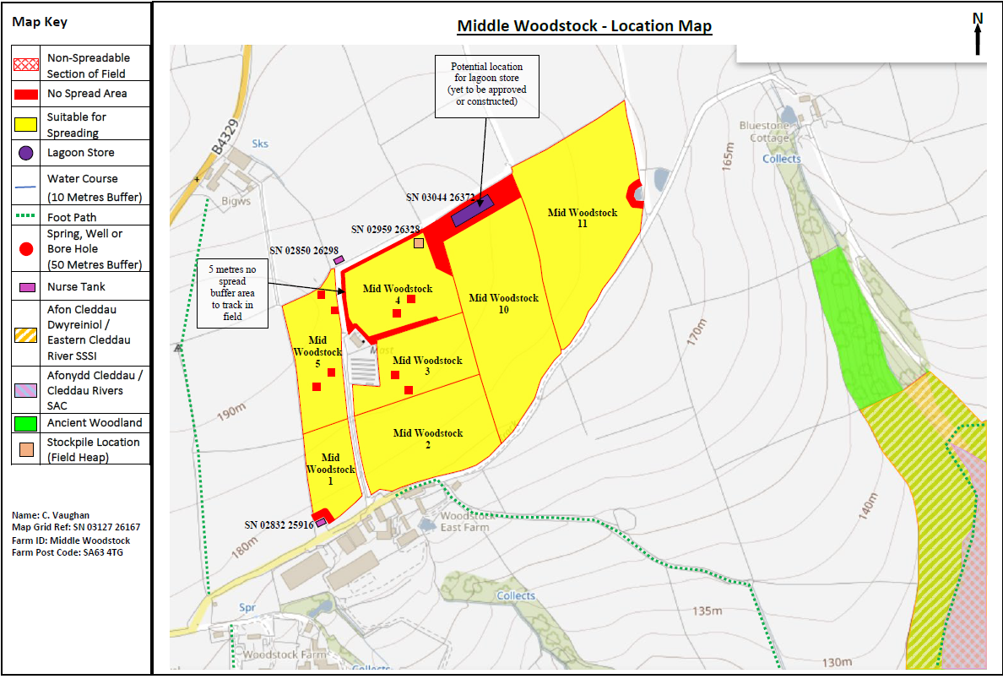
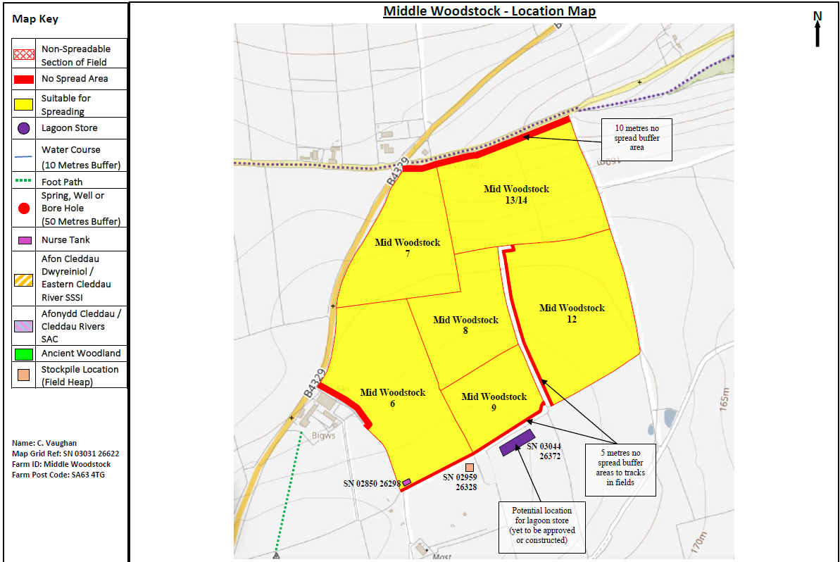
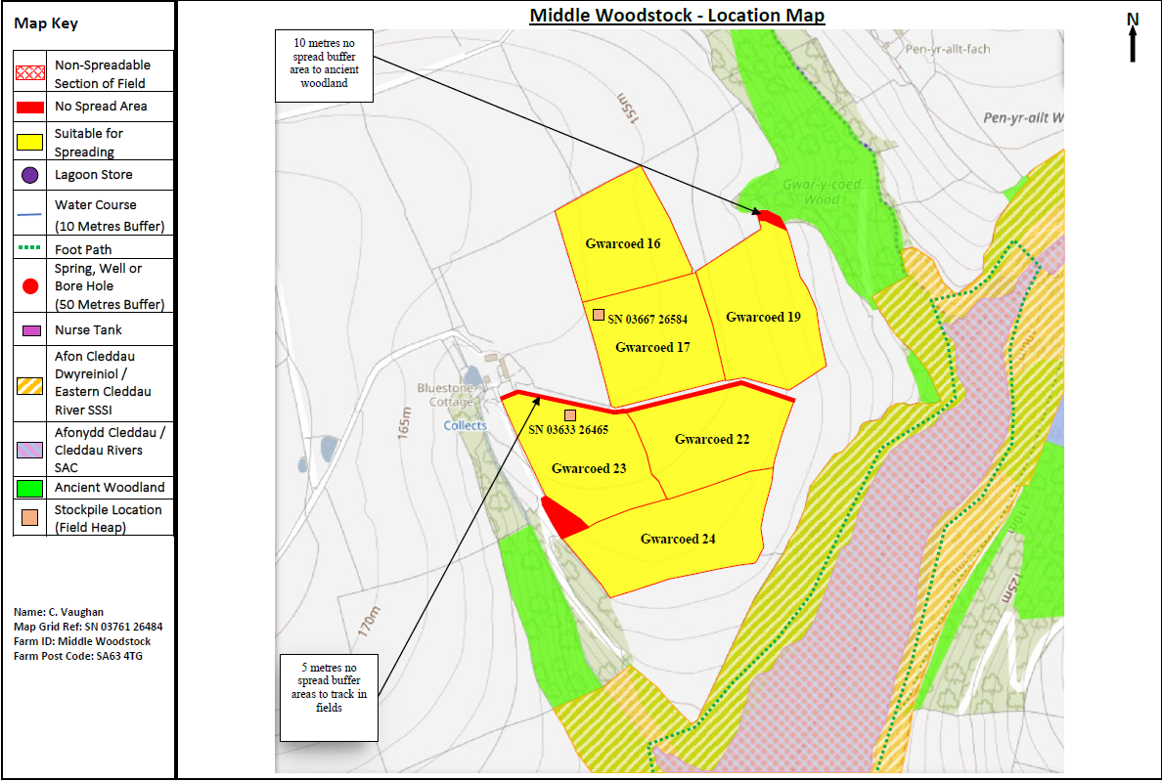

Detailed river network:
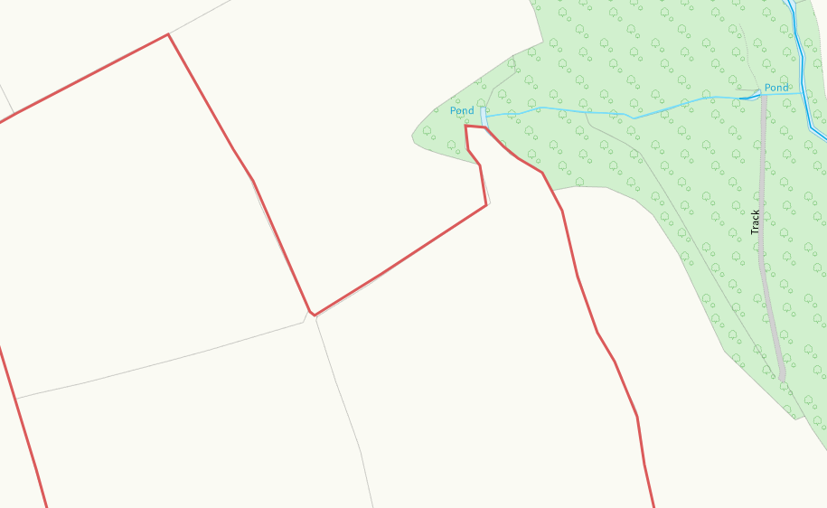

A modified attribution and pond are at the corner of Gwarcoed 19. This has been clearly identified and a no spread buffer zone implemented in the corner. No action required.
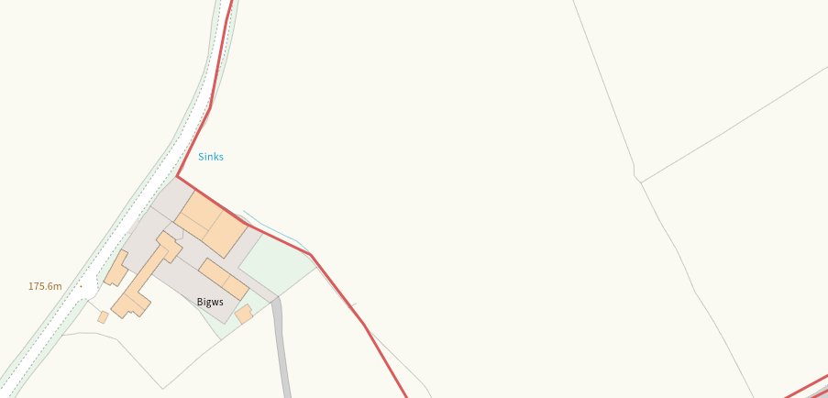
A sink is found within Mid woodtsock 6. This area has been implemented with a no spread buffer zone of 10m to reduce the run off risk. No action required.
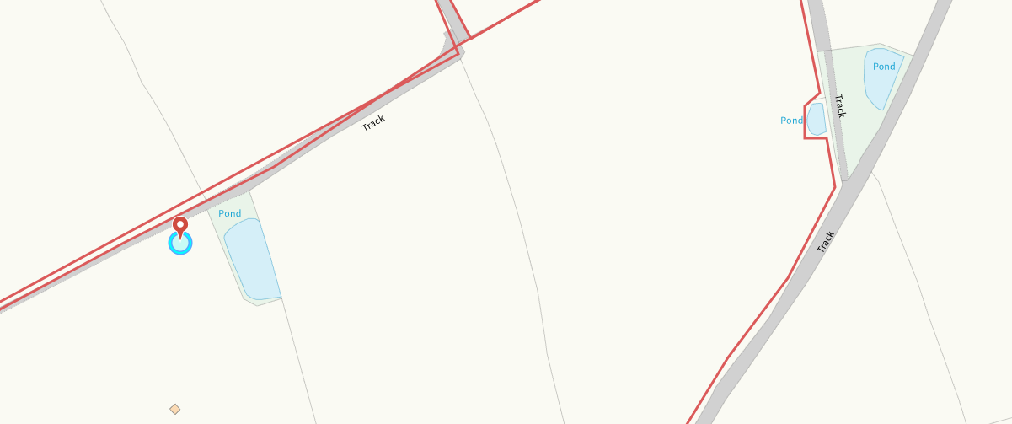
There are two areas of surface water seen in Mid woostock 4 and 11. These have either been excluded from the spreading area or covered with a no spread buffer zone to prevent run off into watercourse. No action required.
Groundwater protection zones (source)
None in range
Wells, springs or boreholes used for the supply of water for human consumption including from a private water supply or supplies
None in range
any springs wells or boreholes not used to supply water for domestic or food production purposes within 50m

None in range

European designated sites- Natura 2000 (SPA, pSPA, SAC or cSAC) or Ramsar- or SSSI within 500m

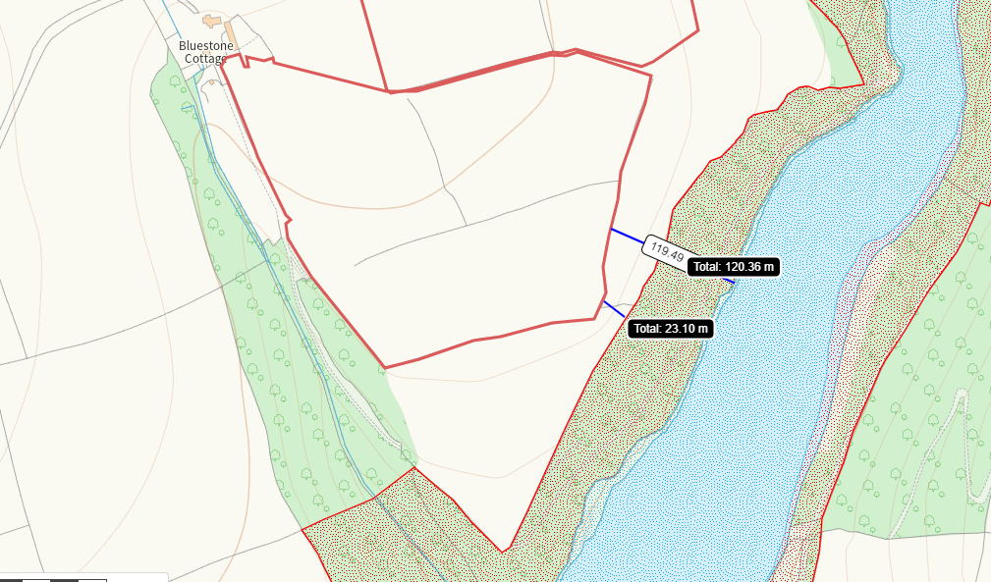
Afon Cleddau SAC and SSSI is both 23m and 141m from the spreading area. This has been identified in submitted maps. Due to the distance and lack os sloping in this area, no impact pathway is perceived.

Other protected sites:
- Protected Species-
None in range
- Protected Habitats-
Nothing of concern
- Scheduled Ancient Monument-
None in range
- Local Nature Reserve-
None in range
- National Nature Reserve-
None in range
- Ancient Woodlands-
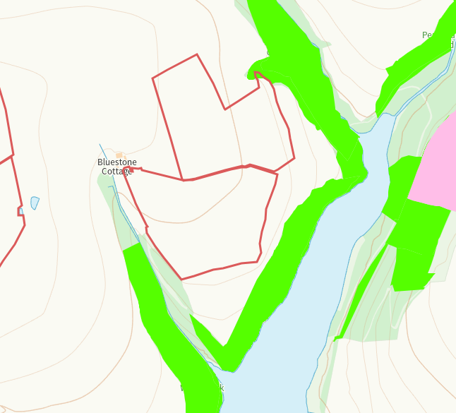

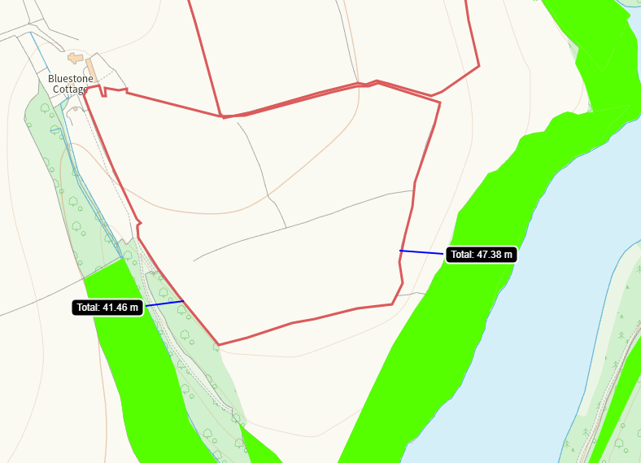

There is areas of ancient semi-natural woodland in close proximity to Gwarcoed 24 and 19. This has been identified on submitted maps and no spread buffer zones implemented on those areas that cross into spreading zones. No action required,
- Local Wildlife Sites (SINC)-
None in range
- National Park-
None in range
- Groundwater Safeguard Zone-
None in range
- ANOBs
None in range
- Heritage coast
None in range
- World Heritage Sites
None in range
- Hedges, Ditches, Local residents, Housing, schools, Workplaces, Recreational facilities
Nothing of concern

Slope Map
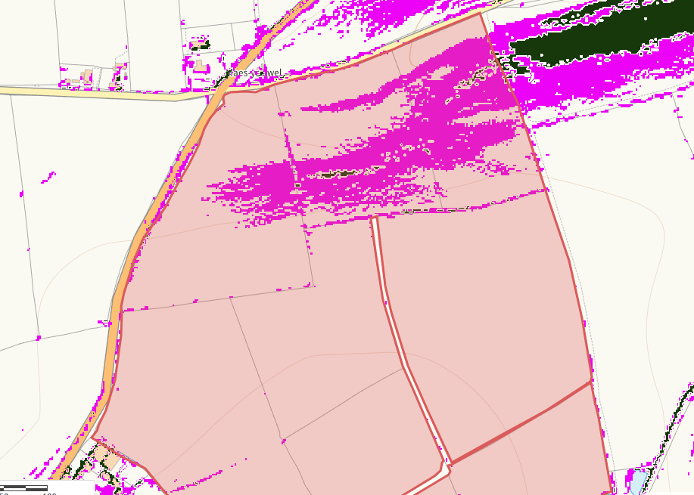

Field Mid Woodstock 13/14 has an area of slope 7-12 degrees (pink) through much of its spreading area. With an area of 12 degrees plus (black) in a very small section of the field, contained within the spreading area. The elevation profile suggests the slope is sloping downward from east to west, however, due to the low application rates (not exceeding 50t/ha) at any time, the application method and the lack of sensitive receptors in the outside vicinity of the fields, no action required.

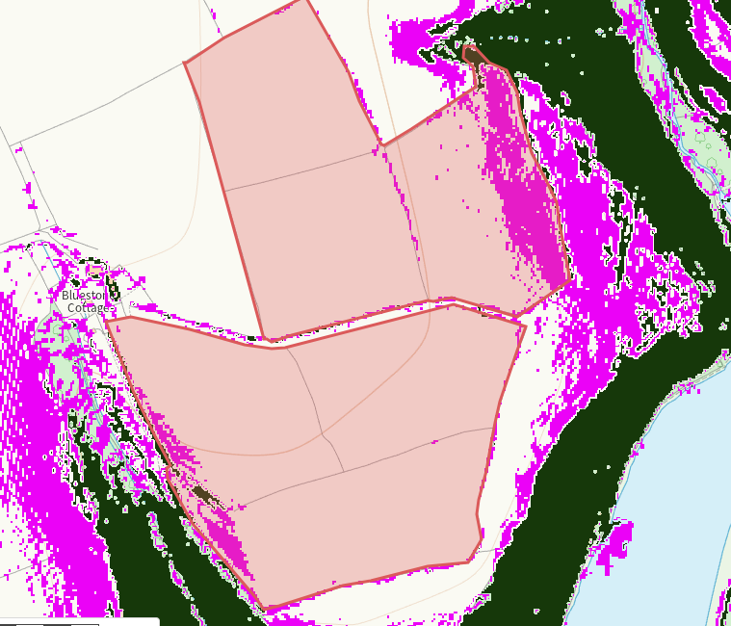
Field Gwarcoed 19 has an area of slope 7-12 degrees (pink) through much of its spreading area although limited sloping continues through the field boundaries themselves. There is an area of ancient woodland encroaching on the west hand side of the field, but all areas crossing a spread boundary and those closest to the receptor have had a no spread buffer implemented. The elevation profile suggests the slope is sloping downward from east to west, however, due to the low application rates (not exceeding 50t/ha) at any time, the application method, and the lack of sensitive receptors in the outside vicinity of the fields, no action required.

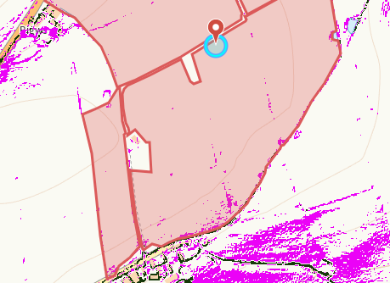
There is very minimal 7-12 degree slopes found in any of the Mid woostock fields 1,2,3,4,5,10 and 11. No action required.

