Plan of location of Ffestiniog Sewage Treatment Plant 2023

Treatment plant
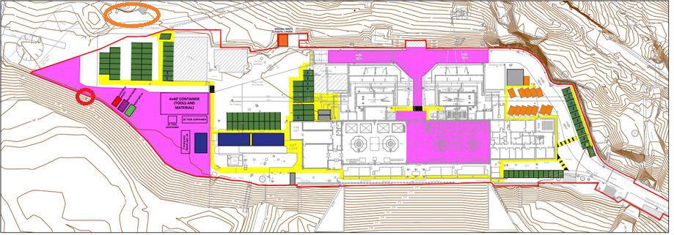
Discharge point


