NAVIGATIONAL RISK ASSESSMENT FOR THE PROPOSED THREE HECTARE SEAWEED AND SHELLFISH FARM ( SHOWN IN BLACK RECTANGLE - EXISTING TRIAL SITES IN FLUORESCENT GREEN )

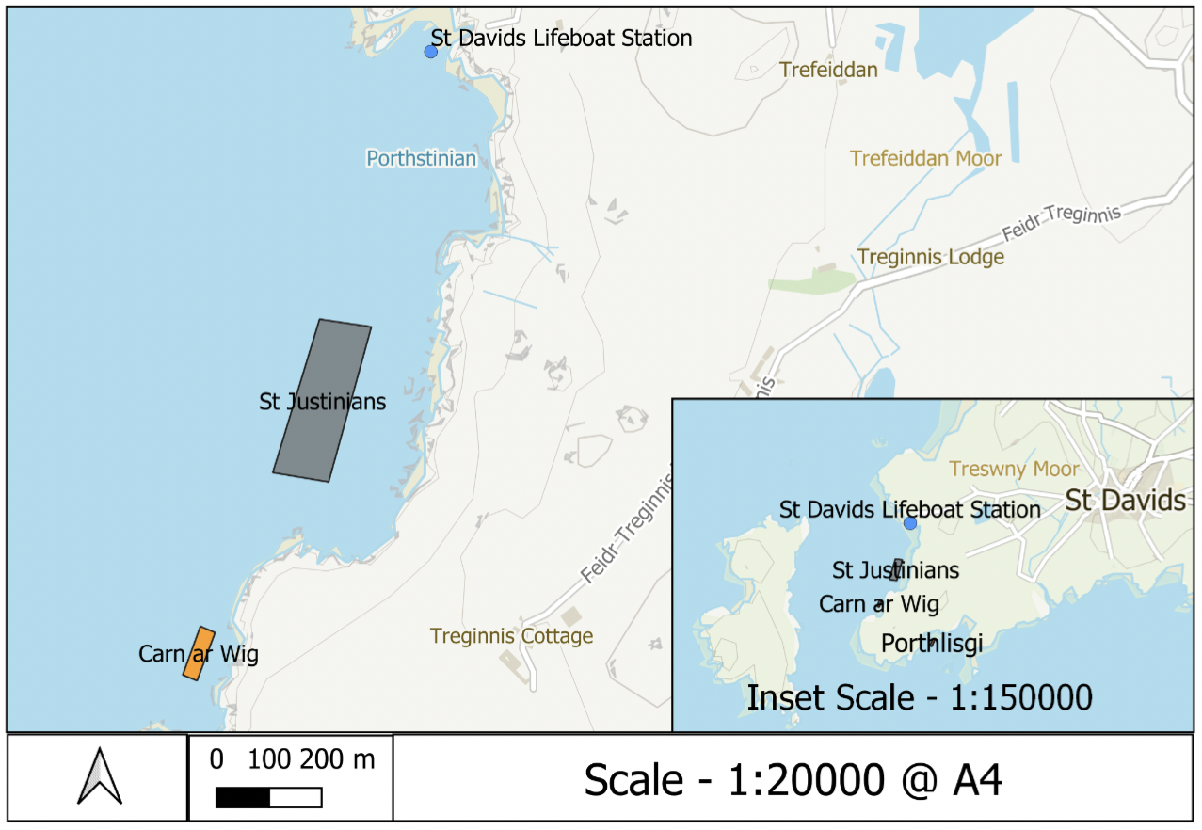

St Justinians Proposed Site
Longitude | Latitude
-5.312440965606686 | 51.87332853640763
-5.3137350082397505 | 51.87070162364426
-5.3121900558471715 | 51.87054263792684
-5.311006965606687 | 51.87319753571296

Summary of vessel traffic in the sound

The main vessel traffic in the sound is from the St Justinian lifeboat station area.Vessels head due west out into the deeper channel then either head North or South - or straight across the sound to Ramsey Island. The site seeing boats comprise most of the traffic with several trips a day in the summer months. Derek Rees operates the boat that primarily services Ramsey island. All fishing in the Sound in by potting boats - there is one full time fisherman and several part time . These fishing boats tend to operate around the edge of the sound, keeping their pots in the shallower waters. The life boat follows this route when launched as well. From time to time occasional other vessels pass through the sound always staying i the deeper central channel.

Potential issues and mitigation measures

There is a risk that when busy, especially in the summer, some vessels will operate in the shallower water to avoid the deep central channel. However the proposed farm will be clearly marked with Trinity House Bouys and white 15 inch bouys above the seaweed lines. Also due to the constant potting activity boat users are always on the look out for bouys in the shallower water .

Further many of the local boat operators are supporters and members of the Community Benefit Society so are fully aware of the trial farms and proposed farm. In fact several of the tour boats divert to the farms to show and explain to their customers about the Community seaweed and shellfish farms and the compelling logic for them being operated.

Several fisherman have also already reported that rod and line fishing is good around the trial farms due to a new ecosystem being created full of marine life. Bird spotters on social media have also reported increased seabird activity around the sea farms

Another potential issue is that any of the farm structure may become slack or mis aligned. Firstly Trinity House carry out an annual inspection of the sites and navigational bouys. The sites will be regularly checked by the operators by diving and underwater monitoring systems. Further as it is a community farm many locals often go out specifically to check them from the coastal paths or by boat - especially after bad weather - and report back. The Coastal Community wishes the farms to succeed - to date we have had no negative feed back.

In conclusion

The proposed farm will be a navigational risk as it is a structure in the water. However it is a small risk because:
- its away from the main vessel routes
- its marked with Trinity house Bouys and smaller seaweed line bouys
- its located away from the coast so that fishing boats have amble room to continue to work around the edges of the sound
- its well publicised as it is supported and equally owned by many in the local community who have a vested interest in reducing any risk and ensuring the farms are a success

