Natural Resources Wales permitting decisions

Variation
We have decided to issue the variation for New Horizon Plastic Co Limited operated by New Horizon Plastics Co Limited.
The variation number is EPR/BB3697ZN/V003
We consider in reaching that decision we have taken into account all relevant considerations and legal requirements and that the permit will ensure that the appropriate level of environmental protection is provided.

Purpose of this document

This decision document:
- explains how the application has been determined
- provides a record of the decision-making process
- shows how all relevant factors have been taken into account
- justifies the specific conditions in the permit other than those in our generic permit template.
Unless the decision document specifies otherwise we have accepted the applicant’s proposals.

Structure of this document

- Key Issues
- Annex 1 the decision checklist

Key Issues

Noise and Noise Impact Assessment

Background to the issue – Existing Noise from Site Higher than Expected.

The Noise Impact Assessment submitted in support of this application (Document Reference) demonstrates that the BS4142:2014 rating level for the existing noise emissions at receptors is in the adverse to significant adverse range this is shown by Figure.1 below.

These rating levels are in excess of those that we would typically expect for a permitted facility. Our guidance Noise and vibration management: environmental permits - GOV.UK (www.gov.uk) indicates that these levels (as shown by the figure below) are unacceptable levels of auidible/detectable noise that means that significant noise pollution is being, or is likely to be, caused at the receptor. Our guidance goes on to say that a permit is unlikely to be issued with noise emission being at these levels.

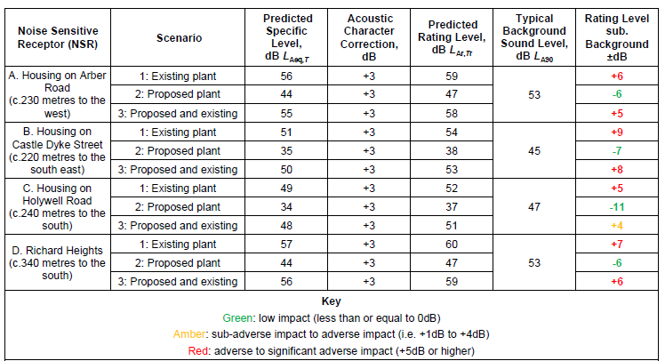

The Noise Impact Assessment (CAS-2560-I Version 1.5, 29/03/22) for the previous variation (EPR/BB3697ZN/V002) which permitted the exisiting activities on site predicted noise emissions in the no noise, or barely auidbile/detectible noise cateogory. There is therefore a contrast between the original prediction and the noise levels in reality.

This is an issue because the Noise Impact Assessment for this variation has argued that through this variation the site is bringing the noise emissions down. Whilst this is understandable and we do not disagree with the statement, the noise levels are and will remain in excess of what was agreed during the previous variation.

There was an Improvement Condition in the permit ( EPR/BB3697ZN/V002) for the operator to undertake a follow up Noise Impact Assessment (to BS4142:2014 Standards) once the site was up and running to ensure that the predictions and assumption with the Noise Impact Assessment submitted in support of variation application PAN-014178 were accurate and the predicted noise impact at receptors was consistent in the real world. Typically compliance against this improvement condition would be assessed outside of the permitting application process during on going regulatory compliance actions. For a number of reasons, such as the short duration between Variation (V002) and this variation (V003) this review has been undertaken during this variation determination.

NRW have formally audited the NIA submitted in support of this application and we do not disagree with the methodology undertaken and therefore are comfortable that it is a robust assessment and the conclulsions can be relied on.

Decision taken to resolve the issue.

We do not disagree with the conclusions of the report which indicate that there will be a reduction in the noise emissions as a result of the changes proposed by this variation. We therefore are in a position the sites existing noise emissions will not prevent us from agreeing to this variation.

However, we need to also address the operators exisiting noise level which are in excess of that agreed to within a previous variation and in excess of acceptable levels outlined in our guidance. We have therefore imposed a number of improvement conditions within Table S1.3 of the permit designed to ensure that the operator is preventing noise pollution at sensitive receptors or where this is not feasible minimise pollution at sensitive receptors.

Following the completion of this suite of improvement conditions the noise emissions from site should be minimised.

Annex 1: decision checklist
This document should be read in conjunction with the Duly Making checklist, the application and supporting information and permit/ notice.

Aspect considered |  | Justification / Detail | Criteria met
 |  | Justification / Detail | Yes
Operator
Control of the facility |  | We are satisfied that the applicant (now the operator) is the person who will have control over the operation of the facility after the grant of the permit.  The decision was taken in accordance with EPR RGN 1 Understanding the meaning of operator.
European Directives
Applicable directives |  | All applicable European directives have been considered in the determination of the application.  Hazardous waste treatment and storage are treatment activities under the Industrial Emissions Directive. Therefore, daily treatment / and storage capacity limits have been set in Table S1.1 of the permit.
Sustainable Management of Natural Resources (SMNR)
Considerations of SMNR - Compliance with our General Purpose | We are satisfied that this decision is compatible with our general purpose of pursuing the sustainable management of natural resources in relation to Wales and applying the principles of sustainable management of natural resources. |  | ✓
Environment Wales Act 2016 – Biodiversity and resilience of ecosystems duty
Consideration of Section 6 | Section 6 of the Environment Wales Act 2016 requires that we seek to maintain and enhance biodiversity in the exercise of our functions, and in so doing promote the resilience of ecosystems, in a manner that is consistent with the proper exercise of our functions. NRW is satisfied that in this case, we have taken into account and had due regard to this duty in so far as it is consistent with the function of determining an application for an EPR permit. |  | ✓
The site
Extent of the site of the facility |  | The operator has provided a plan which we consider is satisfactory, showing the extent of the site of the facility  A plan is included in the permit and the operator is required to carry on the permitted activities within the site boundary.
Site condition report |  | The existing permit included a tre recycling activity which the operator never undertook. As part of this application the operator also requested that this activity was surrendered from the permit.  The operator has provided a description of the condition of the site.  We consider this description is satisfactory. The decision was taken in accordance with our guidance on site condition reports – guidance and templates (H5).
Biodiversity, Heritage, Landscape and Nature Conservation |  | The application is within the relevant distance criteria of a site of heritage, landscape or nature conservation, and/or protected species or habitat .  The project has been screened for likelihood of significant effects and, taking account of the advice received from protected sites advisors, is considered not likely to have a significant effect on any Natura 2000/Ramsar site (As documented in section 3.2 of OGN 200 form 1, or section 5 if applicable)
Environmental Risk Assessment and operating techniques
Environmental risk |  | We have reviewed the operator's assessment of the environmental risk from the facility.  See key issues section above to see how we have considered noise.  The operator’s risk assessment is satisfactory.  The assessment shows that, applying the conservative criteria in our guidance on Environmental Risk Assessment all emissions (excluding noise) may be categorised as environmentally insignificant.
Operating techniques |  | We have reviewed the techniques used by the operator and compared these with the relevant guidance notes.  The Operator has provided the following documents in support of their application that outlines a range of operating procedures and management strategies.  - Fire Prevention and Mitigation Plan (CAS/2570-B-FPMP-v2.3)  - Environmental Management System (CAS/2570-A-EMS-v2.6)  - Enivronmental Noise Impact Assessmentand (P2377-REP01-Rev-A-BDH)  Parts of these documents or the entire documents have been added to Table S1.2 of the permit. This ensures that the procedures and management strategies within the documents form part of the permit.
The permit conditions
Waste types |  | We have specified the permitted waste types, descriptions and quantities, which can be accepted at the regulated facility.  We are satisfied that the operator can accept these wastes as they are consistent with the type of activity and the environmental controls in place on site.
Pre-operational conditions |  | Based on the information in the application, we consider that we need to impose pre-operational conditions.  We have imposed a preoperational condition to ensure that the integral infrastructure required for ensuring the new hazardous waste storage and treatment operations on site do not cause pollution.
Improvement conditions |  | Based on the information on the application, we consider that we need to impose improvement conditions.  See key issues for the explanation of what improvement conditions we have added and why.
Incorporating the application |  | We have specified that the applicant must operate the permit in accordance with descriptions in the application, including all additional information received as part of the determination process.  These descriptions are specified in the Operating Techniques table in the permit.
Operator Competence
Environment management system |  | There is no known reason to consider that the operator will not have the management systems to enable it to comply with the permit conditions. The decision was taken in accordance with RGN 5 on Operator Competence.

