Notice of variation with introductory note
Environmental Permitting (England & Wales) Regulations 2016

Mr Edward Vaughan, Mr John Vaughan and Mrs Eluned Beryl Vaughan

Sychtyn
Llanerfyl
Welshpool
Powys
SY21 0JF

Variation application number
EPR/AB3091ZZ/V002

Permit number

EPR/AB3091ZZ

Sychtyn

Permit number EPR/AB3091ZZ

Introductory note

This introductory note does not form a part of the notice

The following notice gives notice of the variation of an environmental permit.

Operator indicated variation to increase the permit area of SR2012 No10.

The schedules specify the changes made to the original permit.

The status log of a permit sets out the permitting history, including any changes to the permit reference number.

Status log of the permit
Description | Date | Comments
Permit determined  EPR/AB3091ZZ/A001 | 18/12/15 | Original permit for SR2012 No10 issued to Mr Edward Vaughan, Mr John Vaughan and Mrs Eluned Beryl Vaughan.
Application EPR/AB3091ZZ/V002 | Duly made  03/06/24 | Application to increase the permit area of SR2012 No10.
Variation determined EPR/AB3091ZZ | 01/07/24 | Varied permit issued.

End of introductory note

Notice of variation
Environmental Permitting (England and Wales) Regulations 2016

The Natural Resources Body for Wales (“Natural Resources Wales”) in exercise of its powers under regulation 20 of the Environmental Permitting (England and Wales) Regulations 2016 varies

Permit number

EPR/AB3091ZZ

issued to:

Mr Edward Vaughan, Mr John Vaughan and Mrs Eluned Beryl Vaughan (“the operator”)

whose principal office is

Sychtyn

Llanerfyl

Welshpool

Powys

SY21 0JF

to operate a regulated facility at

Sychtyn

Llanerfyl

Welshpool

Powys

SY21 0JF

to the extent set out in the schedules.

The notice shall take effect from 01/07/2024

Name | Date
Huw Davies | 01/07/2024

Authorised on behalf of Natural Resources Wales

Schedule 1 – conditions to be deleted

None

Schedule 2 – conditions to be amended

None

Schedule 3 – conditions to be added

None

Schedule 4 – amended plan

Amended plan attached

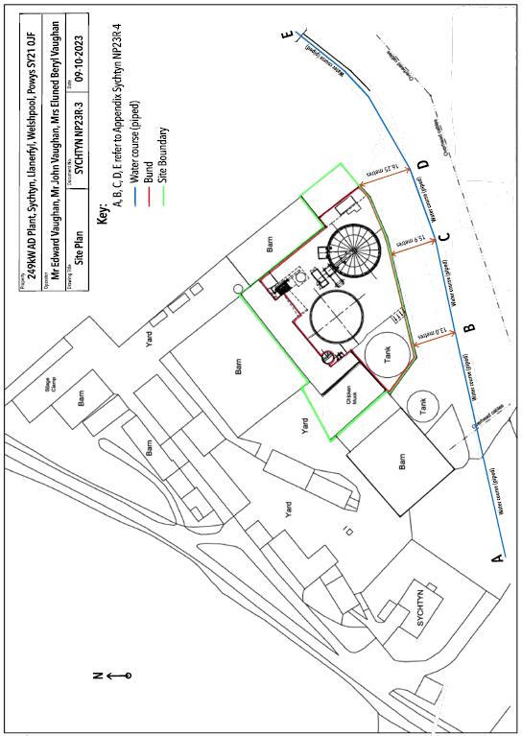
This is the plan referred to in the standard rules SR2012 No10
© Crown Copyright and database right 2024. Ordnance Survey licence number 100019741.

