Monitoring and Maintenance Plan

Great Rhymney Wharf polders is a pilot project and considerations around monitoring and maintenance will be key to inform the success of the project and ensure its viability in the long term. Long-term management plans will be required for any notable retained habitats as well as any newly created habitats to ensure the desired objectives for biodiversity are achieved.

The following change focus areas and monitoring considerations are outlined as follows:

- Sediment accretion: This will be achieved by repeated UAV flights which will show sediment increases over time; survey frequency of every two years is proposed as a minimum.
- Water movement and direction: sondes and mini-buoys to look at hydrodynamics, sediment availability and depth have been established as part of a baseline understanding of conditions and the methodology will be repeated to understand how hydrodynamics will change as sediment accretion progresses.
- Changes in extent of saltmarsh and mudflat and sandflat features: There is a recent (2017) NVC saltmarsh survey for extent of saltmarsh communities, therefore a current baseline can be used against which to evaluate changes. Further extent surveys using UAV will likely take place in year 3 as it is not anticipated that the saltmarsh will develop within a smaller timeframe.
- Changes in saltmarsh communities: Monitoring sites using transects were established in 2023 across the polders footprint (see image below). Using some or all of these transects (depending on changes in sediment accretion), repeat vegetation monitoring will take place every two years.
- Changes in mudflat habitats: Evaluation of the mudflat and saltmarsh biotopes will be undertaken. A baseline survey was undertaken in May 2024 comprising 11 fauna samples and 5 PSA samples. These will be subject to lab analyses to determine biotopes in relevant polder fields to show changes in future. Further surveys will be undertaken in 2026, if saltmarsh has not accreted in the newly formed fields, in which case these areas will be part of the saltmarsh community monitoring outlined above.

The project will consult with NRW advisory to agree a reporting format of monitoring results as per sampling schedule described above.

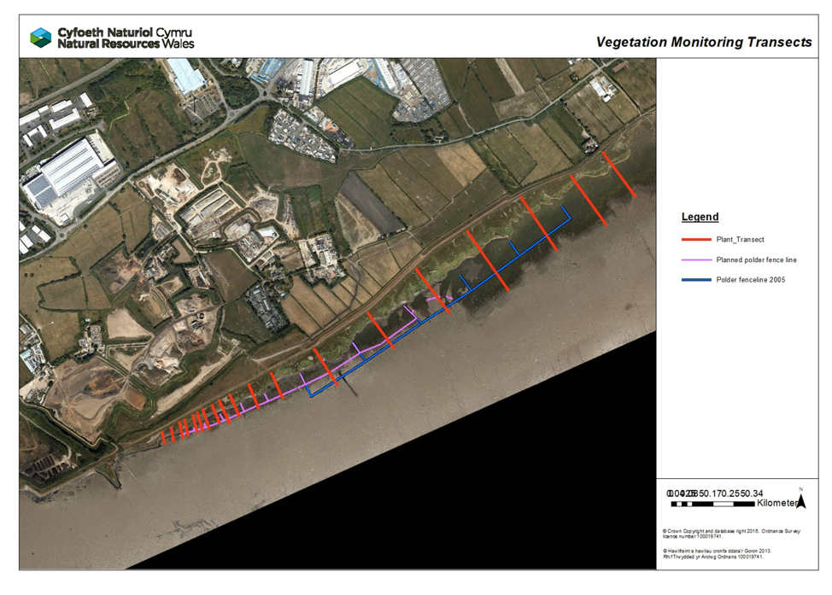
Baseline survey vegetation transects – Rhymney Great Wharf polders.

A monitoring programme will be followed for the first 5 years and then reviewed to inform future plans. Understanding the success or failure of the polders at this stage will lead to an adaptive management strategy. It is anticipated that if the polders are showing success in saltmarsh restoration, then minimal/no intervention will be required. Similarly, if no noticeable changes are seen and further time is needed to allow restoration, no further intervention would be needed either. However, if no restoration is taking place and there is a marked and continued adverse impact on the site (e.g. large-scale scour of sediment), then remediation will be required or removal of some of/all the fencing.

For the first 5 years, pre- and post-winter surveys by asset inspectors will form the maintenance checks and subsequent annual repairs may be required over the summer season once bird features have left (unlikely to be able to do repairs over winter due to overwintering bird restrictions). Frequency of maintenance monitoring will be reviewed after 5 years.

Maintenance checks will consist of:

- Checking if fence posts are still in place
- Checking if brushwood is still in place

If needed, repairs will be undertaken over the course of spring and/or summer.

