ADDITIONAL INFORMATION SUBMISSION FORM

This form is to be used to provide any additional information requested for marine licence application. Ensure that the relevant section to be amended is indicated below and that you provide as much information as possible.

All information submitted may be referred to within a licence, therefore all works must be in accordance with this information, unless otherwise agreed with the Licensing Authority during the determination process.

Application Form Structure
- Applicant Information
- Application Amendments/Additional Information
- Pulbic Register
- Declaration

- Application Information

Licence Reference Number | RML2443
Applicant | Mr Kevin Whyte
Applicant e-mail address | kwhyte@mdmeng.ie

- Application Amendments/Additional Information

Please insert additional rows if more than one section is to be amended.

Section of the Application Form Amended (Number & Name) | Amendments Made
Coordinates; | - Coordinate values updated to same degree of accuracy (6 decimal places) within application  - Coordinates in method statement changed to decimal degrees  Latitude Longitude  51.387326 -3.071430  51.395393 -3.077032  51.424611 -3.076316  51.432735 -3.061528  51.441806 -3.050201  51.451263 -3.041367  51.482694 -3.005819  51.492889 -3.000201  51.513154 -2.995801  51.524196 -3.002047  51.529586 -3.005084  51.530201 -3.006039  51.528935 -3.009088  51.528376 -3.008221  51.523449 -3.005444  51.512955 -2.999507  51.493779 -3.005800  51.484350 -3.010996  51.453210 -3.046211  51.443827 -3.054975  51.435213 -3.065730  51.426259 -3.082028  51.394670 -3.082798  51.384001 -3.075293
Correspondence; | - MCA opinion on works provided (Additional document)  - RCAHNW Final response provided (Additional document)
Applicant details. | Amend errors to applicant company/trading name and company registration number:  - Company or trading name: McMahon Design & Management (MDM) Ltd.  - Company Registration Number: 06106193

If the submission above will result to any changes to the working methodology, these must be reflected in the method statement and any other relevant supporting documents.

If this is the case, please tick to confirm that you have submitted the amended Method Statement/supporting document/drawings. Please ensure that any submitted documents are dated, contain appropriate version numbers and that any changes made to the Method Statement have been clearly highlighted using an alternative colour within the document.

Please indicate below the Sections of the Method Statement that have been amended:
Corrdinates in Table 2: coordinates amended to decimal degrees.

- Public Register

Under The Marine Licensing (Register of Licensing Information)(Wales) Regulations 2011 and the Environmental Impact Assessment Directive (Directive 85/337/EEC – as amended) , all information contained within or provided in support of this application will be placed on the Public Register unless NRW approve of the applicant’s reasons for withholding all or part.

2. Is there any information contained within or provided in support of this application that you consider should NOT be included on the Public Register on the grounds that its disclosure:

2(a). Would be contrary to the interest of National Security? Yes ☐ No ☒

2(b). Would prejudice to an unreasonable degree you, or some other person’s commercial interest of those of a third party? Yes ☐ No ☒

If Yes to either (a) or (b), please provide full justification as to why all or part of the information you have provided should be withheld

Please continue on a separate sheet if necessary. Please tick if you have done this ☐

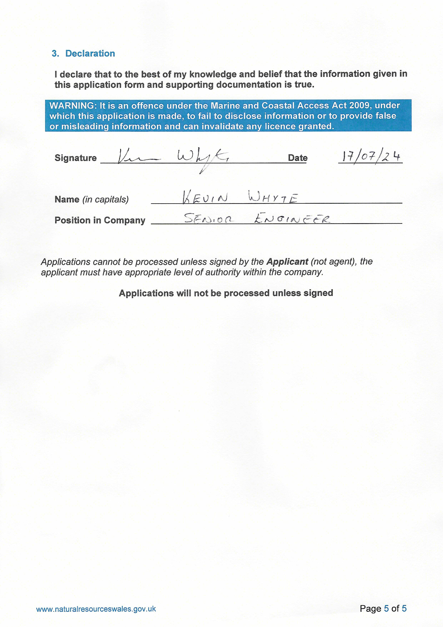
- Declaration

