PAN-025832 - My Map Report:
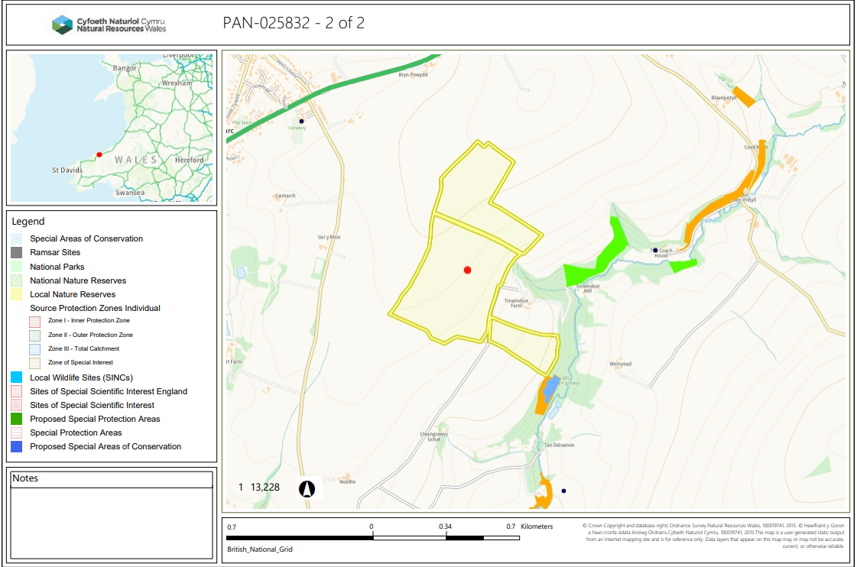
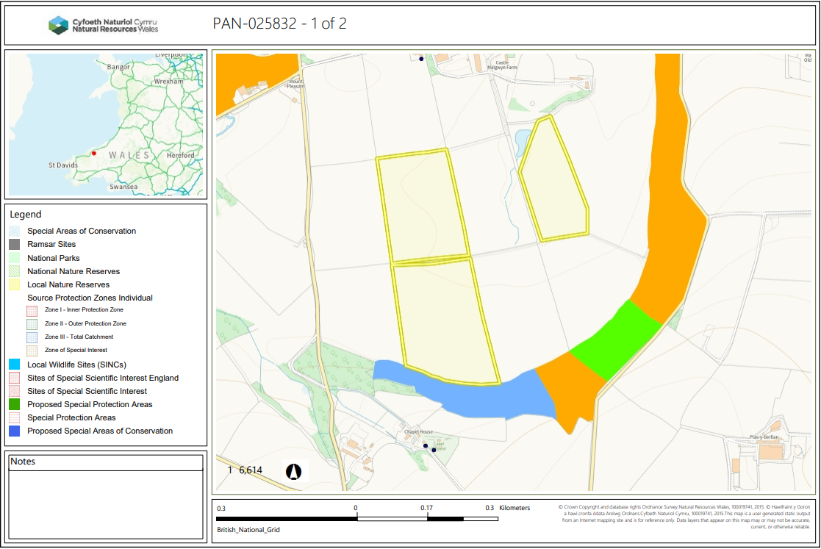
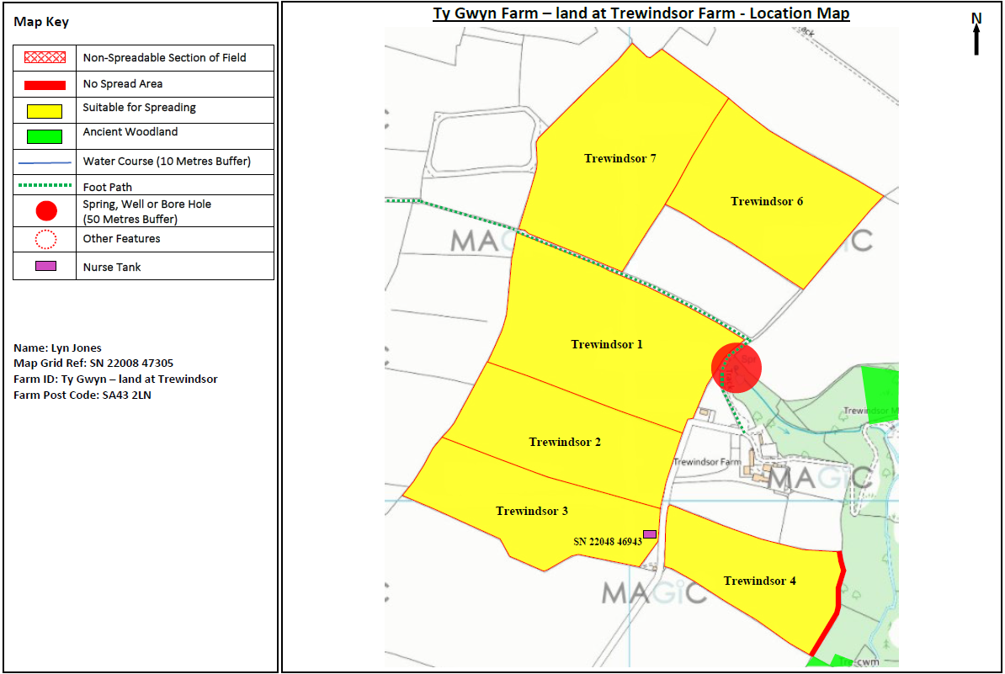

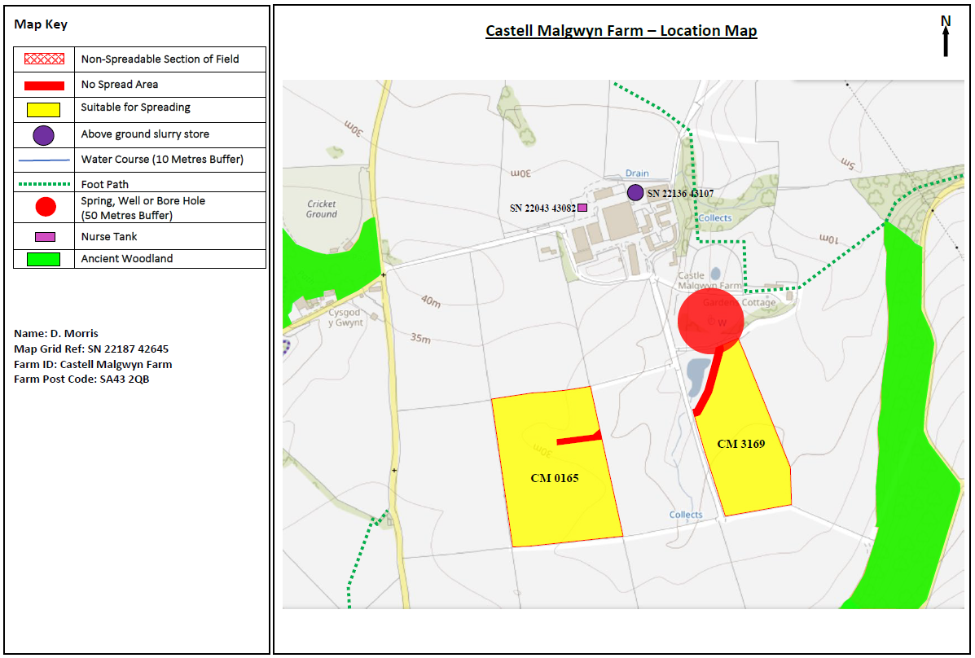

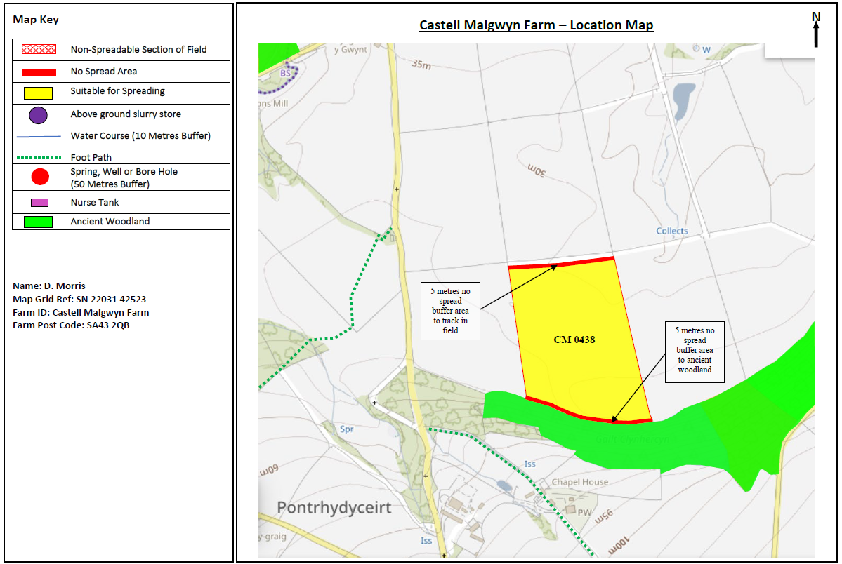

Detailed river network:

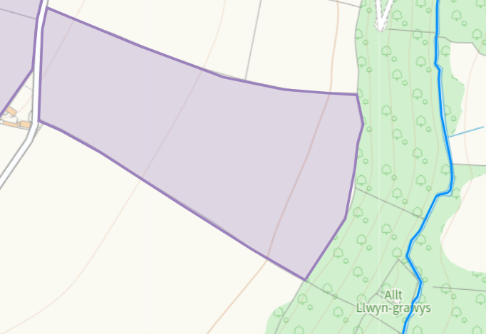
The River Nant runs 70m from the boundary of Trewindsor . This has been highlighted n the submitted maps and a buffer implemted on the field edge to prevent any potential run-off. No action required.
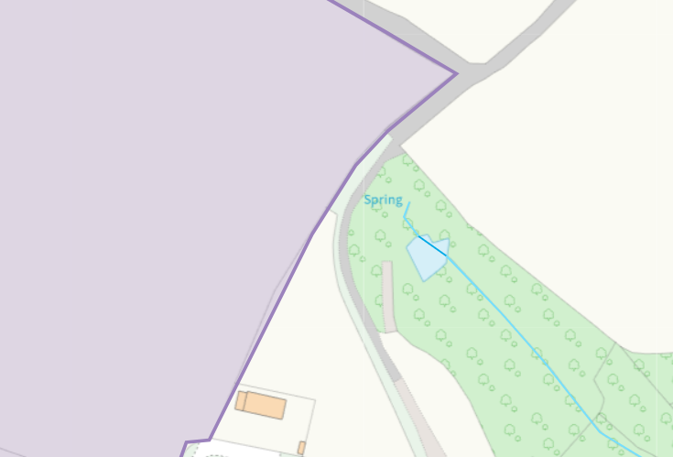
A spring is located within 26.57m of the border of Trewindsor 1. This has been appropriately identified in submitted maps and a 50m buffer implemented around the spring. No action required. Spring 26.57m
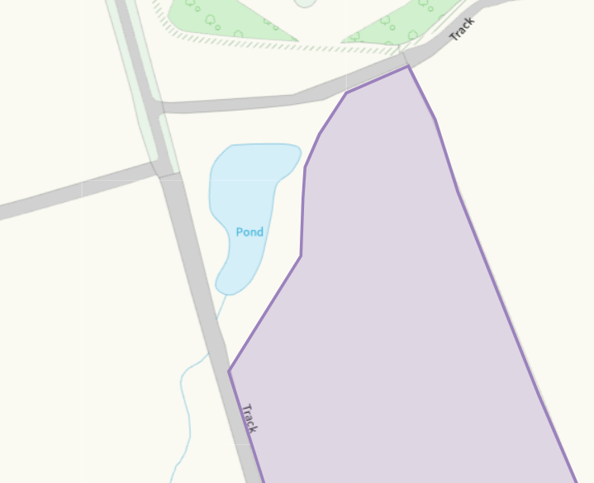
There is a surface pond located at the top of CM 3169 that runs into a collect. There is a no spread buffer implemted on the adjacent border to prevent surface run off. No action required.
Groundwater protection zones (source)
None in range
Wells, springs or boreholes used for the supply of water for human consumption including from a private water supply or supplies
None in range
any springs wells or boreholes not used to supply water for domestic or food production purposes within 50m

None in range
European designated sites- Natura 2000 (SPA, pSPA, SAC or cSAC) or Ramsar- or SSSI within 500m

None in range
Other protected sites:
- Protected Species-
- Protected Habitats-
- Scheduled Ancient Monument-
None in range
- Local Nature Reserve-
None in range
- National Nature Reserve-
None in range
- Ancient Woodlands-
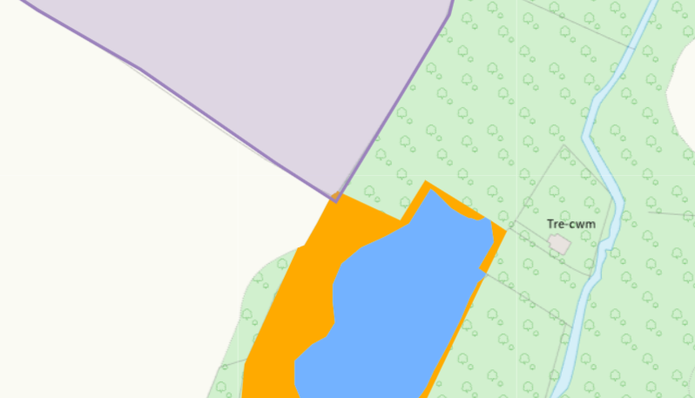
Trewindsor 4 has an area of restored ancient woodland bordering the corner of the field. Due to the no spread buffer zone and lack of slope on this field, no action required.

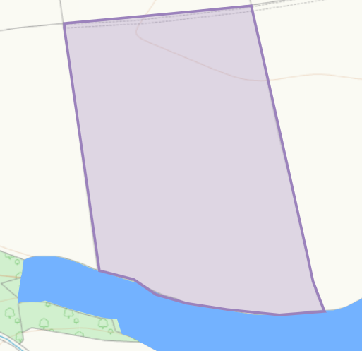
CM 0438 has an area of plantation on ancient woodland. This has been identified in maps and a 5m no spread buffer implemted to prevent run off. No action required.
- Local Wildlife Sites (SINC)-
None in range
- National Park-
None in range
- Groundwater Safeguard Zone-
None in range
- ANOBs
None in range
- Heritage coast
None in range
- World Heritage Sites
None in range
- Hedges-
- Ditches-
- Local residents
- Housing, schools
- Workplaces
- Recreational facilities

Slope Map
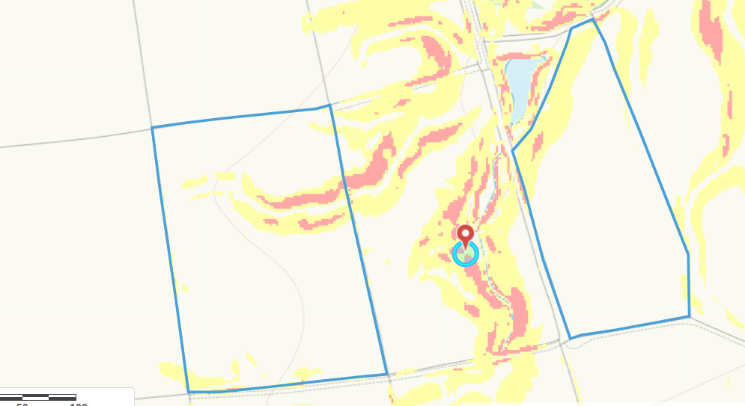
There is a slope of 7-12 degrees (yellow) and 12 degrees plus (red) in fields CM 3169 and CM 0165. Both areas of red sloping have been buffered with no spread zones in submitted maps to minimise and run off risks as well as a buffer implemted in the area adjacent to the pond in CM 3169. Due to the buffer zones and lack of sensitive receptors adjacent to the fields, No action required.
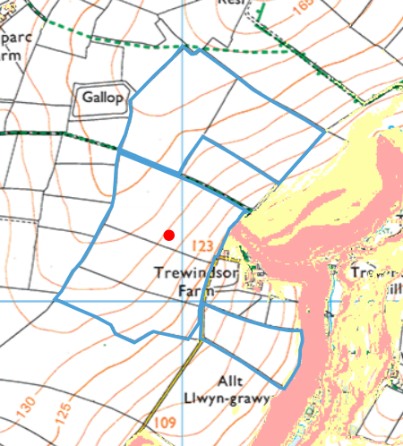
No slope contained in any of the fields shown above.

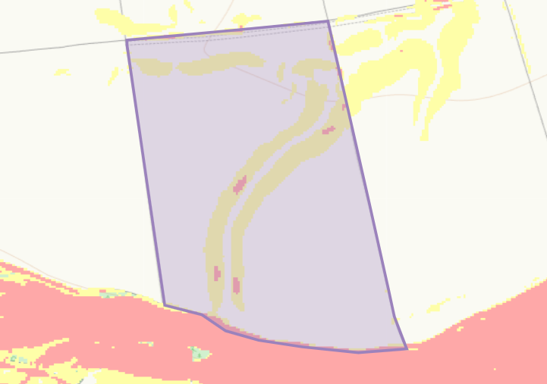
CM 0438 has some areas of slope of 7-12 degrees (yellow) and 12 degrees plus (red). There is a 5m no spread buffer zone implemented at the bottom of the field where the slight red slope is preventing run off into the ancient woodland. The areas of yellow slope are mainly contained within the field and due to the lack of other sensitive receptors around the field no action required.

