CRoW Appendix 4 (140_10_SD02)  CRoW Act 2000: Natural Resources Wales application for permission - Formal Notice |  | 
Natural Resources Wales Formal Notice.
Requirements of Section 28I of the Wildlife & Countryside Act 1981 as amended by the Countryside and Rights of Way Act (CRoW) 2000.
Duty in relation to granting any consent, licence or permit for activities likely to damage Sites of Special Scientific Interest (SSSI).
Guide to filling in this form for Natural Resources Wales staff:
To be completed by Permitting Officers for any applications for a permission which the Natural Resources Wales has considered under S28G duties to protect and enhance SSSIs. This applies to all proposed permissions within a SSSI, and to operations outside the SSSI boundary which are likely to damage its special features.
Refer to OI 140_10 ‘Applying the Countryside and Rights of Way (CRoW) Act 2000 to applications for permits with potential for impact on Sites of Special Scientific Interest (SSSI)’, including the flowchart in Appendix 2.
Pink italic text – drafting notes, to be deleted before completion/consultation.
Blue text – examples, to be replaced with permission-specific information.
Ensure you have completed all sections.
- Natural Resources Wales area/region/NPS hub: | Wales, Cardiff, Ty Cambria
- Name of SSSI: | Gwent Levels
- Type of permission: | Environmental Permit  Section1.1Combustion Activities- Part A (1) (a) Burning any fuel in an appliance with a rated thermal input of 50 or more megawatts.
- Date for Natural Resources Wales permit determination: | 07/06/2019
- Predicted 28 day date for response from NRW conservation/ecology (under S28 I(4)): | 12/09/2019 or asap
- Natural Resources Wales reference no: | PAN-003940
- National grid reference: | ST 28142 84568
- Description of proposal: | The application is for 77 standby diesel engines with a thermal MW of 146 (combined). They will provide back-up generation in event of a power failure supply from the National Grid. Each engine has its own individual stack.  Two operating scenarios possible:  - Emergency – rare scenario, National Grid had a reliability of 99.999964% in 2016/17.  - Testing and maintenance - A more likely operational scenario is a testing and maintenance scenario. Operational hours in this scenario are minimal. Historically, no engine has run for more than 16 hours per year, however the current testing regime leads to fewer annual hours than this.  There are 5 engine types in total with stack heights range from 3.937m to 3.184m. The site is prevented by its planning permission from testing more than two engine cells at any one time. It is also prevented from testing outside the hours of 09:00 and 17:00 Monday to Friday, exclusive of bank and public holidays.  Each cell has its own fuel storage tank, 62 tanks holding a total of 243,680 litres. The engines and fuel tanks are situated on concrete plinths, surrounding by hardstanding. All piping is above ground and connection points are in bunded areas.  The emissions from the exhaust gas will comprise of:  - Oxides of nitrogen (up to 2000mg/NM3@ 5%O2)  - Particulates (worst case scenario, emission will be <80 mg/NM3@ 5%O2. BAT limit is 80.  - Carbon Monoxide CO (worst case 896 mg/NM3@ 5%O2). CO limits do not apply for engines operating for less than 300 hours.  - Carbon Dioxide CO₂  - Sulphur Dioxide (low sulphur fuel will be used, 0.1%). It is considered that the primary techniques employed tocontrolSO2emissionsrepresentBAT for the installation.  Fugitive emissions could result from engine oil leaks, oil distribution pipe leaks, storage tanks/container leaks, delivery leaks and spills, drainage system.  The operator has an accident management plan in place along with a  environmental management system in accordance with ISO  14001:2015. Raw materials will consist of diesel, engine oil/lubricants  and antifreeze/coolants. Waste will be kept to a minimal. Any waste  generator will be disposed of via a licenced contractor.  The only surface water drainage from site will be uncontaminated  surface water discharging to the sites drainage system. A drain  isolation system is in place which can detect spills. ‘Bladders’ located  within the pipes will inflate and capture the contaminated water within  the drainage system which can then be pumped out and disposed of  appropriately.
- Is the proposed activity within (wholly or partially) the SSSI boundary? | No. The Data Centre is approximately 700m from the SSSI site boundary.  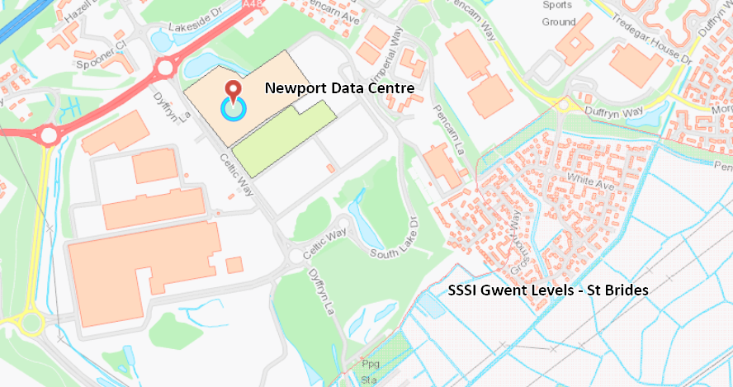  There were several Local Wildlife Sites and Ancient Woodlands within distance of the Installation. Nearest in Celtic Springs Local Wildlife site approximately 156m to the north.  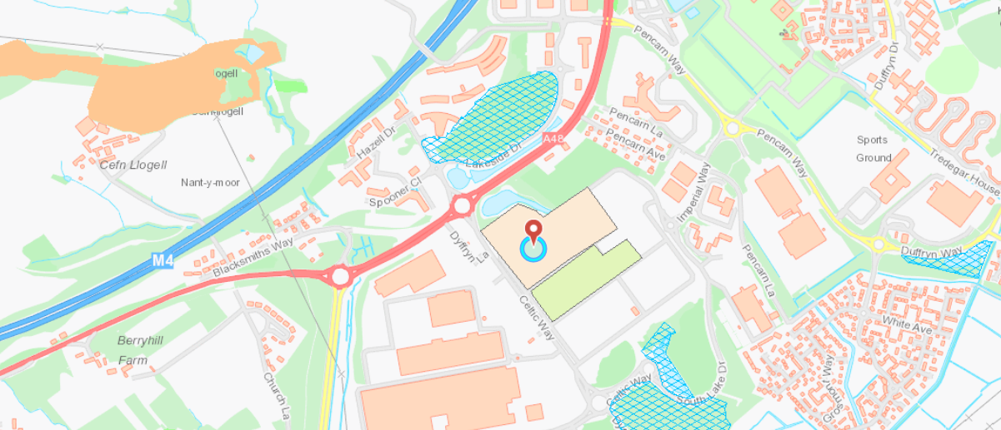
- Has there been any pre-application discussion or correspondence with NRW conservation/ecology | No
- What aspect(s) of the proposed permission may damage the features which are of special interest for the SSSI?
The following ‘Operations Requiring Consent’ (or other activities associated with the permission) that may cause damage) are relevant to the proposed permission:

Emissions from air
Gwent Levels is designated for its Reen and ditch habitats, insects and invertebrates and Shrill Carder Bee species. However, the Gwent Level SSSI are classified as standing open waters and canals.

Features not likely to be impacted by noise.

The following SSSI features and mechanisms of impact have been considered to assess the likelihood of damage:

Potential for increased NOx deposition and acid deposition. PM, SO₂, CO and CO₂ emissions.

- Decision

A detailed air quality assessment was carried out using atmospheric dispersion model (AERMOD) and in line with our guidance. Long term air quality objectives are not relevant to this study due to the very restricted generator run time over the year and hence the short-term nature of the emissions from the engine test regime. A worst case scenario of all 77 engines being run at the same time for one hour has been modelled along with looking at the testing/maintenance scenarios which will be most common.

The principal pollutants associated with diesel engine emissions are oxides of nitrogen, which form nitrogen dioxide in the atmosphere. There is a daily average non-statutory guideline value for oxides of nitrogen concentration of 75 μg/m³ for the protection of vegetation. Sulphur dioxide emissions are also considered in this study. The relevant criteria are 10ug/m3 (with lichens) 20 (without lichens). Low-sulphur fuel which contains0.1% (1,000ppm)sulphur isused at the installation. This is below the requirements of the SCOLF 2007 of 0.1% (1,000 ppm)for diesel fuel, and also TA Luft 2002 which recommends <0.2%sulphur. It is considered that the primary techniques employed to control SO2 emissions represent BAT for the installation.

The Gwent Level SSSI are classified as standing open waters and canals so not considered to be sensitive to oxides of nitrogen (although there is vegetation within the site boundary, it is not an interest feature). However, the applicant has assessed the site and an assessment has been undertaken for comparison to the non-statutory daily average guideline value for the protection of vegetation of 75μg/m³ oxides of nitrogen.

There are two main operating scenarios; emergency and testing/maintenance.

Testing/Maintenance Scenarios:
Testing regimes are as follows:
• Monthly, separate engines are run individually for 10 minutes each
•Twice per year, separate engines are run individually for 15 minutes each
• Twice per year (alternating quarters with the above), separate engines are run individually for two hours
• Twice per year, mains failure is simulated and one bank of engines (up to nine engines) is run for approximately two minutes, with load shedding down to required capacity. It is possible that a bank comprising up to nine engines would continue to run for up to an hour.

The daily average oxides of nitrogen concentrations were modelled for each bank of engines. The engines were treated as operational for eight hours a day every weekday throughout the five year model run. As the banks of engines may only operate continuously for one hour, the modelled maximum daily average concentrations overestimate by a factor of eight. The bank of engines giving the highest maximum daily average concentration, (factored by 0.125 to represent one hour operation for a bank of engines in one day) was found to be TF1. The maximum daily average oxides of nitrogen concentrations were 9.7 and 6.5 μg/m³ for locations A and B respectively. A and B are located on the edge of the SSSI boundary closest to the installation. These results are well below the 75 μg/m³ non-statutory criterion. The PC for concentration of 9.7 and 6.4 would be 12.93% and 8.67% of the critical level respectively. The Newport monitoring site is located 6.4 km to the north east of the NGD facility. The annual average nitrogen dioxide concentrations measured at the urban background location
Over 5 years is 21.6 μg/m³.
Nutrient Nitrogen – No critical loads to assess against for this habitat
Acid Deposition – No critical loads to assess against for this habitat
There are no critical loads to assess against for this habitat in regard to acid and nutrient deposition, therefore no further assessment is required.
EA H1 guidance states that where short term PC is less that 10% of the short term environmental standard, it can be ruled out as insignificant and no further assessment needed. The results at location A are greater than 10% so looks like they need to look at PEC. If the PEC is < 100% of the short-term standard then unlikely to cause an exceedance – therefore emission not significant.

The mean nitrogen dioxide concentration over the five years is 21.6 μg/m³
Assess whether any exceedances are likely:
PEC_{short-term} = PC + (2 x Background_{long-term})

PEC = 52.9 which is 71% of the standard. Less than 100% so not likely to have any exceedances.
So under testing and maintenance operations, there are not likely to be an impact on the SSSI.
The impacts to Local Wildlife Sites and Ancient Woodlands was also assessed based on the bank of engines GF29 which gave the maximum daily mean for any bank of engines. There is no overlap in testing regimes. The two nearest wildlife sites were assessed, LG Duffryn site 1 and Celtic Springs at their nearest points to the site. Results were factored by 0.125 to represent a single hour of testing which may occur in any one day. The maximum daily mean on a day of testing is 14 µg/m³ which is 19% of the AQA. When the short-term PC is less than 100% of the short term standard, the impact can be deemed as insignificant.
PM emissions are within BAT limits for CI liquid fuelled standby generators.

Emergency scenario:
Additional air dispersion modelling has been undertaken for two such emergency
Scenarios (worst case scenario):
Scenario A) a hypothetical scenario in which all 77 engines operate concurrently for one full hour; and
Scenario B) an example emergency scenario in which all 77 engines would be fired up and then load shed after ten minutes to meet the required residual demand for the remainder of the hour.

Not looked at ecological impacts under scenario A as this is a hypothetical scenario.
Scenario B - The contribution to daily mean NOx at closest ecological sites was also considered for this scenario. The results are shown in Table A3.6. The maximum modelled hourly concentration of NOx, which assumes an outage coinciding with the least favourable day of meteorological data in a five year modelled period, is 11,771 μg/m3 at Celtic Springs local wildlife site. Using the simplistic and highly conservative approach to deriving the daily mean from a one-hour outage, the highest time weighted daily mean result is 490 μg/m3 at Celtic Springs. At an ancient woodland location, the highest time weighted daily mean result is 257 μg/m3 and at the Gwent Levels St Brides SSSI it is 311 μg/m3, greater than the short-term standard. There is a vanishingly small probability of such results occurring during an emergency event, given the very low likelihood of an outage occurring on the hour of least favourable meteorological data in five years.

However, this scenario will only happen under emergency situations, Prolonged emergency operations are not anticipated. The facility has a dual connection to the super grid. The probability of an emergency scenario occurring is thus very small; the ONR identifies a conservative value for an outage of up to 2 hours as a 1 in 20 year event. Longer events have a lower probability. The potential impact on sensitive receptors in the event of a grid failure would be mitigated by NGD through the implementation of power shedding to provide only the amount of power necessary to meet the facilities’ demand at the time. While an outage of a few hours has the potential to occur, the likelihood of that is extremely small. For instance, National Grid reliability was reported to be 99.99964% in 2016/17.

Conclusion
The proposed permission is not likely to damage any of the flora, fauna or geological or physiological features which are of special interest under testing and maintenance scenarios.

The proposed permission is not likely to damage the SSSI during a very rare emergency scenario even though predicted concentrations are high. As discussed, the statistical analysis shows that there is a negligible risk of the process resulting in an exceedance of the standard. In the event of an emergency, this is not likely to be over a long duration and will be a rare occurrence.

Natural Resources Wales is minded to:
Issue the permission

- Name and job title of Natural Resources Wales officer: | Kirsty Thomas  Senior Permitting Officer
- Date form sent to NRW conservation/ecology | 15/08/2019
For Natural Resources Wales use only, once NRW conservation/ecology response received
- NRW conservation/ecology comment on assessment: | Please delete as appropriate:  i) NRW conservation/ecology advise the operation can go ahead  ii) NRW conservation/ecology advise the operation can go ahead with conditions  iii) NRW conservation/ecology advise against permitting the operation  Please ensure that the NRW conservation/ecology response is attached to this Formal Notice.
- Name and job title of NRW conservation/ecology officer:
- Date of receipt of NRW conservation/ecology response:

