Hydrogeological Impact Assessment
Taff Wells Rail Depot
Project Number / Report Number Revision x
10/11/2022

Document Control Sheet
Project Name: | Taff Wells Rail Depot
Project Number: | Project Number
Report Title: | Hydrogeological Impact Assessment
Report Number: | Report Number

Issue Status/Amendment | Prepared | Reviewed | Approved
Draft | Name:  Sakellariou, Georgia  Signature:  GS  Date: 11/11/22 | Name:  Joao Marques  Signature:  JM  Date: 11/11/22 | Name:  Dr Doug Lewis  Signature:  DRL  Date: 11/11/22
 | Name:  Signature:  Date: | Name:  Signature:  Date: | Name:  Signature:  Date:
 | Name:  Signature:  Date: | Name:  Signature:  Date: | Name:  Signature:  Date:
 | Name:  Signature:  Date: | Name:  Signature:  Date: | Name:  Signature:  Date:

Contents
Contents 1
Tables 1
Figures 1
1. Overview 3
1.1. Introduction 3
1.2. Scope of Works 3
1.3. Proposed Water Abstraction Details 3
2. Site Location, Proposed Development 4
2.1. Site Location 4
2.2. Proposed Works 4
2.3. Historical Mapping 7
3. Regional Water Resourcing Status and Licensing Policy 8
3.1. Regional Groundwater Resource Availability 8
3.2. Regional Groundwater Abstraction Licensing Policy 8
3.3. Regional Surface Water Resource Availability 8
4. Hydrogeological Conceptual Model 11
4.1. Topography and Geology of the area 11
4.2. Hydrogeology 11
4.3. Hydrology and Flood Risk 12
4.4. Sensitive land uses, Statutory designations and sites of special interest 13
4.5. Water Framework Directive Regulations 2017 13
4.6. Water Features Assessment Methodology 14
4.7. Sources of Information 14
4.8. Water Features Schedule 1
5. Conclusions 1
Tables
Table 1: Restrictions for new consumptive licences in an average rainfall year on the lower River Taff 8
Table 2: Summary Exceedance Statistics for Taff at Pontypridd 10
Table 3: Water Features Schedule 1
Figures
Figure 1: Red-line boundary for the site 4
Figure 2: Location of Cofferdam around proposed building 5
Figure 3: Proposed cofferdam arrangement 6
Figure 4: OS six-inch Glamorgan Sheet XXXVI.SE, published 1900 7
Figure 5: Water resource availability colours for the South East Valleys CAMS Area 9
Figure 6: Groundwater flows on site 12
Figure 7: Fluvial and pluvial flood map for high, medium and low risk storm events 13
Figure 8: Water Features Plan 3

- Overview
  - Introduction
Amey Infrastructure/Amey Seilwaith commissioned Amey Consulting to prepare a Hydrology Impact Appraisal (HIA) to support a temporary groundwater/surface water abstraction licence for the three months September to December 2022, at Taff’s Wells Rail Depot, Moy Road Industrial Estate, Taff’s Well, Cardiff CF15 7QR. This dewatering is to occur within the site boundary up to 600 m³/day and authorisation has been granted by Welsh Water/Dwr Cymru to discharge this as trade effluent to the public foul sewer, so it will not return immediately to the River Taff local environment.
The site is located at Taff’s Well, South Wales and covers an area of approximately 5.53ha. The OS grid reference of the site centre is ST 12554 83262 and the nearest postcode is CF15 7RN. Historically, the site has had various industrial land uses, namely an iron works/forge from the end of the 19th Century, followed by the manufacturing of lathes, drain covers and automotive parts, as well as less industrial uses within recent times. The site is located c. 100m up hydraulic gradient of the River Taff/Afon Taf at its closest point.
  - Scope of Works
This HIA has been prepared in accordance with the Environment Agency’s guidance, as recommended by Natural Resources Wales (NRW), using published reports, site-specific data and following discussions with Sarah Senior, NRW.
Sarah Senior noted that NRW would like to understand the risk of the dewatering to controlled waters and the environment. NRW are not expecting test pumping to inform this consideration, but they would expect the HIA to be desk based following NRW guidance of how to “Prepare an application for a groundwater investigation consent”, and that the Water Features Survey is the most relevant section.
The HIA therefore has the following format:
- Section 1: Introduction and abstraction details
- Section 2: Site location, proposed development
- Section 3: Review the regional water resource status
- Section 4: Presents a conceptual site model and identifies potential receptors through a Water Features Survey
- Section 5: Conclusions.
  - Proposed Water Abstraction Details
This HRA supports a temporary NRW water abstraction.
Licence Holder: will be Transport for Wales Amey Rail Ltd
Point of Abstraction: Taff’s Wells Rail Depot, Moy Road Industrial Estate, Taff’s Well, Cardiff CF15 7QR, Groundwater is in connection with and underlain by river terrace deposits (sand and gravel) of the Quaternary period.
NGR: ST 12554 83262
Use: Industrial
Abstraction Limits: 13.8 l/s, 50m³/hr, 600m³/d, which correspond with the Welsh Water/Dwr Cymru agreement to discharge as trade effluent to the public foul sewer.
This is a temporary water abstraction request for the duration September 2022 to December 2022.
- Site Location, Proposed Development
  - Site Location
The site is located at Taff’s Well, South Wales and covers an area of approximately 5.53ha. The OS grid reference of the site centre is ST 12554 83262 and the nearest postcode is CF15 7RN. The site is 10 miles northwest of Cardiff City centre, and 9 miles southwest of Pontypridd.
  - Proposed Works
The Rail Depot site (Figure 1) is proposed to be redeveloped with a new pump station, bio-waste tank and a carriage wash tank, and as part of the construction process a series of cofferdam arrangement is required to allow installation of sub-surface tanks. This series of cofferdams could be potentially 8m deep (Figure 2 and 3) to ensure connectivity with the known groundwater levels as shown in Figure 6. The cofferdams are open to both surface water flows from the area and groundwater flows. It is reported that it is impossible to determine the split between surface and groundwater flows to be passed into the public sewer as trade effluent. The trade discharge is derived from ground remediation water and surface water from excavations, pre-treated to remove gross solids. For the purpose of this study, we assume that it is all a groundwater abstraction.
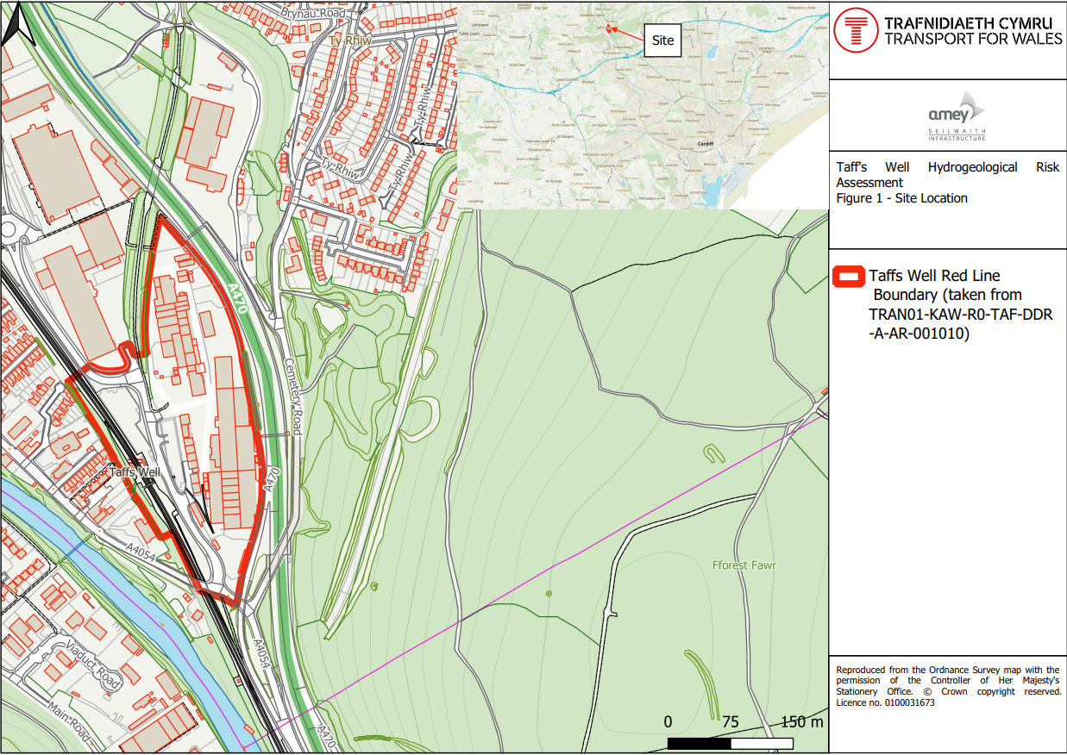
Figure 1: Red-line boundary for the site

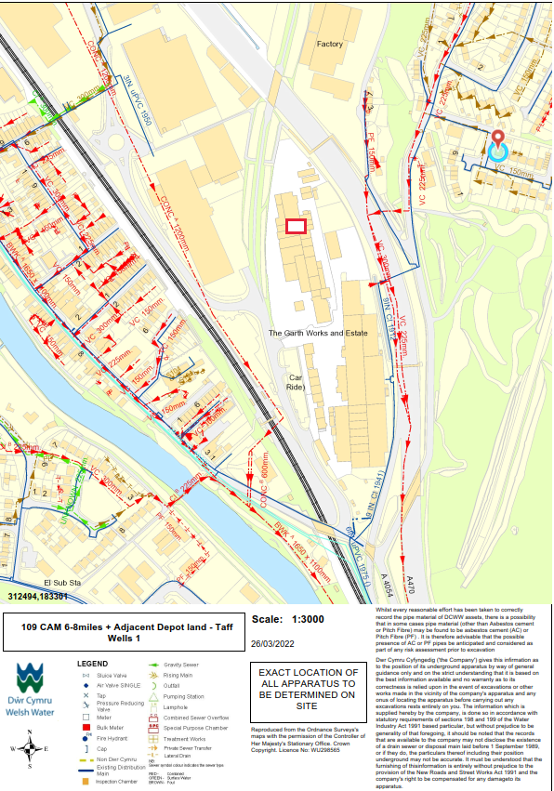
Figure 2: Location of Cofferdam around proposed building

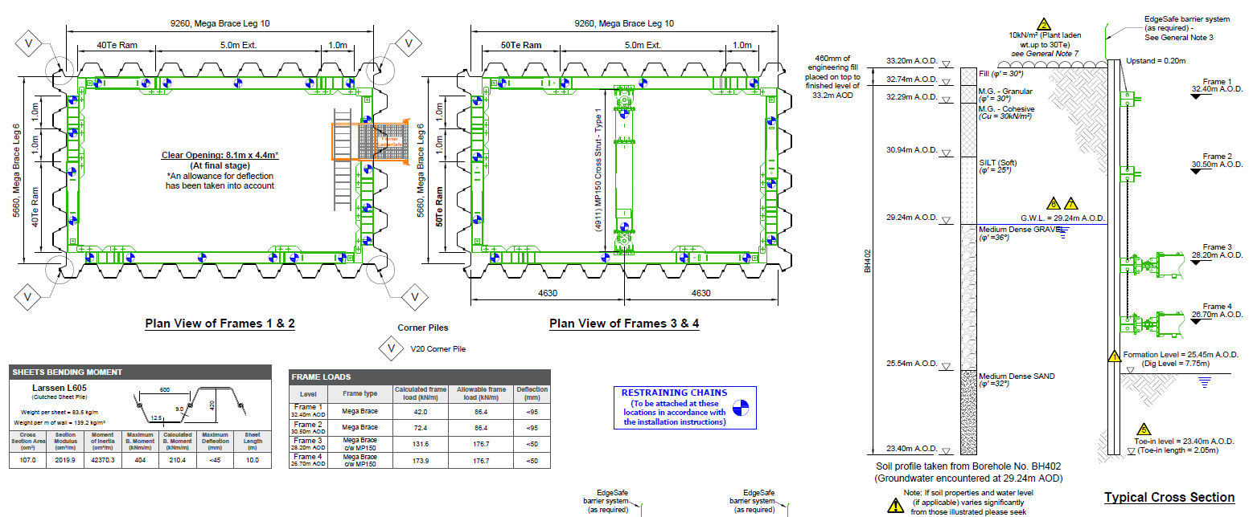
Figure 3: Proposed cofferdam arrangement
  - Historical Mapping
Historically, the site has had various industrial land uses, namely an iron works/forge from the end of the 19th Century, followed by the manufacturing of lathes, drain covers and automotive parts, as well as less industrial uses within recent times. Figure 4 identifies the site in 1900 when the Glamorganshire Canal ran through the site, and which has been replaced by the A470.
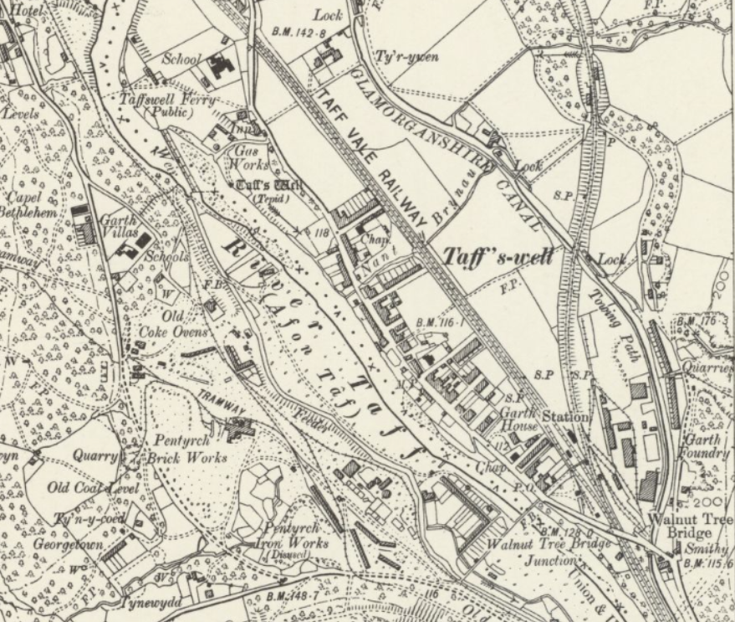
Figure 4: OS six-inch Glamorgan Sheet XXXVI.SE, published 1900
- Regional Water Resourcing Status and Licensing Policy
  - Regional Groundwater Resource Availability
The Taff Wells groundwater abstraction is located within the South East Valleys Catchment Abstraction Management Strategy (CAMS) Area. Review of the 2017 licensing strategy for the South East Valleys CAMS2 confirms the following water resource status:
- Groundwater Resource Availability: There is limited data on groundwater levels and flow within the South East Valleys CAMS area. Groundwater resource availability will be assessed on a case by case basis on application for a groundwater abstraction licence.
Review of NRW’s online mapping confirms that the South East Valleys Carboniferous Coal Measures aquifer, in the region of the groundwater abstraction, has a 2021 Water Framework Directive (WFD) Groundwater Quantitative status of ‘Good’.
A ‘Good’ groundwater quantitative status means that the available groundwater resource is not exceeded by the long-term annual average rate of abstraction.
  - Regional Groundwater Abstraction Licensing Policy
The licensing strategy for the South East Valleys CAMS states:
- Groundwater Licensing Policy: Due to the low numbers of existing groundwater abstractions and low demand for new abstractions within the South East Valleys catchments, there isn’t a separate groundwater licensing policy and each application is treated on a case by case basis.
Where connectivity to a watercourse is a factor and the full licensed flows could fall below the Environmental Flow Indicator EFI, we may seek to reduce unused portions of licensed quantities.
The licensing strategy confirms that abstractions are managed to protect the environment and WFD objectives. The strategy also confirms that since 2001 all new licences have had a time limit imposed, with all time limited licences having a common end date; the current common end date for the South East Valleys CAMS is 31st March 2029.
  - Regional Surface Water Resource Availability
The availability of water for abstraction is determined by the relationship between the CAMS Fully Licensed scenario and the CAMS Recent Actual scenario in comparison to the needs of the environment (EFI), and whether there is an environmental flow deficit or a risk of a deficit. The South East Valleys CAMS area water resource availability colours and licensing implications are shown in Figure 5. The nearest Assessment Points (AP) on the River Taff to the site at Taff Well’s Rail Depot are at Pontypridd (AP2) and at Blackweir (in Cardiff, AP1). For new consumptive surface water licenses the Hands Off Flow (HOF) restrictions in Table 1 will apply.
Table 1: Restrictions for new consumptive licences in an average rainfall year on the lower River Taff
Q HOF Restriction | AP1 water available (m³/day) | AP2 water available (m³/day) | Av number of days a year abstraction allowed
HOF 4 at Q65 | 74,700 | 74,700 | 237 (65%)
Once available water has been licensed HOF 5 at Q50 will be applied to licences
HOF 5 at Q50 | 160,400 | 130,000 | 183 (50%)
Once available water has been licensed HOF 6 will be applied to licences

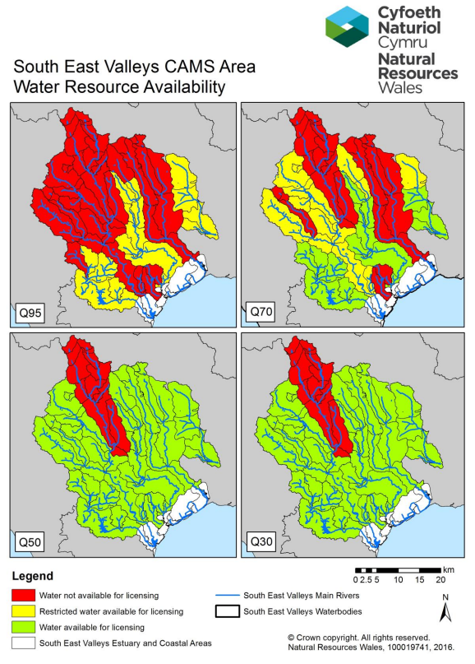
Figure 5: Water resource availability colours for the South East Valleys CAMS Area

The NRFA Station Mean Flow Data for 57005 - Taff at Pontypridd (ceh.ac.uk) was obtained, with data from 1970-2021. Comparing the data at Pontypridd AP2 with the abstraction requirement at Taff Well’s would be a conservative assumption, as clearly there would be more water available at AP1. A difference of 9.5% was calculated between the catchment area for the River Taff at Pontypridd and the river catchment at Taff’s Well, which is also considered to be minor, and it will not severely impact the following calculated flows and percentages.
Using the Pontypridd data set at AP2, the flow values are, Q50 (10.90 m³/s); Q65 (7.89 m³/s); Q70 (7.10 m³/s) and Q95 (3.67 m³/s). Hence provided the river flows are greater than the Q65 value there would be water available to be abstracted from the River Taff at AP2.
Analysis of the percentage of time the Q65 and Q50 values are exceeded over the 51 years of data, is given in Table 2, for the entire year, for the wetter months (September, October, November, December) and the period September to December. Clearly abstraction from the River Taff would be allowed for 90-91% of the time in November to December, 71% in October, dropping to 44% in September, with an average of 74%.
The inference here is that, if the groundwater abstraction at Taff Wells Rail Depot was assumed to be in perfect connectivity with the river gravels and flows, then abstraction would be allowed for an average 74% of the four-month requested licence time. Comparison should also be made between the allowable river abstraction of 74,700 m³/day at AP2 and the requested 600 m³/day which is only 0.8% of the abstraction limit.
Table 2: Summary Exceedance Statistics for Taff at Pontypridd
Taff at Pontypridd | Above Q50 (%) | Above Q65 (%)
Complete Year | 50 | 65
September | 31 | 44
October | 56 | 71
November | 77 | 90
December | 79 | 91
September to December | 61 | 74

- Hydrogeological Conceptual Model
This section of the report presents the local hydrogeological conceptual model for the groundwater abstraction. The geological, hydrogeological and hydrological setting are described, based on published mapping and reports.
Potential water features susceptible to groundwater flow impacts (receptors) are then identified via a water features survey approach. The search radius for the water features survey has been set at 1km from the centre of the site and the licence requirement is 600 m³ /day.
  - Topography and Geology of the area
The area around the site boundary is steeply sloping and draining into the River Taff while the site sits at an elevation of between 30 to 35m AOD. According to BGS Mapping (BGS, 2022), the site is underlain by limestones of the Hunts Bay Ooolite Subgroup. Limestones of this group were formed during the Carboniferous period. In terms of the superficial geology, the site is underlain by river terrace deposits (sand and gravel) of the Quaternary period. On site borehole information record 2-3m of made ground, with an additional 12-17m of alluvium. Limestones (bedrock) is recorded at 15-21 m depth. Essentially the proposed cofferdam base will be within the middle of the alluvium strata.
  - Hydrogeology
Amey undertook a Controlled Waters Detailed Quantitative Risk Assessment using current available groundwater data for the site at Taff’s Well. Groundwater sampling was undertaken between the 16th April 2019 and the 22nd August 2019, following the initial phase of ground investigation and due to the sites proximity to the Taff, a detailed assessment was undertaken following the Environment Agency’s Remedial Targets Methodology. An assessment using the ‘Level 3 Groundwater’ approach has been applied. Using a conservative approach, the Level 3 assessment did not demonstrate any exceedances at compliance point, which was set as that bank of the River Taff/Afon Taf closest to the exploratory location being assessed.
As described in the Amey Infrastructure/Amey Seilwaith for Taff Wells Rail Depot, July 2021 report, groundwater below the site is likely to originate from the slopes of Craig yr Allt located to the east – northeast and flowing downgradient towards River Taff in a southwest direction. Depth to bedrock was considered to influence the direction of groundwater flow; an analysis of the exploratory location records from previous GIs indicates that there is a bedrock “bulge” in the central eastern portion of the site, which is interpreted as likely being caused by either the movement of the River Taff/Afon Taf post glacial-era or caused by glaciers themselves as they traversed the Taff’s Well gorge. It is suspected it is this bulge which causes the deflection of groundwater, from the N-S direction groundwater appears to flow in the northern portion of the site, to the NNE-SSW direction groundwater appears to flow in the southwestern portion of the site. A map of the groundwater flow is shown in Figure 6.
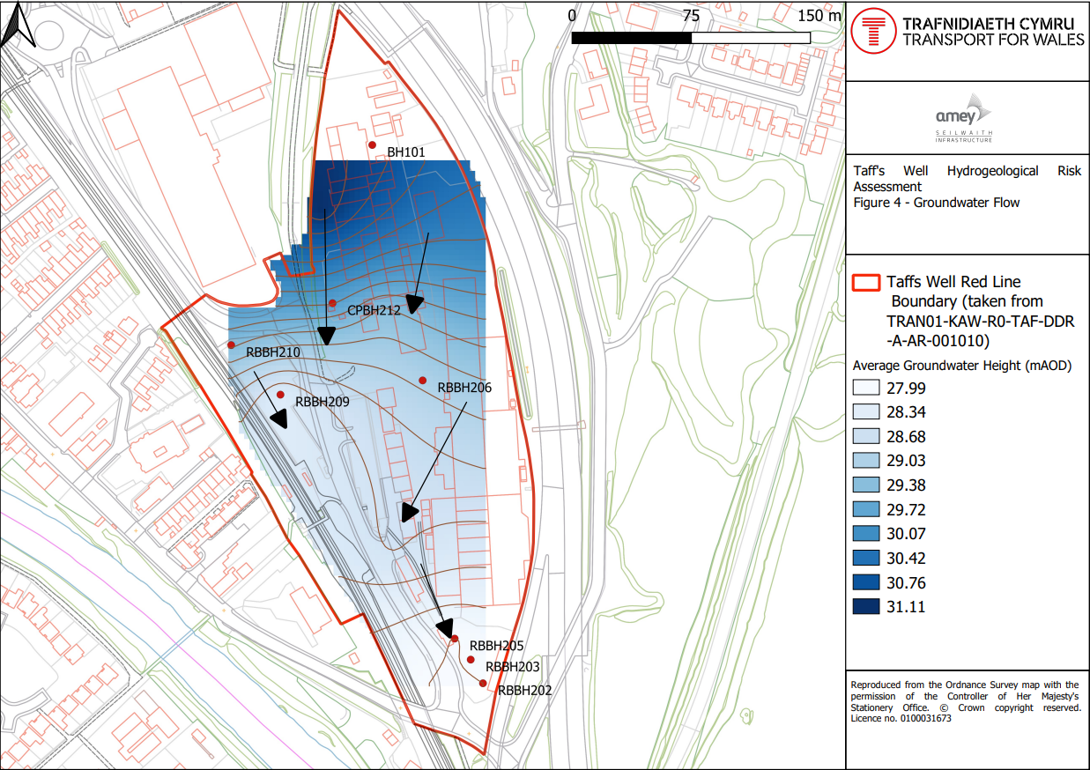
Figure 6: Groundwater flows on site
  - Hydrology and Flood Risk
The river Taff rises as two rivers in the Brecon Beacons National Park and runs for 40 miles to the Bristol Channel at Cardiff. The Taff is formed from the Taf Fechan (Little Taff) and the Taf Fawr (Big Taff); the two rivers merge just north of Merthyr Tydfil. The Taff has seven major tributaries which flow into the river, these are Nant Ffrwd; Nant Morlais; Nant Rhydycar; Taff Bargoed; Cynon; Nant Clydach and Rhondda. The River Taff flows past the settlements of Merthyr Tydfil, Treharris, Pontypridd and then to Cardiff.
The River Taff forms the main south flowing water course located adjacent to and west of the Taff Wells Rail Depot. To the northwest the Nant Y Brynau a small 2.5 km² catchment runs and is diverted into a culvert to the north of the site and hence to the River Taff. To the east of the River Taff, another small watercourse with a 2.4 km² catchment, the Nant Cwmllwydrew, drains into the Taff. The smaller main watercourses are either upstream of the potential abstraction or on the other side of the River Taff and so will not be impacted.
The River Taff has undergone extensive alteration during the 20th Century with most alterations completed before 2015. The flood risk maps (Figure 7) indicates the site has less than a low flood risk from the River Taff and no risk from the close mentioned tributaries of the River Taff, and with medium risk from pluvial flows from the north. Even if there was excellent connectivity between the groundwater and River Taff through the river sands and gravels the analysis in Section 3.3 shows that the abstraction would be allowed between 71% to 91% of the time and the relatively small abstraction of 13.8 l/s compared to the Q65 of 10,900 l/s would mean there is no measurable impact.
The aquifer hydrogeology is designated as a moderately productive aquifer in which flow is virtually all through fractures and other discontinuities. Typically, with yields of 5-10 l/s, rarely 50 l/s with many springs.
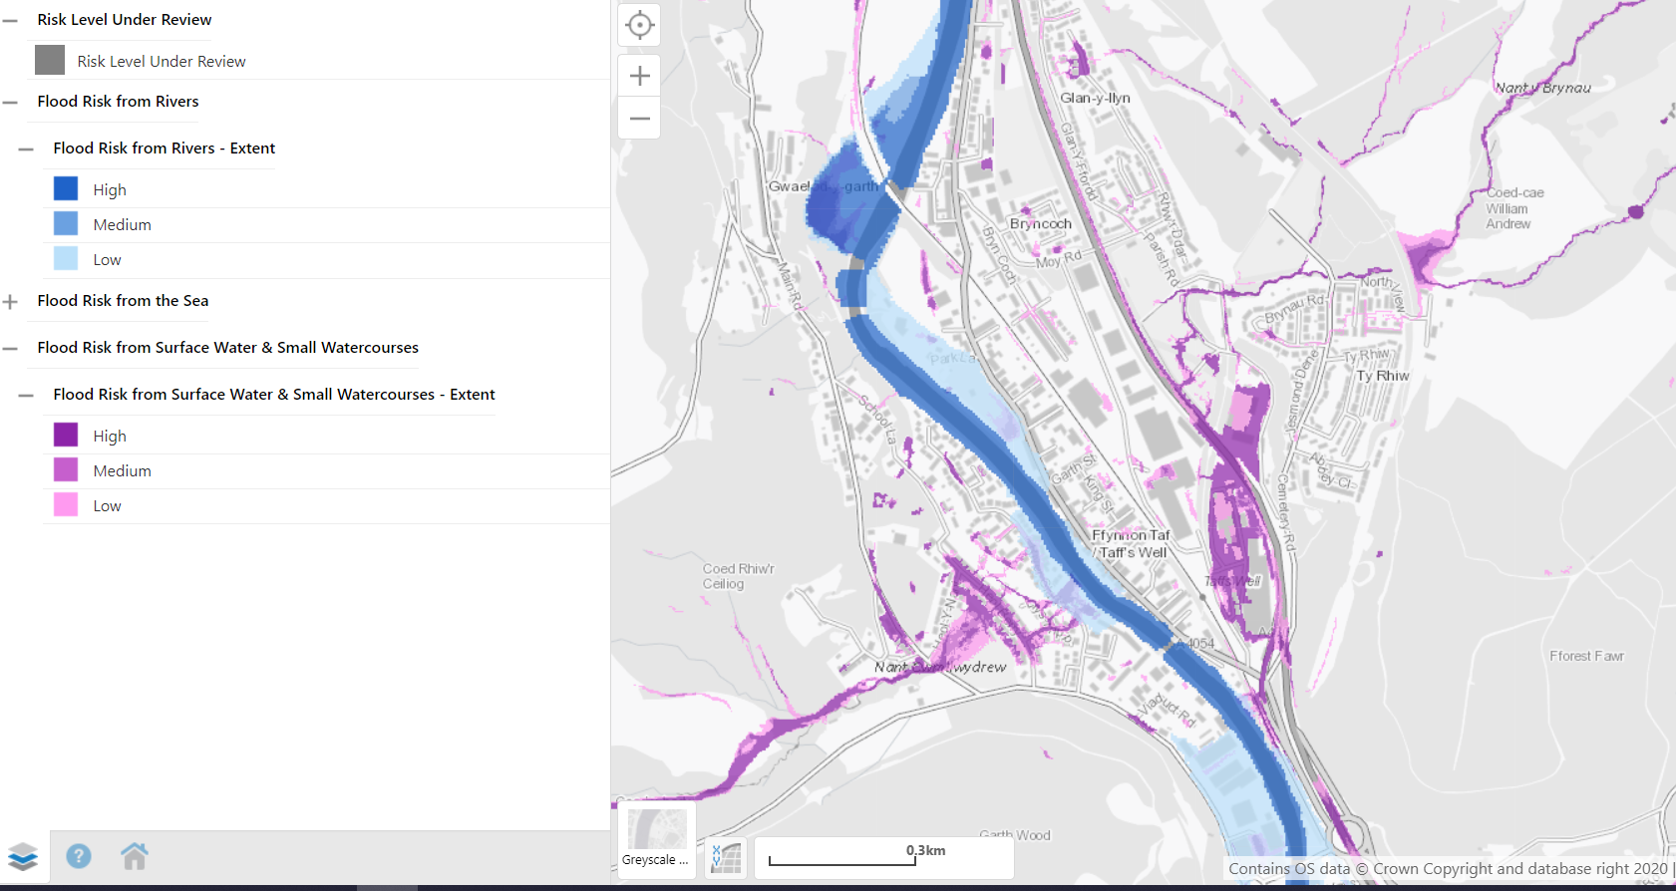
Figure 7: Fluvial and pluvial flood map for high, medium and low risk storm events
  - Sensitive land uses, Statutory designations and sites of special interest
Downstream and within 1000m of the proposed scheme lies the Garth Wood SSSI on the west bank of the River Taff, as well as the Ton Mawr and Taffs Well Quarries SSSI, and the Castell Coch Woodlands SSSI on the east bank of the River Taff. These woodland areas are also designated as SAC Cardiff Beech Woods. Licensing this abstraction should not impede or affect the status of these designations. The west bank woods will have no change in groundwater levels as a result of this abstraction due to being on the opposite side of the river, and the nearer east bank woods are still 600m distant and are likely to have at most a negligible reduction if excellent connectivity was assumed between the groundwater and surface water, and a value that is certainly too small to measure.
  - Water Framework Directive Regulations 2017
The abstraction is located within southeast Valleys Carboniferous Limestone, Waterbody number GB40901G203600. The status of this waterbody is at Good quantitative potential. The relative surface water body (Taff-conf Rhondda R to castle street – GB109057027270) is classified as Moderate, although the waterbody is classed as a heavily modified waterbody on the basis of Flood protection, urbanisation and wider environmental pressures. The hydrological regime for the surface water body passes for flows, the reason for not achieving Good potential is due to failures in fish and chemical status. Although groundwater to surface water connectivity cannot be ruled out, the surface water flows pass and achieves good quantitative potential.
Groundwater quantity is flagged as “Good” but the quality is noted as “Poor” for its potential to impact upon surface water quality. In places, the natural groundwater flow regime has been disrupted as a result of historical mining activities. Complex flow patterns have evolved along the shafts and audits of the old mine workings. Iron-rich groundwaters are known to emerge from the old mine workings at various locations in the area, some causing significant pollution problems. Groundwater protection is an issue that needs to be considered.
Licensing this abstraction should not impede the surface water achieving “Good” status in the future. There is very unlikely to be a change in groundwater levels or quantitative “Good” status of the waterbody from this abstraction.
  - Water Features Assessment Methodology
To investigate a ground water source requires a water feature survey to cover a minimum radius from the site of abstraction. Therefore, for a proposed daily abstraction of 600m³ the guidance requires a 1,000 m-wide radial zone. This distance will be taken from the centre of the site as shown in Figure 8.
Water features in the study area have been identified based upon the following data:
- Hydrological features shown on 1:10,000 Ordnance Survey (OS) map
- Hydrological features identified on in historic 1:10,560 and 1:2,500 OS County Series maps
- Water features searched for in the study area are based on the Natural Resources Wales FORM C Section 14 Water Features. These features include the following: borehole, well, pond, spring, adit, seepage, wetland, lake, watercourse, or other
- All key water features within this study area were identified, categorised and individually labelled as: major watercourse, minor watercourse, pond, abstractions (historic and active wells) and boreholes
- The study area is shown in the Water Features Plan, Figure 8
- The River Taff is within the boundary of consideration and so a catchment area consideration is given using the nearest flow gauge data and CAMS Assessment Point. To be conservative AP2 was taken at the upstream point at Pontypridd
All water features identified will be assessed for potential for impact from the proposed dewatering.
  - Sources of Information
The following sources were consulted to prepare this Desk Study.
- Transport For Wales, Wales and Borders Rail Service and South Wales Taff Well Site Location Plan, from report on controlled waters detailed quantitative risk assessment by Amey Infrastructure/Amey Seilwaith for Taff Wells Rail Depot, July 2021
- Historical OS Maps (1:10,000 and 1:2,500), National Library of Scotland Map Images Database (https://maps.nls.uk/)
- Online borehole information and Geological maps from the British Geological Survey (BGS) (www.bgs.ac.uk)
- Magic maps (https://magic.defra.gov.uk/MagicMap.aspx)
- Google Earth, (earth.google.com/web/)
- Natural Resources Wales Interactive Map, Lle geoportal map browser: http://lle.gov.wales/map#m=-3.2186,51.53271,14&b=europa&l=2017;2013
- BGS Geology of Britain Viewer (http://mapapps.bgs.ac.uk/geologyofbritain/home.html)
- BGS GeoIndex Onshore database (http://mapapps2.bgs.ac.uk/geoindex/home.html)
No other sources of information were consulted during the preparation of this Desk Study Report.

  - Water Features Schedule
The water feature schedule lists the waterbodies identified within the project study area and provides their assigned reference number, NGR location. It is noted that a large number of test boreholes were used for the construction of the A470 to the north and above the site, and which are not assessed here as they are not used to abstract water. Similarly, a borehole on site is currently defunct and so has not been assessed. Similarly bore had an historic abstraction licence number was 21/57/25/0023 but this was decommissioned
The schedule in Table 3 also outlines key environmental information relating to the waterbodies including RBMP status (where applicable) and specific designations (e.g. SSSI, SAC, SPA). Justification for scoping-out water features from the environmental assessment is provided and for those subject to the assessment process, sensitivity values are given for the parameters: water quality (surface and groundwater), hydrology and flood risk.
As the River Taff will act as a hydrological barrier, it is unlikely the proposed scheme will have an impact on water features beyond the opposite banks of the rivers (i.e. right bank looking downstream), and on features upgradient of the groundwater as it has been determined this flows southwest towards the River Taff from a typical level of 31 to 28 m AO across the site.

Table 3: Water Features Schedule
Water Feature |  |  |  |  |  |  | Scoped Out of an Environmental Assessment
Water Feature Ref | Name/ Description | Category | Easting | Northing | Distance from source (km) | Flooding in 200 years | Y/N | Justification
MW01 | River Taff | Major Watercourse | 311813 | 184037 | 0.114 | Less than Low fluvial flood risk, Medium pluvial risk | Y | Abstraction will most likely have a negligible impact even if excellent connectivity between surface and groundwater
MinorW01 | Unnamed | Minor Watercourse | 313035 | 184317 | 1 | N | Y | Not impacted by scheme
MinorW02 | Unnamed | Minor Watercourse | 311547 | 183653 | 0.887 | N | Y | Not impacted by scheme
MinorW03 | Unnamed | Minor Watercourse | 311518 | 183756 | 1 | N | Y | Not impacted by scheme
MinorW04 | Nant Cwmllwydrew | Minor Watercourse | 311538 | 182812 | 1 | N | Y | Not impacted by scheme
MinorW05 | Nant y Brynau | Minor Watercourse | 313341 | 184000 | 1 | N | Y | Not impacted by scheme
MinorW06 | Nant Llywydd | Minor Watercourse | 313358 | 183998 | 1 | N | Y | Not impacted by scheme
BH01 | Taff’s Well Quarry A | Borehole | 312420 | 182400 | 0.771 | N | Y | Not impacted by scheme
BH02 | Taff’s Well Quarry F | Borehole | 312040 | 182530 | 0.815 | N | Y | Not impacted by scheme
BH03 | Taff’s Well No 5 | Borehole | 312290 | 182480 | 0.742 | N | Y | Not impacted by scheme
BH04 | Taff’s Well No 8 | Borehole | 312290 | 182430 | 0.774 | N | Y | Not impacted by scheme
BH05 | Taff’s Well Quarry B | Borehole | 312390 | 182200 | 0.969 | N | Y | Not impacted by scheme
BH06 | Castell – Coch, Tongwynlais 5/4 | Borehole | 313050 | 183450 | 0.559 | N | Y | Not impacted by scheme
BH07 | Taff’s Well No 2 | Borehole | 312140 | 182340 | 0.987 | N | Y | Not impacted by scheme
BH08 | Taff’s Well No 3 | Borehole | 312230 | 182550 | 0.741 | N | Y | Not impacted by scheme
BH09 | Taff’s Well No 12 | Borehole | 312210 | 182170 | 1 | N | Y | Not impacted by scheme
BH10 | Taff’s Well No 9 | Borehole | 312500 | 182190 | 0.980 | N | Y | Not impacted by scheme
BH11 | Taff’s Well Quarry H | Borehole | 311670 | 182780 | 0.951 | N | Y | Not impacted by scheme
BH12 | TY-RHIW 16 | Borehole | 312970 | 183630 | 0.536 | N | Y | Not impacted by scheme
BH13 | Taff’s Well Quarry C | Borehole | 312270 | 182410 | 0.829 | N | Y | Not impacted by scheme
BH14 | Taff’s Well No 10 | Borehole | 312370 | 182390 | 0.816 | N | Y | Not impacted by scheme
BH15 | Taff’s Well No 1 | Borehole | 312160 | 182400 | 0.903 | N | Y | Not impacted by scheme
BH16 | Taff’s Well No 11 | Borehole | 312360 | 182170 | 1 | N | Y | Not impacted by scheme
BH17 | Castell – Coch, Tongwynlais 5/1 | Borehole | 313080 | 183400 | 0.569 | N | Y | Not impacted by scheme
BH18 | Taff’s Well 7 | Borehole | 311950 | 182260 | 1 | N | Y | Not impacted by scheme
BH19 | Ffyon Taf Primary School CP4A Taff’s Well | Borehole | 311884 | 183850 | 0.873 | Localised medium pluvial flood risk | Y | Not impacted by scheme
BH20 | Ffyon Taf Primary School CP4A Taff’s Well | Borehole | 311894 | 183878 | 0.911 | Localised medium pluvial flood risk | Y | Not impacted by scheme
BH21 | Ffyon Taf Primary School CP4A Taff’s Well | Borehole | 311884 | 183850 | 0.910 | Localised medium pluvial flood risk | Y | Not impacted by scheme

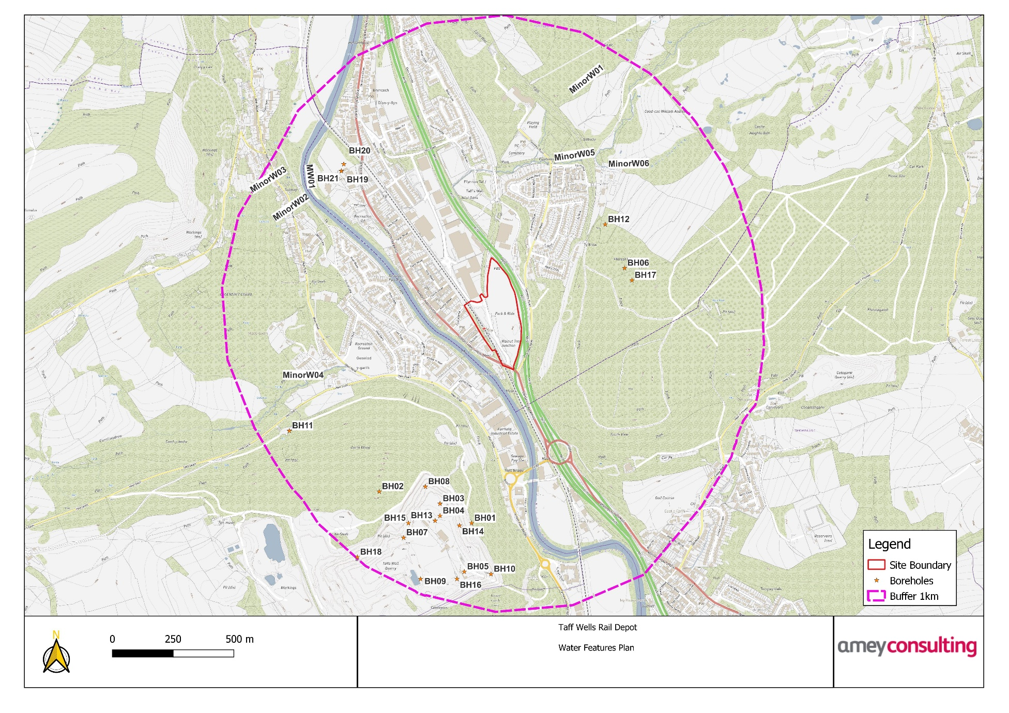
Figure 8: Water Features Plan

- Conclusions
This report presents a summary of the hydrogeological conceptual site model and HIA in support of a temporary abstraction licence for construction purposes within the Taff Well’s Rail Depot site.
The information presented above, demonstrates the environmental sustainability of the abstraction based on available data and that the impact of the relatively small surface water/groundwater abstraction through collection in a cofferdam arrangement is negligible on the water features captured.
Therefore, the abstraction meets the licence criteria of the South East Valleys CAMS.
The discharge to the public sewer system will be monitored via meter fitted to the pump and the abstraction rate will be known for the temporary abstraction during the wet period of the year, September to December. All monitoring equipment should be maintained and calibrated in accordance with the manufacturer’s recommendations.

