

Construction Surface Water Management Plan

Plot B, The Airfields, Northern Gateway, Deeside, Flintshire, CH5 2RD

Client: Marshalls Construction (West Yorkshire) Ltd
CSWMP Reference: 23-041-14a-r1.1
Date: 30th June 2023

Report Issue

Project Name/Report Title: Construction Surface Water Management Plan
Site Name: Plot B, The Airfields, Northern Gateway, Deeside, Flintshire, CH5 2RD
CEMP Reference: 23-041-14a-r1.1

Report Version | Issue Date | Written by | Signature | Check & Approval by | Signature | Comments
Draft 1 | 30/06/2022 | Robert Tinsley |  | Robert Tinsley |  | Issue to client

RJT Consulting Partnerships Ltd,
E3P Building, Taylor Road, Trafford Park, Manchester, M41 7JQ
info@rjtconsulting.co.uk | 0161 706 0402 | www.rjtconsulting.co.uk

This report has been prepared by RJT Consulting Partnerships Ltd in accordance with the agreed terms and conditions of appointment.
CSWMP Document Control: Marshalls Construction (West Yorkshire) Ltd – Principal Contractor)

Revision History
Revision No. | Issue Date | Author | Signature | Reason for Amendment

This Revision
Role | Name | Signature | Position
Checked by
Approved by

Table of Contents
1.0 INTRODUCTION 1
1.1 Background 1
1.2 Aims & Objectives 1
1.3 Guidance & Regulatory Framework 3
2. SITE INFORMATION & Project details 2
2.1 Site Location & Description 2
2.2 Surrounding Land Use 2
2.3 Environmental Site Setting 3
Geology/Ground Conditions 3
Hydrogeology 3
Hydrology 4
Designated Habitat & Conservation Sites 6
2.4 Proposed Development 7
3 DUTY HOLDERS 9
3.1 Client & Developer 9
3.2 Principal Contractor 9
3.3 Key Contractors 9
3.4 Consultant (CSWMP) 10
4 ROLES AND RESPONSiBILITIES 12
4.1 Client & Developer 12
4.2 Principal Contractor 12
4.3 Key Contractors 13
4.4 Information for Contractors & Visitors 14
5 contract works & CONSTRUCTION PROGRAMME 15
5.1 Contract Works Summary 15
5.2 Construction Programme 17
6 construction surface water management – general arrangements 18
6.1 GPP 5: Works & Maintenance In or Near Water 18
GPP 5 - Siltation 19
GPP 5 – Concrete, Cement & Grout 26
GPP 5 – Invasive Non-Native Species 27
6.2 GPP 2 – Above Ground Oil Storage Tanks 28
6.3 GPP 26 – Storage of Drums & Intermediate Bulk Containers 34
6.4 Flood & Weather Alert 41
6.5 Surface Water Flood Risk 42
7 construction surface water management – specific arrangements 45
7.1 Overview 45
7.2 Initial Enabling Works 45
Installation of Foul Water Manhole (FWMH12) 45
Installation of Surface Water Drainage Headwalls & Manholes (Partial) including Wellpoint Installation (Dewatering) 51
8 ENVIRONMENTAL MANAGEMENT SYSTEMS PROCEDUREs – Principal Contractor 56
8.1 Management of Contractors 56
8.2 Training & Competency 57
8.3 Communication & Complaints 58
8.4 Emergency Preparedness & Response 60
8.5 Maintenance of Plant & Equipment 64
8.6 Monitoring & Audit 65
9 nRW Water Resource Licence & Surface water Discharge permit 66

Appendices
Appendix A – Drawings
- Site Location Map
- NRW Main River Plan
- NRW Flood Zone Risk Map
- Development Layout Plan (Ref: M3125-01, Rev D, dated September 2021)
- Drainage Layout (Ref: 4671-JPG-PB-ZZ-DR-D-1400-A5-C03)
- Construction Buildups (Ref: 4671-JPG-PB-ZZ-DR-C-1510-P01)
- Site Preparation Handover Areas 1
- Cut & Fill Analysis (Ref: 4671-JPG-PB-ZZ-DR-C-1200-P06).
- Site Sections (Ref: 4671-JPG-PB-ZZ-DR-C-1500-P01).
- MCWY Bulk Earthworks Buildups/Working Platform Sketch 9.2.23.
- MCWY Bulk Earthworks Buildups/Working Platform Sketch 15.2.23.
- General Arrangements of Foundations Sheet 1&2 (Ref: 4671-JPG-PB-FN-DR-S-2101-S4-P01).
- General Arrangements of Foundations Sheet 2&2 (Ref: 4671-JPG-PB-FN-DR-S-2102-S4-P01).
- General Arrangements of Foundations to Transport Office North (Ref: 4671-JPG-PB-FN-DR-S-2105-S4-P01.
- General Arrangements of Foundations to Transport Office South (Ref: 4671-JPG-PB-FN-DR-S-2106-S4-P01).
- General Arrangements of Base Foundation to Pump House & Sprinkler Tanks (Ref: 4671-JPG-PB-FN-DR-S-2150-S4-P01).
- General Arrangements of External Retaining Walls (Ref: 4671-JPG-PB-FN-DR-S-2120-S4-P01).
- MCWY Groundwater Comments Nr1 14/3/2023.
- MCWY Groundwater Comments Nr2 14/3/2023.
- MCWY Groundwater Comments Nr3 14/2/2023.
- Manhole Schedule (Ref: 4671-JPG-PB-ZZ-DR-D-1401-A5-C03).
- Drainage Construction Details (Ref: 4671-JPG-PB-ZZ-DR-D-1420-S4-P01).
- Drainage Channel & Kerb Drain Surround Details (Ref: 4671-JPG-PB-ZZ-DR-D-1421-S4-P01).
- Fuel Oil Separator Installation Details (Ref: 4671-JPG-PB-ZZ-DR-D-1422-A5-C01).
- Proposed Elevations (Ref: M3125-200 Rev B).
- Warehouse Sections (Ref: M3125-310).
- Floor Layout Plan (Ref: M3125-100 Rev G).
- Transport Office General Arrangement North (Ref: M3125-103 Rev A).
- Transport Office General Arrangement South (Ref: M3125-103 Rev A).
- Transport Office Sections (Ref: M3125-320).
- Office Layout Plan (Ref: M3125-102 Rev B).
- Office Section (Ref: M3125-311).
- Services Plan (Ref: M3125-03).
- Ground Floor Slab Details (Ref: 4671-JPG-PB-00-DR-S-2205-S4-P01).
- General Arrangement of Ground Floor Slab Sheet 1 of 2 (Ref: 4671-JPG-PB-00-DR-S-220-S4-P01).
- General Arrangement of Ground Floor Slab Sheet 2 of 2 (Ref: 4671-JPG-PB-00-DR-S-2202-S4-P01).

Appendix B – Construction Programme
Appendix C – Water Resources Licence
Appendix D – Environmental Permit (Surface Water Discharge)

INTRODUCTION

1.1 Background

    - The following Construction Surface Water Management Plan (CSWMP) has been prepared for Marshalls Construction (West Yorkshire) Ltd (Marshalls) in respect to the development works at Plot B, The Airfields, Northern Gateway, Deeside, Flintshire, CH5 2RD. Plot B is allocated in the adopted Flintshire County Council Urban Development Plan as a key strategic mixed use development site within the Northern Gateway in Deeside, a significant regeneration site in North Wales consisting of 170ha land allocation that will comprise 1,325 new homes ad 72.4ha of B2/B8 employment land and supporting uses.

    - Planning consent for the development was granted by Flintshire County Council on the 8th March 2023 (Ref: RES/000385/22) for the ‘Proposed storage and distribution unit with ancillary offices, associated accesses, car parking, service yards, security gatehouse, electricity substation, pump house and landscaping’.

    - Marshalls are the developer and ‘Principal Contractor’ at the site and the following content of the CSWMP outlines the planned management methods to be employed during the construction of the major storage and distribution unit with ancillary offices.

1.2 Aims & Objectives

1.2.1 The principal objective of the CSWMP is to provide information on the planned procedures and infrastructure on how Marshalls intend to avoid, minimise or mitigate (control) adverse environmental impacts to local surface and groundwater receptors associated with the development within their site boundary and surrounding local area. Furthermore, this CSWMP aims to define general good practice as well as specific actions to be implemented based on the duty to ensure that surface water quality and quantity is managed throughout the various earthworks and construction phases.

1.2.2 The information contained within the CSWMP will form part of the overall environmental management of this development. The methods and principles contained herein, as well as within referenced legislative instruments and published guidance documents will be adhered to by the Principal Contractor as well as appointed sub-contractors in developing (where applicable) design, construction method statements and other plans relating to environmental management and civil works contracts.

1.2.3 As advised by construction best practice, Natural Resources Wales (NRW) and the experiences of RJT Consulting and Marshalls, this CSWMP should include:
                - Details of the project management structure, roles and responsibilities with regard to managing and reporting all aspects of water management during the various construction phase.
                - Programme of Works.
                - Description of Works including site preparation, enabling & groundworks, access and highway works, drainage, foundation and buildings, landscaping and utilities.
                - Working within the vicinity of surface water courses.
                - Details of applicable construction plant, machinery and other associated infrastructure.
                - Conforming with applicable environmental legislation and other applicable statutory requirements.
                - Outlining those overarching Environmental Management Systems Procedures relevant to the earthworks and construction activities (referencing standards such as ISO14001:2015).
                - Describing the operational controls to minimise or mitigate water pollution.
                - Ensuring that any adverse environmental impacts are avoided, minimised, or mitigated.
                - Promoting best practice environmental options (BPEO) and best practicable means (BPM).

    - The scope of this CSWMP will cover the following aspects that are considered applicable to this project:

                - Water Resources Licence.
                - Surface Water Discharge Consent.
                - Clean Water Diversion.
                - Silt Mitigation & Settlement Ponds.
                - Pollution Prevention.
                - Water Quality Monitoring.
                - Environmental Management Procedures.

1.3 Guidance & Regulatory Framework

    - This CSWMP considers best practice environmental management and current legislative requirements for the construction and demolition sector including, but not limited to:

Table 1: Legislation & Guidance
Key Legislation
Water Resources Act 1991
Land Drainage Act 1991
The Water Environment (England & Wales) Regulations 2009
Water Abstraction & Impounding (Exemptions) Regulations 2017
Guidance & Methodologies
Control of Water Pollution from Construction Sites – Guide to Good Practice (CIRIA SP156)
Control of Water Pollution from Construction Sites – Guidance for Consultants & Contractors (CIRIA C532)
Environmental Good Practice – Site Guide (CIRIA C650)
NRW Guidance for Pollution Prevention GPP5 – Works or Maintenance In or Near Water
NRW Guidance for Pollution Prevention GPP2 – Above Ground Oil Storage Tanks
NRW Guidance for Pollution Prevention GPP26 – Storage of Drums & IBC’s

SITE INFORMATION & Project details

2.1 Site Location & Description

    - Plot B is located in the northern part of The Airfields development, approximately 8km northwest of Chester city centre and is centred at Ordnance Survey Grid Reference: SJ 32587 69985. The site is a former airfield with no associated services or buildings present on site. The site is surrounded by a drainage ditch which runs around the whole site boundary, beyond this the surrounding area comprises commercial buildings and the wider Airfields development currently under progress. The main access to the site is via the unnamed road that runs along the southern boundary which connects from Welsh Road (B5441).

    - The site is ~10ha and irregular in shape, comprising predominantly greenfield land, however according to the JPG Geoenvironmental Desk Study Report (Ref: 4671-JPG-XX-XX-RP-G-S2-P01, dated June 2022) ‘most of plot B, except for a small building in the south of the site and a roadway, railway track and small building in the north east corner of the site, which have all since been removed (as part of the Phase 1 remedial works), has remained undeveloped since the earliest Ordnance Survey mapping (1869). A copy of this report can be provided on request from RJT Consulting or the Principal Contractor.

    - There is an earth bund and trees along the north, west and east borders, with undulating land along the southern border before the surface water drainage ditch. A copy of the Site Location Map & Planning Boundary (Ref: M3125-00, dated August 2022) can be observed in Appendix A – Drawings.

2.2 Surrounding Land Use

    - The area immediately around the site is predominantly land under development with mixed commercial and residential end uses. The site is bounded by the following land uses:

                - To the north there is the established Deeside Industrial Park, this is the only adjacent land that is not within The Airfields development.
                - Immediately to the east is the Amazon Warehouse (Plot A, The Airfields). Further east is the undeveloped plot 3, before an access road off the A494, beyond which is agricultural land.
                - To the south is the currently unnamed access road into The Airfields, beyond this, to the south and southwest, is the Anwyl and Bellway Homes residential developments. Further south is the Countryside Homes plot for another residential development (creating a combined 767 properties), this is adjacent to the established Garden City housing estate.
                - To the west is the continuation of the access road, before Plot C of The Airfields, earmarked as a new manufacturing facility for the Italian company ICT.

Environmental Site Setting

Geology/Ground Conditions

    - The site is shown to be underlain by superficial deposits comprising Tidal Flat Deposits (clay, silt and sand). A fault, oriented north to south is shown to cross the eastern part of plot B. To the west of the fault and to the south on the eastern side of the fault, the underlying bedrock comprises Pennine Middle Coal Measures strata. To the north of the eastern side of the fault, the underlying bedrock comprises the Kinnerton Sandstone Formation.

    - According to the JPG Geoenvironmental Ground Investigation (Ref: 4671-JPG-XX-XX-RP-G-0645-S2-P01, dated June 2022), made ground topsoil was encountered to depths of between below ground level (bgl) and 0.3 bgl. Natural Tidal Flat Deposits were found to underlie the made ground topsoil. This comprised light greyish brown medium dense to dense sand, with frequent disseminated shell fragments. This was proven to a maximum depth of 14.45m bgl. Horizons of clay were noted during their investigation, but no bedrock was encountered. A copy of this report can be provided on request from RJT Consulting or the Principal Contractor.

Hydrogeology

    - The superficial deposits underlying the site are classified as a Secondary Undifferentiated Aquifer. The Pennine Middle Coal Measures bedrock, underlying the central, western and southern part of the site is classified as a Secondary A Aquifer. The Kinnerton Sandstone Formation underlying the east and north-east of the site is classified as a Principal Aquifer.

    - The site does not lie within 500m of an NRW Groundwater Source Protection Zone (SPZ). There are four recorded groundwater abstraction licences within 2km of the site, the nearest of which is approximately 1400m northeast of the site. There are no potable water abstraction licences within 2km of the site.
    - During the ground investigation, groundwater seepages were noted in the trial pits at depths between 2.00m bgl and 2.90m bgl. Groundwater was also encountered in both cable percussive boreholes at depth of between 1.9m bgl and 2.00m bgl.

    - In March 2023, JPG compiled a ‘Factual Report on Groundwater Monitoring Investigation’ for the site (Ref: 4671-JPG-XX-XX-RP-G-0060-S2-P01). The objective of this report was to monitor the groundwater levels for upto four weeks in order to assess whether the tide has any influence in groundwater levels t Plot B. The fieldwork was undertaken between the 10th February and 8th March 2023 and consisted of 4no. window sample boreholes drilled to a maximum depth of 4.00m below ground level (bgl). Water level loggers were installed in each of the boreholes (WS201 – 204) which monitored groundwater levels every 30 minutes commencing at 2pm on the 10th February and ending at 9.00am on the 8th March 2023. The results can be summarised as follows:

                - WS201: Minimum depth 3.383mAOD (1.29mbgl) and maximum depth 3.486mAOD (1.19mbgl). Average 3.431m AOD (1.25mbgl).
                - WS202: Minimum depth 3.371mAOD (1.31mbgl) and maximum depth 3.496mAOD (1.18mbgl). Average 3.437m AOD (1.24mbgl).
                - WS203: Minimum depth 3.203mAOD (1.47mbgl) and maximum depth 3.321mAOD (1.36mbgl). Average 3.255m AOD (1.42mbgl).
                - WS204: Minimum depth 3.325mAOD (1.35mbgl) and maximum depth 3.461mAOD (1.22mbgl). Average 3.384m AOD (1.20mbgl).

A copy of this report can be made available if requested from RJT Consulting or the Principal Contractor.

Hydrology

    - The site is entirely bounded by a series of drainage ditches classed as ‘ordinary’ watercourses all of which are located within 10m of the site boundary. Each drainage ditch ultimately converge at the northwest corner of the site where they drain via a single channel into the River Dee approximately 1.3 km southwest of the site western boundary. A copy extract of the NRW Main River Plan for the area including and surrounding the site if shown in Figure 1 below, and a copy included in Appendix A. This plan only indicates the drainage ditch located along the northern boundary of the site but does indicate that the main drainage channel that discharges into the River Dee is classed as a ‘main’ surface water course.
Figure 1: NRW Main River Plan Extract
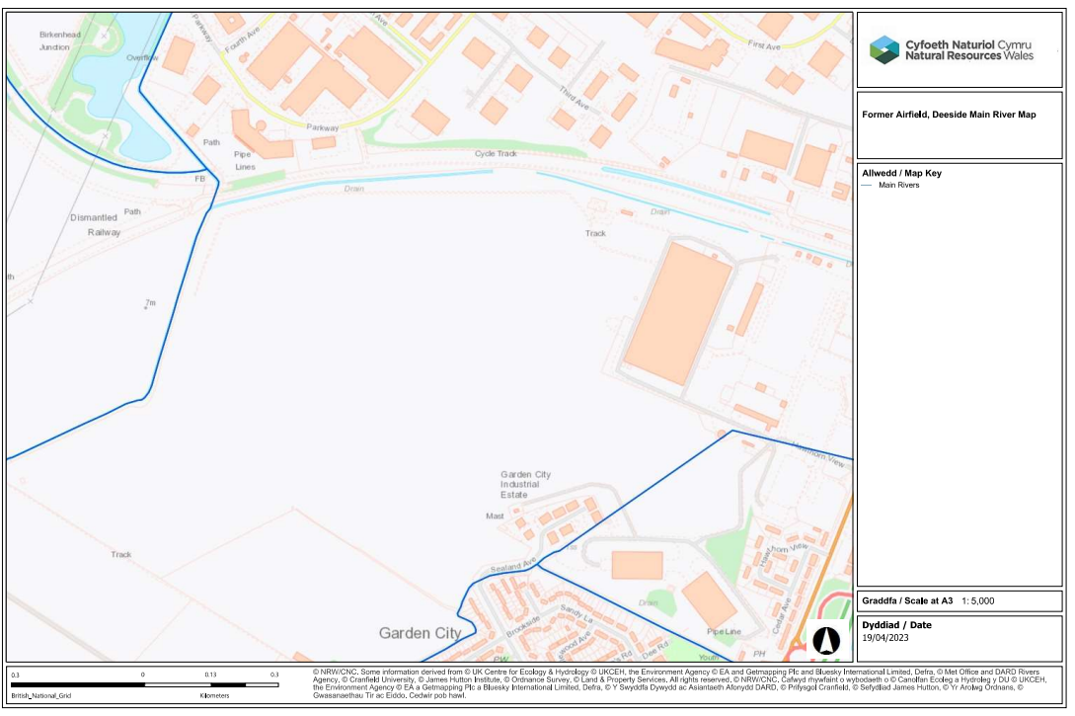
    - The annual ‘Risk of Flooding from Rivers and Sea’ (RoFRaS) is considered low. Information from the NRW website indicate that the site lies within Flood Zone 3, defined as ‘the extent of a flood from rivers with a 1% (1:100) chance or greater of happening in any given year. The extent of a flood from a sea with a 0.5% (1:200) chance or greater of any given year.

    - An extract of the NRW Flood Zone Risk Map for The Airfield development with an outline of Plot B can be seen in Figure 2 below with a full copy located in Appendix A.

Figure 2: Natural Resources Wales Flood Risk Map Extract
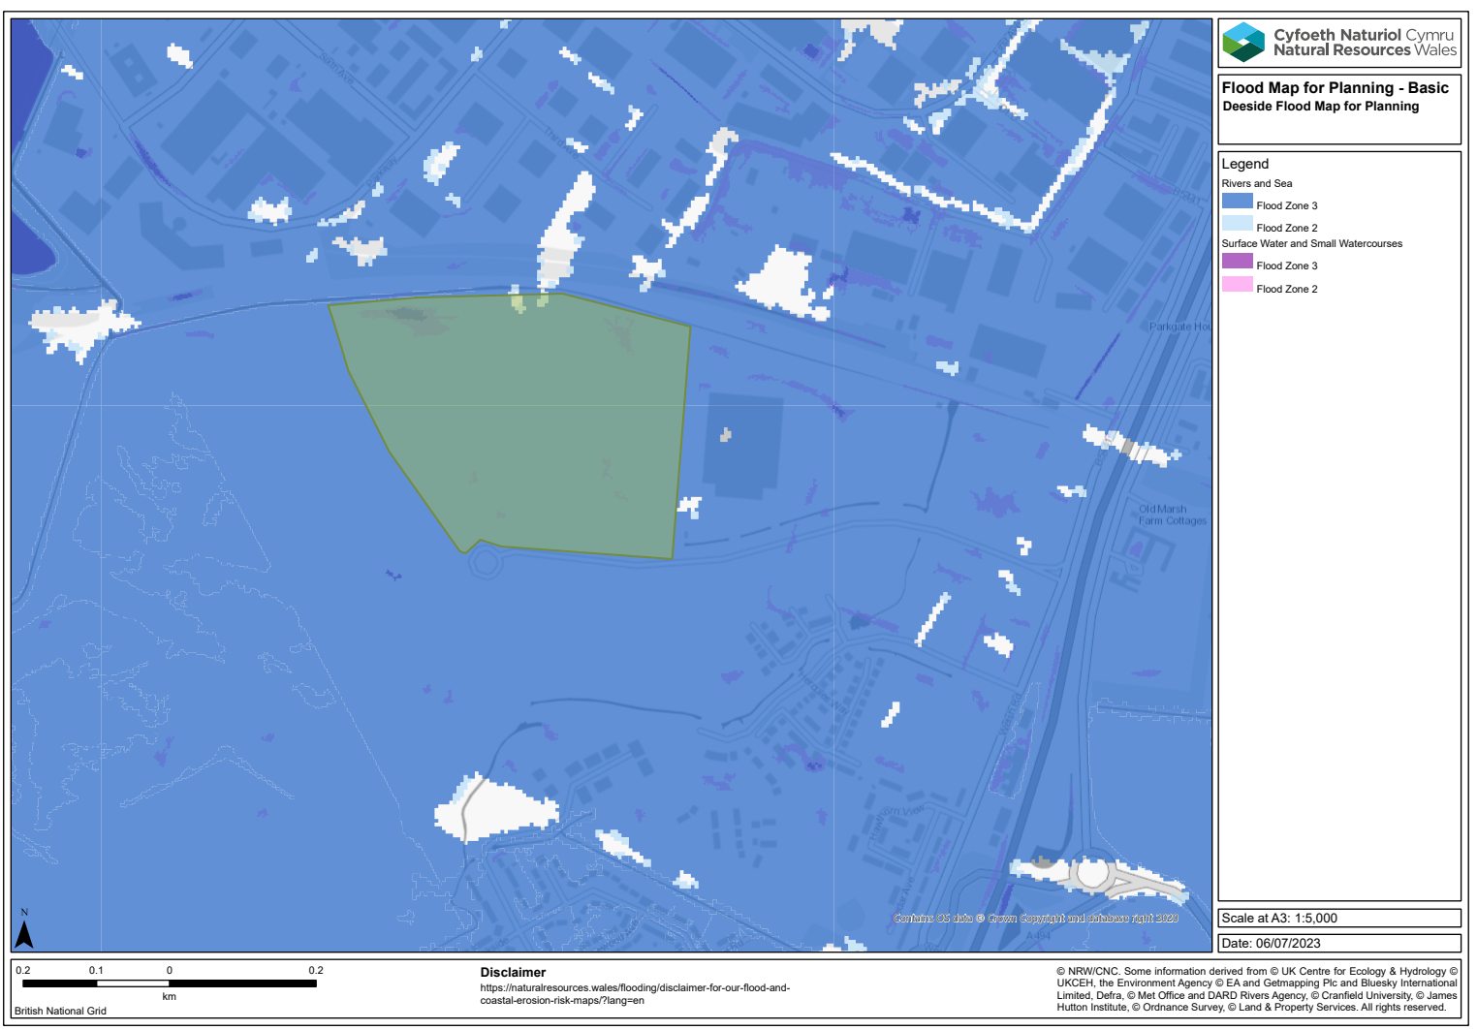

Designated Habitat & Conservation Sites

    - With the required abstraction of groundwater from excavations to be undertaken and its ultimate discharge into the surrounding drainage ditches, an assessment of any pathways that could impact designated habitat and conservation sites has been undertaken.

    - RJT Consulting have reviewed the publicly available information available on the Department of Environment, Food & Rural Affairs (DEFRA) MAGIC Map Software to identify any of the following protected habitat or conservation sites within 500m of the site boundary or in direct connectivity with surface water discharges:

                - Local Nature Reserves.
                - National Nature Reserves.
                - Ramsar Sites.
                - Sites of Special Scientific Interest.
                - Special Areas of Conservation.
                - Special Protection Areas.
                - Ancient Monuments.

    - According to the results of the Magic Map search there are no designated sites within a 500m of the site boundary. RJT Consulting, however, can confirm that any surface water discharges entering the surrounding drainage ditches have the potential to enter the River Dee at approximately 1.2km south west of the site. The River Dee at this location has the following designations:

                - Site of Special Scientific Interest (River Dee & Dee Estuary).
                - Special Area of Conservation (River Dee & Dee Estuary).
                - Special Protection Area (Dee Estuary).
                - Ramsar Site (Dee Estuary).

    - Figure 3 below shows the proximity of the development site to the above River Dee designations. A full copy of Figure 3 can be observed in Appendix A of this report.

Figure 3: Proximity to River Dee Designated Habitat
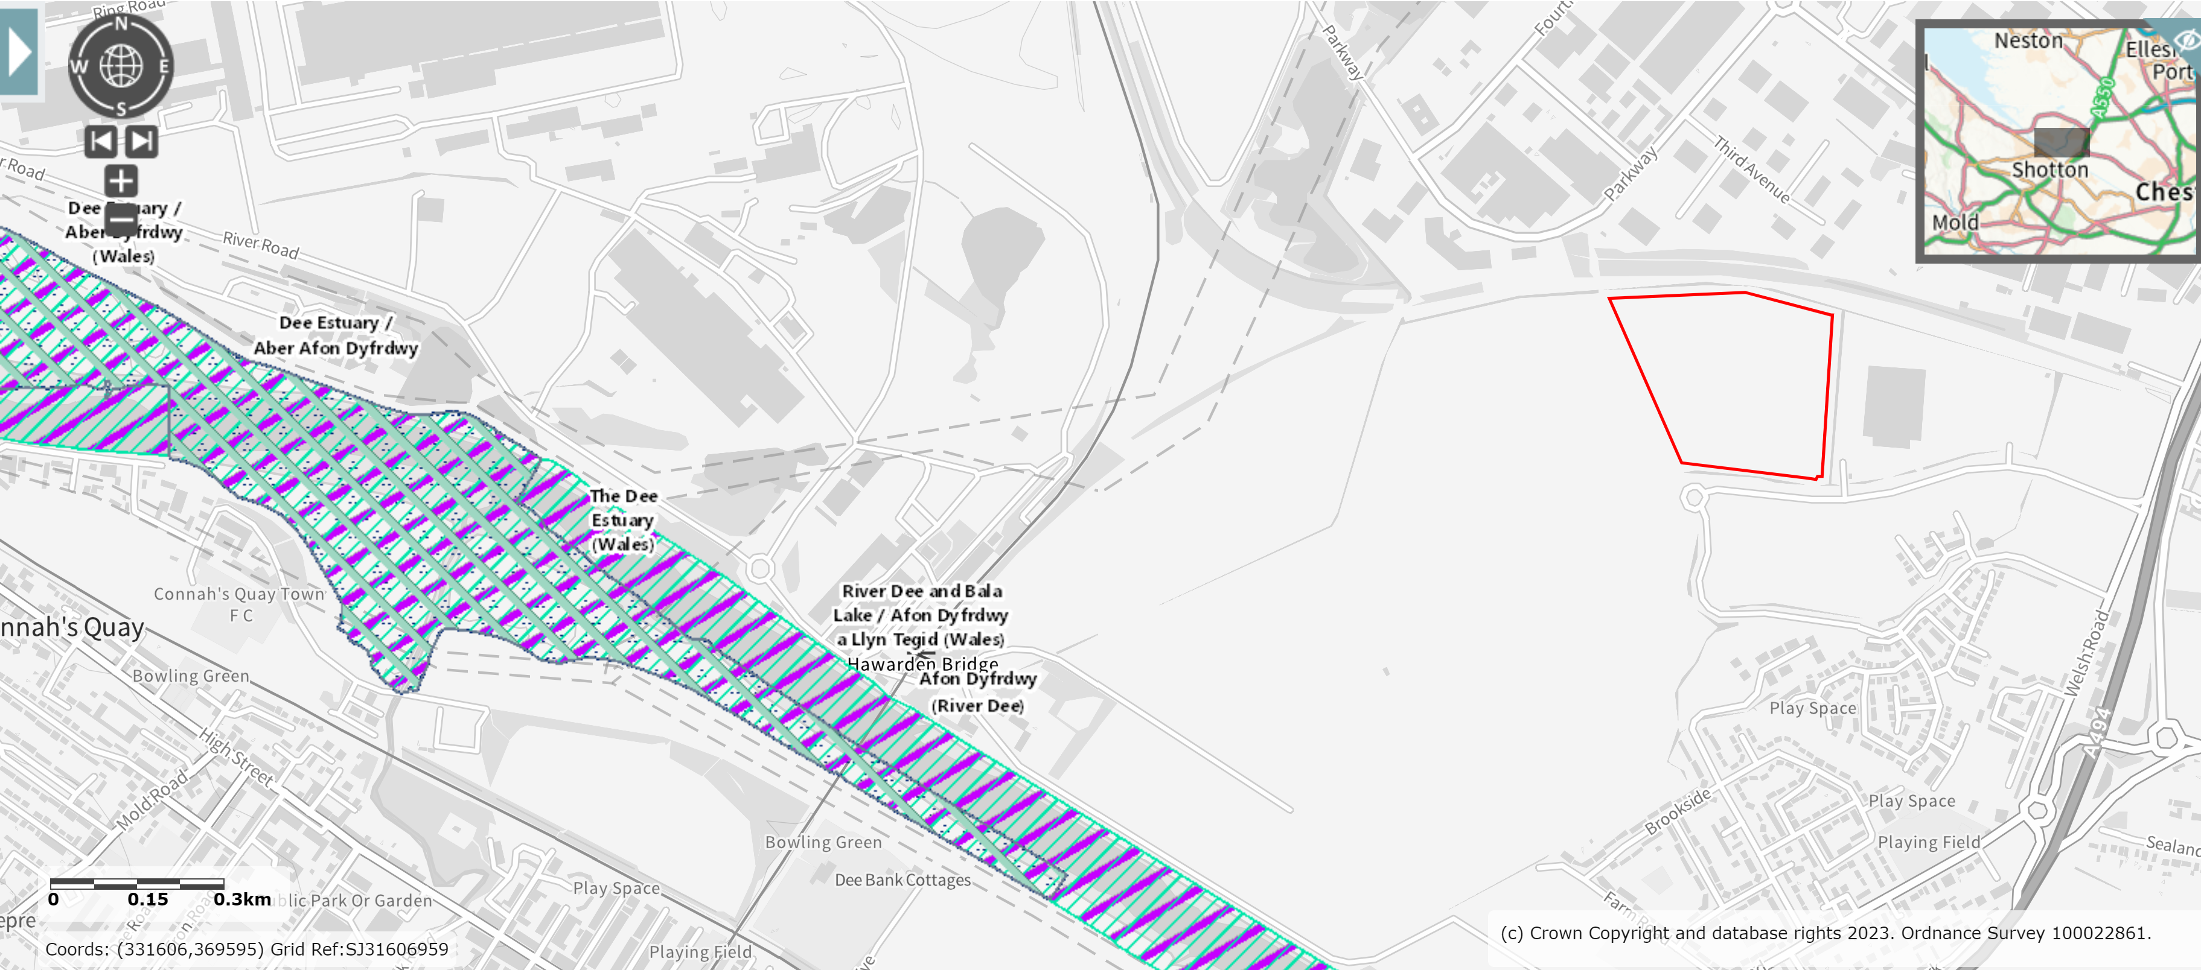

Proposed Development

    - Planning consent for the development was granted by Flintshire County Council on the 8th March 2023 (Ref: RES/000385/22) for the ‘Proposed storage and distribution unit with ancillary offices, associated accesses, car parking, service yards, security gatehouse, electricity substation, pump house and landscaping’. The main storage and distribution aspect of the development consists of an internal employment floorspace of 45,801m² together with 2,5008m² of internal ancillary office floorspace over three floors. Incorporating the gatehouse, pumping station and transport offices there is a total internal floor area of 48,685m².

    - A Development Layout Plan showing the development area can be observed in Appendix A.

    - In summary, the key site activities of Plat B, The Airfields during the enabling, demolition and construction works will include:

                - Securement of the Site and implementation of any temporary fencing and / or hoarding.
                - Creation of temporary construction compounds.
                - Movement and use of static and mobile plant/construction vehicles.
                - Remediation of any existing contaminants, as necessary.
                - Materials handling, storage, stockpiling and disposal.
                - Formation of connections into the existing drainage infrastructure installed as enabling works already.
                - Foundation preparation.
                - Hard and soft landscaping.
                - Provision of associated infrastructure including waste storage/collection facilities, highways infrastructure and car parking.

    - The main building is located centrally within Plot B, allowing for:

                - Parking for 400 cars to the south side of the main building, which includes 24 accessible parking spaces, 16 mobility spaces and 20 EV charging spaces with potential to add an additional 20no. future EWV charging spaces.
                - 38no. HGV trailer bays.
                - One way circular route for HGV’s around the main building leading to all service and delivery areas and secured with security gatehouses at the entry and exit points.

DUTY HOLDERS

Client & Developer

    - Table 2 details the contact information of the Client and Developer for this project.

Table 2: Client & Developer Details
Name | Position | Address | Contact Number | Email
Marlon Chetty | Project Manager | Commercial Development Projects Ltd, Marshall House, Huddersfield Road, Elland, West Yorkshire, HX5 9BW | 07880 526837 | mchetty@marshallcdp.com

Principal Contractor

    - Table 3 details the contact information for the Principal Contractor appointed for the development of the site.

Table 3: Principal Contractor
Name | Position | Address | Contact Number | Email
Tom Slattery | Project Manager | Marshalls Construction (West Yorkshire) Ltd, Marshall House, Huddersfield Road, Elland, West Yorkshire, HX5 9BW | 07557 653302 | tslattery@mcwy.co.uk

Key Contractors

    - Tables 4a, 4b etc. Detail the contact information of key contractors involved in the site preparation, civil engineering and earthworks activities onsite.

Table 4a: Site Preparation Contractor Details
Name | Position | Address | Contact Number | Email Address
Brett Jarman | Contracts Manager | P P O’Connor Ltd, 61 Mosley Road, Trafford Park, Manchester, M17 1GJ | 0161 776 0333 | Bret.jarman@ppoconnor.co.uk

Table 4b: Earthworks Contractor Details
Name | Position | Address | Contact Number | Email Address
Matthew Conroy | Site Manager | MECON Ltd, South Lane, Widnes, WA8 3UB | 0151 420 3974 | info@meconltd.com

Table 4c: Dewatering Equipment Contractor Details
Name | Position | Address | Contact Number | Email Address
Dave Graham | Northern Area Manager | Dewatering Services Ltd, Milbuck Way, Springvale Industrial Estate, Elworth, Sandbach, Cheshire, CW11 3HT | 07540 690598 | davegraham@dewatering.co.uk

Consultant (CSWMP)

    - Table 5 details the contact information for the contract administrator involved in the development of the site. These details will be updated in future to reflect changes.

Table 5: Consultant (CSWMP) Contact Details
Name | Position | Address | Telephone Number | Email Address
Robert Tinsley | Director | E3P Building, Taylor Road, Trafford Park, Manchester, M41 7JQ | 0161 706 0402  07899 026901 | rtinsley@rjtconsulting.co.uk

ROLES AND RESPONSiBILITIES

Client & Developer

4.1.1. The following information describes the key responsibilities of the Client/Developer regarding the surface water management aspects of the enabling and construction phases of this development:

                - Ensure that the CSWMP has been prepared prior to the commencement of the development phases.
                - Appoint a competent consultant to support in the production and implementation of the CSWMP.
                - Implement the methods and infrastructure detailed in the CSWMP and manage all other key contractors working on all applicable development phases. A copy of the CSWMP should be issued to all applicable contractor ensuring they review and provide any comments or feedback prior to implementation and during the development works.
                - Sharing responsibility with the Principal Contractor for reviewing, refining, and revising the CSWMP, as necessary, to ensure that all roles and responsibilities are clear as the project progresses.
                - Overseeing the submission of the CWSMP to the NRW to discharge any applicable licence and permit conditions or for applicable regulatory approvals.

Principal Contractor

    - The following information describes the key responsibilities of the Principal Contractor regarding the surface water management aspects of the enabling and construction of this development:

                - Obtaining a copy of the CSWMP and ensuring it is fully reviewed and, if necessary, providing any comments of feedback before its formal implementation.
                - Ensuring that the CSWMP is fully implemented, and the current version is continually available at the site.
                - Ensuring that the significant surface water management aspects and impacts are identified pre-construction and relevant information required by the NRW is addressed.
                - Introducing specific controls for those significant surface water management aspects and impacts and ensuring they are implemented to minimise or mitigate the risk of damage to the environment (including resources to handle pollution incidents).
                - Controlling access to the site so those entering the site avoid any environmental hazards or pollution incidents. This includes emergency access and egress arrangements in the event of a pollution incident.
                - Updating the CSWMP as work progresses and ensuring that all site operatives and visitors at the site are aware of the CSWMP content and fully co-operate with it.
                - Providing suitable site induction, information, and training to ensure employees, contractors and site visitors engage in the aims and objectives of the CSWMP and these are understood and achieved.
                - Ensuring full regulatory compliance with the environmental legislation associated with the applicable surface water management aspects and impacts. The Principal Contractor will ensure that all contractors are fully compliant with applicable environmental legislation before allowing them to undertake works at the site (Pre-Qualification Process).
                - Undertaking frequent recorded checks/inspections/audits to ensure compliance with applicable environmental legislation and this CSWMP.
                - Investigating and reporting any environmental incidents and near misses. Formal records of the investigation to be retained.
                - Acting as the first point of contact with members of the public and recording any complaints and CSWMP non-conformance and corrective actions as a direct result of any complaints or environmental incidents.
                - Applying for and operating to the required Water Resources Licence (groundwater abstraction) and Environmental Permit (surface water discharge).

Key Contractors

    - All key contractors and site operatives on the site must conform to the arrangements they have been shown in respect of the CSWMP. Site operatives are also responsible for:

                - Ensuring that any control measures identified in the CSWMP which are associated with their work activities are fully implemented and included in their activity method of works.
                - Conforming to the requirements stipulated in respect of any applicable environmental legislation associated with their activities.
                - Ensuring their work activities do not to cause pollution of the environment, harm to human health or serious detriment to local amenities.
                - Informing Principal Contractor of any non-conformances in respect of the CSWMP or associated control measures.
                - Reporting of any environmental hazards or incidents where there is an immediate risk to human health and the environment.

Information for Contractors & Visitors

    - All contractors and visitors to the site will be made aware of the CSWMP and the controls applicable to their presence and activities on site including but not limited to:

- Method statements.
- Site induction.
- Environment briefings
- Toolbox talks.

    - The Principal Contractor Site Management team will be responsible for monitoring communications between all relevant parties involved in the project. This will ensure that all environmental matters relating to the development are discussed and managed with all observations and communications documented in regular meetings and, if necessary, issued via email. All applicable records and correspondence will be retained on site by Principal Contractor.

    - Relevant site layout and location plans/development drawing detailing the location and construction of the site compound, storage locations and car parking are to be displayed on an information board at either the site entrance or main site office.

contract works & CONSTRUCTION PROGRAMME

Contract Works Summary

    - The following provides a summary of activities linked to the enabling and construction works at the site.

                - Initial Enabling Works:
- Installation of surface water drainage headwalls (HW001 – 013). Locations can be observed on the drawing titled ‘Drainage Layout’ (Ref: 4671-JPG-PB-ZZ-DR-D-1400-A5-C03) in Appendix A.
- Installation of Foul Water Manhole (FWMH12). Location can be observed on the drawing titled ‘Drainage Layout’ in Appendix A.
- Connection of foul drainage system from the public road to FWMH12 (main Northern Gateway Access Road – to southeast corner of plot B). Refer to drawing titled ‘Drainage Layout’ in Appendix A.
  - Area 1a & Area 2 earthworks to formation level, aggregate sub-base and base course of tarmac. Refer to drawings titled ‘Construction Buildups’ (Ref: 4671-JPG-PB-ZZ-DR-C-1510-P01) & ‘Site Preparation Handover Areas 1’ in Appendix A.
- Installation of gatic (aco) drain and kerb drainage to area 1, 2 & 11. Refer to drawings titled ‘Drainage Layout’ & ‘Site Preparation Handover Areas 1’ in Appendix A.
                - Earthworks:
- Topsoil strip.
- Bulk filling works (cut & fill). Refer to following drawings in Appendix A.
- Cut & Fill Analysis (Ref: 4671-JPG-PB-ZZ-DR-C-1200-P06).
- Site Sections (Ref: 4671-JPG-PB-ZZ-DR-C-1500-P01).
- MCWY Bulk Earthworks Buildups/Working Platform Sketch 9.2.23.
- MCWY Bulk Earthworks Buildups/Working Platform Sketch 15.2.23.
  - Importation of stone (subbase) to car park, service yards and building area. Refer to drawing titled ‘Construction Buildups’.
                - Foundations:
- Excavation and installation of site foundations. Refer to following drawings in Appendix A.
- General Arrangements of Foundations Sheet 1&2 (Ref: 4671-JPG-PB-FN-DR-S-2101-S4-P01).
- General Arrangements of Foundations Sheet 2&2 (Ref: 4671-JPG-PB-FN-DR-S-2102-S4-P01).
- General Arrangements of Foundations to Transport Office North (Ref: 4671-JPG-PB-FN-DR-S-2105-S4-P01.
- General Arrangements of Foundations to Transport Office South (Ref: 4671-JPG-PB-FN-DR-S-2106-S4-P01).
- General Arrangements of Base Foundation to Pump House & Sprinkler Tanks (Ref: 4671-JPG-PB-FN-DR-S-2150-S4-P01).
- General Arrangements of External Retaining Walls (Ref: 4671-JPG-PB-FN-DR-S-2120-S4-P01).
- MCWY Groundwater Comments Nr1 14/3/2023.
- MCWY Groundwater Comments Nr2 14/3/2023.
- MCWY Groundwater Comments Nr3 14/2/2023.
                - Drainage:
- Installation of remaining drainage systems not completed as part of the initial enabling works. Refer to following drawings in Appendix A.
- Drainage Layout.
- Manhole Schedule (Ref: 4671-JPG-PB-ZZ-DR-D-1401-A5-P04).
- Drainage Construction Details (Ref: 4671-JPG-PB-ZZ-DR-D-1420-S4-P01).
- Drainage Channel & Kerb Drain Surround Details (Ref: 4671-JPG-PB-ZZ-DR-D-1421-S4-P01).
- Fuel Oil Separator Installation Details (Ref: 4671-JPG-PB-ZZ-DR-D-1422-A5-C01).
                - Main Construction:
    - Construction of the main super structure (steelwork & cladding). Refer to following drawings in Appendix A.
- Proposed Elevations (Ref: M3125-200 Rev B).
- Warehouse Sections (Ref: M3125-310).
- Floor Layout Plan (Ref: M3125-100 Rev G).
    - Construction of Transport Office North & South (within main super structure). Refer to following drawings in Appendix A.
- Transport Office General Arrangement North (Ref: M3125-103 Rev A).
- Transport Office General Arrangement South (Ref: M3125-103 Rev A).
- Transport Office Sections (Ref: M3125-320).
    - Construction of internal offices (within main super structure). Refer to following drawings in Appendix A.
- Office Layout Plan (Ref: M3125-102 Rev B).
- Office Section (Ref: M3125-311).
  - Installation of Pump House & Sprinkler Tanks. Refer to drawing titled ‘General Arrangements of Base Foundation to Pump House & Sprinkler Tanks’ in Appendix A.
  - Installation of site services. Refer to drawing titled ‘Services Plan’ (Ref: M3125-03).
  - Construction of main carpark, service yard areas, pedestrian walkways, internal roadways. Refer to drawing titled ‘Construction Buildups’.
  - Construction of Ground floor slabs. Refer to following drawings in Appendix A.
- Ground Floor Slab Details (Ref: 4671-JPG-PB-00-DR-S-2205-S4-P01).
- General Arrangement of Ground Floor Slab Sheet 1 of 2 (Ref: 4671-JPG-PB-00-DR-S-220-S4-P01).
- General Arrangement of Ground Floor Slab Sheet 2 of 2 (Ref: 4671-JPG-PB-00-DR-S-2202-S4-P01).

Construction Programme

    - This project is estimated to last for approximately 70 weeks with the main site works (post initial enabling works) commencing on the 4th September 2023. A copy of the full construction programme will be included in Appendix B of this CMP.

construction surface water management – general arrangements

GPP 5: Works & Maintenance In or Near Water

Overview

    - This Guidance for Pollution Prevention (GPP) has been produced by NRW for compliance with applicable environmental legislation and reflects current best practice requirements. Following this guidance assists contractors in managing their environmental responsibilities to prevent pollution and achieve legal compliance.

    - This guidance applies to any organisation carting out works or activities in or near water environment. Potential environmental risks/activities when working in or near water include:

                - Siltation.
                - Cement & Concrete.
                - Chemicals & Solvent Use.
                - Invasive Non-native Species.
                - Waste Materials.

    - In compiling this CSWMP, potential sources of surface water pollution have been identified followed by the identification of measures to avoid or reduce the risk of causing pollution. This identification process has been undertaken using the source-pathway-receptor pollution linkage approach.

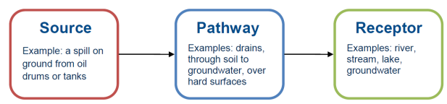

    - The activities will only cause a risk to the environment if all three parts of the pollution linkage are present i.e. a source, a pathway and receptor. Contractors should put in place measures to prevent or minimise or mitigate the effects of any risks and thereby break the pollutant linkages between these three. By doing this, contractors can identify how to prevent or reduce the likelihood of pollution and reduce the impact of any risks that may occur. Appropriate mitigation measures and their applicable guidance are referenced throughout this CSWMP.

Aspects

    - Surface water pollution within the vicinity of the site and immediate surrounding development area could be impacted by silt emissions during the enabling and construction activities. The main sources of these emissions are likely to be from:

                - Exposed ground & stockpiles.
                - Groundwork activities including excavations.
                - Plant & wheel washing activities.
                - Site roads.
                - Abstraction of water from excavations, dewatering and pumping.
                - Storage of Hazardous Substances (oils, chemicals,

Impacts

    - Impacts associated with siltation and spillage of hazardous substances and materials include:

                - Pollution of foul and surface water sewers.
                - Direct discharge and contamination of surface waters.
                - Land and groundwater contamination.

GPP 5 - Siltation

    - Good soil use and management is crucial to preventing silt pollution which is a major cause of environmental incidents. It can harm water quality, damage and kill aquatic life by smothering and suffocation and can cause flooding by blocking culverts and channels.
General Mitigation Controls – Exposed Ground & Stockpiles

    - Soil stripping and vegetation removal at the start of the project can increase the volume of contaminated surface water run-off. It can also reduce the area of vegetated land available for the disposal of silty water. Applicable contractors should plan ahead for intense and prolonged wet weather and implement one of the following pollution mitigation measures including, but not limited to:

                - Minimising the amount of time stripped ground and soil stockpiles are exposed.
                - Only removing vegetation from the area that needs to be exposed in the near future
                - Seeding or covering stockpiles.
                - Using geotextile silt fencing at the toe of any slopes to reduce the movement of silt; this should be undertaken prior to the commencement of any soil stripping and vehicles commence tracking over the site.
                - Collect run off in lagoons and allow suspended solids to settle before disposal.
                - Divert clean water away from the area of construction works in order to minimise the volume of contaminated water.
General Mitigation Controls – Plant/Wheel Washing & Site Roads

    - The movement and maintenance of plant on site can generate silt and oil contaminated water or introduce non-native species from another site. Sources of silt (e.g. plant and wheel washing, site roads) carry a high risk of causing pollution.

    - Plant & Wheel Washing – To reduce the pollution risk, contractors are required to consider all measures including, but not limited to:

                - Plant and wheel washing is carried out in a designated area of hard standing at least 10m from any watercourse or surface water drain or rock outcrop.
                - Run-off is collected in an impermeable sump – recycle and re-use water whenever possible.
                - Settled solids are removed regularly and appropriately disposed of.
                - With appropriate consent from the local water and sewerage provider, it maybe possible to discharge contaminated wash water to the public foul/combined sewer.
                - Contaminated water tinkered off site for authorised disposal.

    - Site Roads – Run off from site roads can contain high levels of silts. Road drains typically drain to a local surface watercourse so are a pathway to pollution. To reduce the pollution risk contractors should implement all relevant measures, including but not limited to:

                - Brushing or scraping roads to reduce dust and mud deposits, appropriately disposing of material collected.
                - Constructing small dams or silt fencing in artificial roadside ditches to retain silt.
                - Divert run-off to settlement lagoons.
General Mitigation Controls – Disposal of Water from Excavations, Dewatering & Pumping

    - Impacts with disposal of water from these activities may be minimised or avoided by:

                - Preventing water from entering excavations by using cut off ditches.
                - Consider the impact on groundwater where well point dewatering is used.
                - Using sump pumps in excavations.
                - Raising inlet hoses above any surface water bed to ensure they do not disturb silt on the bed.
                - Discharging clean water onto a hard surface e.g. concrete slabs/gravel to avoid causing impact from ground/bank erosion.
                - Using appropriate pump rates; to avoid disturbance of bed or bank the maximum rate should be set after consideration of the flow of the receiving surface water course, the location of the discharge and the risk of erosion.
                - Protecting the pump inlet to avoid drawing in aquatic life and other debris.
                - Minimising the disturbance of standing water.

    - As part of the compilation activities for this CSWMP, RJT Consulting reviewed the NRW Briefing Note: Licensing of Dewatering Activities (Version 1). The purpose of this document is to provide clarity on the abstraction licensing requirements for dewatering activities. The briefing note states ‘Where dewatering of groundwater takes place a licence will be required where the abstracted water is from water contained in any underground strata whether hydraulically isolated or not. Establishing whether and how groundwater interacts with other water sources and the impacts this may have on the environment and other abstractions as part of the considerations of an abstraction licence decision. A licence is not required for the dewatering of wholly or mainly rainwater from an excavation’.

    - The Water Resources Act 1991 states that a person needs an abstraction when water is abstracted from any source of supply. A source of supply includes any underground strata in which water is or at any time may be contained. Any excavation into underground strata, where the level o water in the excavation depend wholly or mainly on water entering it from those strata will require a licence before abstraction can take place. The following Figure 5 explains what this means for dewatering activities and highlights when an abstraction licence is needed.

Figure 5: Dewatering Scenarios & Licencing Requirements
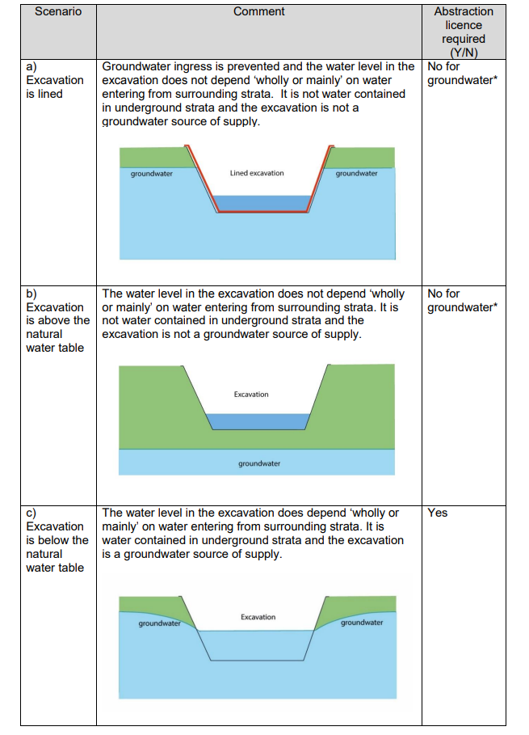
    - * In both a) and b) whilst these are not abstractions from underground strata as defined in the Water Resources Act 1991, in some circumstances they could be considered ‘inland water’ and may need to be licenced as surface water abstractions.

    - As scenario c) will apply to the works being undertaken a Water Resources Licence has been applied for with the NRW. As a consequence of pre-application discussions with Ms Mary Beckett (Senior Officer – Water Resources Permitting) a letter was issued (Ref: PPN-01034, dated 8th June 2023), it was confirmed that a Water Resources Licence was required as ‘the exemption for abstractions of less that 20m3 of water per day is unlikely to apply to your proposal……and that the dewatering activity is likely to continue for longer than 6 months. Therefore the exemption for dewatering activities detailed in Section 5 of the Water Abstraction & Impounding (Exemptions) Regulations 2017 will not apply’. Further details regarding the site Water Resources Licence (Transfer Type) are detailed in Section 9 of this CSWMP.
General Mitigation Controls – Disposal of Contaminated Water

    - Where run off water is contaminated with silt or other pollutants such as oil, this water must not be pumped or allowed to flow (directly or indirectly) into the water environment without treatment. Discharges to the water environment require formal approval from the NRW and discharges to the public foul/combined sewers will require a consent from the water and sewerage provider (Welsh Water). If the water and sewerage provider is unable to approve, it will be necessary to tanker the contaminated water off site for authorised disposal.

    - The choice of method for the treatment and disposal of contaminated water is dependent on the following:

                - The volume of water.
                - The area of land available for storage, treatment and discharge.
                - The amount and type of silt.
                - The presence of any other substance in the water.
                - The conditions of any consent or authorisation.

    - As part of this CSWMP, RJT Consulting have identified the following contaminated water treatment and disposal option for the planned development works.

    - Settlement Lagoons – To be effective a settlement lagoon should retain contaminated water long enough for silt to settle out. The length of time will depend on the type of silt, with finer clay solids taking longer to settle. Figure 6 below gives guidance on the volume of a lagoon or tank needed for a three hour settlement as a defined rate of inlet discharge.

Figure 6: Settlement Lagoon Dimensions
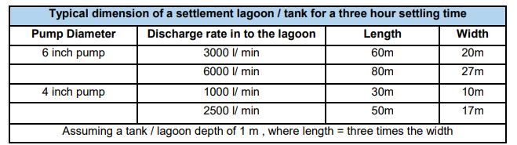

    - It should be noted that there are no plans to use a flocculant to aid settlement in the lagoons and the above figures may not be suitable for fine clay solids.

    - The following points represent a good practice checklist of construction site settlement lagoons and should be considered by all applicable contractors:

                - Maintain a constant pumped inlet rate.
                - Minimise the inlet flow as much as possible by using energy dissipaters or rip rap.
                - Position inlet pipework vertically to dissipate energy.
                - Provide lined inlet chamber to reduce velocity f flow.
                - Line the inlet chamber and outlet weir with materials like geotextile, brickwork, polythene or timber.
                - Have a long outlet weir to minimise disturbance.
                - Provide two or three lagoons in series or parallel to increase silt retention, preferably with a bypass facility to allow maintenance when necessary.
                - Desilt regularly.
                - Monitor discharge regularly.

    - Supplementary information regarding settlement lagoons can be found in CIRIA (2015) Environmental Good Practice on Site Guide (Fourth Edition) (C741).

    - Filtration – Prior to the construction of the proposed site settlement lagoons, applicable contractors can consider the use of filtration systems where water is contaminated with coarse silt. Single sized aggregates 5-10mm, geotextiles or straw bales wrapped in geotextile can be used as a filter. Contractors must monitor the inlet pump rate and discharge quality carefully, to ensure only clean, uncontaminated waster is discharged. Discharges can ither be to a foul/combined sewer (with approvals from the local water and sewerage undertakers consent), land (with the permission of the NRW and landowner) or to surface water (with the NRW’s permission).

    - Pump to Grassland – This method of disposal is only suitable for water contaminated with silt only and you must have permission of the NRW and landowner. The discharge rate must match the rate of infiltration of the soil (refer to figure 7 below), weather amount of vegetation cover and the gradient. Discharges should be well away from excavations to avoid recirculation through the ground and must be monitored to prevent scouring, waterlogging, overland flow and sediment mobilisation issues. Although an option, it is the opinion of RJT Consulting that ‘pump to grassland’ is not a suitable option for the Plot B development.

Figure 7: Typical Infiltration Rates for Different Soil Types (Bettess, 1996).
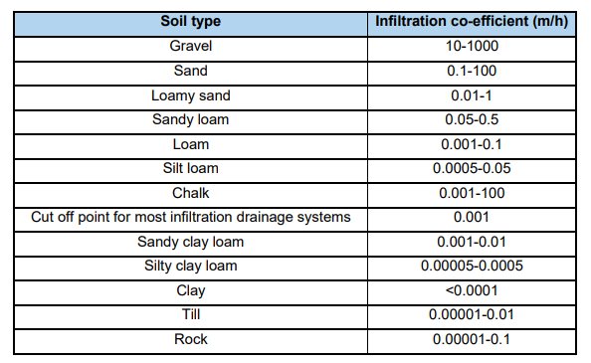

    - Discharges to Sewer – Discharges to foul/combined sewer will require the permission of the local water and sewerage provider. Contractors must approach the applicable water and sewerage undertaker as early as possible. A trade Effluent Discharge Consent is required when the water and sewerage provider is able to approve the discharge. The consent may restrict the volume of waster to be discharged and will include levels for applicable determinands that must be adhered to.

    - Tanker Off Site – Where no other disposal routes are available then contaminated water should be collected by road tanker for authorised disposal of site. This is a very costly option and should only be considered when no other option can be agreed with the applicable regulator. Contractors must comply with all waste Duty of Care obligations and obtain appropriate Waste Transfer/Consignment Notes for any waste leaving site.

GPP 5 – Concrete, Cement & Grout

    - Concrete, cement and grout are very alkaline and corrosive and can cause serious pollution to water.
General Mitigation Controls – Concrete, Cement & Grout

    - Concrete, cement and grout mixing and washing areas should be:

                - Be sited on an impermeable designated area with appropriate containment kerbing and sump for collection of rainwater/spillages.
                - Be sited at least 10m from any watercourse or surface water drain, rock outcrop to minimise the risk of run off entering the water environment.
                - Have settlement and re-circulation systems for water reuse, to minimise the risk of pollution and reduce eater usage.
                - Have a contained area for washing out and cleaning of concrete batching plant or ready mix lorries.
                - Collected wash waters that cannot be re-used and, where necessary, discharge to the foul sewer (you must have the permission of the local water and sewerage provider), or contain wash water for authorised disposal off site.

    - Wash waters from concrete and cement activities should never be discharged into the water environment as this will have a serious impact on the water quality and ecology.

GPP 5 – Invasive Non-Native Species

    - An invasive non-native species is any non-native animal or plant that has the ability tp spread causing damage to the environment, the economy, our health and the way we live. Common examples include Japanese Knotweed, Himalyan Balsam, Giant Hogweed, Asian Clam and Floating Pennywort. In Wales it is an offence to plant or cause to grow in the wild listed invasive non-native species.

    - Contractors should take the necessary steps to eliminate the risk of transferring water and soil potentially containing plant and animal diseases, or invasive non-native species, to or from a development site. If plant material is removed from site, it can only be transported by a registered waste carrier and disposed of at appropriately authorised waste sites. The NRW has a public register which holds this information.
General Mitigation Controls – Invasive Non-Native Species

    - Any pumps and associated pipework used should be:

                - Emptied, thoroughly cleaned using a disinfectant approved for aquatic use, rinsed thoroughly without allowing the cleaning water to enter surface water courses or main drainage system (and preferably dried) before it is taken to site and again before being removed.
                - Positioned to avoid placing the inlet pipe amongst water plants.
                - Positioned with the inlet just below the waters surface, rather than on the bed of the water body.

    - To help minimise the risk of spreading invasive non-native species, and ancillary plant and equipment (including excavators) used in the site establishment of the applicable water management measures defined in this CSWMP needs to be cleaned and dried before it enters site and again before it is removed. In Wales, further information regarding invasive non-native species is available on the following Welsh Government website www.biodiversitywales.org.

GPP 2 – Above Ground Oil Storage Tanks

Overview

    - This GPP is written for all organisations who:

                - Intends to install or replace above ground oil storage tanks.
                - Has existing oil storage tanks on their site to help look after oil safely.

    - Following this guidance will assist all contractors to look after above ground oil storage tanks safely and minimise the risk of causing pollution. They apply to small or medium sized commercial oil storage including for the construction and agricultural sectors. By conforming to the following information, contractors will reduce the risk of pollution caused by the poor storage of oils and fuels in above ground tank installations, poorly maintained tanks and unsuitable filling practices.

    - The NRW recommends that contractors obtain appropriate environmental insurance as oils and fuels are the most common form of surface water pollution in Wales. The policy should include:

                - Environmental clean-up for accidental oil, or deliberate oil loss through vandalism.
                - A high enough liability to cover the affects to neighbouring land, premises and/or boreholes.
                - Cost for cleaning up the landowners property.

    - In Wales Oil Storage is regulated in line with the requirements of The Control of Pollution (Oil Storage) Regulations 2016. This includes petrol, diesel, synthetic/mineral/waste oils and apply to storage volumes of these greater than 200 litres.

Aspect

    - Hazardous substances fuels and lubricants will be stored and used during the enabling and construction phases. Examples associated with construction activities are primarily the following substances:

                - Fuels (red & white diesel, petrol, kerosene).
                - Oils (hydraulic, lubricant).
                - Solvents.
                - Cleaning agents.
                - Adhesives/resins.

Impact

    - Poor handing, storage and use of liquid fuels and oils can result in spillages that can impact both the natural environment and human health. Specific examples of the impacts can include:

                - Pollution of foul and surface water sewers.
                - Direct discharge and contamination of surface waters.
                - Land and groundwater contamination.
                - Inhalation and adsorption of hazardous substances by humans (site workers, visitors, public).
General Mitigation Controls – Storage Tank Location

    - Contractors should avoid locating temporary oil and fuel storage tanks in the following high risk locations:

                - Within 50m of a spring, well or borehole.
                - Within 10m of a surface water course.
                - Locations where spilt oils can enter open drains, losse fitting manholes or soak into the ground where it could pollute groundwater.
                - Places where a spill could run over hard ground to enter a watercourse or soak into the ground where it could pollute the groundwater.
                - Groundwater source protection zones.
                - Outside of any area susceptible to flooding.

    - Oil and fuels spilt in these areas could pollute surface waters and groundwater. If these locations are unavoidable, then additional environmental protection is required e.g. overfill prevention devices or oil separator on the surface water drainage system (where applicable). All storage vessels should include secondary containment measures even when not directly required by the Oil Storage Regulations.

    - Contractors should consider access for maintenance and deliveries to the tanks. Checks should be made with oil delivery company before making the final decision where to place the tank. They will need to take into account pollution prevention and staff health and safety aspects of filling tanks. This includes where they can safely park the oil tanker, where delivery pipes will be located ad access to the tank. They will also be able to give advice relating to the height of the fill point above ground and delivery pipe size.
General Mitigation Controls – Type of Oil Storage

    - There are a range of oil /fuel storage tanks available. Above ground tanks are usually made from steel or polyethylene. Tanks can be single skinned, double skinned or have built in (integrally bunded) as a complete containment system. For the Plot B development all contractors will be required to store oils and fuels in integrally bunded tanks constructed of polyethylene.

    - Integrally bunded tanks have a primary container manufactured with integral secondary containment that can hold a minimum of 110% of the design volume of oils/fuels from the primary inner tank. Ancillary equipment must also be positioned within the secondary containment. The following Figure 8 shows a diagrammatic example of an integrally bunded polyethylene tank.

Figure 8: Example of Integrally Bunded Tank
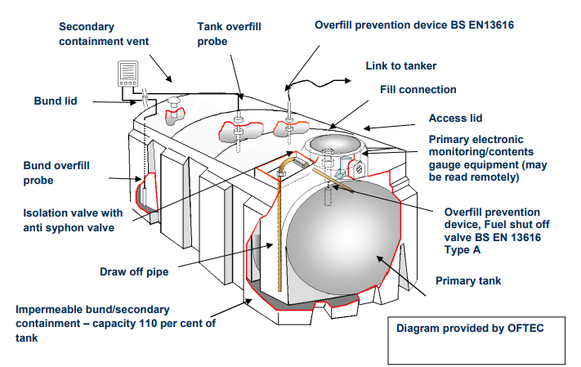
    - Figure 8 is for illustration only. Different configurations exist depending on manufacturer, type of tank and installation. It is recommended top tank outlets, as manual valves on bottom tank outlets must have someone in attendance. Oil Care Campaign tank stickers should also be visual as these provide useful information for all site operatives.
General Mitigation Controls – Ancillary Equipment

    - These are the fittings and pipework that tanks are fitted with and include items such as vents, refuelling pump, flexible delivery hose, site gauges etc.

    - Valves, filters, sight gauges, vents or other tank ancillary equipment, not including the fill pipe, draw off pipe or pumps for oil with a flashpoint less than 32°C must be within the secondary containment system so all discharges are retained. These are illustrated on Figure 8 above.

    - Sight Gauges: Contractors should ensure the following is implemented:

                - Must be located in the secondary containment.
                - Must be properly supported.
                - Must be fitted with a valve that closes automatically when the gauge isn’t in use.
                - Valves should never be kept open.
                - Valves should only be opened when taking content readings.

    - Delivery drivers should close sight gauge valves at the end of their delivery. After the tank has been filled, check that the sight gauge is shut and not leaking. Sight gauge tubes aren’t suitable for use with integrally bunded tanks.

    - Vents: This allows vapour and air to escape from the tank during filling operations or when gases expand with heat on hot days, it also allows air in when fuels are being drawn off. Vents should be visual during deliveries and they should discharge into the secondary containment. In Wales, vents must be in the secondary containment system and must be arranged so that any discharge is directed vertically downward into the system. Tanks must be fitted with an overfill protection device if the filling operation is controlled from a place where it is not reasonably practicable to see the tank and vent.

    - Fill Point: The fill point is where the tanker delivery hose connects to the tank. The fill point should have a lockable fill cap with a chain and be clearly marked with the product type, tank capacity. The cap should be replaced onto the fill point after each delivery to protect from damage and unauthorised use. The fill point should be protected within the secondary containment. If a fill point drip tray is needed (not recommended), these should be:

                - Clean, free from water and other debris prior to use.
                - Able to be moved without the risk of spilling the oil. It is recommended that the drip tray have a minimum capacity of 3 litres.
                - Checked after each delivery and if necessary be safely emptied before being stored away when not in use to minimise rainwater ingress.

    - Remote filling will not be permitted at this development.

    - Flexible Delivery Pipe: These should only be used when contractors need to move the end delivery point e.g. when fuelling vehicles. The fuel delivery pipe must be fitted with a trigger nozzle which closes automatically when not in use. The pipe must either:

                - Have a lockable valve where it leaves the tank which is locked shut when not in use and be retained within secondary containment; or,
                - Must be in an enclosed secure cabinet which is locked shut when not in use and have a drip tray.

    - Dispensing pumps should be installed with the following:

                - Positioned to minimise the risk of damage by collision or protected from collision
                - Fitted with a valve in its feed that prevents the tank contents from emptying if there damage to the pump or feed line.
                - Protected from unauthorised use e.g. fitted with a remote electrical switch or locked when not in use.

    - Underground pipework is prohibited at this site.

    - Overfill Protection Devices: It is recommended that tank systems include overfill protection devices to safeguard against spills. These can be electronic or mechanical which sound an alarm and/or give visual warning or automatically stop the delivery. Overfill protection devices should comply with the Oil Firing Technical Association (OFTEC) standard OFS E105.
General Mitigation Controls – Deliveries

    - All tanks should be clearly labelled with the capacity and type of oil/fuel they contain. Prior to any delivery contractors are required to:

                - Check how much oil is in the tank.
                - Calculate the spare capacity.
                - Decide how much oil is needed to ensure there is no over ordering.

    - All deliveries should be supervised. Appropriate training must be given to the person supervising the delivery so they are aware of the applicable tank, its equipment, how any overfill protection system works and what actions to take if there is a spillage. Each contractor must have their own applicable delivery and management procedures as part of their environmental management procedures for the development.

    - Protecting Soil & Water: The area around the tank where deliveries and refuelling are made and, if applicable, oil/fuel is dispensed should have an impermeable surface and be isolated from surface water drains. This will help stop the oil and/or contaminated water getting into soil and groundwater. If any oil is spilt during delivery contractors should immediately implement measures to stop the material from entering the ground or surface water drainage systems.
General Mitigation Controls – Maintenance

    - Contractors should inspect all accessible parts of their tanks, secondary containment, ancillary equipment and pipework regularly, for signs of damage or leaks. As a minimum contractors should inspect all tanks before delivery especially of they become aware that the oil level in the tank is decreasing faster than expected. General checks should also be undertaken on at least a weekly frequency. Should contractors notice any damage, they must have it repaired or replaced immediately by a registered competent person. An example maintenance sheet can be observed in GPP2.

    - A thorough inspection of any tanks should be undertaken annually by a registered competent person and this should include all ancillary equipment. A written report should be compiled at the end of each inspection. Any repairs or alterations detailed in the report should be done by a competent person immediately. All contractors are required to keep the following records:
                - Keep a log of all inspections, any repair work and the persons who completed along with dates.
                - Record oil usage. Contractors should inspect all accessible parts of their tank, secondary containment, ancillary equipment and pipework regularly, for signs of damage or leaks, As a minimum contractors should inspect tanks before an oil delivery and if they are aware that the oil level in the tank is decreasing faster than expected. If contractors notice any damage, they should have it repaired or replaced immediately by a registered competent person.
General Mitigation Controls – Mobile Bowsers

    - Mobile bowsers are oil/fuel storage containers that can dispense oil and are designed to be moved, either being towed or lifted onto another vehicle, but which can’t move under their own power. As well as the requirements for the storage of oils/fuels described above, the following apply to mobile bowsers:

                - Any flexible pipe, tap or valve must be fitted with a lock where it leaves the container and be locked shut when not in use.
                - Flexible delivery pipes must be fitted with manually operated pumps or a valve at the delivery end that closes automatically when not in use.
                - The pump or valve must have a lock and be locked shut when not in use.

GPP 26 – Storage of Drums & Intermediate Bulk Containers

Overview

    - This GPP has been produced by NRW for compliance with applicable environmental legislation and reflect current best practice requirements. Following this guidance assists contractors in managing their environmental responsibilities to prevent pollution and achieve legal compliance.

    - The guidelines give information and advice about storing liquids, for example oil and chemicals, in:

                - Small containers.
                - Drums, up to 205 litres.
                - IBCs up to 1000 litres.
    - Containers of oil, chemicals or other potentially polluting materials can pollute surface water and groundwater. Pollution can be caused by spills from:

                - Incorrect storage and handling of containers.
                - Accidental leaks.
                - Vandalism.
                - Overfilling or failure of storage structures.
                - Run-off from fires and contaminated firewater.
                - Incorrect or damaged drainage systems.

    - Pollutants can escape into the environment from your site, or where a spill happens off site, via different routes or pathways:

                - Through the surface water drainage system.
                - Direct run-off into a watercourse.
                - Through the soil or via soakaways, drains or damaged surfaces to groundwater.
                - Through the foul sewer system, where pollutants:
                - may be discharged through storm sewage overflows.
                - could pass through the sewage treatment works o may reduce the performance of the works so it can’t treat sewage properly.
General Mitigation Controls – Storage Basics

    - To control the pollution risk at the site all contractors need to know what and how much they are storing and be able to identify it quickly. Contractors should only store materials that they are allowed to. All contractors must keep Material Safety Data Sheets for all the substances stored on site.

    - It is recommended that all contractors:

                - Clearly label individual containers with details of what they contain and any hazard they pose.
                - Label storage areas with details of what can be stored in them.
                - Fit warning signs, for example appropriate hazardous substances symbols (pictograms), at access points to dedicated stores.
                - Store different materials separately so they can’t mix if there’s a leak (it’s easier to deal with a spill of just one material than a mixture); this may be a legal requirement for some substances.
                - Only keep the minimum working quantity of materials on site.
                - Protect storage from extremes in weather whenever possible, for example sunlight, frost.
                - Keep storage areas away, or isolated, from onsite drainage, surface waters and groundwater and vehicle routes.
                - Retain an inventory of all substances stored on site at any one time.
                - Retain all COSHH Risk Assessments for each substance.
General Mitigation Controls – Safe Storage

    - Primary Container: Contractors must ensure primary containers have sufficient strength and structural integrity, so they don’t leak or burst under normal use. For example, rusty or dented containers are unlikely to be fit for use. Repair or remove any damaged or unsuitable containers as soon as they are identified.

    - Unless legal requirements say otherwise, contractors should store primary containers inside a building/container, under cover or protected from the elements by another method. Steel drums stored outside in a vertical position are at risk of rusting from rainwater, while plastic containers can deteriorate over time and become brittle. Don’t store drums directly on top of one another because this greatly increases the risk of drums splitting under pressure or falling over.

    - Secondary Containment: It’s good practice (and a legal requirement for all containers with greater than 200 litres capacity holding oil or its products, including waste oil) to store all drums or IBCs on, or in, an impermeable secondary containment system. Secondary containment systems are designed to catch leaks or spills from the primary container while it is in use.

    - All drums and IBCs must be stored in a suitable secondary containment system. This will significantly reduce the risk of causing pollution. It will also allow recovery of any spilled material and will help to stop spilled product escaping. The secondary containment must not have any drainage. Examples of secondary containment options include:

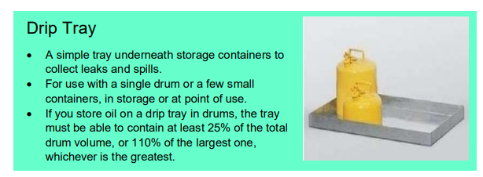
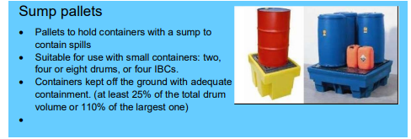
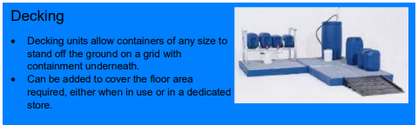
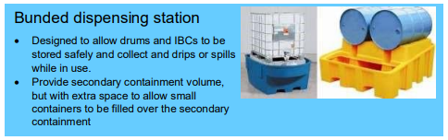
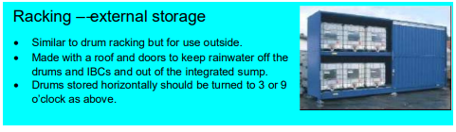
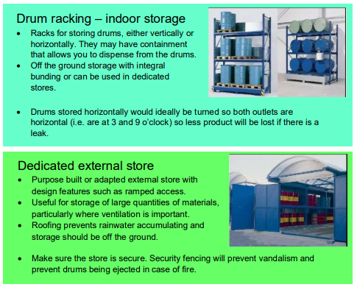
General Mitigation Controls – Storage Location

    - Drums and IBC’s should be stored in an external store (e.g. storage container). This reduces the risk of vandalism and weathering that can damage the integrity of the container. It also prevents the build up of rainwater in any bund or drip trays.

    - Drums and IBC’s should not be stored within 10 metres of surface water or 50 metres of a borehole, well or spring.

    - Contractors should ensure that storage areas are located away from:

                - Surface water drains.
                - Sensitive groundwater areas.
                - Designated vehicle movement areas.
                - Ignition sources.
                - People who could be affected by odours, fire or spills.
                - Other storage areas that contain materials that would react with those in this storage area.
General Mitigation Controls – Containment Size

    - The amount of liquid your secondary containment facilities can hold should be based on the maximum volume of materials contractors are storing at any one time. Figure 9 below details the minimum secondary containment volumes required.

Figure 9: Secondary Containment Volume Requirements
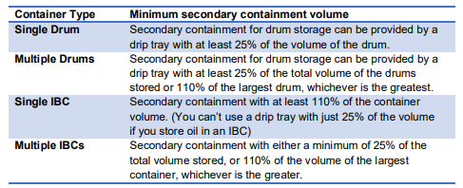
General Mitigation Controls – Delivery & Handling

    - Many pollution incidents involving drums and IBCs happen during the delivery and handling of containers, for example forklift/telehandler damage or spills.

    - Contractors should designate and clearly mark delivery, handling and transfer or decanting areas. Make sure the area is impermeable and isolated from the surface water drainage system, possibly with the use of ramps, sumps or drainage shut-off valves. This will minimise the risk of stored materials causing pollution if an accident happens.
    - Where contractors are unable to isolate the area from surface water drains, consider placing reusable drain covers over the drains during every delivery to prevent pollution if there is an accident.

    - Contractors to ensure that all applicable personnel are trained on the correct procedures for these activities. Contractors will ensure someone is responsible for supervising all deliveries and transfer processes. They should know where spill kits are kept, and they should know how to use them.

    - Only allow forklift trucks/telehandlers to be used by trained operators and supervise deliveries (loading and unloading). Any damaged containers or spills should be reported immediately for action. Use drum carriers, drum taps, funnels and containers with lids to minimise the risk of spillage during handling and transfer.

    - Unless decanting into a container with a wide neck, use a funnel to reduce the chance of material spilling. The funnel should be stored within the secondary containment, or in a secure area, when it’s not in use so drips can’t cause pollution. Make sure all taps are closed after the transfer of materials is completed and that there are no leaks from valves or seals.
General Mitigation Controls – Inspection & Maintenance

    - Drums and IBCs will last longer if they’re protected from direct sunlight and rainfall, both of which can degrade the primary container and secondary containment.

    - Contractors should inspect primary containers and secondary containment facilities at least weekly unless the material being storing requires inspection more frequently. Contractors should make sure that:

                - They aren’t damaged or leaking, for example no corrosion, deformities, cracks or stains from the material stored.
                - Rainwater that has collected in the bund or drip tray has been removed.
                - The bund or drip tray is clean and clear of product and debris.
                - Product label signs and hazard information are undamaged.
                - Maximum storage volumes and stack heights haven’t been exceeded and products are stored in the correct area.
                - All taps not in use are closed and any pipework attached to the container is completely inside the secondary containment.

    - Secondary containment checks should also be undertaken to identify if there is any accumulated liquid, such as rainwater and check that it is uncontaminated and not the result of a leak. Contained water shows that the secondary containment is intact, however it will also reduce the capacity of the containment. Any liquid should be pumped or bailed out in a controlled way. If it is contaminated it may need to be disposed of as hazardous/special waste.

    - Any defects or damage to the container or the secondary containment should be repaired as soon as possible. Contractors should ensure the repairs are done in a way that ensures the container or secondary containment remain impermeable to the product being stored. If it can’t be repaired, then the container or containment system should be taken out of use immediately. Contractors are required to keep records of inspections, cleaning and maintenance.

Flood & Weather Alert

    - The Principal Contractor should sign up to the NRW flood warning system to ensure they receive any relevant alerts or warnings. The relevant alerts have been summarised in Table 5 below.

Table 5 – Flood Alerts
Alert Level | Definition | Action | Responsibility
Flooding Alert | Flooding is possible – be prepared | 1. Check basin/bunds  2. Clean Filters/gullies  3. Check pumps  4. Check contact details for all personnel on site.  5. Safely store/relocate any hazardous material | Principal Contractor
Flood Warnings | Flooding is expected – immediate action required | 1. Pumps in place.  2. Ready to increase bund height.  3. Water levels and run-off monitored.  4. Move equipment to high ground  5. Instigate flood safety procedures. | Principal Contractor
Severe Flood Warning | Severe flooding danger to life | 1. Secure site.  2. Move labour to safe accommodation/high ground with means of escape | Everyone

Surface Water Flood Risk

    - The principal contractor should sign up to the Met Office weather warning system which covers the UK. The potential alerts have been summarised in Table 6 below.

Table 6 – Weather Alerts
Alert Level | Definition | Action | Responsibility
Yellow: Be Aware | Yellow warnings can be  issued for a range of weather situations. Many are issued when it is likely that the weather will cause some low-level impacts, including some disruption to travel in a few places. Other yellow warnings are issued when the weather could bring much more severe impacts to many people but the certainty of those impacts occurring is much lower. It is important to read the content of yellow warnings to determine which weather situation is being covered by the yellow warning | 1. Basin / ditches / bunds to be checked.  2. Drains and gullies checked.  3. Pumps and hoses checked.  4. Check filters. | Principal Contractor
Amber: Be Prepared | There is an increased likelihood of impacts from  severe weather, which could potentially disrupt your works plans. This means there is the possibility of travel delays,  road and rail closures, power cuts and the potential risk to life and property | 1. Place pumps to hoses ready for use.  2. Run off monitored.  3. Water levels monitored.  4. Equipment moved to high ground.  5. Only attempt to travel if safe to do so. | Principal Contractor
Red: Take Action | Dangerous weather is expected and, if you haven’t already done so, you should take action now to keep yourself and your works force safe from the impact of the severe weather. It is very likely that there will be a risk to life, with substantial disruption to travel, energy supplies and possibly widespread. You should avoid travelling, where possible, and follow the advice of the emergency services and local authorities | 1. Pumps running. 2. Secure site.  3. Move labour to high ground/safe place with means of escape.  4. Temporary accommodation for onsite workers. | Everyone

construction surface water management – specific arrangements

Overview

    - In addition to the application of the CSWMP General Arrangements as detailed in section 6, the following specific arrangements will be undertaken with respect to the various applicable phases of the development. Each of the specific activities will also be supplemented with a contractors ‘Method of Work’ that will incorporate the general arrangements as well as other specific details as detailed throughout this CSWMP. This will include personnel involved, plant and machinery, mitigation controls etc.

Initial Enabling Works

Installation of Foul Water Manhole (FWMH12)

    - The installation of FWMH12 will be undertaken by P P O’Connor with the works commencing on the 3rd July 2023 and anticipated to last 1week (5no. working days). The works will be undertaken in line with the PC approved Method Statement (Ref: PPO C0546-MS/03, dated 28th June 2023). This includes the connection to the public foul sewer situated (main Northern Gateway Access Road – to southeast corner of plot B). A copy of the Method Statement can be provided upon request from the Principal Contractor.

    - Prior to the works commencing all operatives will complete the PC site induction that will incorporate the requirements of surface water management in line with the requirements of this CSWMP. All applicable operatives will be provided a toolbox talk on the content of the method statement and risk assessments (including environmental risks) and required to provide written acknowledgement of their understanding.

    - The following details the applicable elements of the P P O’Connor that are associated with surface water management, it is not the intention to fully reference their Method Statement here.

    - Plant, equipment and materials will be delivered to Area 1 as illustrated in drawing titled ‘Site Preparation Handover Areas 1’ in Appendix A. The location of FWMH12 can be observed on the ‘Drainage Layout’ in Appendix A and is located in Area 11 on the ‘Site Preparation Handover Areas 1’ drawing.
    - Material excavated to reduce the working platform level is to be retained in Area 1a and replaced at in and around FWMH12 after works completion to return round levels to the levels at the commencement of the works.

    - The immediate area around FWMH12 will be fenced off (heras fencing) allowing for the use of a 24t tracked excavator, dewatering pump, settlement tank and to allow for the installation of the temporary works system and to stockpile initial excavation arisings.

    - Temporary Works Bracing System: The temporary works bracing system will be assembled adjacent to the location of FWMH12 along with any associated materials and equipment in readiness to commence with the excavation and installation of the system. The temporary works system to be installed is illustrated in Figure 10 below:

Figure 10: Temporary Works Installation (Bracing System)
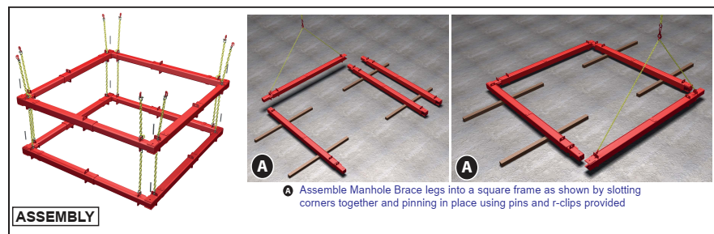
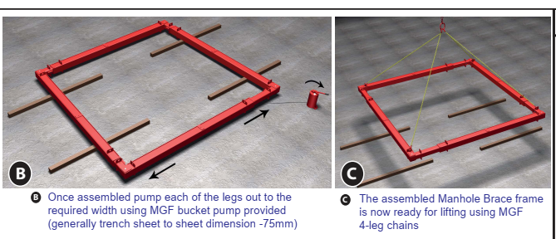
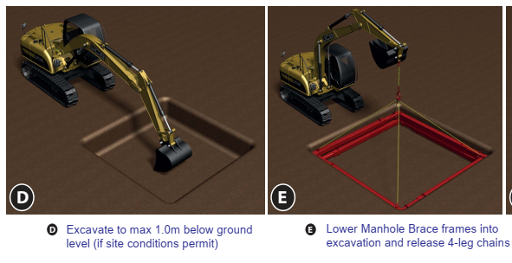
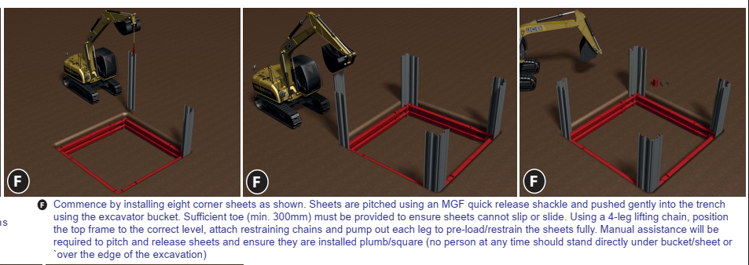
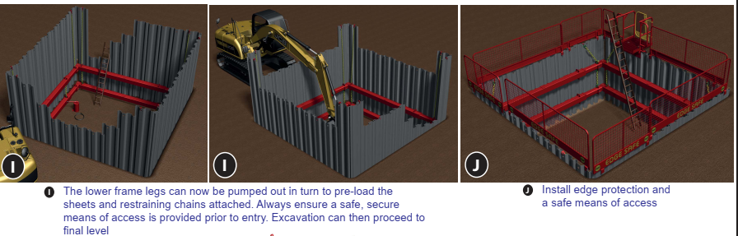

    - Excavation will commence with a ‘dig & push’ method. If groundwater is encountered either a 2” or 4” mobile pump system will be utilised for dewatering. Installation of a 300mm – 450mm water hose and 100mm of clean stone will be used to maintain dewatering. The placement of stone will reduce the extraction of silt from the base of the excavation.
    - Settlement Tank: Pumped water will be transferred directly to a settlement tank (such as a ‘siltbuster’) to assist in the removal of any sediment generated from the dewatering operation. Figure 11 provides illustration of a settlement tank system and its basic functionality.

Figure 11: Mobile Settlement Tank & Function

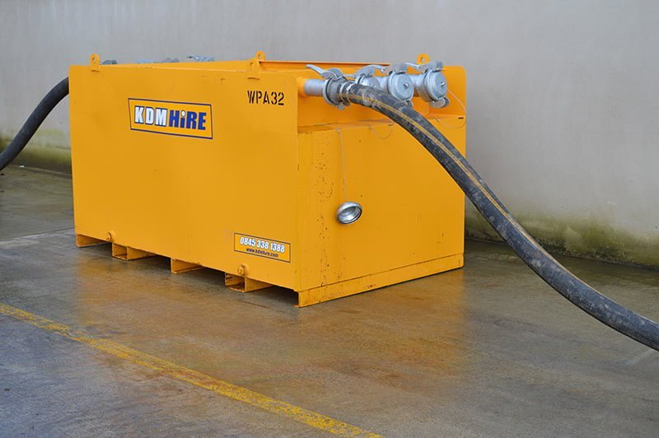

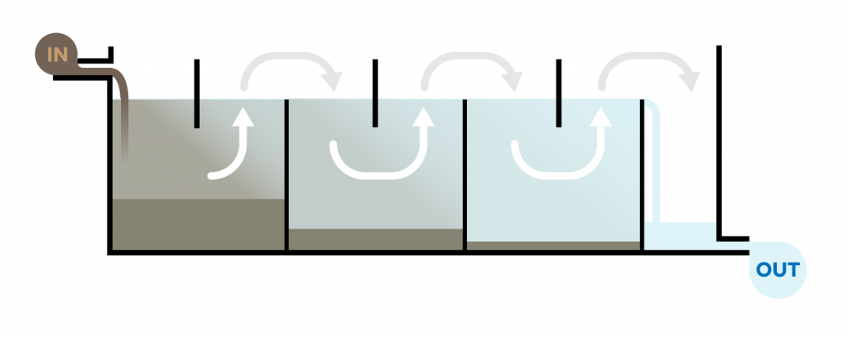
    - Once settled, the final discharge will be transferred via hose into the grassed area in and around the location south of headwall 10 (refer to the ‘Drainage Layout’ plan in Appendix A. The discharge will be trickle drained into the adjacent drainage ditch at this location. Due the size of the operation considerably less than 20m³ of groundwater will be extracted from the excavation and as the works will only last for 1 week it will therefore meet the exemption requirements of Section 5 of the Water Abstraction & Impounding (Exemptions) Regulations 2017 as stated in the NRW letter of the 8th June 2023 (Ref: PPN-01034). Additionally, this temporary dewatering to surface water is covered by the Environment Agency ‘Regulatory Position Statement’ RPS261, adopted by the NRW. Preapplication discussions with NRW have provided agreement that the first three months of works can be done using RPS261 (starting 3rd July 2023). The main works will be undertaken in line with the surface water discharge environmental permit.

    - Manhole Installation: The base of the excavation will be bottomed out to a depth to allow the commencement of the manhole construction. The manhole will be constructed to the specifications as detailed on the drawing titled ‘Drainage Construction Details’ in Appendix A. Figure 12 provides the extract illustration of FWMH12.

Figure 12: Manhole Design
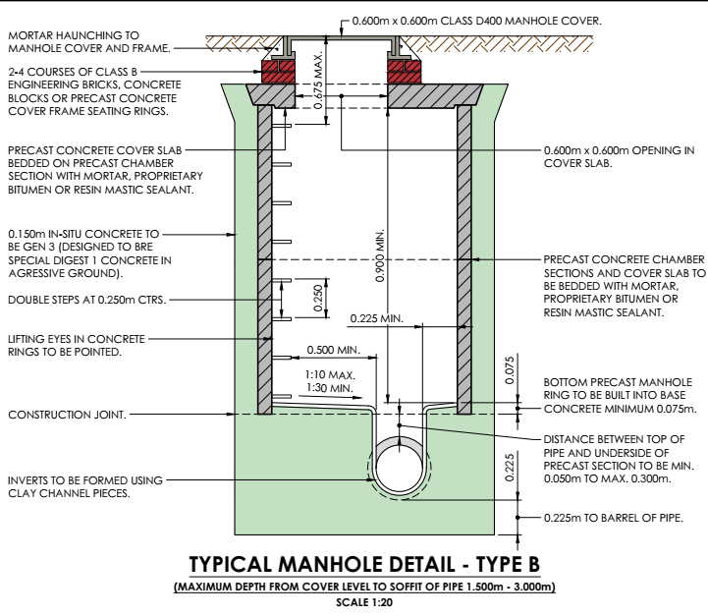
    - Concrete will be positioned in the base of the excavation using an excavator to form the base. The channels, stubs and rockers will be installed. When channels are finalised the full base construction will commence with concrete placed by machine and shovelled into place and shaped. The lowest concrete ring will be positions with final shaping of the concrete will be completed and left to cure.

    - All remaining concrete rings will be installed and sealed with the cover slab landed and concrete surround shutters positioned around the manhole. The opening will be covered/protected, and concrete will be installed to the shutters. The concrete will then be allowed to cure. Shutter will then be removed (post cure) followed by the backfill and compacting around the manhole surround.

    - The removal of the temporary works will be the reverse of the installation as shown in figure 10 and the removed from the work area. After removal of the temporary works the manhole brickwork will be completed, and the lid frame bedded on and allowed to cure. The lid will be positioned and final trimming around the manhole will be undertaken and left as per the original conditions.

    - All concrete used will be delivered ‘ready mix’ and placed directly into the relevant sections of the manhole construction. No concrete wash water will be undertaken/drained on the site.

    - Plant & Equipment: The following plant and equipment will be in use during this activity.

                - 24t tracked excavator.
                - MGF trench support temporary works system.
                - 4” pump from excavation de-watering to settlement tank.
                - 2” pump for final post settlement discharge.
                - Heras fencing.
                - Emergency escape system.
                - 600mm Ramax trench compactor.
                - 2.7kva electricity generator.
                - Stihl saw (petrol).
                - Mobile fuel bowser.

    - Delivery, storage, refuelling and spillage of fuel and chemicals will be undertaken in line with P P O’Connor management procedure SOP5. Additional water pollution controls are also included in their management system procedure SOP10.

Installation of Surface Water Drainage Headwalls & Manholes (Partial) including Wellpoint Installation (Dewatering)

    - The installation of the headwalls and patrial manhole installation will be undertaken by P P O’Connor as part of the initial enabling works. Installation will be undertaken in line with the information in Table 7 below.

Table 7 – Headwall & Manhole Installations & Dates
Week  Commencing | Headwall / Manhole Ref. | Dewatering Equipment
19th June 23 | Headwalls: 001, 002, 004, 012, 013. | 2 No. sets of dewatering equipment for movements between each headwall location. Includes 1no. mobile pump and 20m header main. Single sided wellpoints.
19th June 23 | Separator: 001 | Additional 1no. mobile pump and 80m header main.
27th June 23 | Headwall: 011 | 1no. set of dewatering equipment consisting of 1no. mobile pump and 20m header main.
27th June 23 | SWMH: 022, 023, 024 (all Type E) | 1no. set of dewatering equipment consisting of 1no. mobile pump and 95m header main. Single sided well points.
3rd July 23 | Separator: 004 | 1no. set of dewatering equipment consisting of 1no. mobile pump and 20m header main.
10th July 23 | FWMH: 008 (Type B), 009 (PPIC), 010, 011, 012 (Type B), 015 (PPIC). | Double sided well points = 252m well pointing. 2 No. sets of dewatering equipment for movements between each headwall location. Includes 1no. mobile pump and 70m header main
10th July 23 | FWMH: 007, 013, 014 | Single sided well points = 153m. Dewatering equipment as above.
10th July 23 | SWMH: 019 (Type E), 020 & 021 (Type B). | Double sided well points = 160m well pointing. Additional 2 no. mobile pumps and 70m header main.
10th July 23 | Headwall: 010. | 1no. set of dewatering equipment consisting of 1no. mobile pump and 20m header main.
Note: Manhole types and specifications can be observed on drawing titled ‘Drainage Construction Details’ in Appendix A. PPIC = Polypropylene Inspection Chamber.

    - Dewatering equipment and establishment will be undertaken by contractor Dewatering Services Ltd in line with their Method Statement (Ref: 233205, dated 23rd June 2023). A copy of this method statement can be made available upon request from the Principal Contractor.

    - Installation of Wellpoints: The wellpoints will be installed using standard water jetting. A steel placing tube is suspended from a suitable excavator (minimum 7m lift) and connected via high-pressure hose to a jetting pump and an air compressor.

    - The installation of wellpoints will commence once:

                - The banksman has accurately positioned the excavator.
                - The excavator operator has the steel tube suspended above the wellpoint location and clear of any obstructions.
                - Jetting pump is primed.

    - At each wellpoint position the action of the high-pressure water washes away the ground beneath the tube allowing it to drop into the void created. This process continues until the tube reaches the required depth. It may be necessary to push the placing tube down into the ground if clays, heavy gravel or cobbles are encountered. For this purpose, the tube is fitted with a platform to protect the cap and hose fittings.

    - Once the required depth has been reached the jetting pump and air-compressor (if used) are switched off. The operator will then check that there is no residual pressure within the placing tube and hoses before the top cap of the tube is opened.

    - The wellpoint is then lowered into the tube and the coarse (washed) filter sand placed around it using a bucket. Finally, the top cap is replaced, and the tube withdrawn from the ground by the excavator. Once the tube is withdrawn the process is repeated at the next location. Each wellpoint has a 38mm diameter and will be installed to a depth of 6m bgl. Each well point is connected to the header pipe via flexible swivel connectors for the transfer of groundwater.

    - A correctly installed wellpoint dewatering system will discharge groundwater free from suspended solids. The steel jetting tube uses water flush to produce a clean hole in which to place the wellpoint. The wellpoint tip is made from a 50mm slotted pipe with an external geotextile wrap.

    - Once the wellpoints have been installed the piston pumps, 150mm header pipe main and discharge pipe are laid out and connected by the contractor operator. Pumping can then start, and the contractor operator will monitor the system and will ‘trim’ the system if necessary to optimize the drawdown. Trimming is when the valves on each wellpoint are adjusted to restrict the air flow through the wellpoints to increase the vacuum on the system. The piston pump for the dewatering has a maximum pumping capacity of 90m³ per hour.

    - P P O’Connor will nominate a suitable person to be responsible for the daily maintenance of the system. They will be instructed by the Dewatering Services Ltd operator in the operation of the system and the daily checks that are required through a toolbox talk. Daily checks will include:

                - Identification of optimum performance (including discharge rate and system vacuum level).
                - Refuelling of the pumps and oil checks.
                - Callout procedure in the event of pump failure.
    - In the vent of any fault or problem they will be instructed to contact Dewatering Services Ltd to arrange appropriate measures to resolve the issue identified.

    - Labour & Equipment (Dewatering Services Ltd): The following details the labour and equipment to be supplied by Dewatering Services Ltd;

                - Wellpoint Operator with appropriate Construction Skills Certification Card (CSCS).
                - 6m steel jetting tube with platform head.
                - Lifting chain for jetting tube. (weight not exceeding 100kg).
                - Jetting pump complete with suction hose (weight not exceeding 1 tonne).
                - 3no. dewatering pump sets (weight not exceeding 2.5tonnes).
                - 120m header pipe and fittings.
                - 50m discharge pipe and fittings.
                - 195no. disposable wellpoints and risers.
                - Settlement tank.

The dewatering pumps operate continuously and will be maintained in accordance with the manufacturer’s recommendations.

    - Labour & Equipment (P P O’Connor): The following details the labour and equipment to be supplied by P P O’Connor.

                - 360excavator with driver.
                - Banksman.
                - Labour to assist with installation and setting up of the dewatering system.
                - Water supply for jetting.
                - Wellpoint filter sand: washed coarse sharp sand.
                - Two-tool compressor and hoses. 100cfm capacity.
                - Fuel & oil for pumps.
                - Fill sand for the wellpoint depressions (where required).

    - The following Figure 13 provides a standard illustration of a wellpoint dewatering system.

Figure 13: Wellpoint Dewatering System Illustration
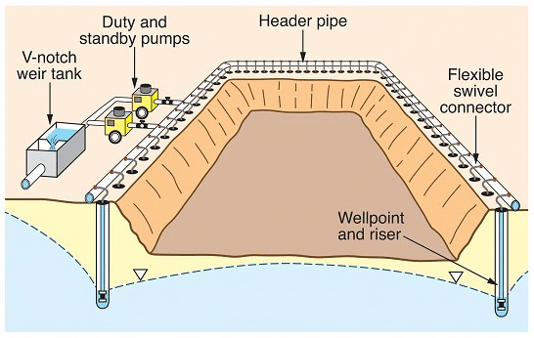

ENVIRONMENTAL MANAGEMENT SYSTEMS PROCEDUREs – Principal Contractor

Management of Contractors

    - When applicable, contractors will be required to provide method statement(s) and risk assessments covering all their activities and state the environmental aspects and impacts of their activities along with the associated control and mitigation measures. This information must be issued to the Principal Contactor prior to their commencement to allow for suitable review and scrutiny.

    - Contractors will be instructed that their method statement(s) should include as a minimum:

                - A description of the works being undertaken.
                - Descriptions of the impacts to the environment caused by their works based on a review of surveys and information available for the development. The impacts should consider areas such as hazardous substances, water pollution, waste, noise, dust, and vibration etc.
                - Details of the activities to be undertaken, equipment to be used, hours of operation, site access arrangements, vehicle movements and details of waste and emissions expected to be generated.
                - Management and mitigation measures.
                - Monitoring and measurement processes.
                - Training & competency details for their respective activities.
                - Maintenance; and,
                - Emergency preparedness and response procedures.

    - The method statement(s) must also confirm that the following specific control measures are incorporated into their work activities:

                - All waste to be segregated (where applicable) and placed in a suitable waste container.
                - All fuel to be stored in suitable double skinned bowsers, tanks or within a bunded area.
                - Drip trays or absorbent blankets to be placed under all static plant when not in use.
                - All hazardous chemicals to have an up-to-date COSHH assessment, be appropriately labelled and be stored in a locked container.
                - Emergency arrangements for spill response.
                - Vehicle and plant engines to be turned off when not in use; and
                - All excavations work to cease immediately if unknown contamination and waste hotspots are identified.

    - Furthermore, the Principal Contractor shall ensure that contractors are communicated with prior to commencing on site to cover the following:

                - Each contractor will nominate an individual who will be on site and who will control quality, health, safety and environmental affairs on their behalf
                - Contractor’s employees must comply with any quality, safety and environmental instructions given by Principal Contactor representatives.
                - All contractors and their employees will attend a Site Induction Talk at times arranged with the Principal Contactor.
                - Any personal injury, damage, loss or negative environmental impact sustained or caused by contractor employees must be reported immediately to Principal Contactor Site Manager.
                - No contractor will subcontract all or part of the contract without prior approval of Principal Contactor.
                - Contractors must advise Principal Contactor Site Management of any deviation from methods of work or materials use and seek approval before proceeding.

    - Only those contractors that have been formally assessed in line with the Principal Contactor safety and environmental pre-qualification process will be allowed to undertake work activities on site as part of this development.

Training & Competency

    - Site operatives, either working directly for the Principal Contactor or for contractors, will be competent to perform their respective roles especially those which have the potential to cause significant environmental impacts. Competence is defined in terms of appropriate qualifications, training and work experience. Assessment of contractor competency forms part of Principal Contactor safety and environmental pre-qualification process.

    - All site operatives will receive an environmental induction prior to the commencement of any site works and this induction will include:
                - Summary of the CSWMP and its contents.
                - Project duty holders & management structure.
                - Key roles & responsibilities.
                - Details of the applicable environmental aspects and impacts of the development.
                - Pollution prevention & control measures.
                - Emergency preparedness & response (use of spill kits, reporting of incidents, incident investigation, non-conformance/corrective actions).
                - General environmental awareness.

    - A record of all the inductions undertaken will be kept by the management of the Principal Contactor, this will include the names and signatures of each delegate and their respective organisation, along with the date the induction was completed. This will form part of all the records generated as a result of the implementation of this CSWMP.

    - All contractor Method Statements will include training & competency details for their respective activities and their operatives.

Communication & Complaints

Internal Communication

    - A copy of this CSWMP will be retained on site throughout the duration of the works. A copy will also be distributed to the project team, including all applicable contractors, to ensure that all the applicable environmental management requirements are communicated effectively. Key activities and environmental sensitive operations will also be briefed to staff and contractors through the induction process and supplementary toolbox talks. Client and Principal Contractor environmental policies shall be displayed on site.

    - A site environmental management meeting will be scheduled (either weekly or monthly) and undertaken following a structured agenda that will include discussion items including:

                - All internal and external environment communications and complaints (including those from statutory bodies such as the NRW).
                - Environmental incidents and near misses.
                - Amendments to the CSWMP or site working practices.
                - Environmental training (including inductions and toolbox talks).
    - Internal communication occurs on an on-going basis and is achieved through various mechanisms that include, but are not limited to:
                - Email
                - Toolbox Talks
                - Team meetings and briefings
                - Noticeboards
                - Minutes of meetings
                - Training sessions

    - A register will be maintained by the Principal Contactor site management which must be signed and dated by all attendees along with details of the organisation they represent.

    - At the end of every Toolbox Talk the site operatives shall have the opportunity to raise any concerns which shall be recorded.

External Communication

    - Procedures may be implemented to clearly demonstrate how the local community will be informed of the consequences of applicable work activities and how the Principal Contactor will control or mitigate any impact they could have on them. These procedures will also detail who the key point of contact is at the site for the local community to approach should they wish to discuss any aspect of the development works.

    - Liaison arrangements will be maintained throughout the development period and will include elements such as:

                - Consultation with the relevant statutory bodies (e.g. Local Authority, NRW) in conjunction with the Principal Contractor (when applicable).
                - Information to local community representatives regarding the future programme of works, (if required).
                - Advance notification to those most affected by particular environmental impacts (verbal discussions or written correspondence).

Complaints

    - Any concerns the local community or statutory bodies wish to raise can be brought to the attention of the Principal Contactor. Any complaints received by other site operatives shall be immediately reported to the Principal Contactor site management. Site operatives will be informed about the process to deal with complaints from members of the public as part of their site induction.

    - When a complaint is reported the following information shall be recorded on a Complaints Log by the Principal Contactor:

                - Details of the issue leading to the complaint.
                - Details of the complainant.
                - Date
                - Name
                - Address
                - Contact number
                - Preferred contact method

    - It is the responsibility of personnel receiving such complaints to notify the Site Manager and Senior Management Team of the Principal Contractor All complaints will be investigated where necessary and appropriate corrective and preventative actions put in place.

    - If a complaint has been previously made, details of the previous incident should also be recorded on the complaint record form and checks should be made as to the corrective actions considered and implemented as a result of the previous complaints.

Emergency Preparedness & Response

Emergency Spill Control

    - Immediately after observing any leakage or spillage of oils, fuels, or chemicals at the site; works should cease immediately until deemed safe to continue by the Principal Contactor.

    - If the spillage consists of flammable liquids all possible sources of ignition should be extinguished, and the Principal Contactor informed immediately. The Principal Contactor should contact the Client as soon as reasonably practical to inform of the incident.

    - It will be the responsibility of Principal Contactor & Site Operatives to identify the source of the leakage/spillage and seek to rectify the problem or reduce the amount of material that could continue to leak out. On open ground use absorbent pads as a barrier to any further contamination. If required put on appropriate Personal Protective Equipment prior to coming into direct contact with any leaked/spilled material.

    - Once the possibility of any further spillage/leakage has been stopped the Principal Contactor site management should seek to contain the spillage taking into consideration the following:

                - On land - use suitable material to construct a bund around the spill to stop it from spreading.
                - Use booms to contain oil spills that have entered or about to enter drainage.
                - In internal buildings use absorbent pads or oil absorbent granule; and,
                - Any contaminated soils will be excavated, taken to the quarantine area, and sampled to identify for waste classification purposes (NRW Technical Guidance WM3). Further validation sampling will be undertaken at the land around the ‘hot spot’ of contamination to provide clarification that all contaminated material has been removed.

    - It is crucial to protect any spillage from entering a sensitive receptor area. Should any spillage enter a sensitive receptor and cause a pollution incident it will be the responsibility of Principal Contactor site management to inform the NRW on the emergency pollution incident number 0800 807 060.

    - In the event of an incident on site that requires the emergency services attendance dial 999.

    - Once all spilled materials have been contained, clean-up of the material should commence. All contaminated materials (soil, sand, absorbent granules) should be disposed of as hazardous waste in line with current waste regulations. Materials should be placed in a suitable hazardous waste receptacle; however, for bigger spillages a larger waste receptacle such as a self-contained skip should be used. These can temporarily be held in a designated quarantine area. All contaminated material must be forwarded to an appropriately permitted waste recovery or disposal site as specified by a technically competent waste consultant/contractor.

    - All leaks and spills must be fully investigated by the Principal Contractor with support from applicable contractors along with the immediate replenishment of any materials and items taken from the emergency spill kits.

Incident Investigation

    - All environmental incidents will be reported directly to the Principal Contractor immediately and to the Client as soon as reasonably practicable.

    - Examples of environmental incidents can include:

                - Spillage of hazardous substance onto ground, into drains or a watercourse.
                - Damage to the habitat of protected species.
                - Releases of significant dust, particulates and odours that cause a nuisance to the local community.
                - Incidents involving fugitive releases of waste or the non-compliant transfer of waste.
                - Noise emissions leading to human health impacts and/or statutory nuisance.

    - All Environmental Incidents must be notified to the Principal Contractor Site Manager. They are also responsible for notifying the client of the incident and ensure they are kept up to date with any close out actions taken.

    - The Site Manager will verbally notify all environmental incidents to the Principal Contractors Environmental Manager who will in turn notify the client/developer This notification will be followed up within 24 hours by sending a copy of the Non-Conformance / Incident Report relating to the incident to the Environmental Manager with a written explanation of the cause and the proposals to prevent recurrence of the incident.

    - The Principal Contactor Site Manager will complete a formal written investigation by completion of a Non-conformance / Incident Report. The investigation must be carried out in a timely manner and should focus on gathering evidence and information including but not limited to:

                - Description of events.
                - Photographs.
                - Drawings, sketches.
                - Details of applicable substances.
                - Witness statements.
                - Description of damage.
                - Analysis and physical investigation of any contamination.

    - The information gathered during the investigation should be analysed to determine:

                - Factors contributing to the incident and root causes; and,
                - Opportunities for corrective and preventative actions.

    - All site operatives connected to the incident may be included in the investigation process when required by the incident investigator.

    - On completion of the incident investigation, the Principal Contactor will identify a suitable corrective and preventative action to mitigate the incident from occurring again. On completion, Principal Contactor should also conduct a review of the CSWMP and any associated environmental aspects and impacts evaluations and make suitable amendments if required.

    - Table 8 below displays the key emergency contact information.

Table 8 – Emergency Contact Details
Contact | Address | Contact Details | Role/Function
Natural Resources Wales | Chester Road  Buckley  CH7 3AJ | 0300 065 3000 | Environmental protection and pollution control. Environmental permits & licences.
Flintshire County Council | County Hall  Mold  Flintshire  CH7 6NB | 01352 702121 | Planning & Environmental Health
Site Manager | Marshalls Construction (West Yorkshire) Ltd  Marshall House  Huddersfield Road  Elland  West Yorkshire  HX5 9BW | Tom Slattery 07557 653302 | Principal Contractor
Environmental Manager | TBC | TBC | Principal Contractor

Maintenance of Plant & Equipment

    - The Principal Contractor has implemented procedures which describe the controls applied to ensure that their plant & equipment is capable of meeting a defined level of performance or a known standard of accuracy in circumstances where performance is critical to the quality of the work to be undertaken.

    - Every new vehicle or plant asset purchased by the Company is given a fleet asset number. The following details are noted on a master file located within the main plant office:

                - Description
                - Serial number
                - Date of registration
                - Service mileage / Hrs. interval

    - Servicing may be undertaken by the Principal Contractor or a third party depending on the vehicle location and agreements at time of plant and machinery purchase. Both the Principal Contractor and third-party vehicle service records will be retained in the appropriate vehicle folder, together with the daily driver checklists and any defect sheets. Records of plant servicing and repair records are retained on file.

    - All hired plant is subject to service schedules controlled by the relevant hire company.

    - Plant will be inspected on a daily basis by the operator, any damage / defects will be recorded in a Daily Plant Inspection Checklist book. These sheets will be actioned as required by the Principal Contractor.

    - During plant operation, any losses and damages shall be reported to the Site Manager immediately, who shall then report it to the Plant/Engineering Manager.

    - All contractors are required to include details of all service ad maintenance requirements for their respective plant and equipment in their method statement. This should also detail how all applicable service and maintenance records will be retained and their record location.

Monitoring & Audit

    - Appropriate monitoring of the environmental aspects of all Contractors activities enables the effectiveness of environmental mitigation to be evaluated. It also allows environmental issues to be identified and responded to at an early stage. Monitoring will also assist the Principal Contractor identify and implement environmental improvements which will contribute to the overall environmental performance of the project.

    - The Principal Contractor will carry out appropriate environmental inspections and monitoring of environmental performance on a monthly basis. An audit checklist will be used which provides the mechanism to monitor and assess compliance against all the Principal Contractors requirements and standards.

    - In addition, the Principal Contractors Site Manager is responsible for monitoring Contractors to ensure work is being undertaken in accordance with the agreed method statement, environmental procedures and to the standards of quality required.

nRW Water Resource Licence & Surface water Discharge permit

    - Details to be submitted here on receipt.

END OF CSWMP

APPENDIX A

Drawings

APPENDIX B

Construction Programme

APPENDIX C

Water Resources Licence

APPENDIX D

Environmental Permit (Surface Water Discharge)

This CSWMP will be monitored on a regular basis to ensure that work is progressing according to its content and will be updated/amended to record details of any changes to its content along with justifications for these changes.
Checks and approvals should be undertaken by the Principal Contractor with support provided by RJT Consulting where necessary.

