Natural Resources Wales permitting decisions

Variation

We have decided to issue the variation for New Horizon Biofuel and Animal Bedding Co Ltd operated by New Horizon Biofuel & Animal Beddings Co Ltd.
The variation number is EPR/CB3797CA/V002
We consider in reaching that decision we have taken into account all relevant considerations and legal requirements and that the permit will ensure that the appropriate level of environmental protection is provided.

Purpose of this document

This decision document:
- explains how the application has been determined
- provides a record of the decision-making process
- shows how all relevant factors have been taken into account
- justifies the specific conditions in the permit other than those in our generic permit template.
Unless the decision document specifies otherwise we have accepted the applicant’s proposals.

Structure of this document

- Annex 1 the decision checklist
- Annex 2 the consultation, web publicising and newspaper advertising responses

Annex 1: decision checklist
This document should be read in conjunction with the Duly Making checklist, the application and supporting information and permit/notice.

Aspect considered |  | Justification / Detail | Criteria met
 |  | Justification / Detail | Yes
Consultation
Scope of consultation |  | The consultation requirements were identified and implemented. The decision was taken in accordance with our Public Participation Statement and our Working Together Agreements.
Responses to consultation |  | The consultation responses (Annex 2) were taken into account in the decision.  We decided to consultation limited to consultation with North Wales Fire and Rescue Service in regards to the Operators Fire Prevention and Mitigation Plan.  Specifically we had questions regarding:  - Site Layout and Fire Fighting Access.  - Water Supply and Fire Hydrants.  The responses to this consultation are visible in Annex 2.  Wider consultation (eg. with the public) was not undertaken, in line with our Public Participation Guidance and Working Together Agreements.  The decision was taken in accordance with our guidance.
Operator
Control of the facility |  | We are satisfied that the applicant (now the operator) is the person who will have control over the operation of the facility after the grant of the permit.  The decision was taken in accordance with EPR RGN 1 Understanding the meaning of operator.
European Directives
Applicable directives |  | All applicable European directives have been considered in the determination of the application.  Pre-treatment of waste for incineration and co-incineration and Hazardous waste storage are treatment activities under the Industrial Emissions Directive. Therefore, daily treatment / and storage capacity limits have been set in Table S1.1 of the permit.
Sustainable Management of Natural Resources (SMNR)
Considerations of SMNR - Compliance with our General Purpose | We are satisfied that this decision is compatible with our general purpose of pursuing the sustainable management of natural resources in relation to Wales and applying the principles of sustainable management of natural resources. |  | ✓
Environment Wales Act 2016 – Biodiversity and resilience of ecosystems duty
Consideration of Section 6 | Section 6 of the Environment Wales Act 2016 requires that we seek to maintain and enhance biodiversity in the exercise of our functions, and in so doing promote the resilience of ecosystems, in a manner that is consistent with the proper exercise of our functions. NRW is satisfied that in this case, we have taken into account and had due regard to this duty in so far as it is consistent with the function of determining an application for an EPR permit. |  | ✓
The site
Extent of the site of the facility |  | The operator has provided a plan which we consider is satisfactory, showing the extent of the site of the facility.  A plan is included in the permit and the operator is required to carry on the permitted activities within the site boundary.
Site condition report |  | The operator has provided a description of the condition of the site.  We consider this description is satisfactory. The decision was taken in accordance with our guidance on site condition reports – guidance and templates (H5).
Biodiversity, Heritage, Landscape and Nature Conservation |  | The application is within the relevant distance criteria of a site of heritage, landscape or nature conservation, and/or protected species or habitat .  A full assessment of the application and its potential to affect designated sites has been carried out. The only designated site within the relevant screening distances is the Stryt Las a’r Hafod SSSI / Johnstown Newt Sites SAC.  No FORM 1 completed:  HRA is not required because there is no conceivable impact pathway to any Natura 2000/Ramsar site  Note: From OGN 200 - no conceivable impact on any Natura 2000 site, by virtue of the scale or location or nature of the project.  Appendix 4 Completed:  A full assessment of the application and its potential to damage the features which are of special interest for the SSSI. The assessment concludes that the proposed variation is not likely to damage any of the flora, fauna, geological, or physiological features which are of special interest.
Environmental Risk Assessment and operating techniques
Environmental risk |  | We have reviewed the operator's assessment of the environmental risk from the facility.  With the exception of the risk from site surface water we  consider the operator’s risk assessment is satisfactory.  Unit 10 – Site Surfacing and Site Run-off  During the determination of EPR/CB3797CA/A001 the site surfacing to the external areas of Unit 10 were permitted as shown in the plan below. This shows the site mainly has impermeable surfacing apart from a small area of of hardstanding around the building indicated by draker grey colour and the purple oval overlayed.  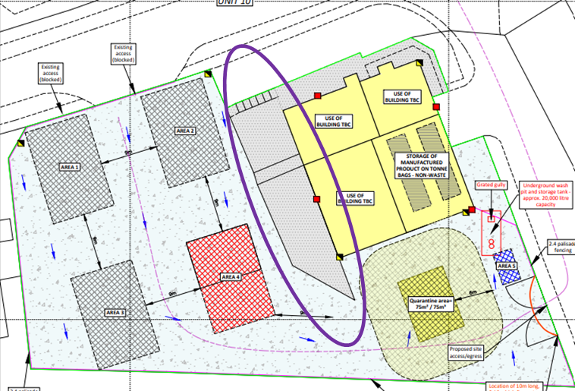  During this determination (EPR/CB3797CA/V002) the operator has demonstrated that the site surfacing is as shown in the plan below. The majority of the site is impermeable surfacing but with larger area of permeable hardstanding shown by the darker grey area with an orange oval overlayed. (NOTE: The change in permeable hardstanding is as a result of a mistake on the original plan. The Operator has not removed impermeable surfacing from the site.)  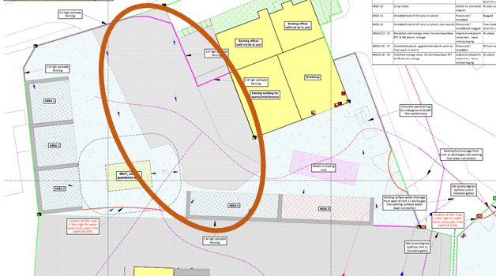  The result of this amended site surfacing is that the normal operational risk is reduced as waste is not proposed to be stored on areas of hardstanding. (Note: this is considering the real world conditions of the site not the permitted circumstances.) however it does increase the risk of contaminated fire water entering the environment through the permeable surface should there be a fire on site. This is because the slope of the site would take the firewater directly over this hardstanding towards the surface water containment.  We must also consider that the Fire Prevention & Mitigation Plan indicates that wastes stored in these bays are there short term (<10 weeks) and therefore there is limited risk of self combustion.  We considered the above points and have determined that the site must remove the risk of surface water run-off entering the environment through the permeable hardstanding surface. However, this may be done through on-going compliance and does not need to be considered further as part of this determination. This is because the risk of contaminated run-off (normal and abnormal conditions) entering the environment through the permeable hardstanding surface was already present.  We therefore have included an improvement condition in Table S1.3 of the permit to ensure that the Operator either:  - Demonstrates through robust risk assessment that there is no pathway from the permeable hardstanding to the environment.  - Remove the risk by for example resurfacing the hardstanding area of the site OR using kerbing, or ACO drains to ensure that water from the site surface cannot enter the environment through the hard standing area or a mixure of these options.
Operating techniques |  | We have reviewed the techniques used by the operator and compared these with the relevant guidance notes.  The operator has identified suitable measures in accordance with the relevant technical guidance note for waste activities; ‘How to comply with your environmental permit’.  The operator submitted a Dust Management Plan (DMP), Noise Management Plan (NMP) and Fire Prevention & Mitigation Plan (FPMP) detailing measures used to prevent or minimise the risk of emissions from the activity.  The measures included in the DMP, NMP and FPMP have been assessed and are considered as suitable to control the risk of emissions from the activity and the risk of fire. These were assessed in accordance with ‘How to comply with your environmental permit’, ‘Noise and vibration management: environmental permits’ and ‘Fire prevention and mitigation plan - waste management Guidance No. 16.’
The permit conditions
Waste types |  | We have specified the permitted waste types, descriptions and quantities, which can be accepted at the regulated facility.  We are satisfied that the operator can accept these wastes as they are consistent with the activities to be undertaken on site and the environmental controls present.  We made these decisions with respect to waste types in accordance with our ‘How to comply with your environmental permit’ and ‘WM3: Waste Classification Technical’ guidance.
Pre-operational conditions |  | Based on the information in the application, we consider that we need to impose pre-operational conditions.  We have imposed a preoperational condition to ensure that the integral infrastructure required for ensuring the new waste storage and treatment operations on site do not cause pollution, during normal or abnormal (eg. Fire) conditions.
Improvement conditions |  | Based on the information on the application, we consider that we need to impose improvement conditions.  See environmental risk assessment section above for further information on IPC1.  We have imposed IPC2 to carry out a Noise Impact Assessment within 6 months of permit issue. The NIA is required to confirm the predictions in the modelling and the conclusions are correct once the facility is fully operational.
Incorporating the application |  | We have specified that the applicant must operate the permit in accordance with descriptions in the application, including all additional information received as part of the determination process.  These descriptions are specified in the Operating Techniques table in the permit.
Operator Competence
Environment management system |  | There is no known reason to consider that the operator will not have the management systems to enable it to comply with the permit conditions.  The decision was taken in accordance with RGN 5 on Operator Competence.

Annex 2: Consultation responses
Summary of responses to consultation, and the way in which we have taken these into account in the determination process.

Response received from
North Wales Fire & Rescue Service on 29/04/24 &24/06/24
Brief summary of issues raised
The FRS confirmed it was crucial the max stack sizes are managed to keep them at least 1m below the wall height, and that the daily checklist must be used.

Additionally, following further discussion they confirmed that according to their data, the fire hydrants acting as water supply in the event of a fire are of between 100-150 mm in diameter so it is assumed the flow expected should suffice for the site concerned.

Summary of actions taken or show how this has been covered
The FPMP has been assessed in line with our guidance and incorporated into the permit in S1.2. This includes measures on maintaining a freeboard and checks in line with the FPMP.

