PAN-025226 My Map Report:
Application map
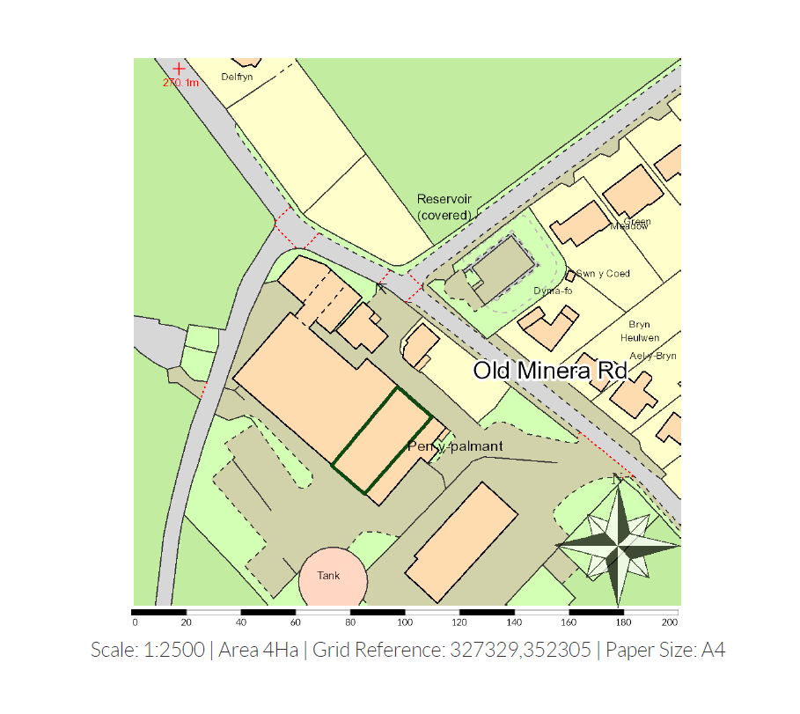
Site Boundary
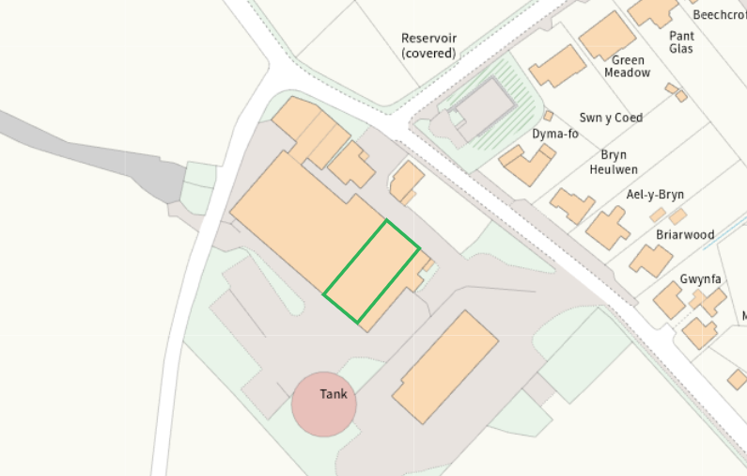

Source protection Zone 1. Any well, spring (or issue) or borehole used / not used for the supply of water for human consumption including from a private water supply or supplies within 50m.
None in range
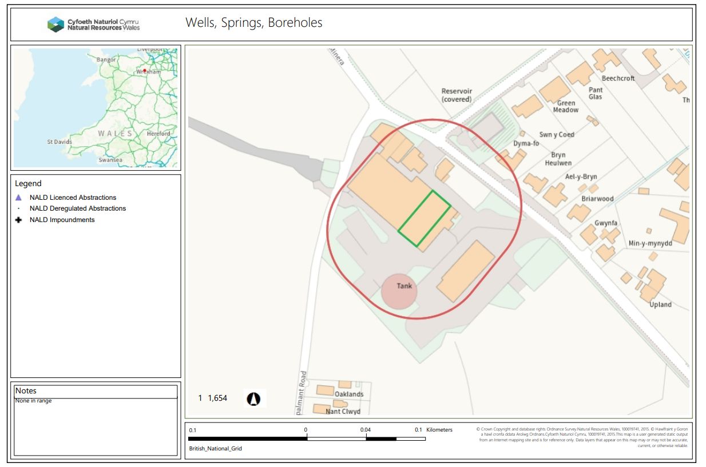

European designated sites- Natura 2000 (SPA, pSPA, SAC or cSAC) or Ramsar- or SSSI within 200m
None in range
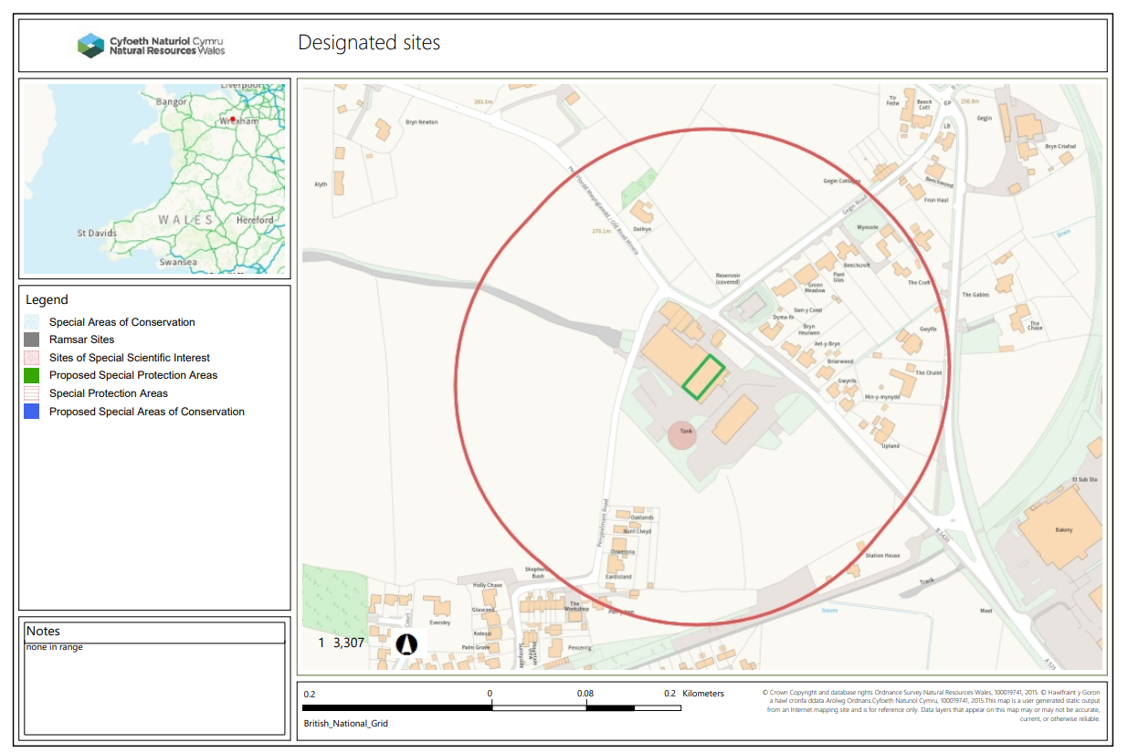
END

