Permit
The Environmental Permitting (England & Wales) Regulations 2016

Mr Philip Tomlinson

Pen Y Palmant Farm
Old Road
Minera
Wrexham
LL11 3YR

Permit number

EPR/DB3295HH

Permit
The Environmental Permitting (England and Wales) Regulations 2016
Permit number

EPR/DB3295HH

The Natural Resources Body for Wales (“Natural Resources Wales”) authorises, under regulation 13 of the Environmental Permitting (England and Wales) Regulations 2016

Mr Philip Tomlinson (“the operator”),

of

Pen Y Palmant Farm

Old Road

Minera

Wrexham

LL11 3YR

to operate waste operations at

Pen Y Palmant Farm

Old Road

Minera

Wrexham

LL11 3YR

to the extent authorised by and subject to the conditions of this permit.

Under regulation 27(2) of the Regulations, standard rules SR2011 No3 are conditions of this permit.

Name | Date
Huw Davies | 27/08/24

Authorised on behalf of Natural Resources Wales

Schedule 1 - Site plan

This is the plan referred to in the standard rules SR2011 No3

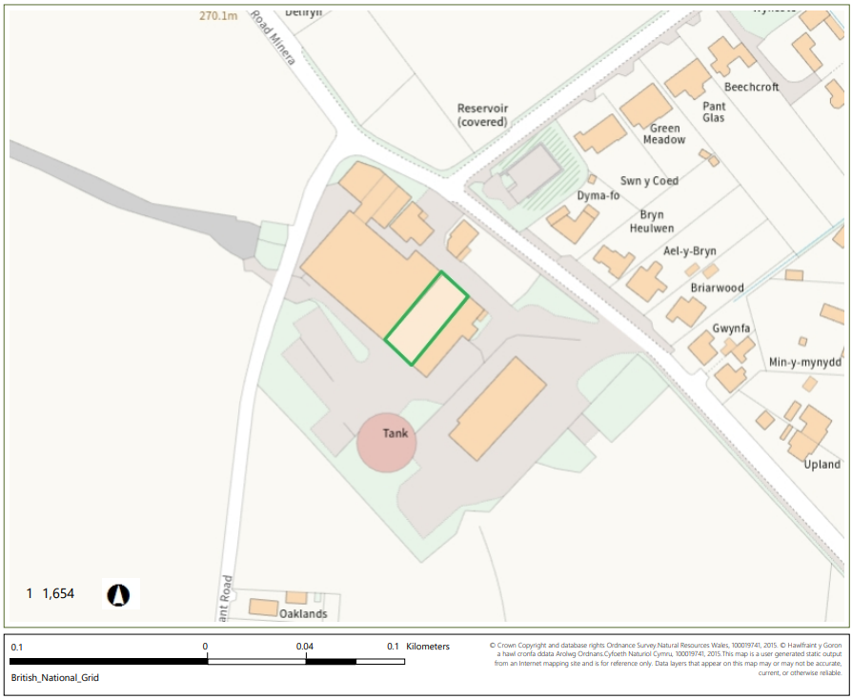

© Crown Copyright and database right 2024. Ordnance Survey licence number 100019741.

END OF PERMIT

