PAN-025886 MyMap Report
The provided application map does not comply with requirements, not bordered in green and does not take into account the requirements of condition 2.2.2 of the requested permit. See points below. Return
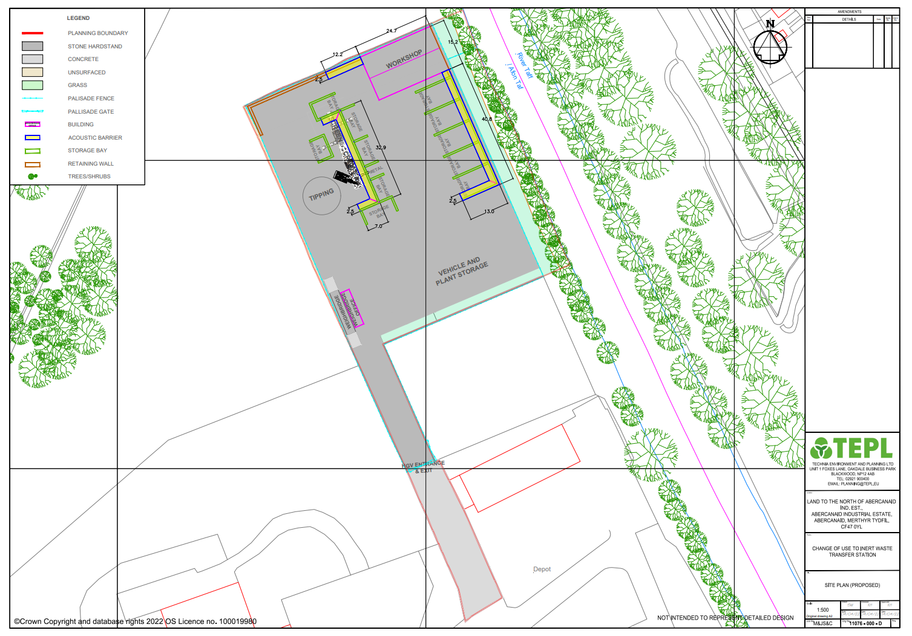
Condition 2.2.2 of the requested permit states that the activities shall not be carried out within:
(a) 500 metres of a European Site or Site of Special Scientific Interest (SSSI);

SSSI Cwm Glo a Glyndyrys to the West. Return

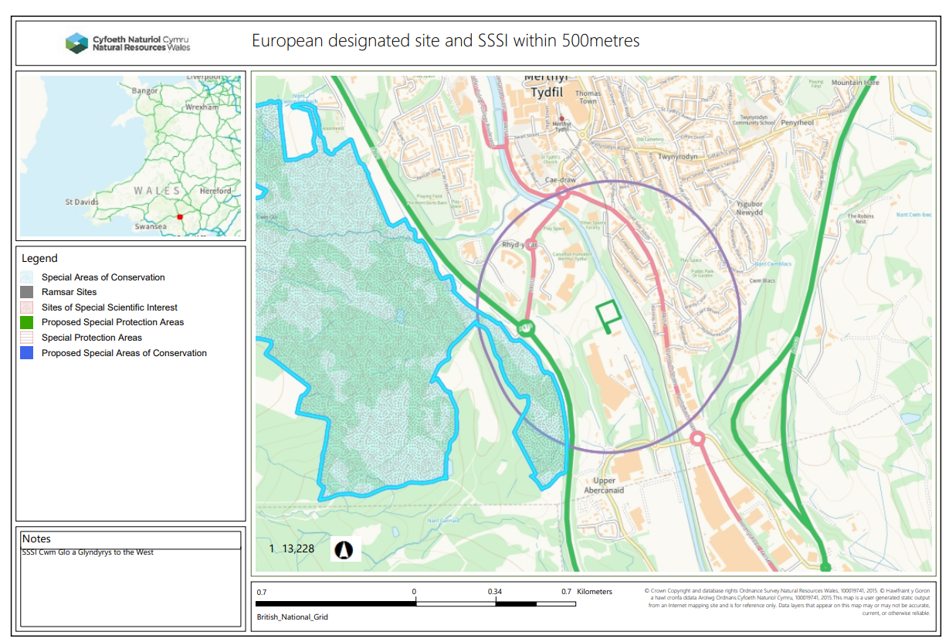
(b) 10 metres of any watercourse;
Afon Taf to the E. Return
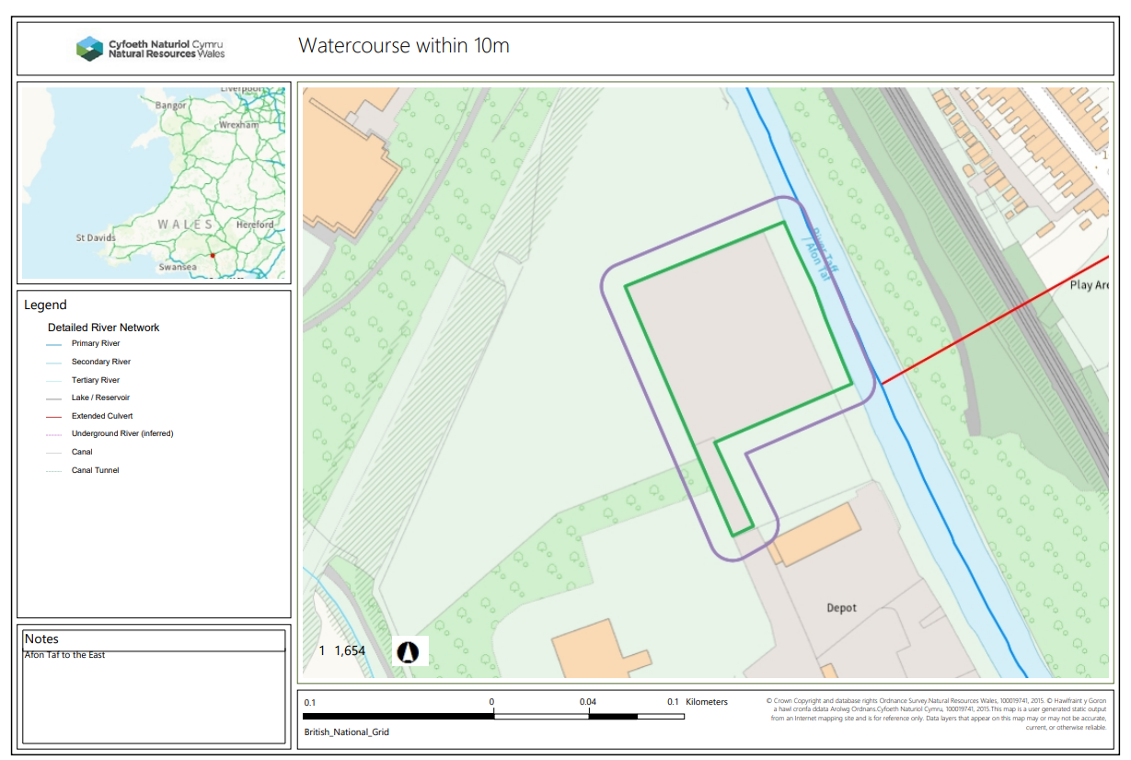
(c) 50 metres of any spring or well, or any borehole not used to supply water for domestic or food production purposes;
(e) 50 metres from any well, spring or from any borehole used for the supply of water for human consumption. This must include private water supplies.

None
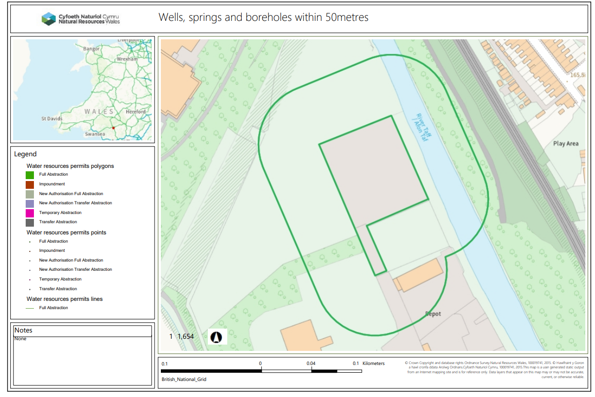
(d) a specified AQMA;
None
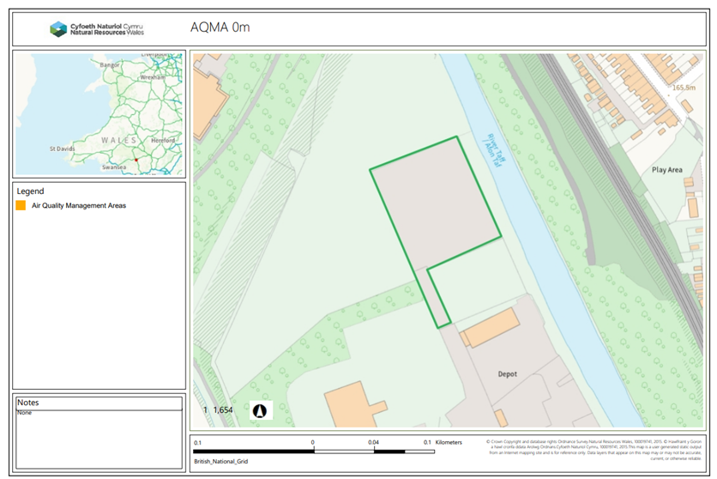
(f) 250 metres within the presence of Great Crested Newts where it is linked to the breeding ponds of the newts by good habitat;

None
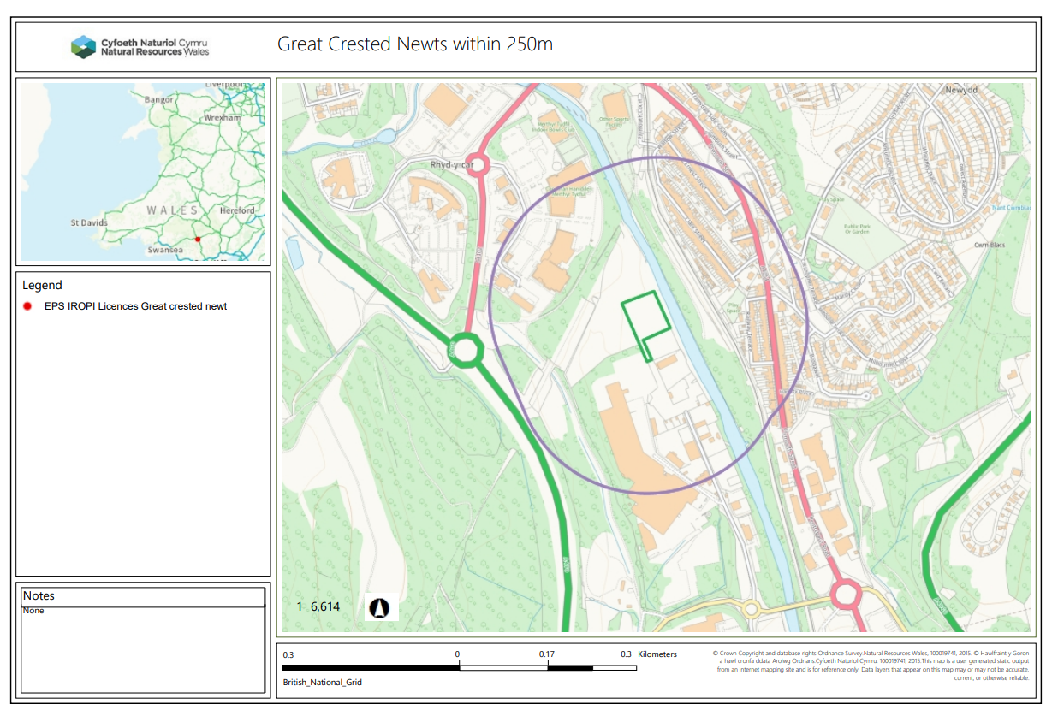

2.2.2 (g) 50 metres of a site that has species or habitats protected under the Biodiversity Action Plan that Natural Resources Wales considers at risk to this activity
None in range, nearest noted was approx. 145metres.
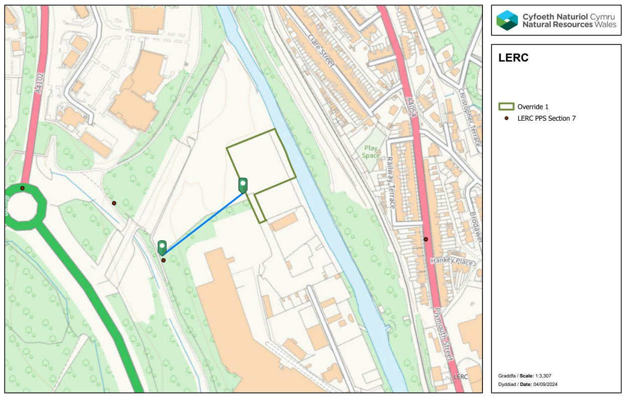

(h) 50 metres of a National Nature Reserve (NNR), Local Nature Reserves (LNR), Local Wildlife Site (LWS), Ancient woodland or Scheduled Ancient Monument
- National Nature Reserve-none
- Local Nature Reserve- none
- Local Wildlife Site (LWS) - Afon Taf Local wildlife site (SINC) to the E within 50m. Return
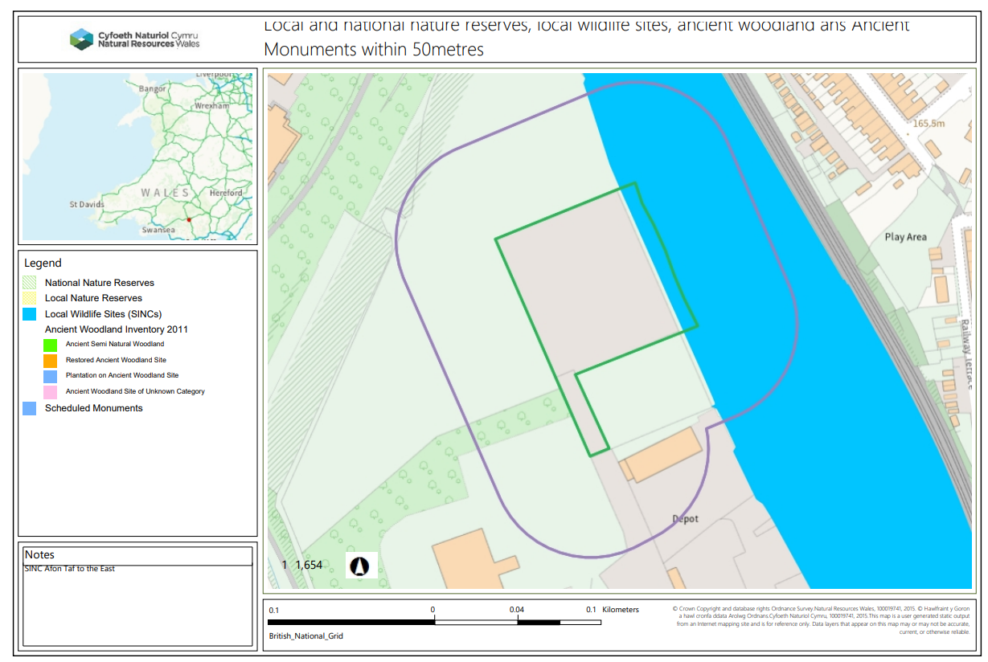
- Ancient Woodlands-none
- Scheduled Ancient Monument- none

END

