Notice of variation with introductory note
Environmental Permitting (England & Wales) Regulations 2016

Vale Bio-Energy Limited

Pancross AD plant
Pancross Farm
Llancarfan
CF52 3AJ

Variation number
EPR/HB3935AE/V003

Permit number

EPR/HB3935AE

Pancross AD plant

Permit number EPR/HB3935AE

Introductory note

This introductory note does not form a part of the notice

The following notice gives notice of the variation of an environmental permit.

As part of the review of the best available techniques (BAT) conclusions and BAT Associated Emissions Limits (AEL), required by the Industrial Emissions Directive 2010/75/EU), the standard rules permit SR2018 No10 has been superseded by SR2023 No01 that incorporates the changes required. SR2018 No10 has been revoked and is no longer be available.

The schedules specify the changes made to the original permit.

The status log of a permit sets out the permitting history, including any changes to the permit reference number.

Status log of the permit
Description | Date | Comments
Permit determined  EPR/HB3935AE | 15/06/2012 | SR2010No16 issued to the Operator
Application EPR/HB3935AE/V002 | Duly made  20/01/2015 | Application to vary from existing waste facility SR2010No16 to an installation SR2012No9 in order to operate above Industrial Emissions Directive threshold limits
Variation determined EPR/HB3935AE/V002 | 03/07/2015 | Varied and consolidated permit issued in modern condition format
Application EPR/HB3935AE/V003 |  | NRW led variation varying to SRP2023No01
Variation determined EPR/HB3935AE/V003 | 17/07/2023 | Varied permit issued

End of introductory note

Notice of variation
Environmental Permitting (England and Wales) Regulations 2016

The Natural Resources Body for Wales (“Natural Resources Wales”) in exercise of its powers under regulation 20 of the Environmental Permitting (England and Wales) Regulations 2016 varies

Permit number

EPR/HB3935AE

issued to:

Vale Bio-Energy Limited (“the operator”)

whose registered office is

4 Ynys Bridge Court

Gwaelod-y-Garth

Cardiff

CF15 9SS

company registration number 07256167

to operate an installation at

Pancross AD Plant

Pancross Farm

Llancarfan

CF52 3AJ

to the extent set out in the schedules.

Under regulation 27(2) of the Regulations, standard rules SR2023No01 are conditions of this permit.

The notice shall take effect from 17/07/2023

Signed | Date
Holly Noble | 20/08/2024

Authorised on behalf of Natural Resources Wales

Schedule 1 – conditions to be deleted

The permit has been varied from SR2018No10 to SR2023No01.

Schedule 2 – conditions to be amended

None

Schedule 3 – conditions to be added

None

Schedule 4 – amended plan

Amended plan attached

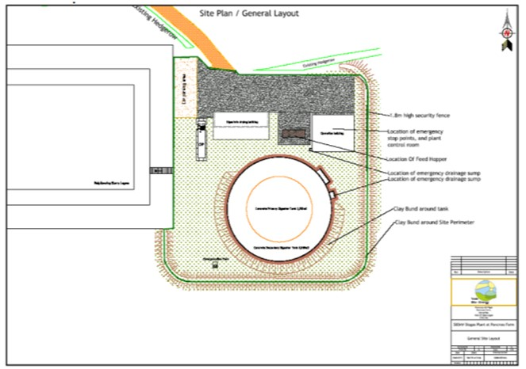

(© Crown Copyright and database right 2015. Ordnance Survey licence number
100019741.)

