PAN-025198 MyMap Report

None within 2km: sites of special scientific interest (SSSIs)
None within 1km: national parks, areas of outstanding natural beauty (AONBs), special areas of conservation (SACs), special protection areas (SPAs), Ramsar sites (wetlands), marine conservation zones, ancient woodlands, local sites, local wildlife sites

historic items (ancient monuments, historic sites etc.)
- SAM
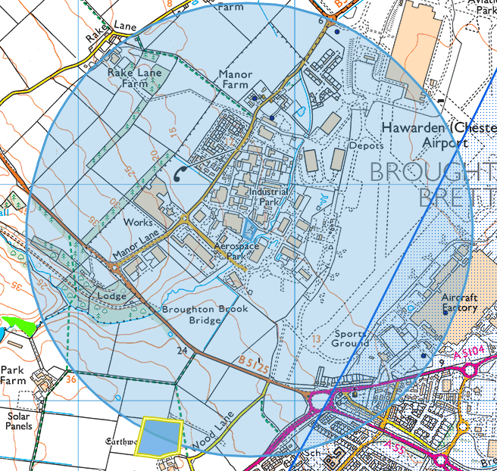
Green Lane Farm Moated Site
- Historic monuments
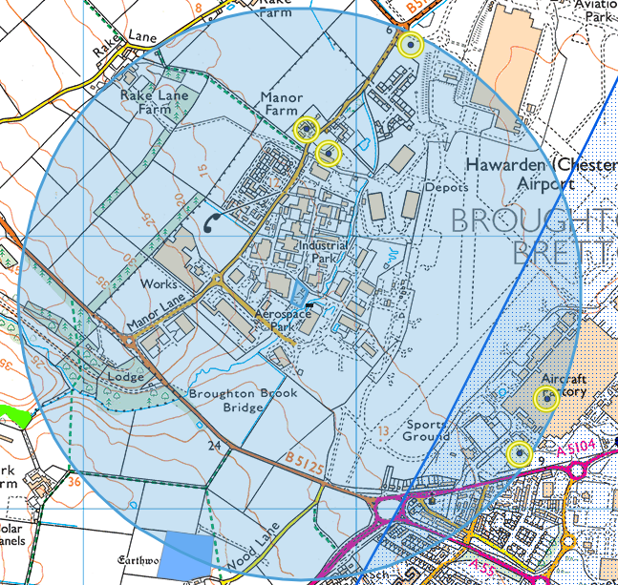
North to South: PILLBOX HAWARDEN, MANOR FARM Farmhouse, MANOR HOUSE HAWARDEN, HAWARDEN AIRCRAFT FACTORY HAWARDEN, PILLBOX HAWARDEN
- Listed buildings
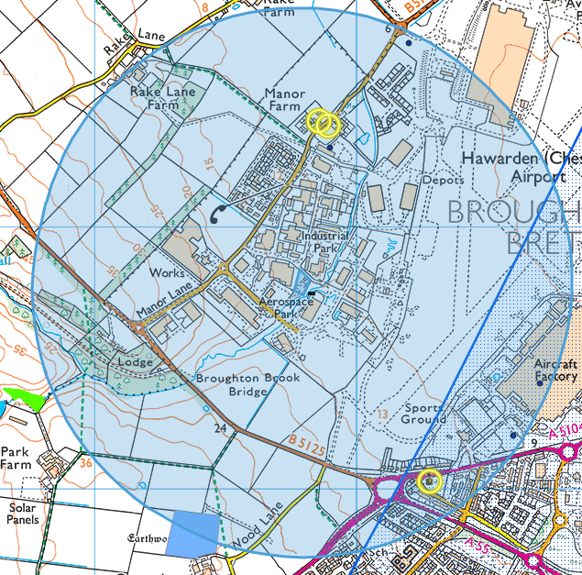
North to south: Manor farm x2, Church of St Mary

source protection zones/aquifers
- SPZ3 within 1km of the site:
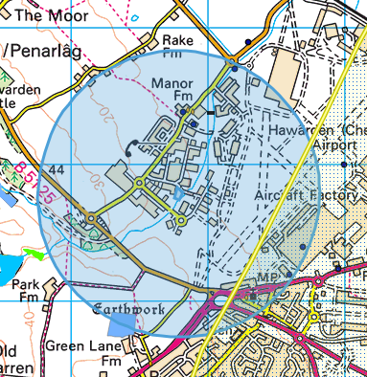

- Aquifer designation (superficial)
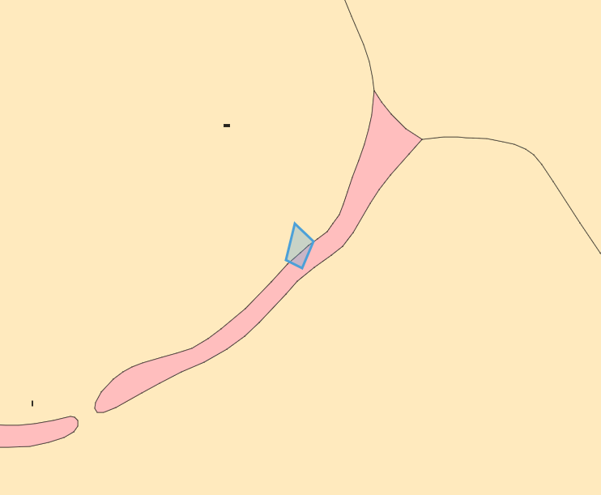
Secondary A (pink), Secondary (undifferentiated) (yellow)
- Aquifer Designation (bedrock)
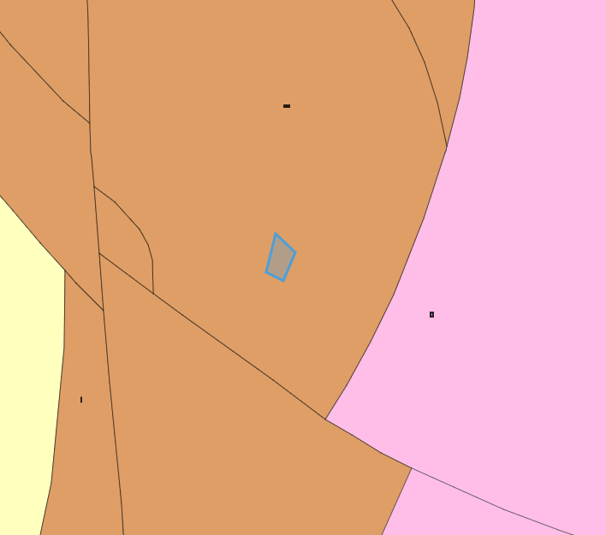
Secondary A
surface water courses (sinks/issues/springs/wells etc.)
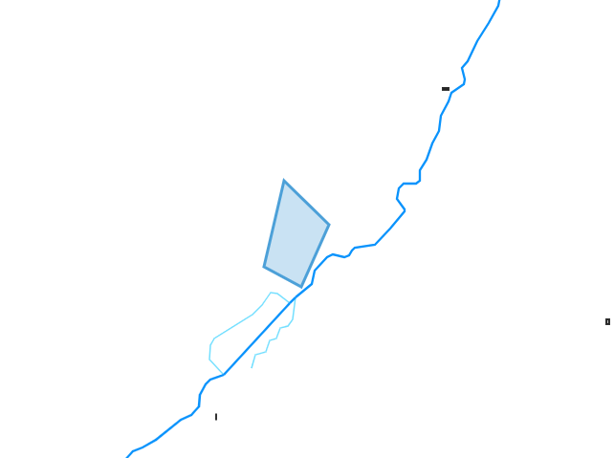
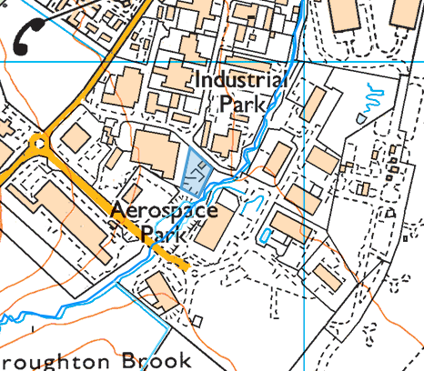
Broughton Brook flows north to River Dee (canal section)
Broughton Brook is approx. 5 meters from the site boundary

local residents
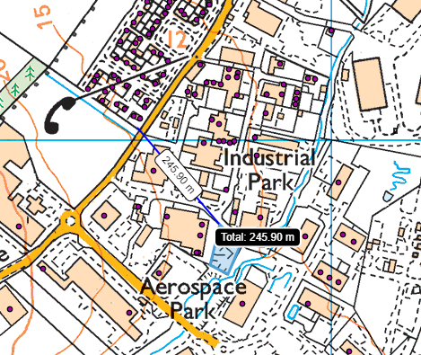
Nearest residents are approx 250 meters away at Cwrt Cwellyn, CH5 3PW

flooding
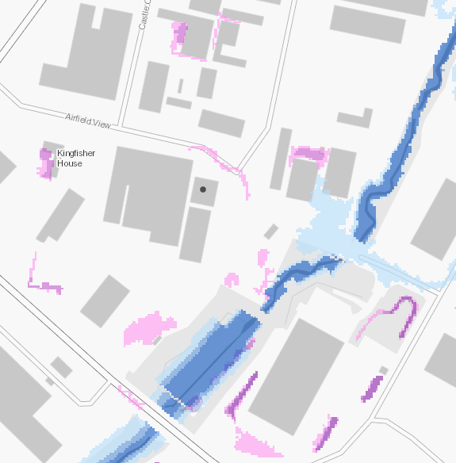
High flood risk from rivers on the watercourse to the east and south of the site, but does not cover the permit boundary
Low flood risk from surface water and small watercourses on the site
protected habitats/species and section 6/7 species
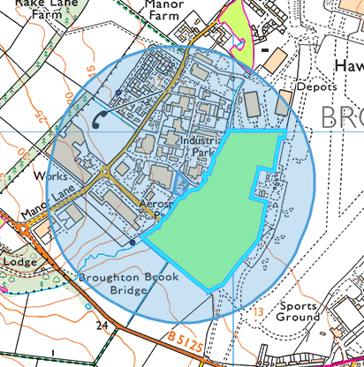
Lowland dry acid grassland and Lowland calcareous grassland to the north and east of the site

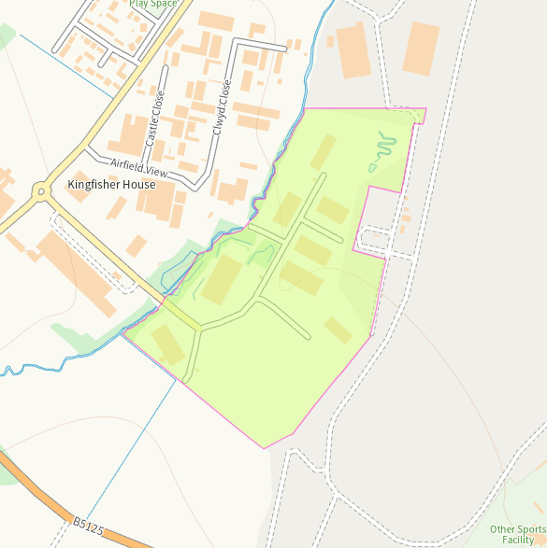
Grassland to the east of the site is within 6 meters, however has been built over so may no longer be present.
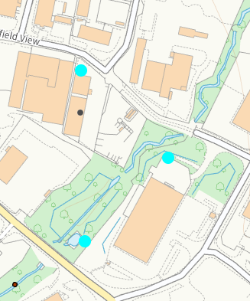
European Water Vole in water course

