PAN-026153 My Map Report:

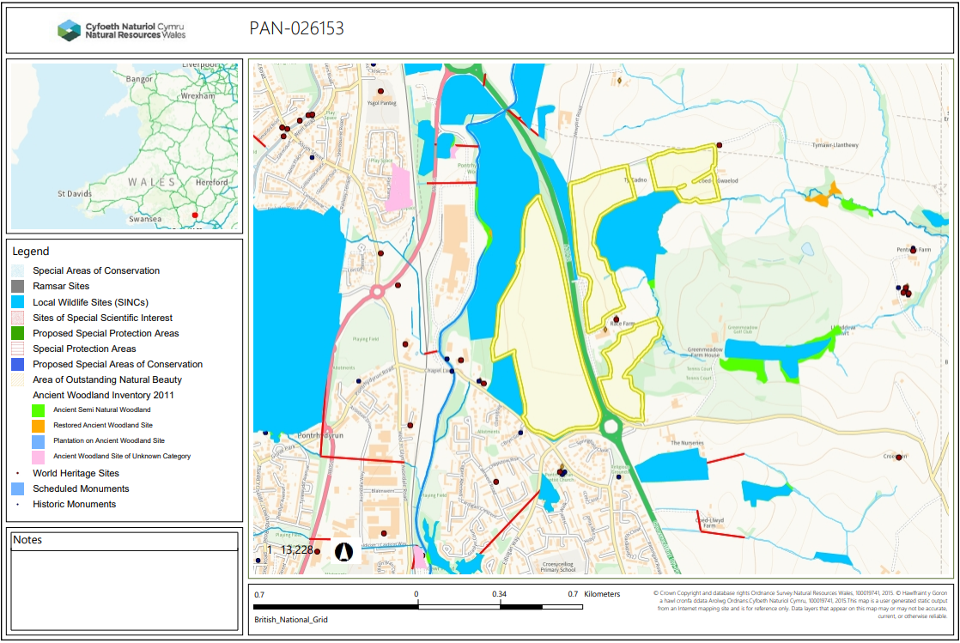

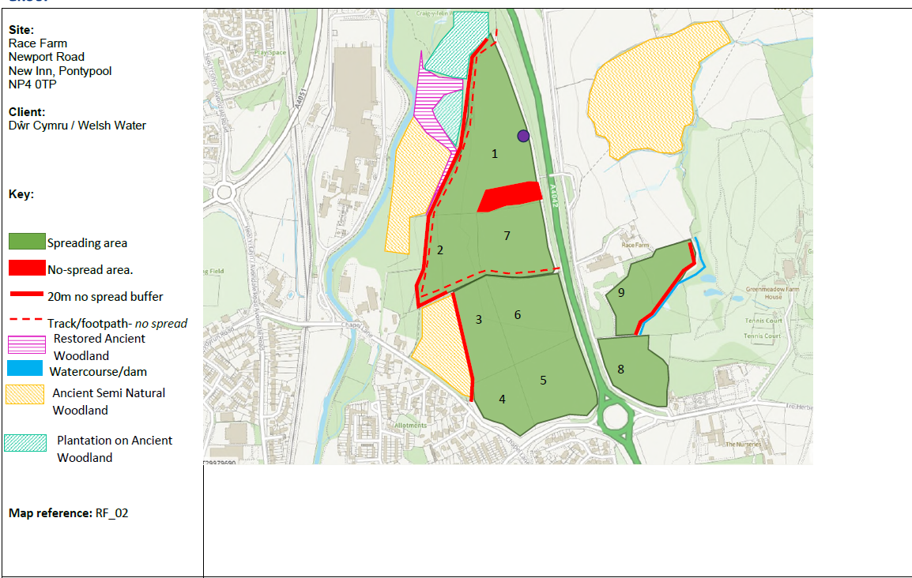
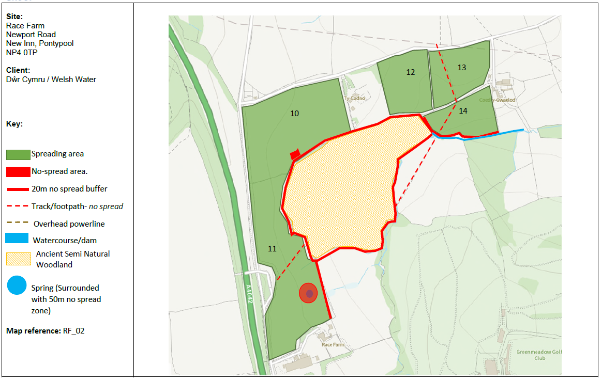

Detailed river network:
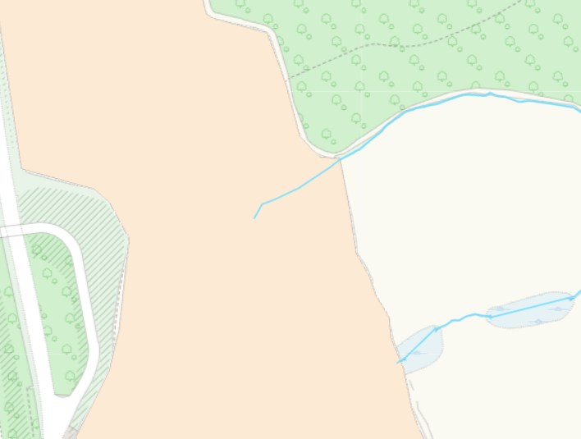
A modified attribution runs through he spread area of field 11, this has not been identified or buffered. See RFI 1.
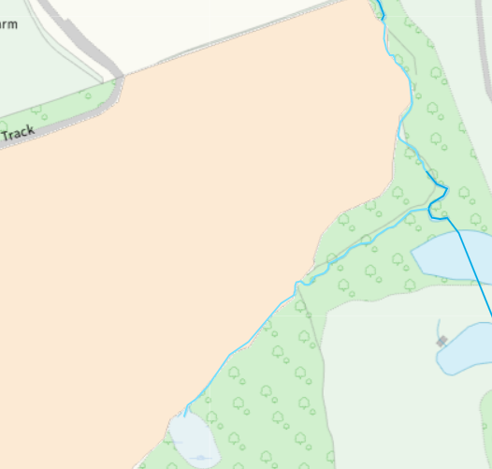
A modified attribution runs along the edge of field 9. This has had an appropriate buffered implemted on its border.
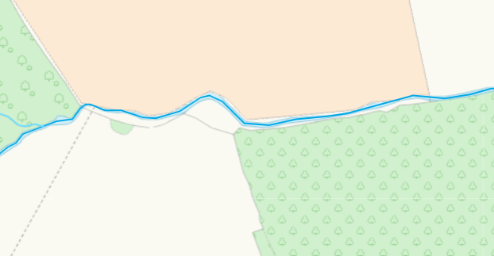
A modified attribution runs along the edge of field 14. This has had an appropriate buffered implemted on its border.
Groundwater protection zones (source)
None in range
Wells, springs or boreholes used for the supply of water for human consumption including from a private water supply or supplies
None in range
any springs wells or boreholes not used to supply water for domestic or food production purposes within 50m

None in range
European designated sites- Natura 2000 (SPA, pSPA, SAC or cSAC) or Ramsar- or SSSI within 500m
None in range
Other protected sites:
- Protected Species-
- Protected Habitats-
- Scheduled Ancient Monument-
None in range
- Local Nature Reserve-
None in range
- National Nature Reserve-
None in range
- Ancient Woodlands-
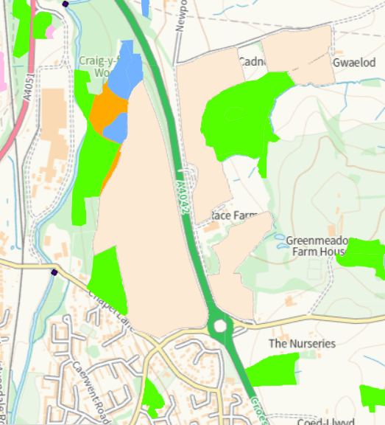
There are several areas of ancient woodland bordering fields 1, 2, 3, 4, 10, 11 and 14. This has all been appropriately identified on submitted maps and buffer zones implemented on all adjacent edges.

- Local Wildlife Sites (SINC)-
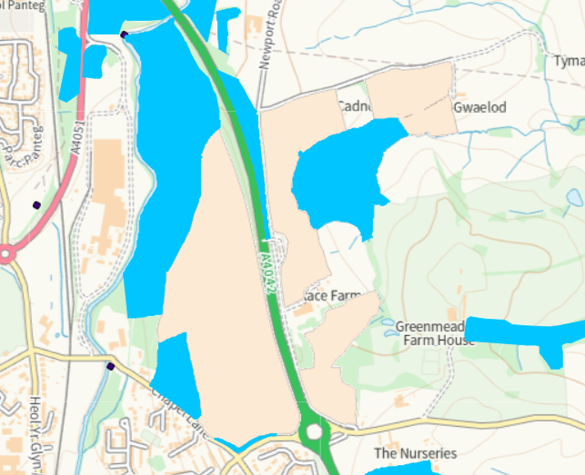
Field 1 and 2 Craig Y felin woods
Field 4 and 5 Craig y felin
Field 10 and 11 a4042 bank meadow
10, 11, 12, 14 coed y gwaelod

There is multiple SINC bordering a large proportion of the spreading area. Due to the sensitive nature of these sites they are only identified via RFI to the applicant.

- National Park-
None in range
- Groundwater Safeguard Zone-
None in range
- ANOBs
None in range
- Heritage coast
None in range
- World Heritage Sites
None in range
- Hedges, Ditches- Nothing of concern
- Local residents, Housing, schools, Workplaces, Recreational facilities - Nothing of concern

Slope Map
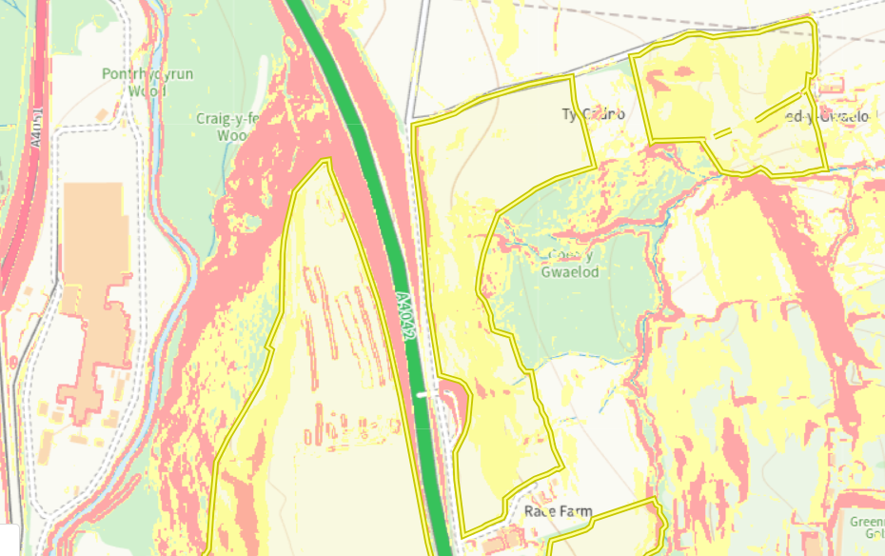
Fields 1,2,, 10, 11, 12, 13 and 14 all have areas od 7-12 degree slope (yellow) with fields 1,2,10,11 and 12 also having areas of 12 degrees plus slope (red). In the areas slope is adjacent to field boundaries no spread buffer zones have been implemented to reduce run off risk.
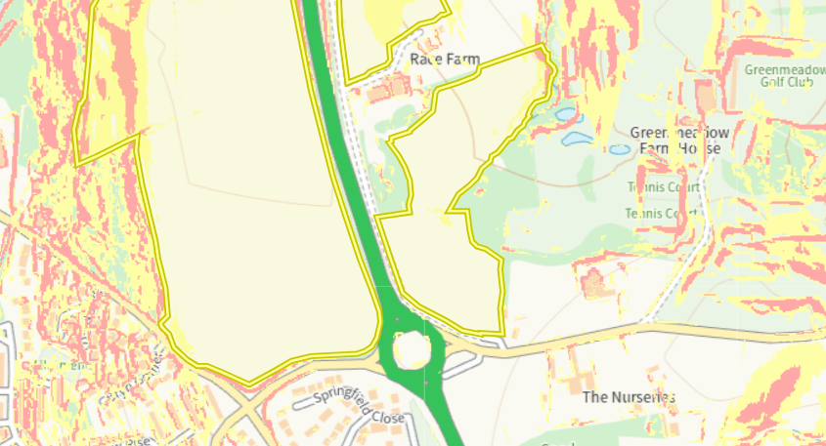
Field 9 hand 3 have smalls sections of 7-12 degree slope (yellow) and 12 degree plus (red). No spread buffers are implemented on the edges where all of these slopes are present to reduce run off.

Flood risk
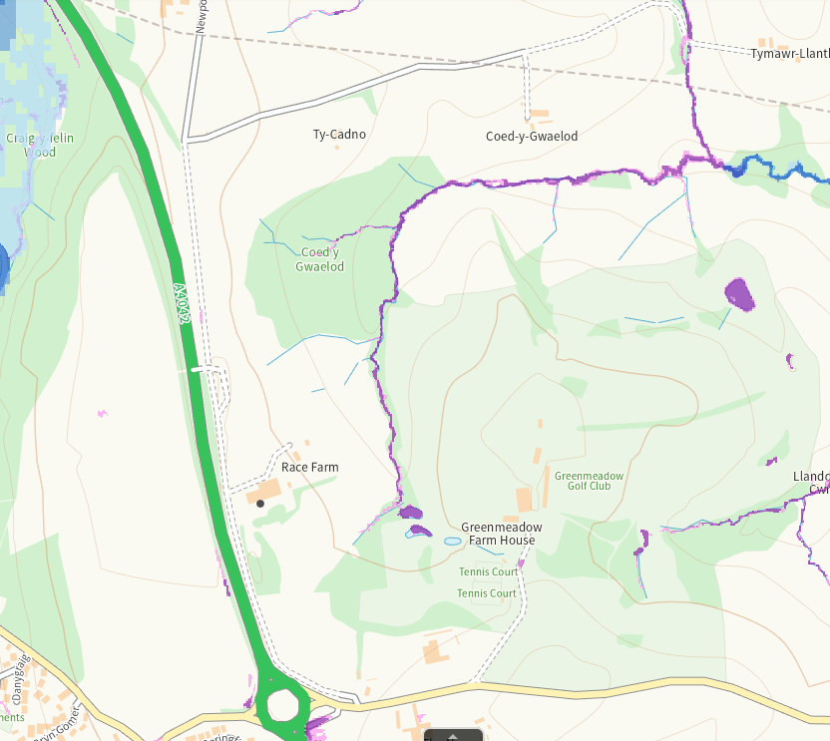
Little to no flood risk associated with any of the fields. No action required.

