PAN-026354 My Map Report:
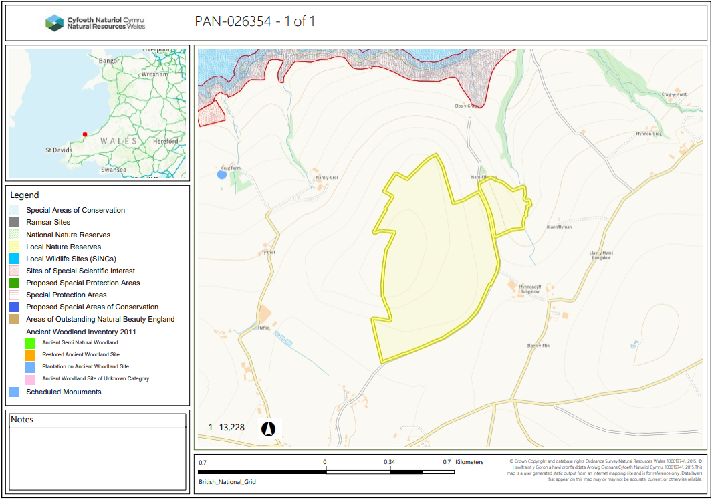

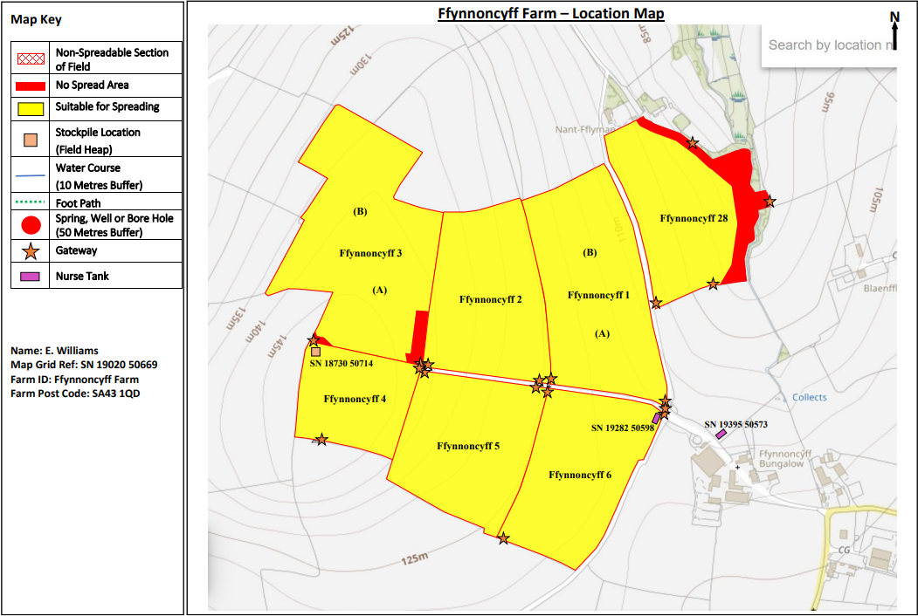
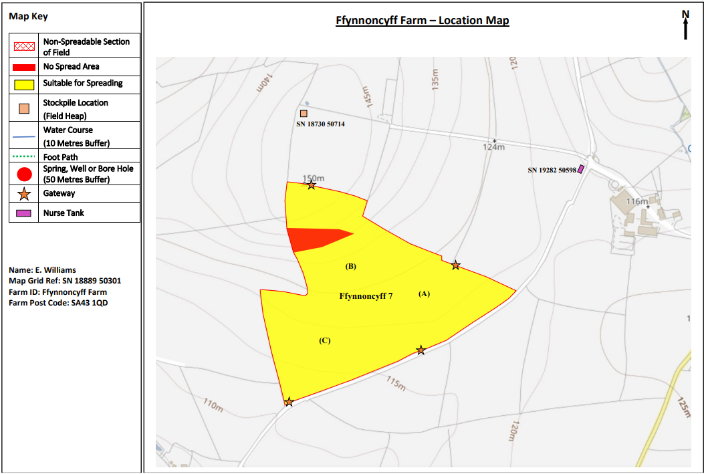
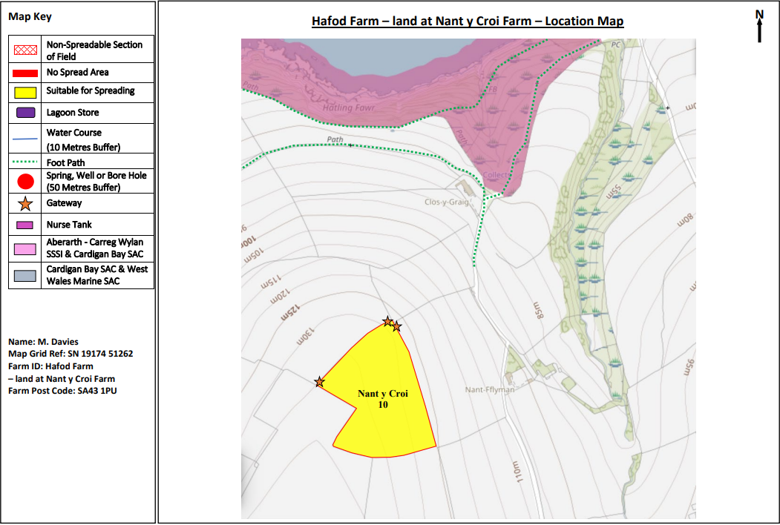

Detailed river network:
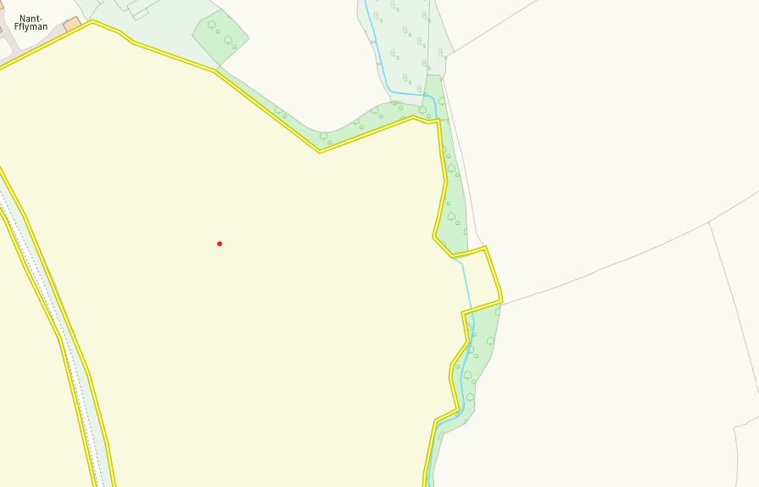
A modified attribution runs on the edge of Ffynnoncyff 28. This has been clearly identified and a no spread buffer zone implemented. No action required.
Groundwater protection zones (source)
None in range
Wells, springs or boreholes used for the supply of water for human consumption including from a private water supply or supplies
None in range
any springs wells or boreholes not used to supply water for domestic or food production purposes within 50m

None in range

European designated sites- Natura 2000 (SPA, pSPA, SAC or cSAC) or Ramsar- or SSSI within 500m

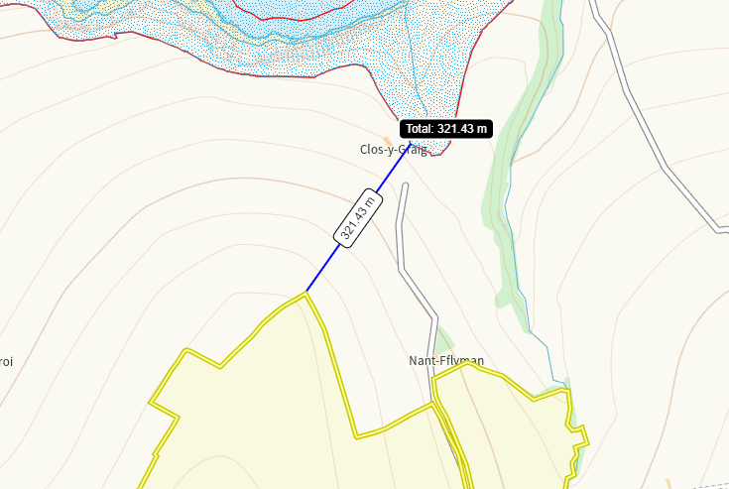
Cardigan Bay SAC and Aberarth Carreg Wylan SSSI are both 321m from the nearest area of spreading in field Ffynnoncyff 7. This has been identified in submitted maps. Due to the distance, no impact pathway is perceived.
Other protected sites:
- Protected Species-
None in range
- Protected Habitats-
Nothing of concern
- Scheduled Ancient Monument-
None in range
- Local Nature Reserve-
None in range
- National Nature Reserve-
None in range
Ancient Woodlands-
None in range
- Local Wildlife Sites (SINC)-
None in range
- National Park-
None in range
- Groundwater Safeguard Zone-
None in range
- Heritage coast
None in range
- Hedges, Ditches, Local residents, Housing, schools, Workplaces, Recreational facilities
Nothing of concern

Slope Map
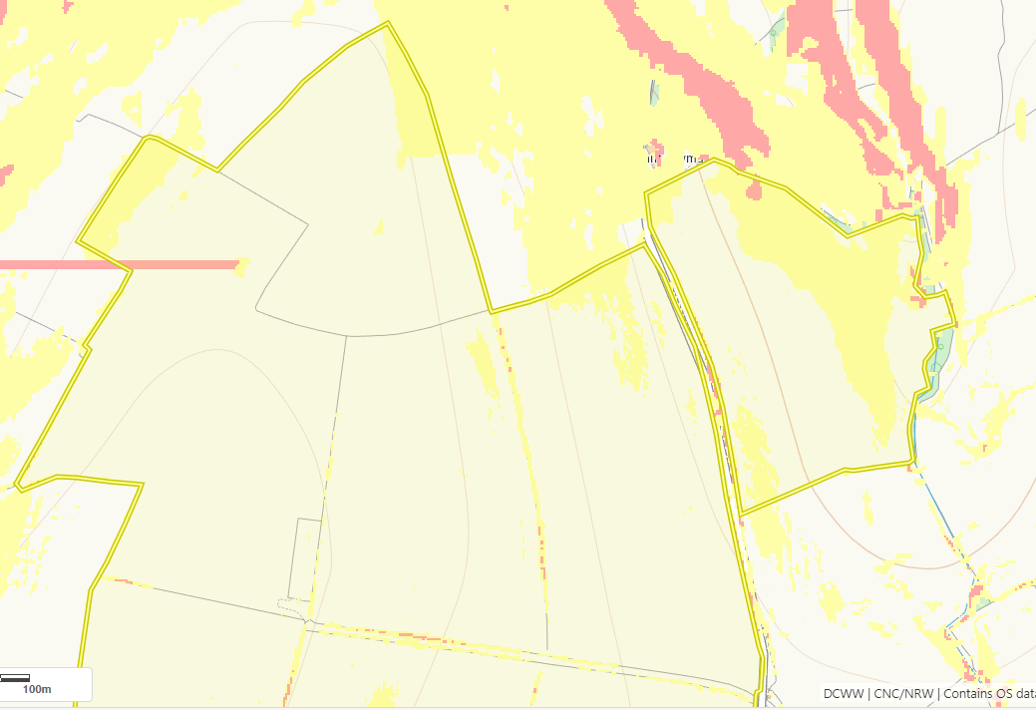
There are several areas of 7-12 degree slope (yellow) throughout fields Ffynnoncyff 1, 2, 3, 28 and Nant Y Croi 10 as well as smaller areas of 12 degree plus (red) throughout fields Ffynnoncyff 1, 2, 3, 28. The areas of sloping are majority contained within the spreading areas and there are no sensitive receptors on the proximity of these fields. No action required.
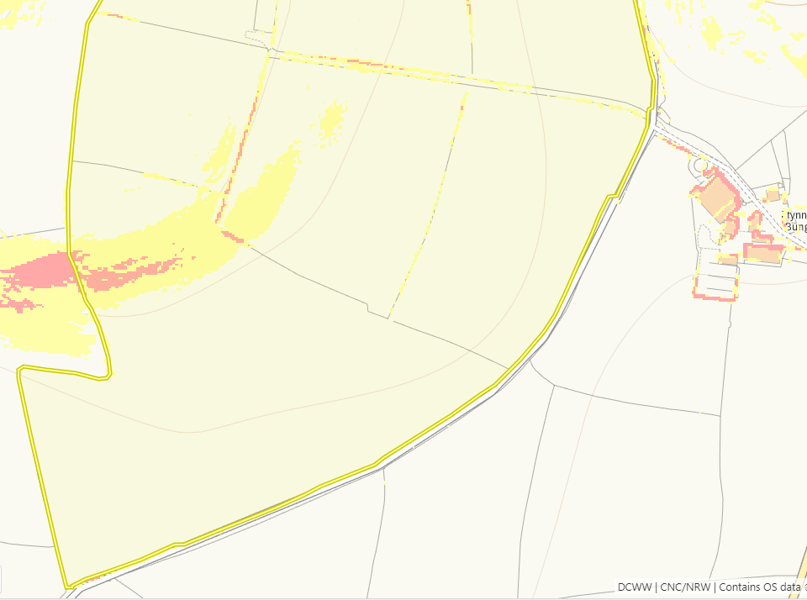
There are several areas of 7-12 degree slope (yellow) as well as areas of 12 degree plus (red) throughout fields Ffynnoncyff 4,5,6 and 7. The areas of sloping are majority contained within the spreading areas and there are no sensitive receptors on the proximity of these fields. The largest area of sloping has a no spread buffer zone imposed. No action required.

