PAN-025950 My Map Report

2.4.1 The activities shall not extend beyond the site, being the land shown edged in green on the site plan attached to the permit.
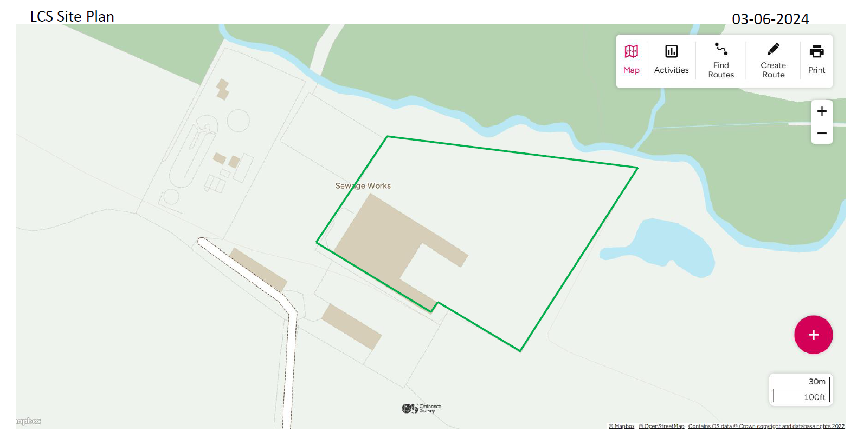
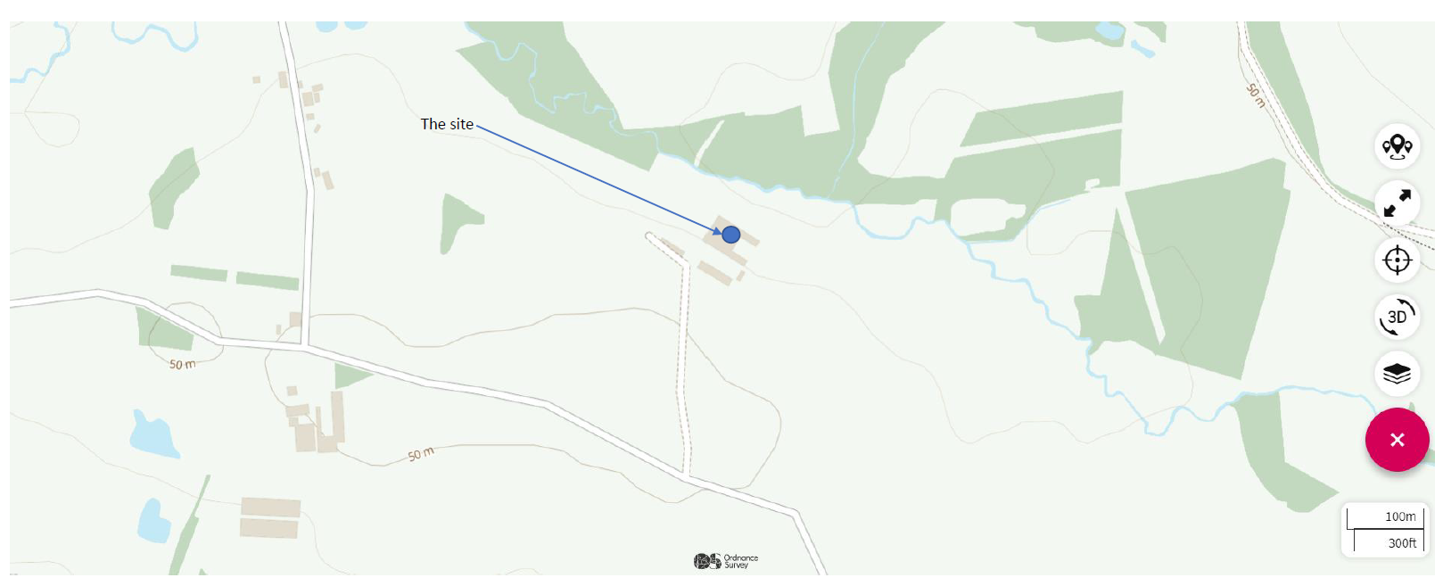
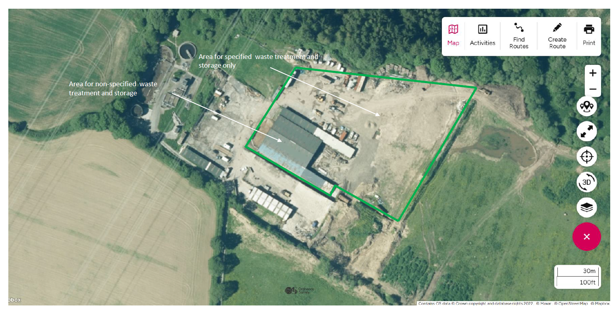

2.4.2 The activities shall not be carried out within 500 metres of a European Site or a SSSI.
None in range
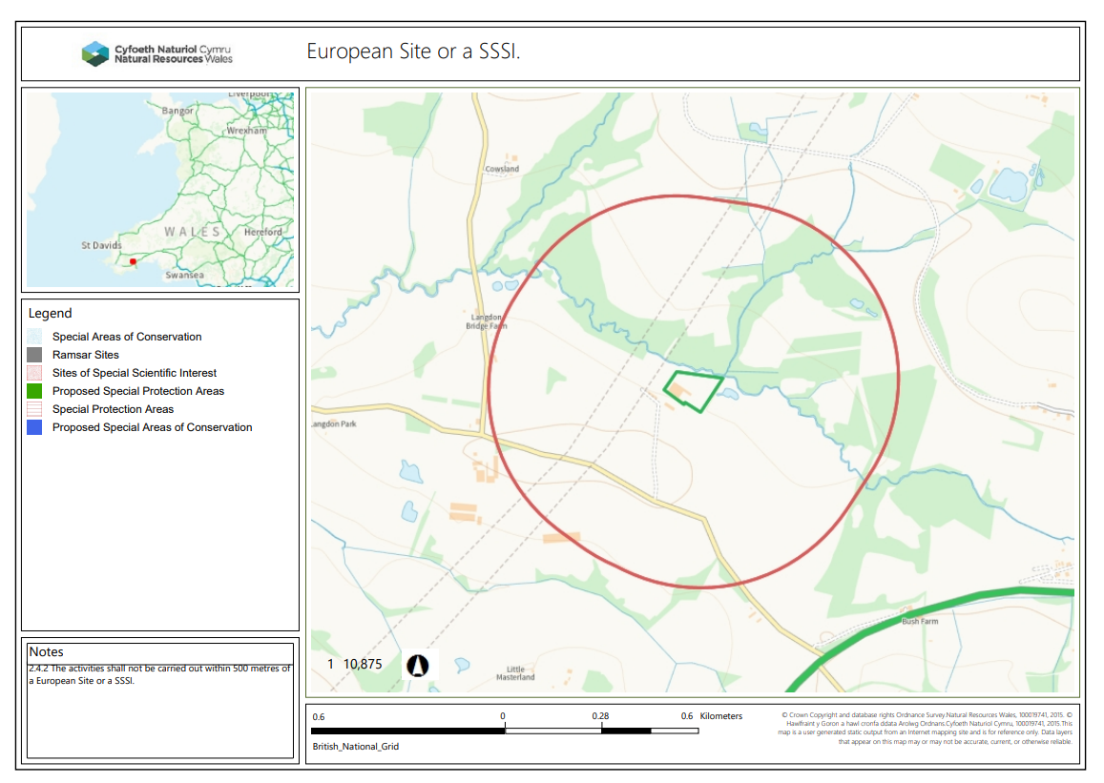
2.4.3 The activities shall not be carried out within 50m of any well spring or borehole used for the supply of water for human consumption. This must include private water supplies.
None in range
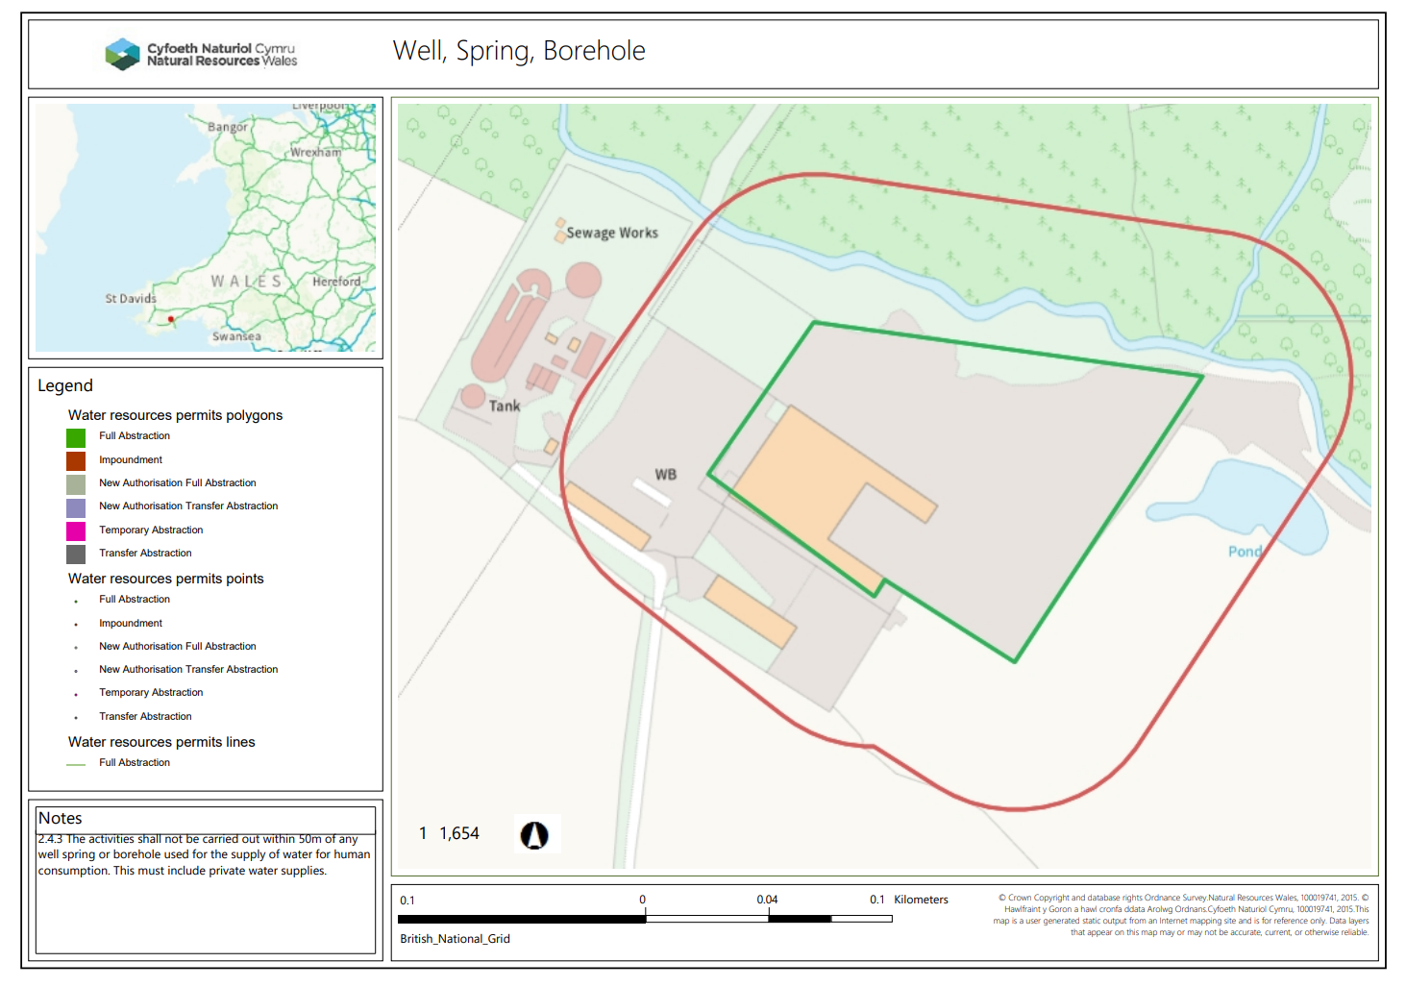

2.4.4 No treatment of specified waste, unless undertaken in a building, shall take place within a specified AQMA.
None in range
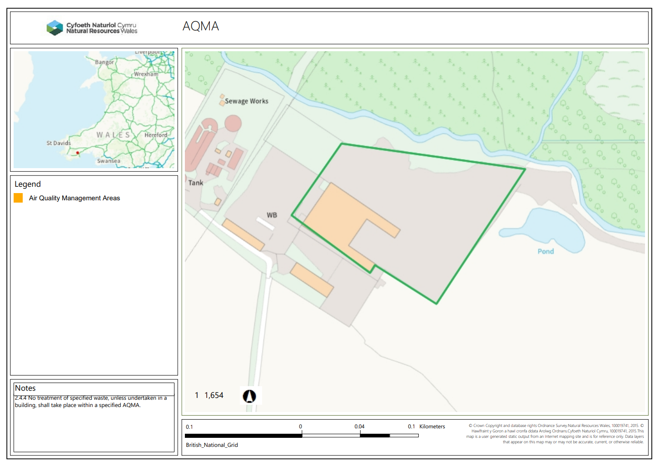

END

