PAN-026593 My Map Report:
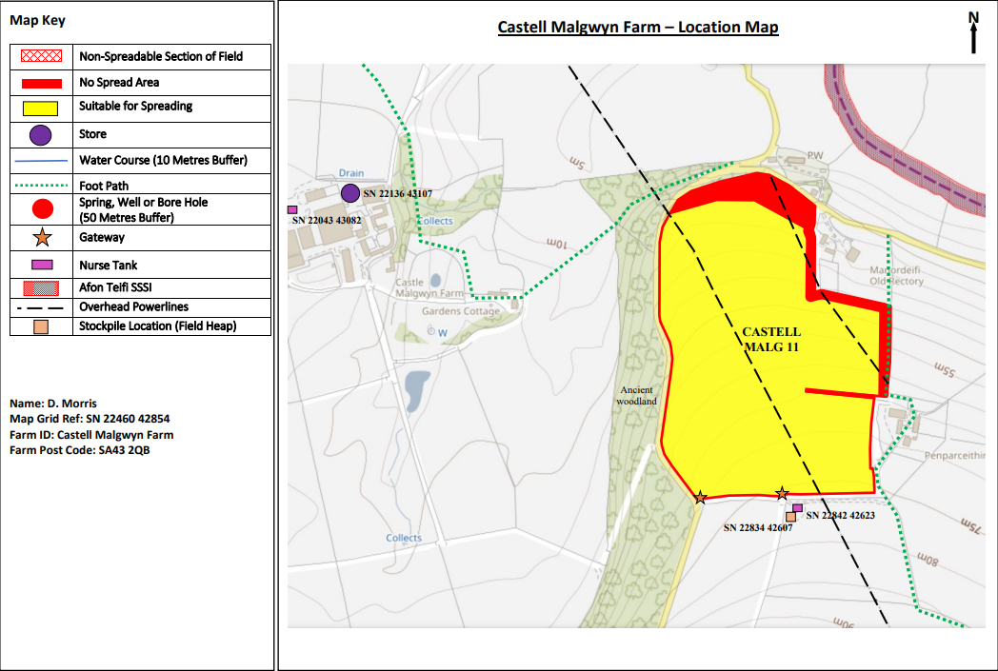
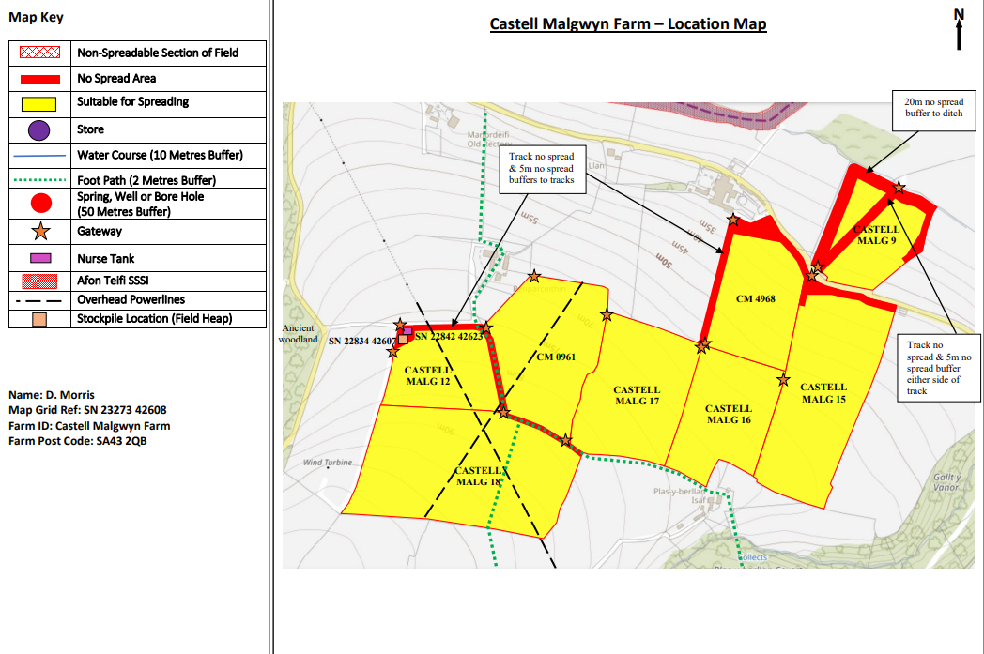
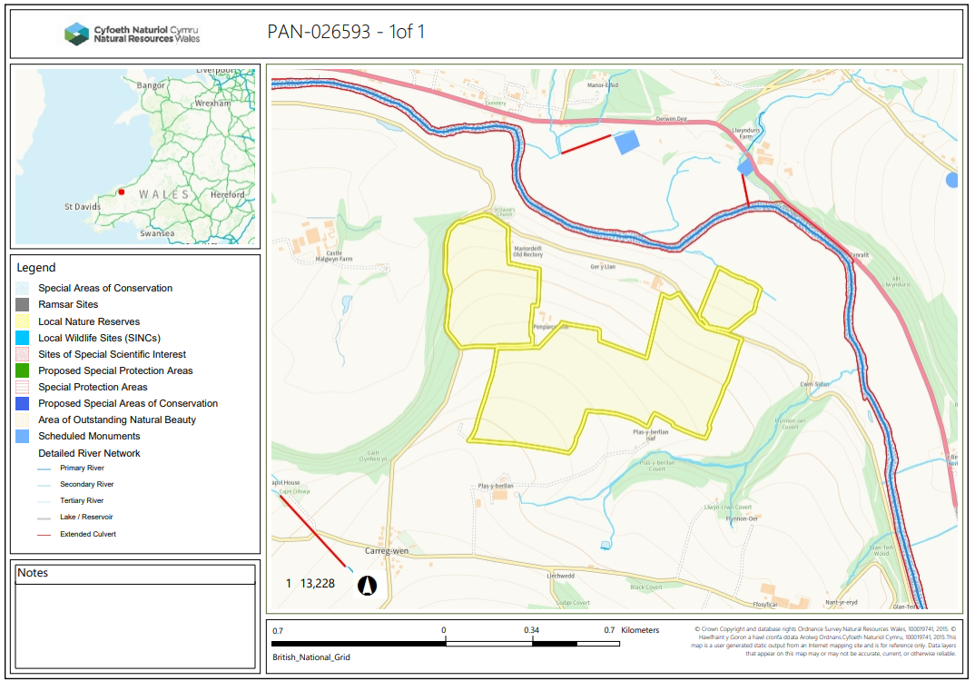
Detailed river network:

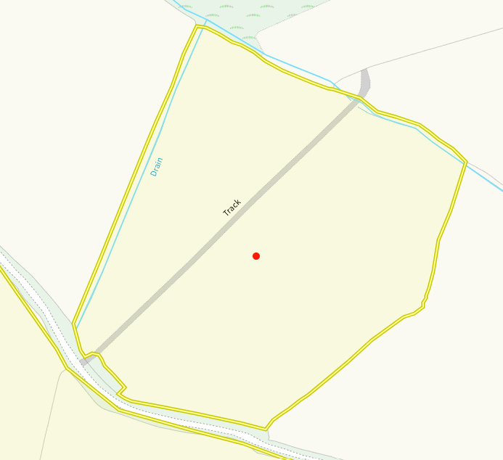
There is a modified attribution which runs north of field and a drain running along the side also. Both of these have been adequately buffered with no spread zones as per the rule set conditions. No action required.
Groundwater protection zones (source)
None in range
Wells, springs or boreholes used for the supply of water for human consumption including from a private water supply or supplies
None in range
any springs wells or boreholes not used to supply water for domestic or food production purposes within 50m

None in range
European designated sites- Natura 2000 (SPA, pSPA, SAC or cSAC) or Ramsar- or SSSI within 500m

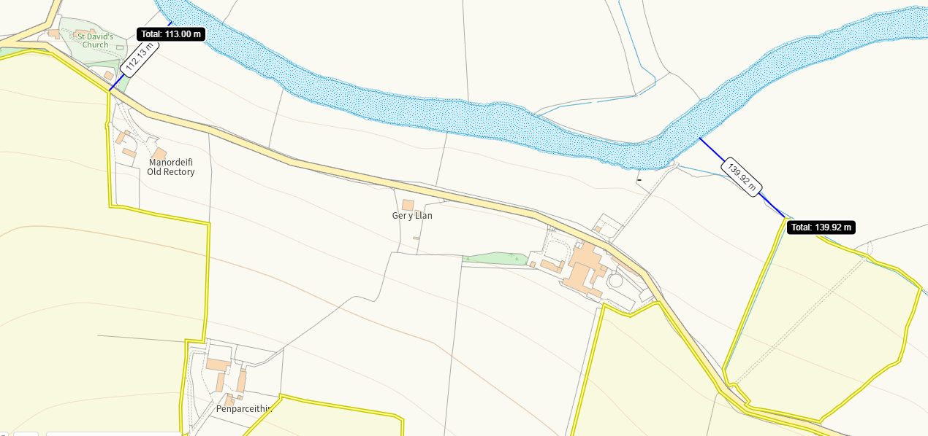
The Afon Teifi SAC and SSSI is 113m form the nearest points. The SSSI has been identified in maps but not as a SAC which will be rectified in RFI 1. There are additional buffers on those borders closest to the SSSI/SAC site which also means there is increased distance form the spreading area and protected sites.

Other protected sites:
- Protected Species-
None in range
- Protected Habitats-
None in range
- Local Nature Reserve-
None in range
- National Nature Reserve-
None in range

- Ancient Woodlands-
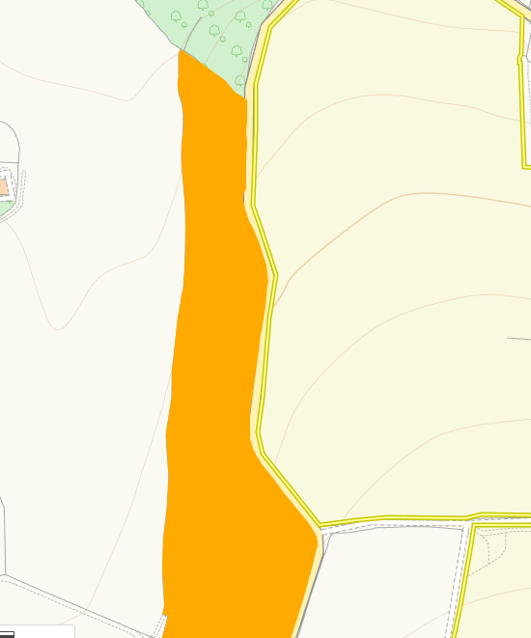
There is a section of restored ancient woodland next to the border of field 11. This has been noted on the submitted maps but there is no mention of the size of the no spread buffer imposed. Due to the sloping also on this field this has been clarified in RFI 1.

- Local Wildlife Sites (SINC)-
None in range
- National Park-
None in range
- Groundwater Safeguard Zone-
None in range
- ANOBs
None in range
- Heritage coast
None in range
- Hedges-
None in range
- Ditches, Local residents, Housing, schools
Nothing of concern
- Workplaces, Recreational facilities
Nothing of concern

Slope Map
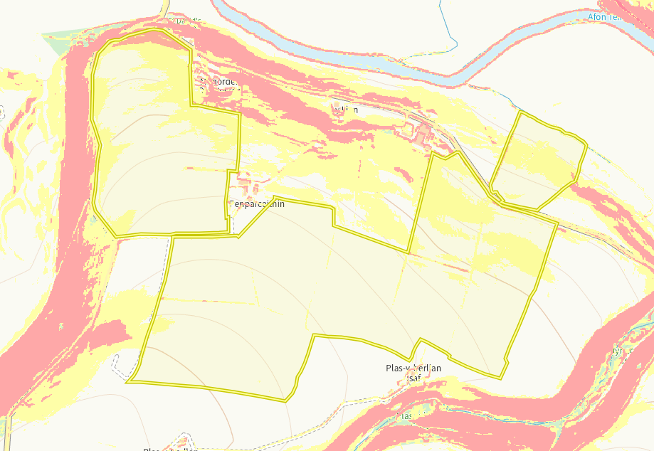
There are section of sloping over all fields within the deployment. There is section of 12+ degree slope (red) in field 11 as well as 9, 16 and 18. There is wide spread 7-12 degree slope over fields 4968, 15, 11, 12, 9 and 17. There is limited receptors in range for the sloping to cause and potential impact. Due to the precise dribble bar application and no application at one time over 50t/ha, no action required.

