- Application type and fee
For the application types listed, complete this form and/or the relevant additional forms named below. Please tick which forms have been included with your application. Forms should be completed with reference to Guidance Note WRX.
* Pre-application enquiry (non-hydropower) ☐ Only complete this form
* Pre-application enquiry (hydropower) ☐ Also complete form WRB
* Application for a Groundwater Investigation Consent ☐ Only complete form WRC
New full abstraction licence X☐Also complete form WRD
New temporary abstraction licence ☐ Also complete form WRD
New licence to transfer water ☐ Also complete form WRD
New impoundment licence X☐ Also complete form WRE
Renewal of a time-limited licence ☐ Also complete form WRD
Removal of an existing impoundment ☐ Also complete form WRE
Technical variation of an abstraction licence ☐ Also complete form WRD
Technical variation of an impoundment licence ☐ Also complete form WRE
* Administrative variations to existing licences ☐ Only complete form WRF
* No fee required

Please indicate how you wish to pay your application fee and provide a reference number where relevant.
Cheque X☐ BACS ☐ Credit or debit card ☐ Your reference number
Ystalyfera Hydro

- Applicant details

This is who the licence would be issued to and must be a legal entity such as an individual, registered company, charity or public body. If you are an agent acting on behalf of an applicant, provide their details here and yours in Section 3. See Guidance Note WRX for clarification of the details required and signatories permissible for organisations.

Applicant type:

Individual X☐ Limited company ☐ Charity ☐ Corporate body ☐ Partnership ☐ Sole trader ☐ Club ☐ Other ☐

If other, please specify

Brendan Coles
Mr
Title Full Name

Company, Charity or

Trading Name

Company or Charity
Registration Number
4 Wernwood Road, Ystalyfera, Swansea

Postcode:SA9 2NE
Registered Address

Mobile: 07856 304592

Telephone Number
brendan@ionacustoms.co.uk
Email Address

We will contact you by email unless you tick here ☐

Please specify who we should contact with regard to your site operation.
Site operations contact Applicant X☐ Agent ☐

For applications for abstraction licences, please also specify who we should contact for invoices and abstraction records (returns).
Invoice address* Applicant X☐ Agent ☐
Abstraction records contact* Applicant X☐ Agent ☐
* Not required for temporary or transfer licences.

Enter the agent’s details in Section 3, or provide details of alternative or additional contacts on a separate sheet and tick here to show that you have done so. ☐

Details of agent or individual authorised to act as application contact

This is who we will correspond with unless otherwise informed. If an agent has signed on behalf of an applicant, please include a letter of authorisation from the applicant allowing the agent to act as signatory.
Grenville Ham
Mr
Title Full Name
The Green Valleys CIC
Company, Charity or
Trading Name

Position in Company
Director
CRiC, Beaufort Street, Crickhowell, Powys
Postcode: NP8 1BN
Registered Address

Mobile: 07921 385344

Telephone Number

Email Address
gren@thegreenvalleys.org

- Entitlement to apply (only required for abstraction licence applications)
Does the applicant have a legal right of access to the point of abstraction?
Has a right of access X☐ Has an expected right of access ☐
Owner/occupier of land ☐ Date these access rights are expected
For formal abstraction licence applications where you are the landowner/occupier, provide a map with the land boundary and all abstraction and discharge point(s) marked. Please tick here to show that you have done this. X☐

For expected rights of access, please also provide the additional evidence as outlined in Guidance Note WRX. Please tick here to show that you have done this. ☐
- Application reference number
Have you undertaken a pre-application enquiry or had any previous discussions with us?
No X☐ Yes ☐ Provide reference

number or staff
member’s name

- Remediation work
Is this proposal as a result of a Restoring Sustainable Abstraction programme or other work requested by us?
No X☐ Yes ☐ If yes, provide your

licence number
- Source of supply
7.1 State where you intend to abstract from
Surface Water X☐ Groundwater ☐

Give Groundwater Investigation Consent number
if applicable

7.2 Provide a 12 digit National Grid Reference for the proposed or existing abstraction or impoundment point (e.g. ST 19057 76826)
SN
76243
08656

Unnamed Tributary of Afon Tawe

7.3 Source of supply or location of
proposed impoundment

Ystalyfera Hydro

7.4 Site name / reference

- Proposal summary
Please provide an outline of your proposal as described in Guidance Note WRX, including any sketches. If you are submitting a pre-application enquiry, this must include the quantities of water you propose to abstract. If necessary continue on a separate sheet and tick here to show that you have done this. X☐
An ultra small scale hydropower scheme to provide enough energy for a sustainable off-grid dwelling.

The land is all owned by the applicant, Brendan Coles. The depleted reach is short, approximately 80m, and the net head of 20m means that the site comfortably fits into NRW Zone 3 with a gradient of 25%. There is a waterfall within the depleted reach of approx. 5m with no opportunity for upstream or downstream migration of fish species. The intake utilises an existing 1.2m bedrock fall with only a very small impoundment in order to ensure HOF can be maintained. A 70/30% split is proposed. Qmean (10.5ls) is proposed for peak abstraction, providing approximately 1.5kW of power.

Immediately downstream of the proposed development the watercourse disappears into a long culverted section, showing that there is limited connectivity with the wider ecology and limited potential for impact. The proposed depleted reach has been assessed and has shown to have no rare lower plant species or areas of significant interest. The gradient of the depleted reach is approximately 25% and has limited opportunities for natural in stream sedimentation, flora or fauna.

This scheme is incredibly small scale in nature.
- Declaration

Please see Guidance Note WRX for details of who can sign this section and note the information in that document relating to the Data Protection Act 1998.

By signing below, you are declaring that as far as you know and believe the information given in this form, on any map and in any supporting or additional information, is true.

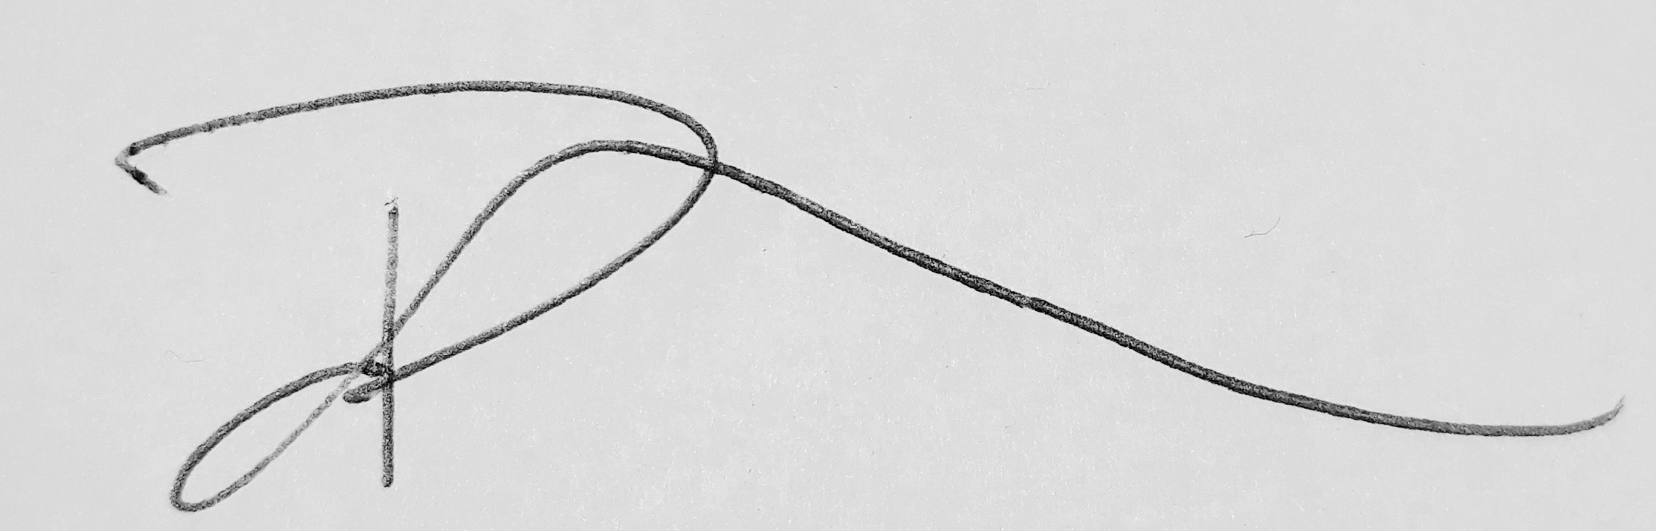

Signed

Brendan Coles

Print name

Landowner

Position

30th October 2018

Date

Application Checklist

Please tick the following checklist items to indicate that you have included the required information. If any sections of the form are left blank and no supporting information submitted, where we have insufficient information to make a decision on your application, we will return your application to you.

Essential:

Letter of authorisation from the applicant, allowing the agent to act as signatory ☐
Map showing the land ownership boundary with all abstraction and discharge point(s) clearly marked X☐

Where relevant:

Evidence of negotiations of expected access rights, if applicable ☐
For groundwater abstractions, results of pump test (if not previously submitted) ☐

For Natural Resources Wales’ use only:

Date received ________________________

Reference Number ________________________

Payment received Yes ☐ Amount received _______________________
No ☐ Not required ☐

