- Application type
New impoundment licence X☐
Removal of an existing impoundment ☐ Complete sections 2 and 4
To licence an existing impoundment ☐
Technical variation to an impoundment licence ☐

Give existing licence or pre- application reference number(s)

2. Impoundment details
All information should correspond with any maps and drawings submitted with this application

2.1 Provide details of all impoundment points. For structures spanning a watercourse, provide a National Grid Reference for each bank. If necessary, continue on a separate sheet and tick here to show that you have done this. ☐

Impoundment  location name / reference | National Grid Reference for each bank,  looking downstream  (12 digit)
Impoundment  location name / reference | Left bank | Right bank
Intake | SN 76243 08657 | SN 76243 08657
2.2 Please provide a full description of the impoundment, outlining its purpose and how it will operate. If this information is detailed in a supporting document, provide the document title
or reference in the space below.
If necessary, continue on a separate sheet and tick here to show that you have done this. ☐
Proposal for a small intake consisting of a reinforced low height concrete weir wall a stainless steel intake box looking to abstract water from a small unnamed tributary of Afon Tawe. The intake will used for the purpose of generating hydroelectric power for an ultra small scale system providing enough annual power for one dwelling. The intake is proposed to have a 3mm drilled hole screen and operate at 70% of flows (above HOF) upto Qmean and in full accordance with a granted abstraction and impoundment licence from NRW.

The abstraction will be controlled by the hydraulic nature/friction of the pipe and spear valve (which is part of the Turgo turbine). The spear valve has a maximum capacity of 15 ls-1 at the driving dynamic head. The spear valve can be restricted via the use of a locking ring. By measuring the flow of water discharging out of the discharge pipe the spear valve will be locked to provide a maximum flow of 10.5 ls-1. Peak, weekly, monthly and annual abstraction volumes will then be monitored via electric generation records.

- Description of impoundment

3.1 Name of watercourse
Unnamed tributary of Afon Tawe

3.2 Will your proposed impoundment result in a change to the wetted perimeter (downstream) or new submerged areas behind (upstream of) the impounding works?
No X☐ Yes ☐ If yes, ensure this is shown on any map or drawings submitted

3.3 Will the ponded area created by the impoundment be lined? No X☐ Yes ☐
If yes, give details.

3.4 Give the height of the impoundment structure, from the downstream toe to crest or top of spillway (in metres above Ordnance Datum). If the proposal involves an existing impoundment, state the change in height (in millimetres).
75mm height of weir. From 160.00m AOD to 160.075m AOD

3.5 What is the overflow or crest level of the impoundment (in metres above Ordnance Datum)?
160.075m AOD

3.6 What is the proposed capacity of the impoundment when full to spillway level (in cubic metres)?
<0.1m3

3.7 Will the proposal create a raised reservoir? No X☐ Yes ☐

3.8 Does the proposal involve the controlled release of water to safeguard downstream flows? No X☐ Yes ☐ If yes, provide details

3.9 Is the impounded water to be used for a subsequent purpose? No ☐ Yes X☐

If yes, provide details (for abstractions, state the daily and annual quantities in cubic metres).

Hydropower generation for one off-grid domestic property.

Daily = 907.2 m3

Annual = 331,128 m3

3.10 How will the impounded area be filled initially, and subsequently refilled if applicable?

n/a

- Fish and eel passage
4.1 Confirm the fish species present at your site.
Our ecology survey indicated that the presence of fish species is unlikely.

4.2 Complete the table below with full details of the measures you intend to take to safeguard these fish species.

 | Intake | Outfall
Type of fish screen | Drilled Hole | Square mesh
Screen aperture size (mm) | 3mm | 10mm
Screen height and width (mm) | 900mm x 330mm | 300mm Diameter
Type of upstream fish passage | n/a – 5m waterfall immediately below
Proposed flow for fish pass (m/s) | n/a
Type of downstream fish passage | n/a – upstream and downstream not possible
- Construction, maintenance and operation

5.1 Provide details of maintenance or activities relating to the operation of the impoundment. If necessary, continue on a separate sheet and tick here to show that you have done this. ☐

The main element of the maintenance will be to regularly inspect the intake for blockages to the intake screen, which would be cleared either by hand or through the use of a brush. This would be expected top take place on a weekly basis. At the same time the Hands off Flow notch would be inspected to ensure that it is clear of any debris that has floated downstream.

5.2 Provide details of diversion works or removal of existing works.
Temporary bypass od intake location using sandbags and 300mm pipe to create dry working conditions. All materials removed from site following the completion of the works.

- Planning application
Have you sought advice on your planning application?
No X☐ Yes ☐
If yes, submit a copy of the Planning Authority’s response.

- Declaration

Please see Guidance Note WRX for details of who can sign this section and note the information in that document relating to the Data Protection Act 1998.

By signing below, you are declaring that as far as you know and believe the information given in this form, on any map and in any supporting or additional information, is true.

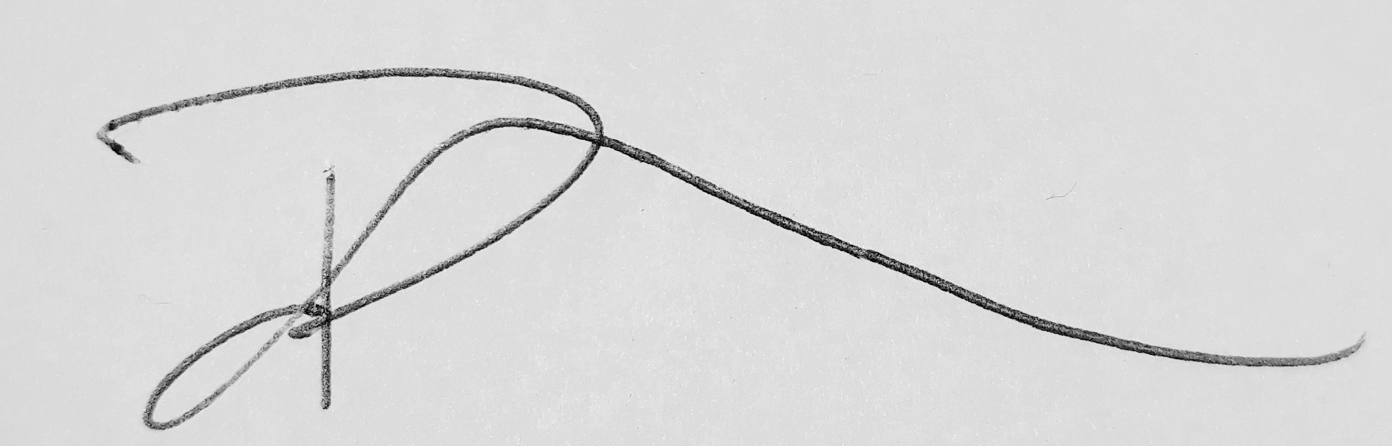

Signed

Brendan Coles

Print name

Landowner

Position

30th October 2018

Date

Application Checklist

Please tick the following checklist items to indicate that you have included the required information. If any sections of the form are left blank and no supporting information submitted, where we have insufficient information to make a decision
on your application, we will return your application to you.

Essential:
Form WRA completed, if there have been any changes since pre-application an updated Form WRA is required X☐
Map with all impoundment points and new wetted perimeters/submerged areas X☐
clearly marked
Drawings and Design Statement X☐
State number of continuation sheets (enter 0 if none included)
0

Where relevant:
Form WRD completed, if your proposal also requires an abstraction licence X☐
Stage 1 photo survey (contact us for more details on this requirement) X☐
Letter of authorisation from the applicant, allowing an agent to act as signatory X☐
Further information requested in our pre-application response letter to you ☐
Planning Authority response, where available ☐
Additional supporting information - please list below:

