Environmental Permitting (England and Wales) Regulations 2016
Regulation 36

ENFORCEMENT NOTICE TO TAKE SPECIFIED STEPS IN RELATION TO A BREACH OF PERMIT CONDITION(S)

To: Mr Paul Andrew Gareth Cox
58 Pwll y Waun
Porthcawl
CF36 5HH

Environmental permit: EPR/EB3893HR

Regulated facility: Cox Skip and Waste Management
Plot 80 Village Farm Road
Village Farm industrial Estate
Pyle
Bridgend
CF33 6BN

Natural Resources Wales considers that the following condition of the environmental permit is being contravened:

2.3.1 The activities shall be operated using the techniques and in the manner described in Table 2.3 below.

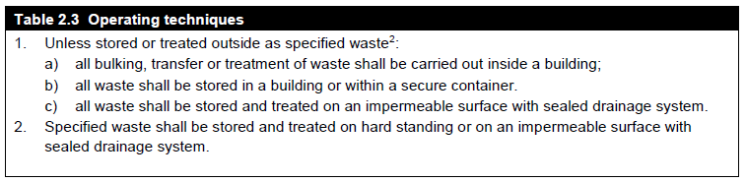

continued overleaf

because bulking, transfer and treatment of waste was being undertaken outside and not in a building. Waste in secure containers was being stored on hard standing and not on impermeable surface with sealed drainage.

You are required to take the steps set out in Schedule 1 by the date specified in order to remedy the contravention.

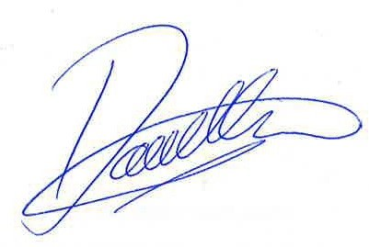

Date: 26 September 2018 Signed ....................................................
David Ellar
Acting Team Leader Waste Regulation – South West

Natural Resources Wales
Maes Newydd
Britannic Way West
Llandarcy
Neath Port Talbot
SA10 6JQ Please see over for notes.

Environmental Permitting (England and Wales) Regulations 2016
Regulation 36

Notes:

General
- Failure to comply with this notice is an offence under Regulation 38(3) of the Environmental Permitting (England and Wales) Regulations 2016 and may result in legal action being taken against you.

- Without prejudice to the requirements of this notice, failure to comply with a condition of an environmental permit is an offence and may result in legal action being taken against you.

- You may wish to seek independent legal advice.

Appeal provisions
You are entitled to appeal against this notice under Regulation 31(1)(f) of the Environmental Permitting (England and Wales) Regulations 2016. Notice of appeal must be made within two months of the date of this notice. An appeal does not affect the requirements of this notice.

You must send written notice of the appeal and the documents listed below to:
The Planning Inspectorate
Crown Building
Cathays Park
CARDIFF
CF10 3NQ

Tel: 029 2082 3866
Email: wales@pins.gsi.gov.uk
Website: http://www.planningportal.gov.uk/planning/appeals

At the same time you must send a copy of the appeal notice and documents to Natural Resources Wales.

The required documents are:
- A statement of the grounds of appeal
- A copy of any relevant application
- A copy of any relevant environmental permit
- A copy of any relevant correspondence between the appellant and the regulator
- A copy of any decision or notice which is the subject matter of the appeal
- A statement indicating whether you wish the appeal to be in the form of a hearing or dealt with by way of written representations.

You may withdraw an appeal by notifying The Planning Inspectorate in writing and sending a copy of that notification to Natural Resources Wales. Further information about making an appeal and the forms that you will need are available from The Planning Inspectorate detailed above.

Legislation note
In this document “Natural Resources Wales” means the Natural Resources Body for Wales established by Article 3 of the Natural Resources Body for Wales (Establishment) Order 2012. On 01 April 2013 the Natural Resources Body for Wales (Functions) Order 2013 transferred the relevant functions of the Countryside Council for Wales, and functions of the Environment Agency and the Forestry Commission in Wales to the Natural Resources Body for Wales.

Environmental Permitting (England and Wales) Regulations 2016
Regulation 36

SCHEDULE 1
STEPS TO BE TAKEN
Condition  number | Steps to be taken | By date
2.1.3  2.1.3 | All bulking, transfer and treatment of waste shall be undertaken within a building.  All storage of waste in secure containers (skips) unless specified waste in accordance with Standard Rules Set 2008 No 1 shall be stored on impermeable surface with sealed drainage system. | 1 August 2019  1 August 2019

