CRoW Appendix 4 (140_10_SD02)  CRoW Act 2000: Natural Resources Wales application for permission - Formal Notice |  | 
Natural Resources Wales Formal Notice.
Requirements of Section 28I of the Wildlife & Countryside Act 1981 as amended by the Countryside and Rights of Way Act (CRoW) 2000.
Duty in relation to granting any consent, licence or permit for activities likely to damage Sites of Special Scientific Interest (SSSI).
Guide to filling in this form for Natural Resources Wales staff:
To be completed by Permitting Officers for any applications for a permission which the Natural Resources Wales has considered under S28G duties to protect and enhance SSSIs. This applies to all proposed permissions within a SSSI, and to operations outside the SSSI boundary which are likely to damage its special features.
Refer to OI 140_10 ‘Applying the Countryside and Rights of Way (CRoW) Act 2000 to applications for permits with potential for impact on Sites of Special Scientific Interest (SSSI)’, including the flowchart in Appendix 2.
Pink italic text – drafting notes, to be deleted before completion/consultation.
Blue text – examples, to be replaced with permission-specific information.
Ensure you have completed all sections.
- Natural Resources Wales area/region/NPS hub: | Installations/MCP/RSR national permitting function, south-east Environment Team
- Name of SSSI: | - 33WDB Gwent Levels – Nash and Goldcliff (E2)  - 33WUH Gwlyptiroedd Casnewydd / Newport Wetlands (E4)  - 33WEP Gwent Levels – St Brides (E6)  - 33WGX Severn Estuary (E7)  - 33WEA River Usk / Afon Wysg (E8)
- Type of permission: | Environmental Permit - MCPD
- Date for Natural Resources Wales permit determination: | ASAP
- Predicted 28 day date for response from NRW conservation/ecology (under S28 I(4)): | N/A
- Natural Resources Wales reference no: | PAN-024107
- National grid reference: | Point source: NGR 332013.1, 184315.9:
- Description of proposal: | Permitting the existing 6 MW_{th} steam-raising boiler, which has been operating since 2017 and is normally fired on Liquid Petroleum Gas (LPG), to provide process heat to an adjacent existing cardboard plant (fuel oil as a backup 1% of the time). Permit required for this “existing” medium combustion plant >5MW from 1st January 2024 owing to change in regulations. i.e. the boiler requires a permit now where it did not before owing to the MCP rules, it continues to operate the same, but with additional controls (e.g. confirmation of performance via emissions testing). The application concerns the MCP only. The existing cardboard production facility is not permitted under EPR and is not undergoing change via this consent.  This assessment considers the possible impacts of the air emissions (NOX and SO2) from the boiler at the point it is brought into regulation, the only credible and regulated impacts of the operation on protected habitats sites. Other factors (e.g. disturbance) are not relevant as it is only air emissions under consideration. NOX and SOX concentrations at Habitats sites will be assessed, alongside “consequential” impacts of nutrient nitrogen deposition and acid deposition as relevant.  Owing to the operation being adjacent to the Usk protected site (and very close to the Severn), detailed air dispersion modelling of the pollutants is required, and as a result consideration in this assessment for possible impact on SSSIs. However, when the detail is examined, it is found to be a relatively low impact operation (relatively small boiler and relatively clean fuel). The assessment reflects this. (As a guide, a 6MW_{th} boiler is approximately the same fuel capacity as around 200 domestic home boilers)
- Is the proposed activity within (wholly or partially) the SSSI boundary? | NO - but industrial site in which it sits is immediately adjacent to the river Usk SSSI, ~300m from Severn Estuary SSSI and Gwent Levels, as per applicant’s diagram below:  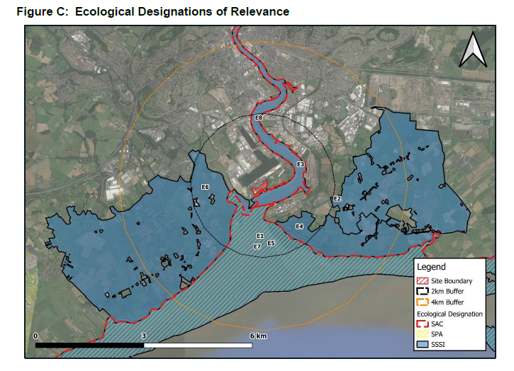
- Has there been any pre-application discussion or correspondence with NRW conservation/ecology | NO However, an HRA has also been prepared for the European site designations (also Usk and Severn with very similar boundaries in the location) – agreement has been reached of “no adverse effect on site integrity”, which is informative to the parallel SSSI assessment on this form
- What aspect(s) of the proposed permission may damage the features which are of special interest for the SSSI?
The following ‘Operations Requiring Consent’ (or other activities associated with the permission) that may cause damage) are relevant to the proposed permission.
(for Usk) 7. Dumping, spreading, discharging or storage ofany materials – i.e. specifically discharging of emissions from the boiler chimney stack, and subsequent spreading/dispersion into the environment, including the atmosphere (air) over the SSSI’s, and following this, deposition (nutrient nitrogen) onto the SSSI, as calculated/described in air dispersion modelling.
The other SSSIs have similar ORC’s, described slightyly differently for each, but the need for assessment and possible impact mechanisms are the same.
The following SSSI features and mechanisms of impact have been considered to assess the likelihood of damage:

Protected flora:
- general critical level for NOX of 30ug/m3 annual mean for all ecological sites,
- general higher critical level for NOX of 200ug/m3 daily mean for all ecological sites where O3 has been shown to be low – as demonstrated in the application
- general critical level for SOX of 10ug/m3 annual mean for all ecological sites
- Precautionary critical loads as detailed in the application AQA (noting some may be overly precautionary on location-specific basis, but adequate for screening purposes):
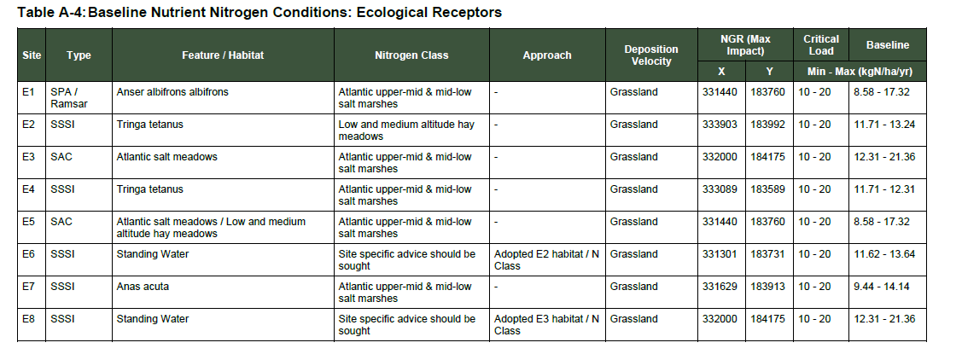
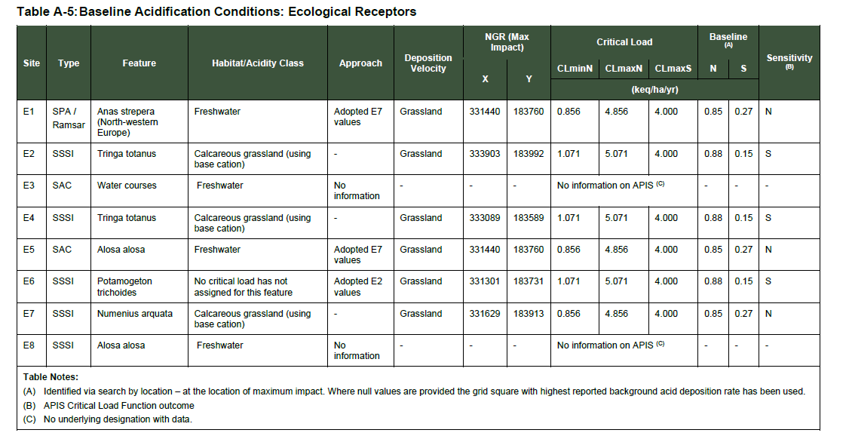

All plants may be impacted by adverse air pollutant concentrations, or deposition, if the screening values above are exceeded. Below these levels, it is considered that significant pollution will not be caused and damage to the SSSIs is unlikely.

For NOX annual average, the maximum process contribution from the boiler is modelled at 2.3ug/m3 at the Usk, 7.8% of the critical level. As this cannot automatically be considered insignificant, the PEC was calculated, at between 76-81% of the critical level. The critical level is not predicted to be breached at point of maximum impact of the most affected SSSI, therefore significant pollution is not caused and damage is not likely.

For NOX 24-hour average the maximum process contribution from the boiler is modelled at 35.2 ug/m3 at the Usk, 17.6% of the critical level. As this cannot be automatically considered insignificant, the PEC was calculated, at 40% of the critical level. The critical level is not predicted to be breached at point of maximum impact of the most affected SSSI, therefore significant pollution is not caused and damage is not likely.

For SOX annual average the maximum process contribution from the boiler is modelled at 0.3 ug/m3 at the Usk, 3.3% of the critical level. As this cannot be automatically considered insignificant, the PEC was calculated, at 40% of the critical level. The critical level is not predicted to be breached at point of maximum impact of the most affected SSSI, therefore significant pollution is not caused and damage is not likely.

For acid deposition, the maximum process contribution from the boiler (on to the Severn SSSI) is 0.3% of the critical load, or 0.014 kgeq/ha/yr. At <1% this is considered insignificant, and unlikely to damage the SSSI. The Usk is not considered acid deposition sensitive, but the data in the AQA nevertheless indicates that the magnitude and extent of acid deposition is small.

For nutrient nitrogen deposition, the applicant-calculated PCs and PECS, are shown below:
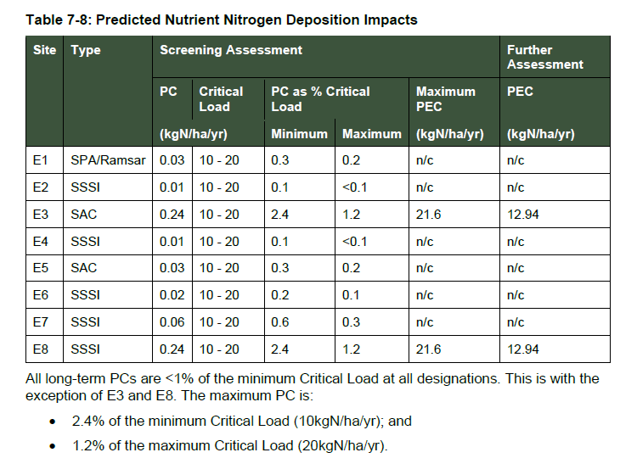
For all SSSI receptors other than E8, the nitrogen deposition PC from the boiler is insignificant, <1% of the ES, so unlikely to cause significant pollution. At slightly over 1% of the upper critical load for E8, the impact cannot be automatically considered insignificant, but is low. The maximum PEC is calculated to be 13 kgN/ha/yr, compared to the upper critical load of 20 kgN/ha/yr. As the upper critical load at point of maximum impact on the Usk is not breached (with considerable headspace), the permitted activity is unlikely to damage features of the adjacent SSSI.

The applicant has provided spatial information in their air quality assessment showing that the extent of exceedance of the 1% significance threshold is small on the Usk (yellow bordered area in the diagram below, further confirming that damage is unlikely. However, this need not be assessed in detail as the upper critical load is not breached as explained above.

- Decision
i) The proposed permission is not likely to damage any of the flora, fauna or geological or physiological features which are of special interest.
Detailed modelling of air dispersion impacts from the boiler have demonstrated that significant pollution is unlikely – either process contribution from the boiler is insignificant because it is so small (<1% of an annual average critical level/load or <10% of a short-term-average critical level), or because when other sources are also considered, it has been shown that the relevant critical level/load is unlikely to be breached. As no breach of protective standards is predicted, significant pollution is unlikely, and damage is therefore unlikely to occur.
There are no special “conditions” associated with the SSSIs – the limits on the industrial operation are those set for all plant (MCP) in this class.

.

Natural Resources Wales is minded to: Issue the permission

- Name and job title of Natural Resources Wales officer: | Dr David Poole, Industrial Decarbonisation Senior Specialist Advisor, on behalf of NRW permitting service
- Date form sent to NRW conservation/ecology | NA – assessment placed on file as per our guidance as there is clear evidence “unlikely to damage”
For Natural Resources Wales use only, once NRW conservation/ecology response received
- NRW conservation/ecology comment on assessment: | Please delete as appropriate:  i) NRW conservation/ecology advise the operation can go ahead  ii) NRW conservation/ecology advise the operation can go ahead with conditions  iii) NRW conservation/ecology advise against permitting the operation  Please ensure that the NRW conservation/ecology response is attached to this Formal Notice.
- Name and job title of NRW conservation/ecology officer:
- Date of receipt of NRW conservation/ecology response:

