PAN-026626 My Map Report:
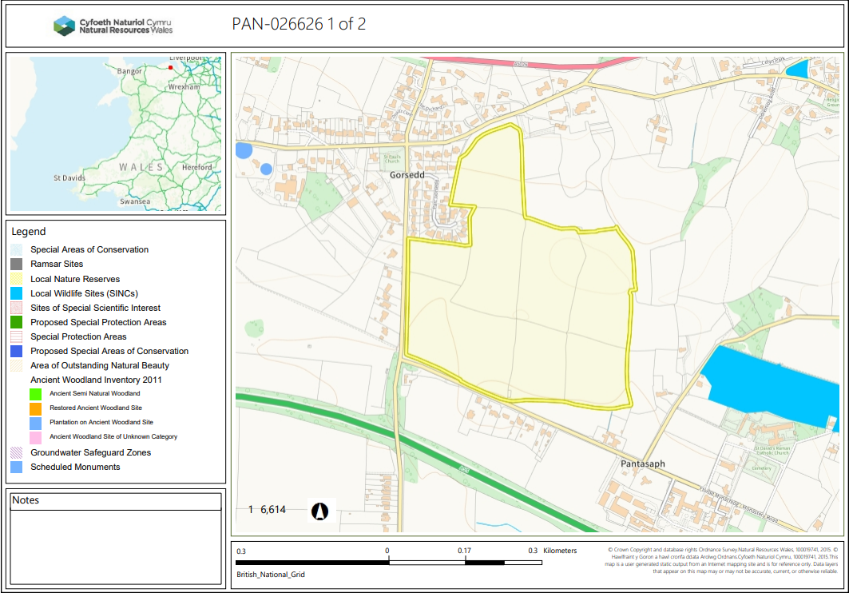
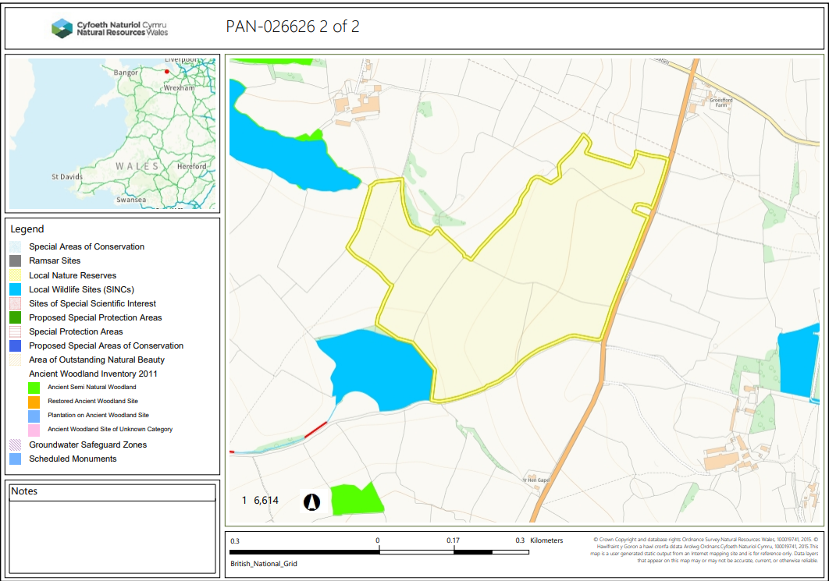
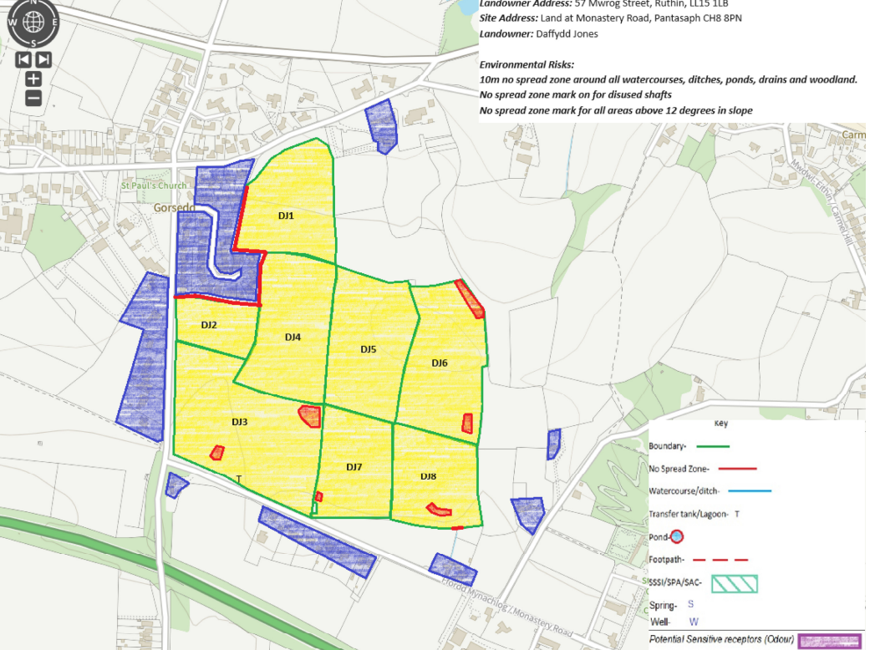
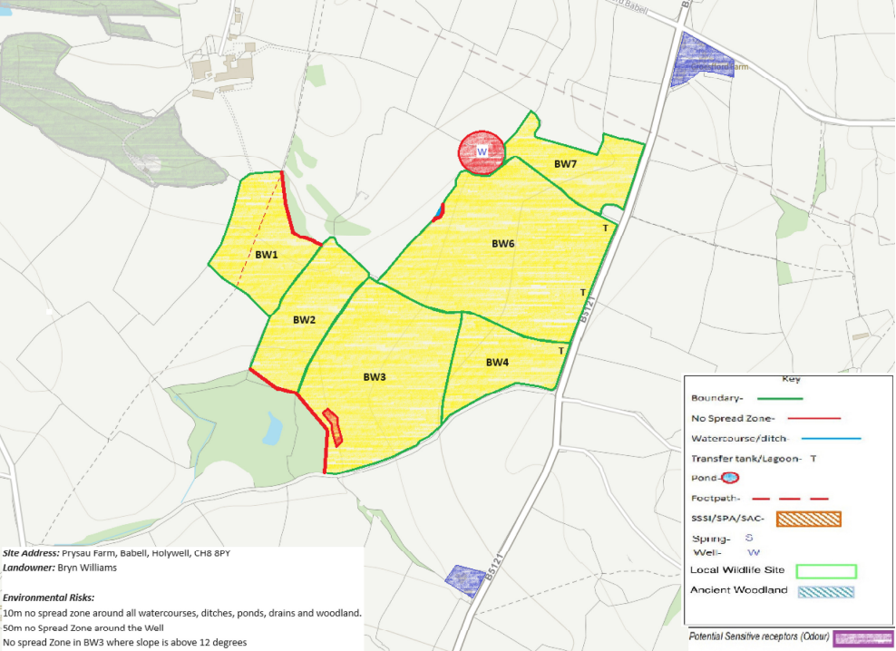
Detailed river network:
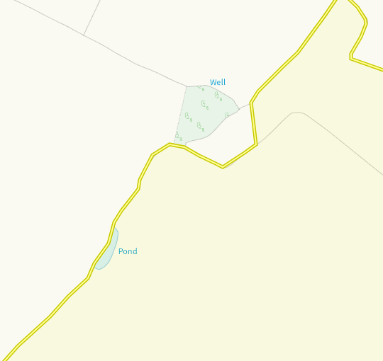
A well and surface pond water is found on the border of BW6. Both have been identified in submitted maps and buffer zones implemented.
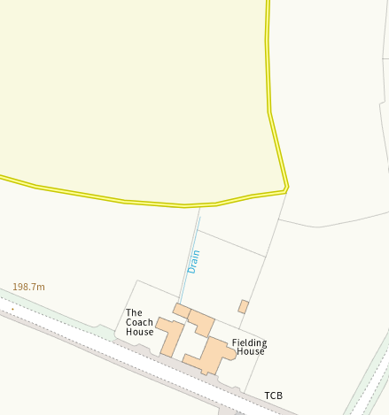
A drain sits at the bottom of DJ8 border. This has been buffered on the submitted maps to prevent run off.
Groundwater protection zones (source)
None in range
Wells, springs or boreholes used for the supply of water for human consumption including from a private water supply or supplies
None in range
any springs wells or boreholes not used to supply water for domestic or food production purposes within 50m

None in range
any springs wells or boreholes used to supply water for domestic or food production purposes within 250m

None in range
European designated sites- Natura 2000 (SPA, pSPA, SAC or cSAC) or Ramsar- or SSSI within 500m

None in range
Other protected sites:
- Protected Species-
None in range
- Protected Habitats-
None in range
- Scheduled Ancient Monument-
None in range
- Local Nature Reserve-
None in range
- National Nature Reserve-
None in range
- Ancient Woodlands-
None in range
- Local Wildlife Sites (SINC)-
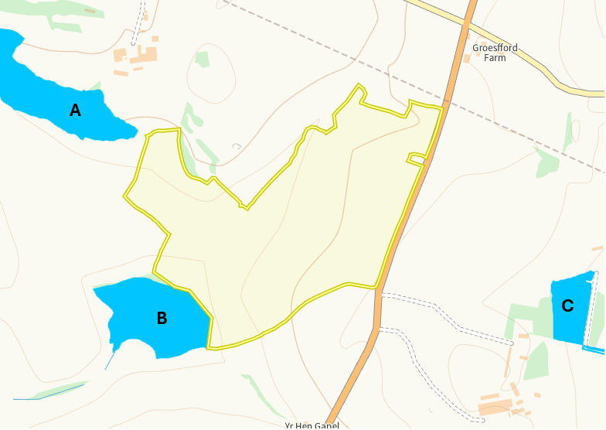
A number of SINCS border fields at Prysau Farm. These have been made aware to the applicant via RFI.

A - Prysau Woodland and Scrub
B- Prysau wetland
C- Plas coch meadow and verge
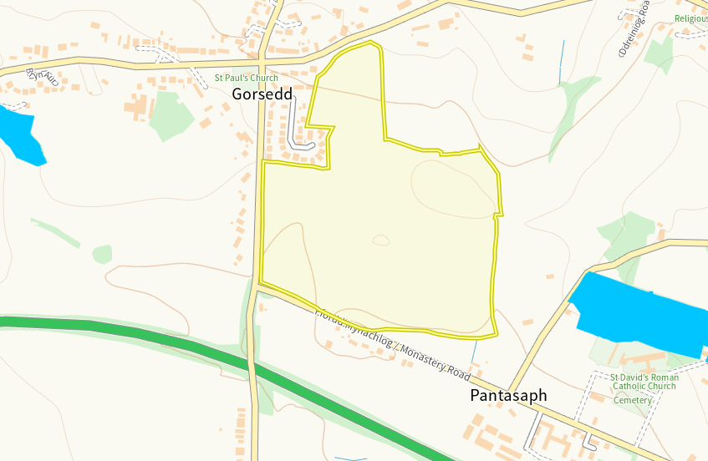
A number of SINCS border fields at Mwrog Street. These have been made aware to the applicant via RFI.
Right - Calvary wood and grange quarries Left – Lloc lead mine and quarry
- National Park-
None in range
- Nitrate Vulnerable Zone (NVZ)-
None in range
- Groundwater Safeguard Zone-
None in range
- ANOBs
None in range
- Heritage coast
None in range
- Hedges, Ditches-
Nothing of concern
- Local residents, Housing, schools, Workplaces, Recreational facilities
Identified receptors on maps and odour management plan

Slope Map
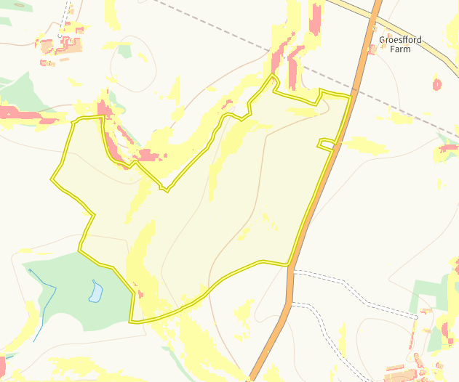
There are some areas of 7-12 degree slope (yellow) within fields BW2, BW3 BW4 BW6 and BW7. There is a small area of 12 degree + slope in field BW3 however, this has a no spread buffer zone implemented to minimise run off. Due to the limited slope over the fields and the precise method of application (soil injection). No action required.
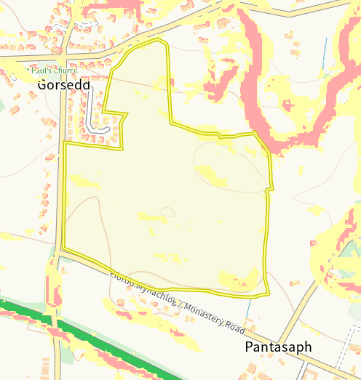
There are some areas of 7-12 degree slope (yellow) within fields DJ1, DJ5, DJ6, DJ2, DJ3, DJ7 and DJ8. There is a small area of 12 degree + slope in field DJ8 however, this has a no spread buffer zone implemented to minimise run off. Due to the limited slope over the fields and the precise method of application (soil injection). No action required.

