Notice of variation with introductory note
Environmental Permitting (England & Wales) Regulations 2016

AWD (Group) Ltd

Byass Works
The Docks
Port Talbot
SA13 1RS

Variation application number
EPR/AB3895CN/V002

Permit number

EPR/AB3895CN

Byass Works

Permit number EPR/AB3895CN

Introductory note

This introductory note does not form a part of the notice

The following notice gives notice of the variation of an environmental permit.

This is an administrative variation to increase the permit boundary of the site.

The schedules specify the changes made to the original permit.

The status log of a permit sets out the permitting history, including any changes to the permit reference number.

Status log of the permit
Description | Date | Comments
Permit determined  EPR/AB3895CN/A001 | 06/04/18 | Permit issued to AWD (Group) Ltd
Application EPR/AB3895CN/V002 | Duly made  07/09/18 | Application to vary the permit by extending the site boundary.
Variation determined EPR/AB3895CN | 18/09/18 | Varied permit issued.

End of introductory note

Notice of variation
Environmental Permitting (England and Wales) Regulations 2016

The Natural Resources Body for Wales (“Natural Resources Wales”) in exercise of its powers under regulation 20 of the Environmental Permitting (England and Wales) Regulations 2016 varies

Permit number

EPR/AB3895CN

issued to:

AWD (Group) Ltd (“the operator”)

whose registered office is

1 Picton Lane

Swansea

City & County Of Swansea

SA1 4AF

company registration number 09374296

to operate a regulated facility at

Byass Works

The Docks

Port Talbot

SA13 1RS

to the extent set out in the schedules.

The notice shall take effect from 18/09/2018

Name | Date
Huw Davies | 17/09/2018

Authorised on behalf of Natural Resources Wales

Schedule 1 – conditions to be deleted

None

Schedule 2 – conditions to be amended

None

Schedule 3 – conditions to be added

None

Schedule 4 – amended plan

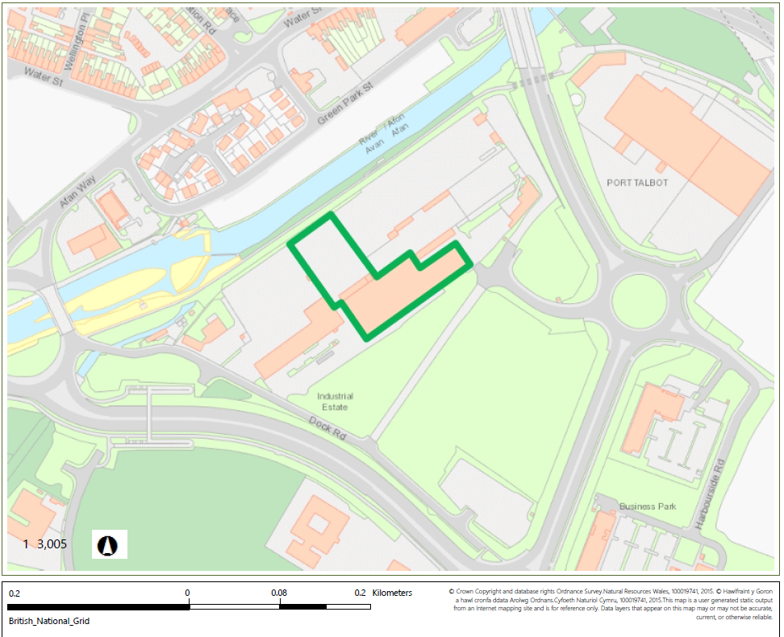
Amended plan attached

© Crown Copyright and database right 2018. Ordnance Survey licence number 100019741.

