Permit
The Environmental Permitting (England & Wales) Regulations 2016

K.J. Services Holdings Limited

KJ Services Holding Limited
Unit 2-4
Capital Valley Industrial Park
Rhymney
Tredegar
NP22 5PT

Permit number

EPR/DB3298FN

Permit
The Environmental Permitting (England and Wales) Regulations 2016
Permit number

EPR/DB3298FN

The Natural Resources Body for Wales (“Natural Resources Wales”) authorises, under regulation 13 of the Environmental Permitting (England and Wales) Regulations 2016

K.J. Services Holdings Limited “the operator”,

whose registered office is

Capital Valley Industrial Park

Rhymney

Tredegar

United Kingdom

NP22 5PT

company registration number 13161506

to operate waste operations at

KJ Services Holding Limited

Unit 2-4

Capital Valley Industrial Park

Rhymney

Tredegar

NP22 5PT

to the extent authorised by and subject to the conditions of this permit.

Under regulation 27(2) of the Regulations, standard rules SR2008 No11 are conditions of this permit.

Name | Date
Huw Davies | 14/10/2024

Authorised on behalf of Natural Resources Wales

Schedule 1 - Site plan

This is the plan referred to in the standard rules SR2008 No11

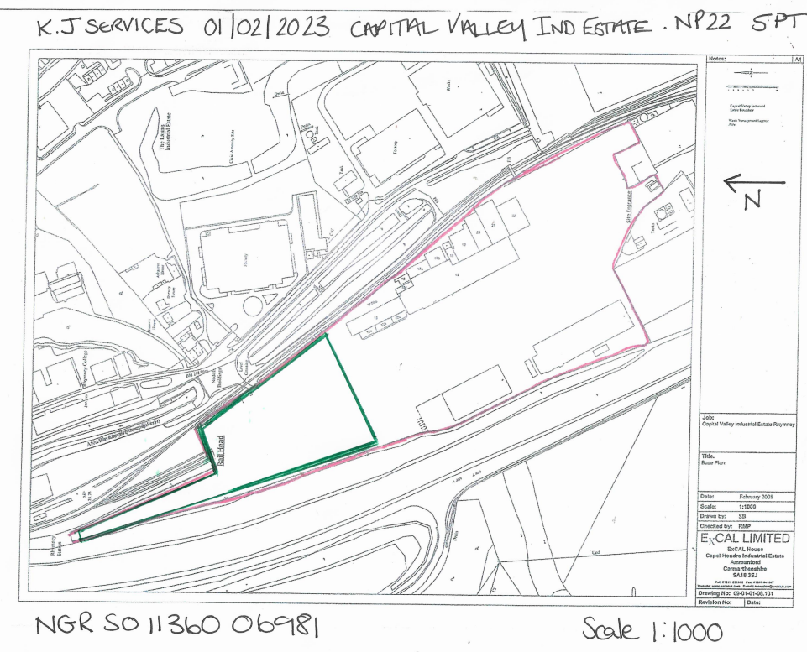

END OF PERMIT

