Environmental Permitting (England and Wales) Regulations 2016
Regulation 37(12)

WITHDRAWAL OF SUSPENSION NOTICE

To: South Wales Wood Recycling Limited
Old Post Office,
Curwen Terrace,
North Cornelly,
Bridgend,
CF33 4AW

Environmental permit: EPR/FP3095ET
Regulated facility: South Wales Wood Recycling Limited, Locks Yard, Heol Llan, Coity, Bridgend, CF35 6BU

With effect from 21 September 2018 the suspension notice dated 13 September 2018 served under Regulation 37(1) and (5) of the Environmental Permitting (England and Wales) Regulations 2016 relating to the above environmental permit is withdrawn.

Date: 21 September 2018 Signed: 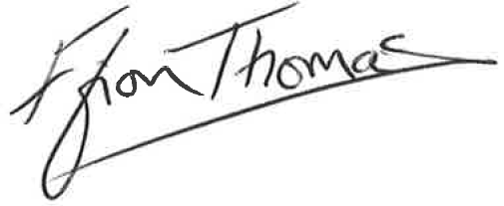
Ffion Thomas
Acting Team Leader – Waste Regulation South West

Natural Resources Wales
Maes Newydd,
Britannic Way West
Llandarcy,
Neath Port Talbot,
SA10 6JQ

Legislation note
In this document “Natural Resources Wales” means the Natural Resources Body for Wales established by Article 3 of the Natural Resources Body for Wales (Establishment) Order 2012. On 01 April 2013 the Natural Resources Body for Wales (Functions) Order 2013 transferred the relevant functions of the Countryside Council for Wales, and functions of the Environment Agency and the Forestry Commission in Wales to the Natural Resources Body for Wales.

