Heritage Railway Environmental Risk Assessment – Cable Replacement

1.1 Identification of Risks
The activity which requires an environmental permit is the discharge of rainwater and groundwater from excavations along the heritage railway during the installation of a replacement 400kV cable. Whilst the likelihood of contamination along the route is generally low there may be surface contamination associated with the use of the heritage railway itself in the form of ash, soot and coal as well as oils and greases that may have fallen from the train during its operation. Additionally, it is considered likely that sediment will become entrained within the pumped water unless specific measures are taken to prevent this.

The need for a bespoke permit is driven by the proximity of the proposed cable routes to the Llyn Padarn, and Coed Dinorwig Sites of Special Scientific Interest (SSSI).

Figure 1: Cable route in proximity to SSSIs
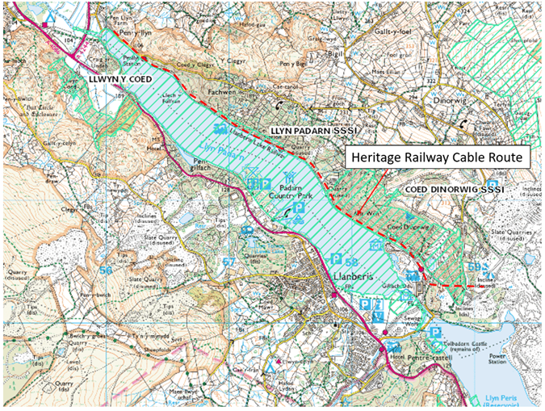
Source: Ordnance Survey © Crown copyright 2020. All rights reserved. Licence number 100026791
The Afon Fachwen and several small ordinary watercourses that discharge into Llyn Padarn along its northern shore are at high risk of surface water flooding. The NRW flood risk map (Figure 2) shows areas of high flood risk behind the railway, indicating that the railway embankment is holding surface water back during periods of heavy rainfall.

Figure 2: Surface Water Flood Risk
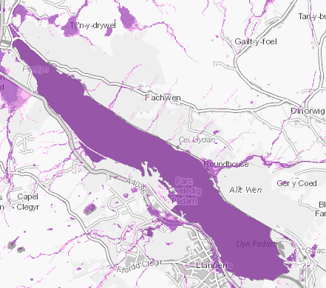
Source: Natural Resources Wales

The operation to install the new cable ducts will comprise the following sequence of works:
- The existing cable will be powered down, disconnected and earthed to prevent any sudden or incidental discharges of electricity during the works;
- The existing cables will be drained of cooling liquid before being cut into sections and removed;
- A trench will be excavated in sections along the line of the existing cable route, the ducting will be installed, and the section will be backfilled before moving along to the next section. Existing concrete joint bays will be utilised.
- Dewatering will be used to keep the excavations dry throughout the works as the cables cannot meet any water until they ends have been joined and sealed.

The pumping system will comprise portable pump(s) which will be used as required to drain the trench during excavation and filling.

1.2 Receptors
The cable route passes alongside Llyn Padarn SSSI which is identified as the primary risk receptor. This lake is designated as a SSSI because of the genetically distinct species of Arctic char that live in the lake as well as aquatic plants. Arctic char and other salmonid fish species present within the lake are sensitive to suspended sediment entering the lake. The lake is also an important amenity to the local community. The Coed Dinorwig SSSI is designated due to being a large representative example of a wood sage with abundant oak and birch woodland. There are no impact pathways to these features as the cable route lies almost entirely within the existing railway corridor with the sole exception being where the route crosses the Afon Fachwen when the route deviates into the woodland to the north of the heritage railway between chainages Ch2+100 and Ch2+500. Although the Llwyn y Coed SSSI is also in the vicinity there are no impact pathways to this site as it is on the opposite side of Llyn Padarn.

1.3 Proposed Mitigation
The following mitigation measures are proposed to control sediment release into Llyn Padarn:
- Prior to excavating a trench along the line of the existing cable any ballast stone associated with the heritage railway will be excavated and stockpiled separately and as far away from the lake as is reasonably practicable while avoiding the need for material transport and double handling;
- Any grossly contaminated material will be visually identified and segregated for assessment for disposal;
- Excavated natural soils and stone will then be excavated and again placed as far from the lake as practicable to avoid the potential for migration of soils or run-off into the lake;
- Water will be pumped out of the excavation and ultimately discharged to the existing surface water drainage system which runs alongside the Heritage Railway.
- Prior to discharge the water being abstracted from the excavations will be passed through a filtration sock to trap sand and silt particles to prevent it entering the surface water drainage system.
- The surface water drainage system discharges to ditches which will allow water to infiltrate through the underlying sediments.
- Should any visual evidence of oil or other hydrocarbons be found within any excavation, any dewatering required will be collected and removed from the work site. Sediment impacted by hydrocarbons will be removed and segregated for assessment for disposal.
- Should any excavation require dewatering a watching brief will be maintained at the discharge point to ensure that no over land flow can reach the lake shore. If over land flow is seen all pumping activities will stop.
- Each section of cable will require the following approximate time in the programme:

The works are estimated to take 12 months and stages included are:

- Excavate and lay ducting
- Install in situation concrete protection slabs
- Install cables
- Jointing of the cables
- Backfill and reinstate

- Sandbags will be used to channel surface water away from the excavation to minimise the volume of dewatering required.
- A supply of intermediate bulk containers will be kept on hand in case dewatering to the surface water drainage system becomes impossible due to over land flow towards the lake.

1.4 Discharge Quality
With the exception of the ballast used to support the heritage railway track, which will be separated from the natural soil and stone at source, the excavations are expected to be free of contaminants, the ground underlying the railway is comprised of slate gravel and free from mobile contaminants. The discharge may contain suspended sediment washed into the excavation by groundwater and surface water and a proposed limit of 50mg/l suspended solids is proposed to be discharged into the surface water drainage system. The water will be subject to further attenuation as it moves through the drainage system and into the drainage ditch and ultimately into the underlying soil or Llyn Padarn.

1.5 Conclusion
With the mitigation measures described above it is considered that there will be no adverse risk to water quality within Llyn Padarn.

