Background Information Note:

Llyn Padarn and Coed Padarn Sites of Special Scientific Interest
Dinorwig Heritage Railway replacement 400kV buried electricity cable replacement scheme – Dinorwig – Pentir 400kV (Heritage Railway cable replacement)
The purpose of this note is to provide Natural Resource Wales (NRW) with background information on the Dinorwig to Pentir 400kV buried electricity cable replacement scheme (Heritage Railway route) that National Grid Electricity Transmission (‘National Grid’) proposes to undertake near to and adjacent to the Llyn Padarn SSSI and Coed Dinorwig SSSI.
National Grid is a ‘public body’ in respect of Section 28G of the Wildlife and Countryside Act 1981 (as amended). Morgan Sindall therefore have notified Natural Resources Wales of our intention to undertake operations near to and adjacent to Llyn Padarn SSSI and Coed Dinorwig SSSI that ‘are likely’ to damage its flora or fauna.
Non-Technical Summary
Morgan Sindall on behalf of National Grid are installing new, and replacing old underground electricity cables connecting the hydroelectric power station at Llanberis to the national grid node at Pentir.
Part of the works includes the replacement of an existing cable that underlies the Heritage Railway route that runs along the northern shore of Llyn Padarn. The route runs along the shore of Llyn Padarn and to the immediate south of Coed Dinorwig, both Sites of Special Scientific Interest.
The need for SSSI Assent is driven by the proximity of the proposed cable routes to the Llyn Padarn and Coed Dinorwig Sites of Special Scientific Interest. As the route proceeds north along the A4244 there are no other designated sites within 50m of the route (Figure 1). Llwyn Y Coed SSSI is designated for its mosses, liverworts and ferns. There are no impact pathways to these features and so this SSSI is not considered further.
Figure 1: Cable route in proximity to SSSIs
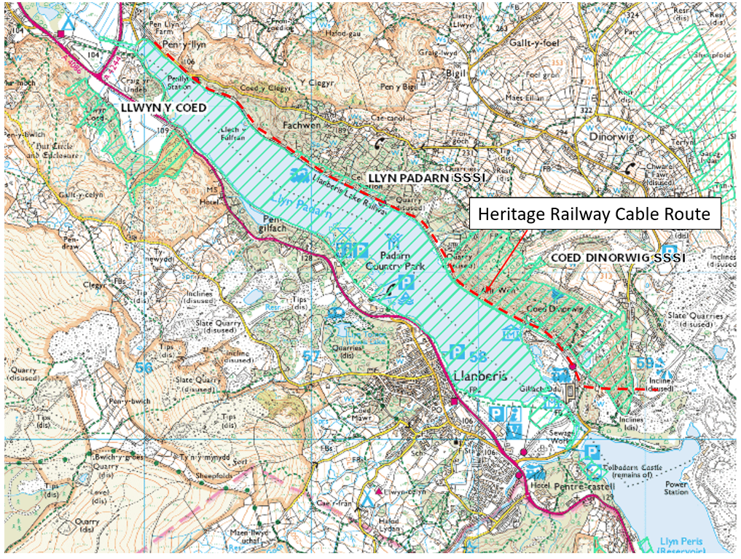
Source: Ordnance Survey © Crown copyright 2020. All rights reserved. Licence number 100026791
Receptors
Llyn Padarn SSSI
The cable route passes alongside Llyn Padarn. This lake is designated as a site of special scientific interest because of the genetically distinct race of Arctic Char that live in the lake as well as aquatic plants and geological exposures within a railway cutting. Arctic Char and other salmonid fish species present within the lake are sensitive to suspended sediment entering the lake. Spawning in Llyn Padarn occurs locally in shallow, marginal waters, notably along Afon y Bala. The lake is also an important amenity to the local community. Llyn Padarn has now been designated as Wales's only freshwater bathing lake and the results of samples taken by Natural Resources Wales there in 2015 have reached the highest "excellent" standard.
Coed Dinorwig SSSI
The cable route passes along the southern border of Coed Dinorwig. Coed Dinorwig SSSI is due to being a large representative example of a wood sage with abundant oak and birch woodland. There are no impact pathways to these features and so this SSSI is not considered further.
Measures to prevent potential damage to the interests of the SSSIs
The Llyn Padarn SSSI is designated for Arctic charr (lake dwelling), geological interest at the northern lake shore, and aquatic plant species. The cable ducting installation works are approximately 10m from the nearest lake edge and so will not directly affect aquatic flora or fauna. The geological ex[psurs within the cutting will not be affected.
Indirect effects will be controlled by following the Guidance for Pollution Prevention Works and maintenance in or near water (GPP5 & PPG6).
Any temporary dewatering activities will be overseen by the Morgan Sindall Environmental Advisor or nominated substitute. Any pumping for dewatering of excavations will be controlled by the issue of a permit to pump and controls put in place to prevent silt entering any nearby watercourses. Silt mitigation such as silt curtains and / or straw bales may be required. Morgan Sindall Environmental Advisor to review silt mitigation management prior to and during the works. Inclement weather to be assessed prior to works. Regular weather forecast reviews will be undertaken.
The operation to install the new HV cable will comprise the following sequence of works:
The operation to install the new cable ducts will comprise the following sequence of works:
- The existing cable will be powered down, disconnected and earthed to prevent any sudden or incidental discharges of electricity during the works;
- A trench will be excavated along the line of the existing cable route and the existing cable will be cut and drained of cooling liquid before being cut into sections and removed;
- The new cable will then be installed within the now empty trench with the cable sections being joined using the existing joint bays.
- Dewatering will be used to keep the excavations dry throughout the works as the cables cannot come into contact with any water until they ends have been joined and sealed.
There are a number of joint bays that have been positioned in agricultural field parcels along both carriageways including Padarn Country Park.
Each cable is 140mm in diameter and with a surface area of 2,500mm², the cable weighs 37kg per metre.
Each phase needs to be separated from the others to meet the electrical characteristics of the cable system design.
As water ingress into the cables would be catastrophic the excavations are to kept dry using sumps excavated at regular intervals to facilitate the removal of any water ingress.
It’s worth noting, the two main sources of water ingress in the joint bay will be from rainwater run-off from the surrounding area, or groundwater ingress. The cable will not be encased in concrete and the existing joint bays will be reused so there is no risk of cementitious leachate to contaminate the collected water.

The trenches will require dewatering should rainfall start to fill the excavations or groundwater levels are high and excavations beneath the groundwater level are required. Any dewatering will be discharged either via the surface water drainage system which discharges to the adjacent land and or Llyn Padarn via a drainage ditch or direct to ground following which the water will flow under gravity towards the Llyn Padarn, the same as any other natural overland flow.
A number of mitigation measures have been developed to reduce the risk of any sediment laden water entering the lake directly:
The following mitigation measures are proposed to control sediment:
- Prior to excavating a trench along the line of the existing cable any ballast stone associated with the heritage railway will be excavated and stockpiled separately and as far away from the lake as is reasonably practicable to avoid the need for material transport and double handling;
- Excavated natural soils and stone will then be excavated and again placed as far from the lake as practicable to avoid the potential for migration of soils or run-off into the lake;
- Water will be pumped out of the excavation and ultimately discharged either to the existing surface water drainage system which runs alongside the Heritage Railway or to ground via silt bags and, should scour be found to occur, though hay bales or similar to dissipate the energy of the water.
- Prior to discharge the water being abstracted from the excavations will be passed through a filtration sock/silt bag to trap sand and silt particles followed by a series of settlement tanks to further remove suspended solids prior to it entering the surface water drainage system.
- Where present the surface water drainage system discharges to ditches which will allow water to infiltrate through the underlying rock and sediments
- Should any visual evidence of oil or other hydrocarbons be found within any excavation, any dewatering required will be collected and removed from the work site.
- Should any excavation require dewatering a watching brief will be maintained at the discharge point to ensure that no over land flow can reach the lake shore. If over land flow is seen all pumping activities will stop.
- Sandbags will be used to channel surface water away from the excavation to minimise the volume of dewatering required.
- A supply of intermediate bulk containers will be kept on hand in case dewatering to the surface water drainage system becomes impossible due to over land flow towards the lake.
- A road bowser will be mobilised to site should this become necessary to cope with large volumes of water.

With these mitigation measures it is considered unlikely that the lake will be adversely affected.
The enclosed Morgan Sindall RAMS provide more detail on the measures to be taken at site during the works.
The proposed discharge locations have been included in Table 1 below and can also be seen in Figure 2.
Table 1. Abstraction and Discharge Location Information
Location Reference | National Grid Reference | Discharge Type
Abstraction Reach (North) | SH 55883 62572 | n/a
Abstraction Reach (South) | SH 58629 60366 | n/a
DC1 | SH 58605 60387 | Discharge to ground/via site drainage
DC2 | SH 58605 60387 | Discharge to ground/via site drainage
DC3 | SH 58152 60757 | Discharge to ground
DC4 | SH 57929 60893 | Discharge to ground
DC5 | SH 57790 61141 | Discharge to ground
DC6 | SH 57707 61277 | Discharge to ground
DC7 | SH 57473 61401 | Discharge to ground
DC8 | SH 57256 61512 | Discharge to ground
DC9 | SH 57055 61601 | Discharge to ground
DC10 | SH 56802 61773 | Discharge to ground
DC11 | SH 56589 61972 | Discharge to ground
DC12 | SH 56341 62132 | Discharge to ground
DC13 | SH 56110 62319 | Discharge to ground
DC14 | SH 55883 62572 | Discharge to ground

Figure 2: Plan of the heritage railway route with abstraction and discharge locations


