

 | Consent no | NRWWIA408
WATER INDUSTRY ACT 1991

SECTION 165 / 166

CONSENT TO DISCHARGE

TO: Dwr Cymru Cyfyngedig
Linea
Fortran Road
St. Mellons
Cardiff
CF3 0LT

The NATURAL RESOURCES BODY FOR WALES ("Natural Resources Wales") in pursuance of its powers under the Water Industry Act 1991 HEREBY CONSENTS to the making of a discharge as follows:

Raw Water

FROM: GRWYNE FAWR RESERVOIR, FOREST COAL PIT, ABERGAVENNY NP7 7NP
AT: NATIONAL GRID REFERENCE SO 23291 30699
TO: Grwyne Fawr River
SUBJECT TO: the conditions set out in the following schedule:

Raw Water Schedule No. NRWWIA408
This consent is issued on the 29th day of October 2024
This consent takes effect on the 1st day of January 2025
This consent shall cease to have effect on the 31st day of December 2026

Signed: Emma Jones

CONDITIONS OF CONSENT TO DISCHARGE
RAW WATER (“the Discharge”)

NATURE OF THE DISCHARGE

1. The Discharge shall consist solely of raw water.

SOURCE OF THE DISCHARGE

- The Discharge shall be derived from Grwyne Fawr Reservoir.

LOCATION OF DISCHARGE

3. The location of the Discharge shall be at NGR SO 23291 30699, marked Discharge Point to Watercourse’ on ‘the site plan in Annex 1.

SAMPLE POINT

4. A sample point shall be provided and maintained so that a representative sample of the Discharge may be obtained.

VOLUME

- The total volume of the Discharge shall not exceed 1,523,006 cubic metres.

- The total daily volume of the Discharge shall not exceed 380,751 cubic metres.

- The rate of the Discharge shall not exceed 1,500 litres per second.

COMPOSITION

8. The consent holder shall take all necessary steps to secure that any water discharged by it under this consent is as free as may be reasonably practicable from —
(a) mud and silt;
(b) solid, polluting, offensive or injurious substances;
and
(c) any substances prejudicial to fish or spawn, or to spawning beds or food of fish.

SCOURING

9. The rate of discharge shall be controlled to prevent any significant scouring of the bed or bankside of the receiving water.

FLOODING

10. The discharge shall not cause or significantly contribute to flooding in the downstream catchment.

PERIOD OF DISCHARGE

11. The Discharge shall only be made between 1st day of January 2025 and the 31st day of December 2026.

ANNEX 1- PLAN No. NRWWIA408

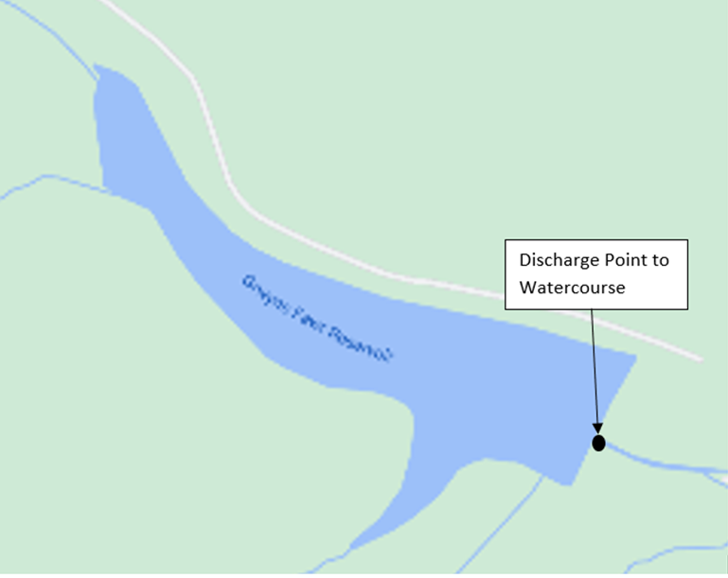

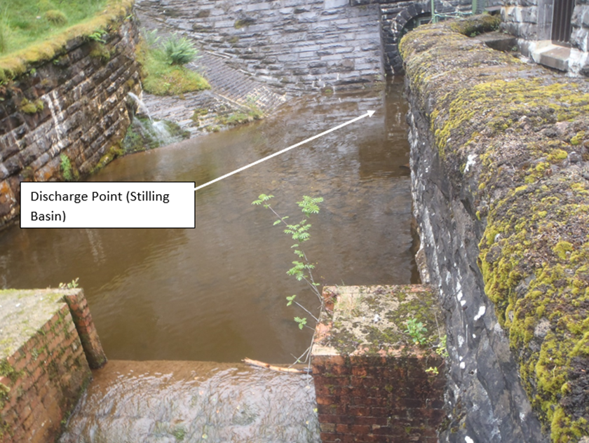
© Crown Copyright and database right 2024. Ordnance Survey licence number 100019741.

