PAN-027058 My Map Report:
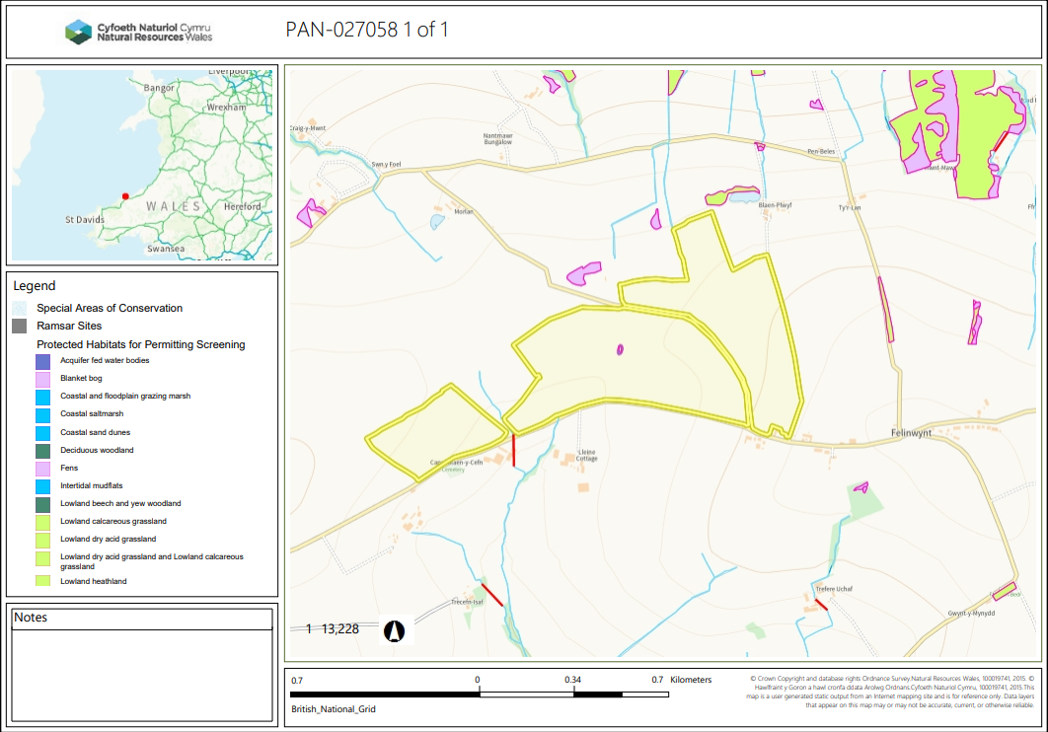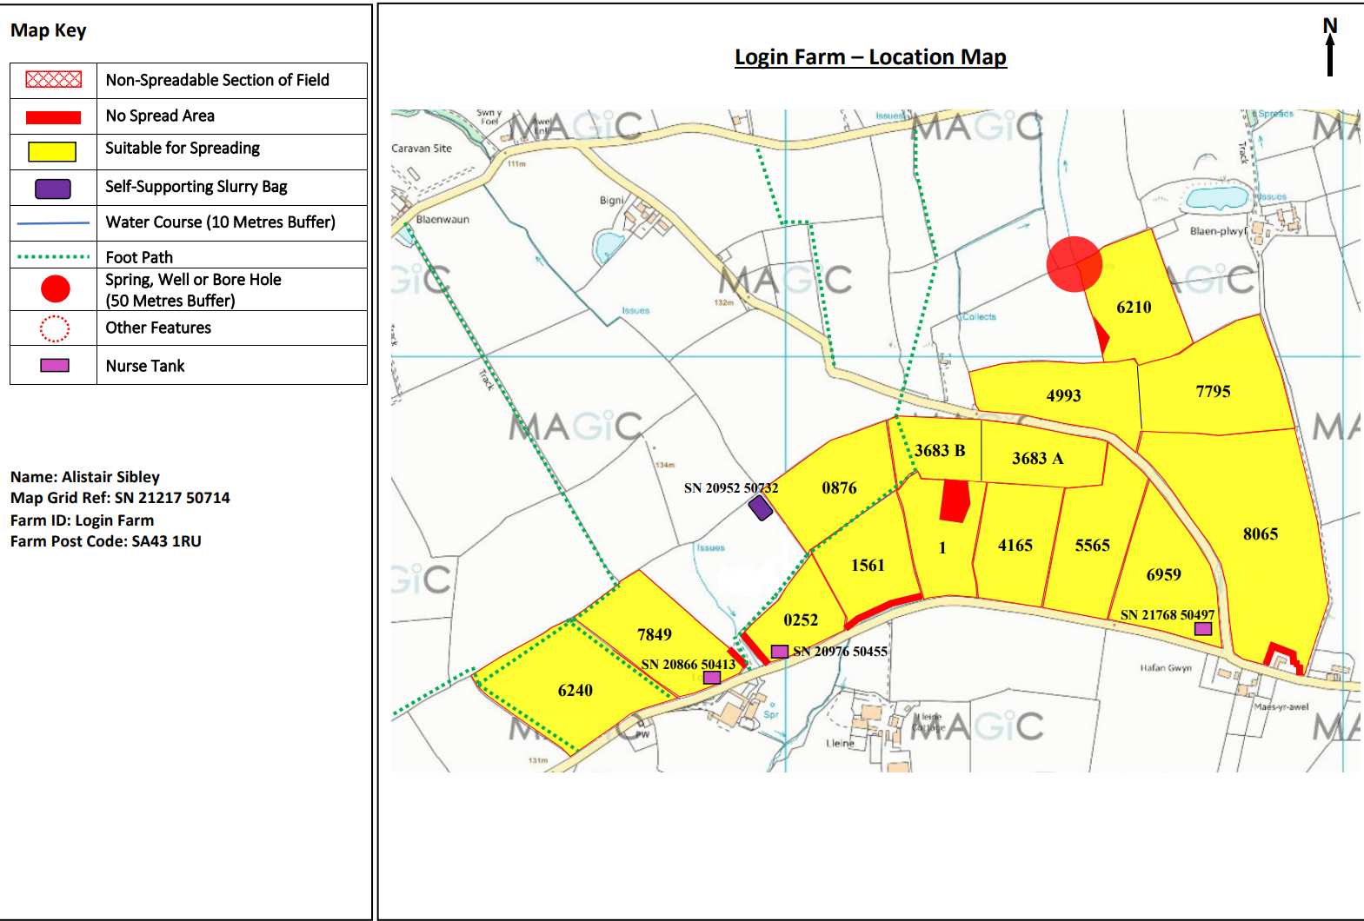

Detailed river network:
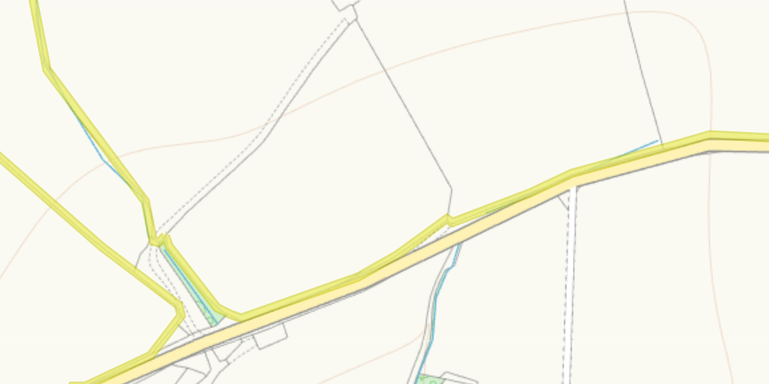
A modified attribution runs on the border of 0252 and 1561. 10m no spread buffer zones are implemented on these borders to compensate any run off.
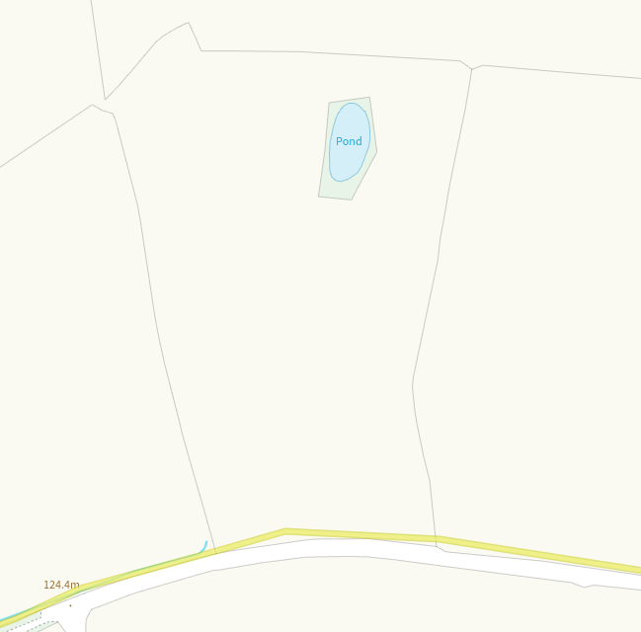
A pond is on the centre of field one. This had a no spread buffer zone implemented over its entirety to prevent run off.
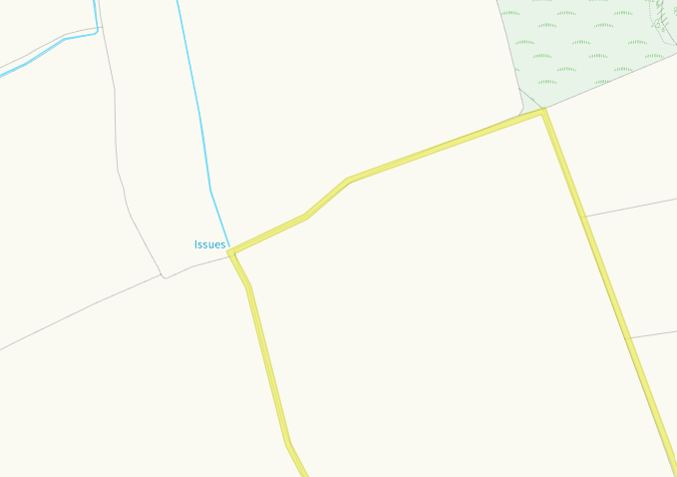
An issue is at the top corner of 6210. There has been a 50m no spread buffer implemented this corner to prevent run off.
Groundwater protection zones (source)
None in range
Wells, springs or boreholes used for the supply of water for human consumption including from a private water supply or supplies
None in range
any springs wells or boreholes not used to supply water for domestic or food production purposes within 50m

None in range
European designated sites- Natura 2000 (SPA, pSPA, SAC or cSAC) or Ramsar- or SSSI within 500m

None in range

Other protected sites:
- Protected Species-
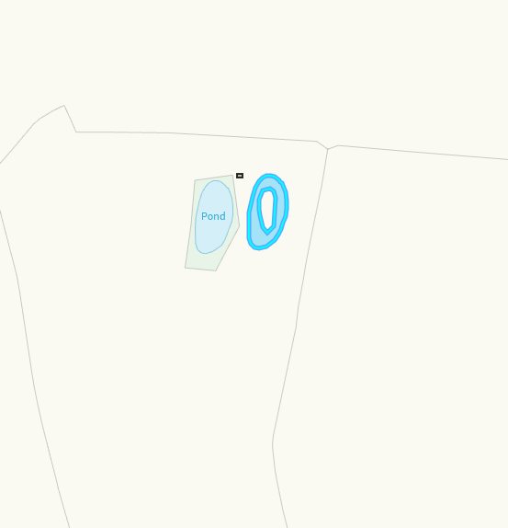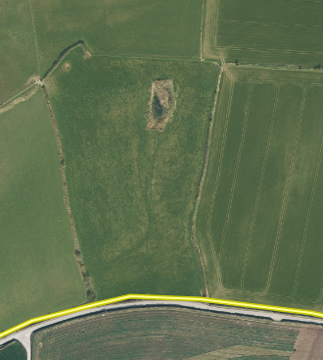
Protected species reedbeds are to the right of the pond area. Ariel images suggest the pond is the only differing habitat in this field and the buffer zone protects this area.
- Protected Habitats-
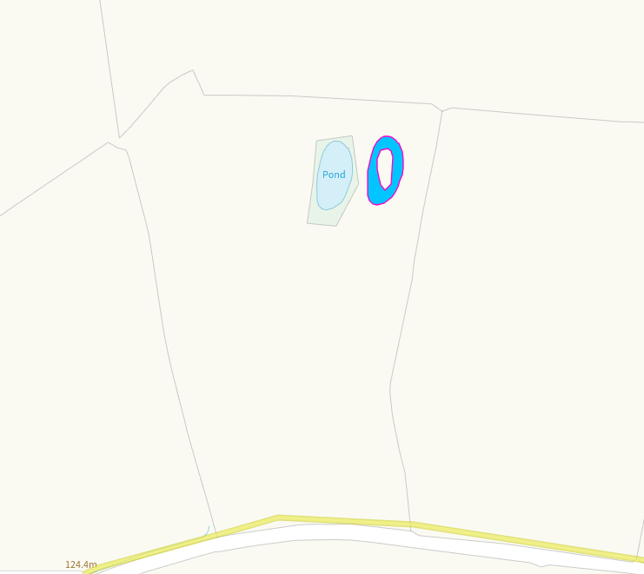
Protected species reedbeds are to the right of the pond area. Ariel images suggest the pond is the only differing habitat in this field and the buffer zone protects this area.

- Local Nature Reserve-
None in range
- National Nature Reserve-
None in range
- Ancient Woodlands-
None in range
- Local Wildlife Sites (SINC)-
None in range
- National Park-
None in range
- Groundwater Safeguard Zone-
None in range
- ANOBs
None in range
- Heritage coast
None in range
- World Heritage Sites
None in range
- Hedges-
None in range
- Ditches, Local residents, Housing, schools, Workplaces, Recreational facilities
Nothing of concern

Slope Map
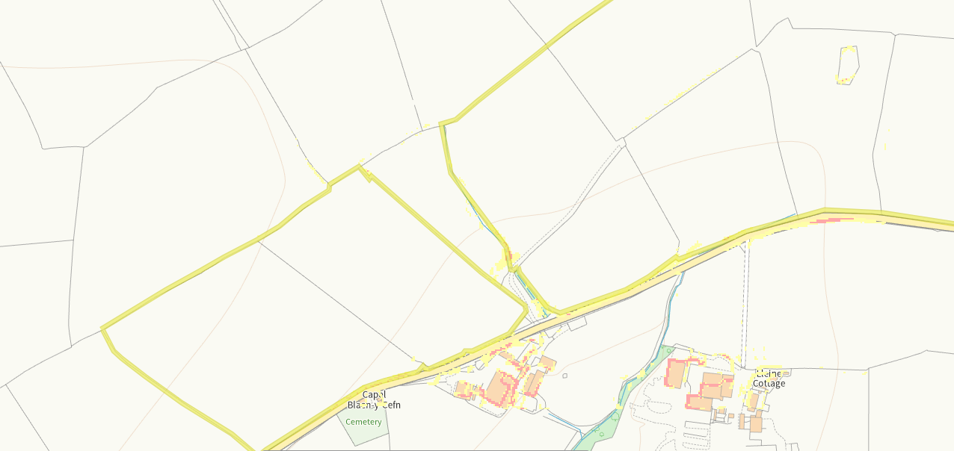
There is slight 7-12 degree slope (yellow) at the edges of field 0252, 1561 and the pond in field 1. Sloping is very minimal and the areas that aren’t buffered do not have any sensitive receptors in close proximity. Wastes will only be spread at a rate of 50t/ha in a 3 week period so the chance off run off is low. No action required.

