PAN-026945 My Map Report:
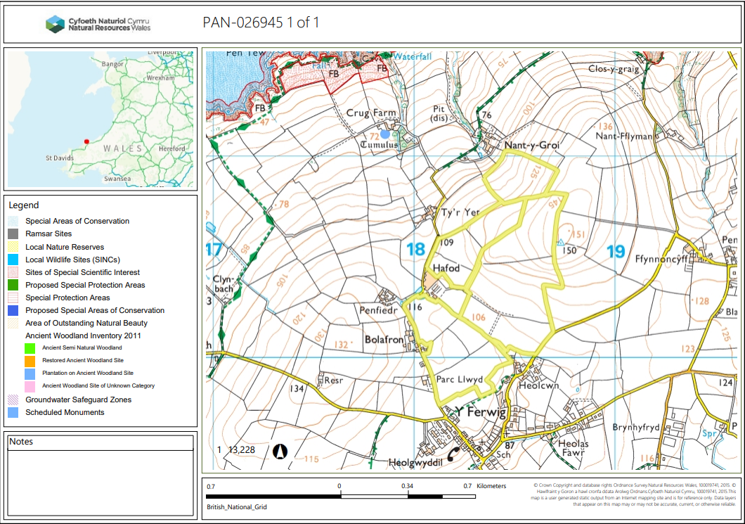
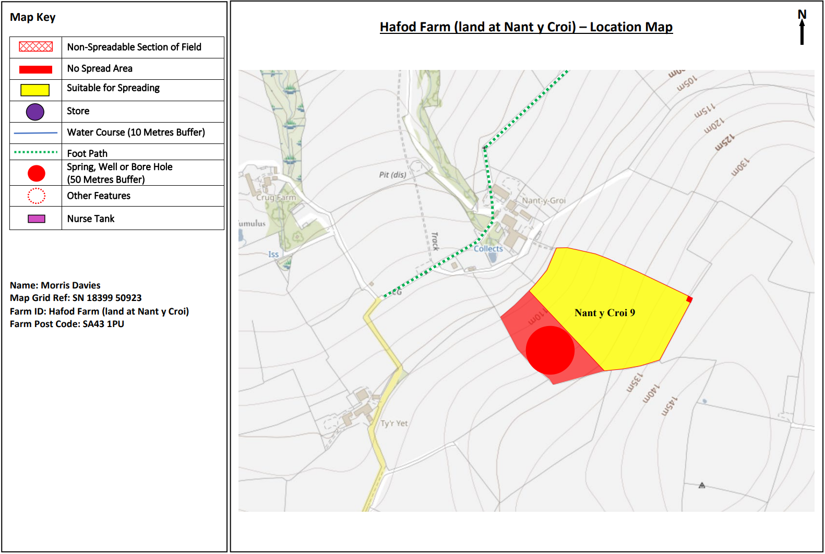
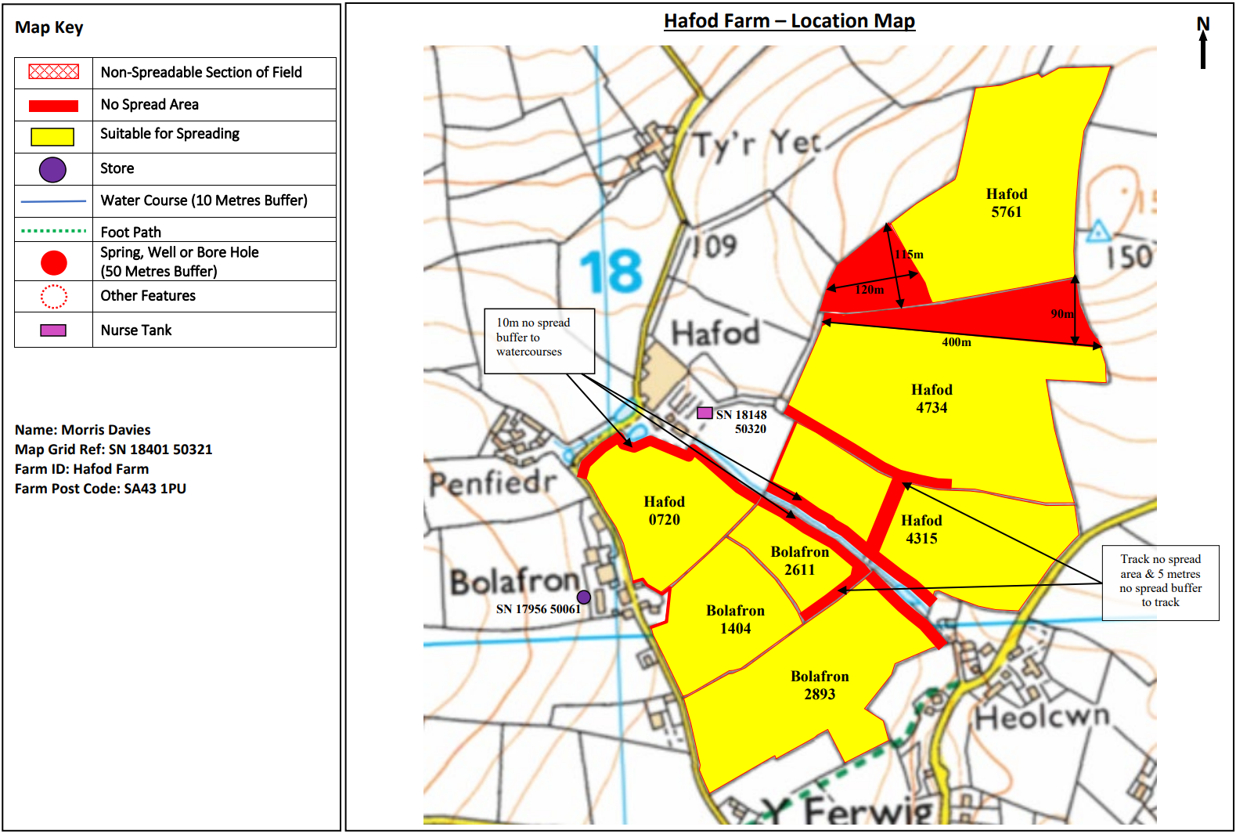
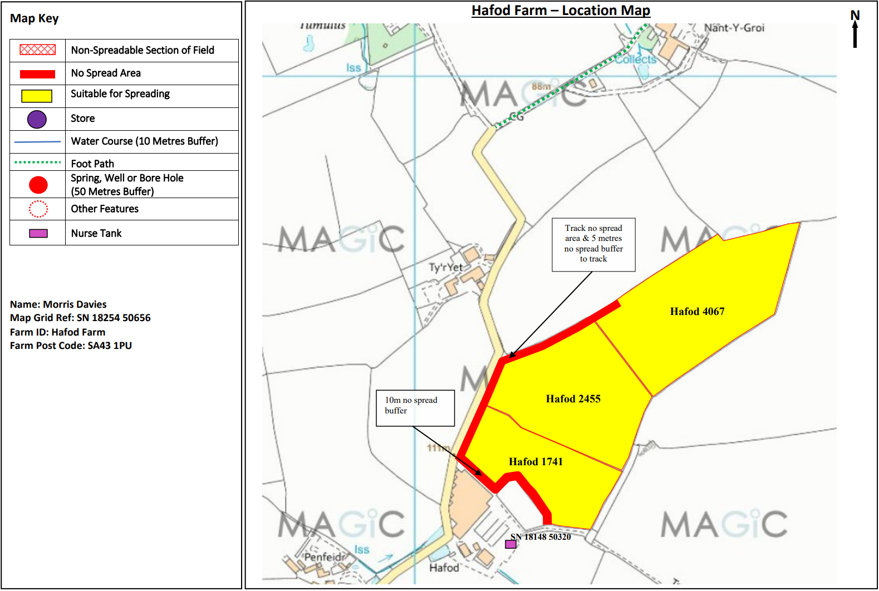

Detailed river network:
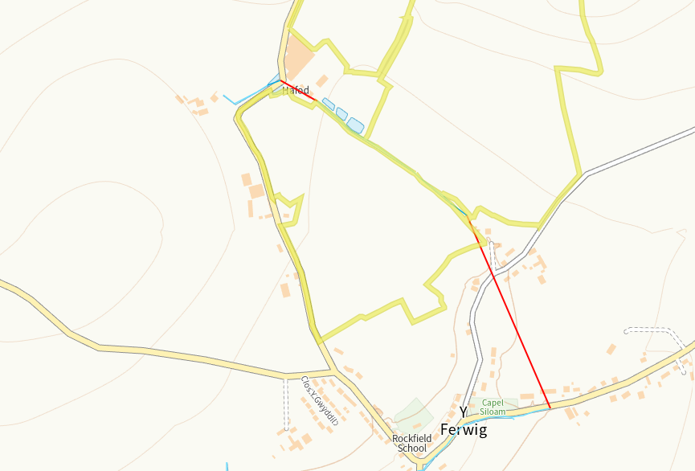
There is a modified attribution runs adjacent to Hafod 0720, Bolafron 2611, Bolafron 2893 and Hafod 4315. There is 10m no spread buffer zones implemted either side of the watercourse to mitigate any potential run off.
Groundwater protection zones (source)
None in range
Wells, springs or boreholes used for the supply of water for human consumption including from a private water supply or supplies
None in range
any springs wells or boreholes not used to supply water for domestic or food production purposes within 50m

None in range
European designated sites- Natura 2000 (SPA, pSPA, SAC or cSAC) or Ramsar- or SSSI within 500m

None in range

Other protected sites:
- Protected Species-
None in range
- Protected Habitats-
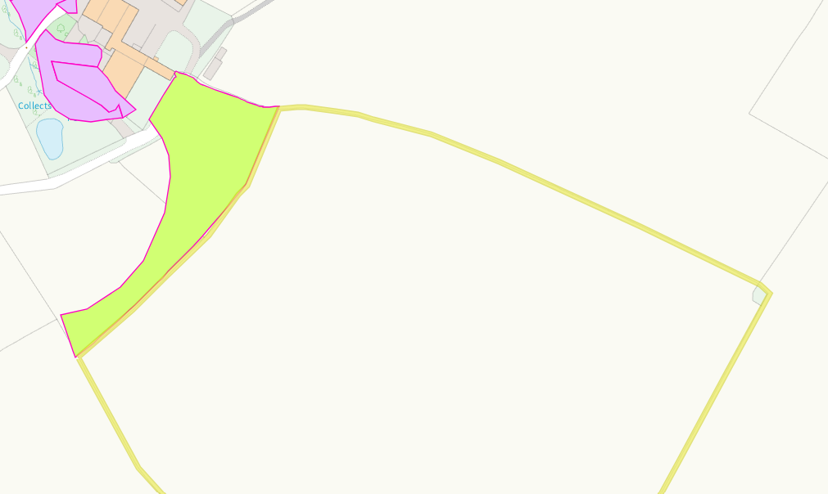
There is a section of Lowland dry grassland and Lowland calcareous grassland on the border of Nnat Y croi 9. The section of some of the field is a designate no spread buffer zone. The ariel images how on the border adjacent to the habitat there is a hedgerow I situ. Due to the accurate application method and physical barrier of a hedgerow, run off risk is low, no action required.
- Scheduled Ancient Monument-
None in range
- Local Nature Reserve-
None in range
- National Nature Reserve
None in range
- Ancient Woodlands-
None in range
- Local Wildlife Sites (SINC)-
None in range
- National Park-
None in range
- Hedges, Ditches
Nothing of concern
- Local residents, Housing, schools Workplaces, Recreational facilities
Nothing of concern

Slope Map
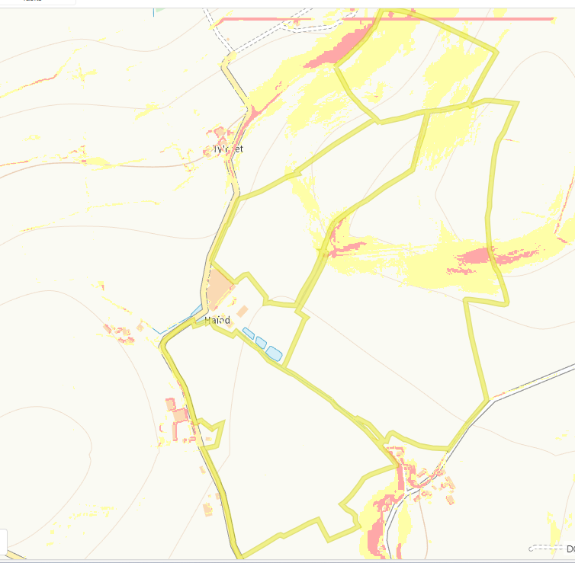
There is area of medium slope 7-12 degrees (yellow) found in fields Hafod 5761, Hafod 4734, Nant Y croi 9 and Hafod 2455. In addition 12 degree plus slopes (red) are found in fields Nant Y Croi 9 and Hafod 4734. The application method of a dribble bar is specific and in addition there is a lack of sensitive receptors in proximity to the fields. All potential receptors have appropriate buffers implemented. No action required.

