Permit
The Environmental Permitting (England & Wales) Regulations 2016

G W Lewis & Sons Ltd

1 Acre Farm
Springfield Hill
Pentre Halkyn
Holywell
Flintshire
CH8 8BA

Permit number

EPR/DB3391CQ

Permit
The Environmental Permitting (England and Wales) Regulations 2016
Permit number

EPR/DB3391CQ

The Natural Resources Body for Wales (“Natural Resources Wales”) authorises, under regulation 13 of the Environmental Permitting (England and Wales) Regulations 2016

G W Lewis & Sons Ltd “the operator”,

whose registered office is

18 Pant Glas

Pant Glas

Sychdyn

Mold

Wales

CH7 6SY

company registration number 10723570

to operate waste operations at

1 Acre Farm

Springfield Hill

Pentre Halkyn

Holywell

Flintshire

CH8 8BA

to the extent authorised by and subject to the conditions of this permit.

Under regulation 27(2) of the Regulations, standard rules SR2008 No20 are conditions of this permit.

Name | Date
Huw Davies | 13/11/2024

Authorised on behalf of Natural Resources Wales

Schedule 1 - Site plan

This is the plan referred to in the standard rules SR2008 No20

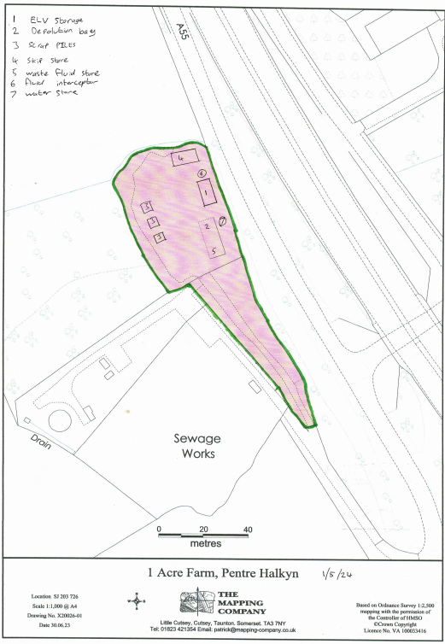

END OF PERMIT

