Annex (iv) – SSSI Assessment Form
SSSI Assessment for permit/licence and deployment applications | 
To be completed by Permitting Officers for any applications for a permission which Natural Resources Wales has considered under S28I duty to notify SNCB and take their advice into account. This applies to all proposed permissions within a SSSI, and to operations outside the SSSI boundary which are likely to damage its special features.
NRW as a Section 28G authority has, when exercising its functions, a general duty to take reasonable steps, consistent with the proper exercise of its functions, to further the conservation and enhancement of the flora, fauna or geological or physiological features by reason of which the site is of special interest’

Part 1 – SSSI Assessment
Part 2 – Formal notification to SNCB (to be completed if part 1 assessment concludes likely damage, not likely to damage because of conditions or you cannot conclude no likely damage)
Part 3 – Decision

Part 1 – SSSI Assessment

- Permitting officer/team | Anna Gale (Waste Permitting)
- Permit application reference and site name | PAN-025870
- a. SSSI name(s)  b. location  c.NRW Operational Area/Environment Team | a. Cwm Cydfin, Leckwith  b. The SSSI is located approx. 850m south of the site boundary.  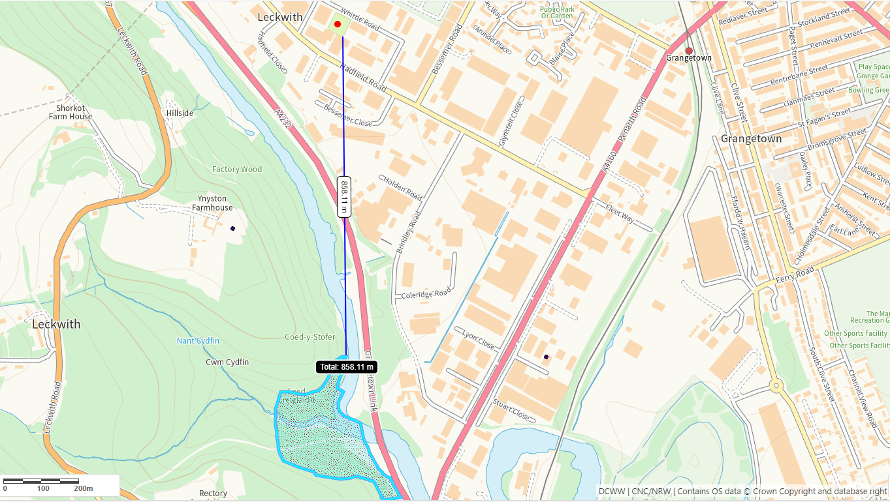  c. South Central
- Brief description of proposal | The application is a variation to change the method of treatment to mechanical dewatering by use of a hydrocyclone. The facility is currently permitted to manually dewater via gravity.  There is no other change proposed to the existing permitted activity, the change is not considered likely to increase the risk from the operation. Whilst there may be a small increase in noise from the facility as a result of the introduction of mechanical treatment, it is still considered to be a low risk and would not impact upon the SSSI due to the distance.
- What aspects of the proposed permission are likely to damage the SSSI features of special interest?

The following activities are likely to cause damage:

The only change proposed to the activity is to allow for mechanical treatment through use of a hydrocyclone. No other changes are proposed. The hydrocyclone could introduce a noise source, however due to the distance from the site boundary to the SSSI there is no pathway for noise to impact the SSSI.

The following SSSI(s) features and potential impacts have been considered to assess the likelihood of damage:

The SSSI is designated for its flora of mixed deciduous woodland and ground flora which is varied and especially rich alongside the streams. There is no mechanism for noise to impact upon flora.

- Summary of any informal advice received from internal experts (if required and including pre-app advice) | N/A
- Recommendation | The proposed permission is not likely to damage any of the flora, fauna or geological or physiological features which are of special interest.
- Signature and date assessment made | A. Gale  14/11/2024
- Officers name and job title | Anna Gale  Senior Permitting Officer (Waste)



