Navigational Risk Assessment: Inland Sea, Anglesey 2024
Background
The proposed works considered in this assessment form part of a joint project between Welsh Government, North & Mid Wales Trunk Road Agent (NMWTRA), RSPB, Kehoe Countryside & others aimed at monitoring and protecting a mixed seabird colony breeding on small islands within the Inland Sea, Anglesey.
Funded by Welsh Government via NMWTRA, a warden has been employed by RSPB from April to July 2023 & 2024 and, with necessary SSSI consents from Natural Resources Wales, habitat management works have been undertaken to improve the success of the breeding Tern colonies in particular and therefore for the site to provide a positive contribution to the Conservation Status of the Anglesey Terns SPA within which it lies.
The proposed works are planned to further protect the colony from predators (fox) and to help reduce the chance of human disturbance.
Location
The site lies within the Inland Sea on Anglesey, centred around 53.28890, -4.58938 (SH275799). The island – referred to as ‘the Spit’ – is a former spit which was cut off to form an island as mitigation for the A55 construction project.
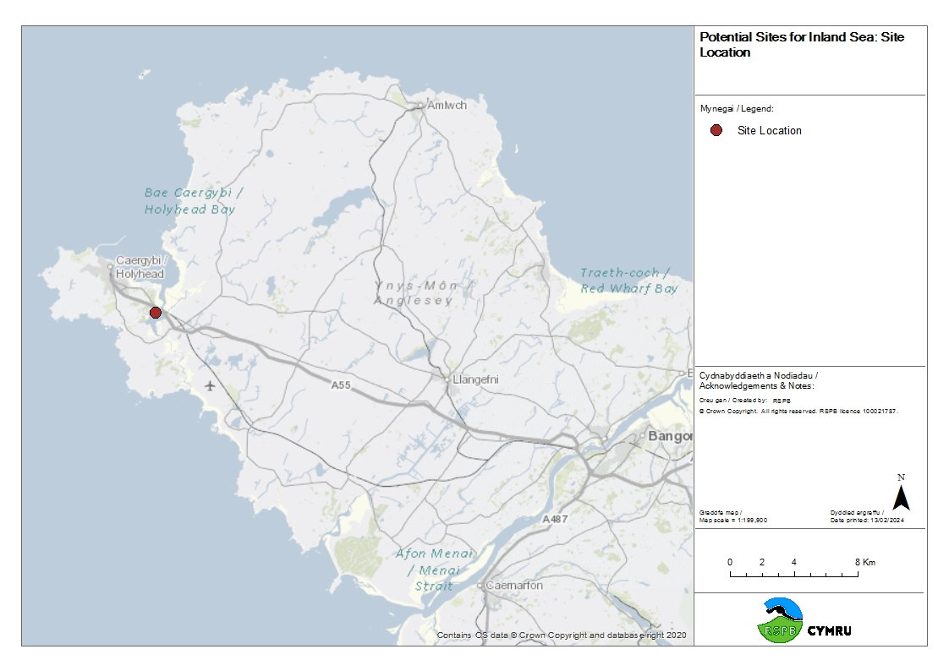
Fig 1: General Location

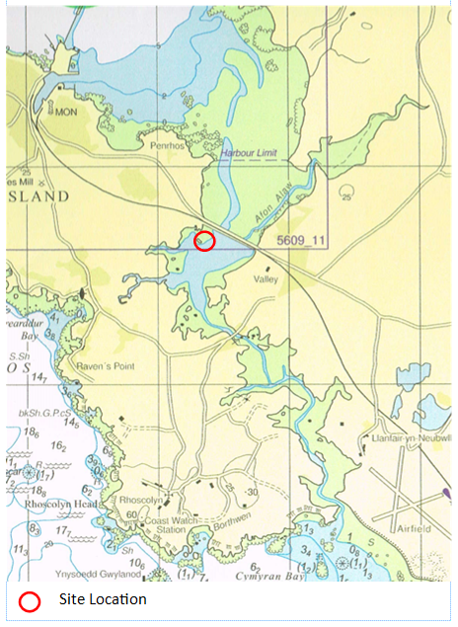
Fig 2: General location on Admiralty Chart 5609_10
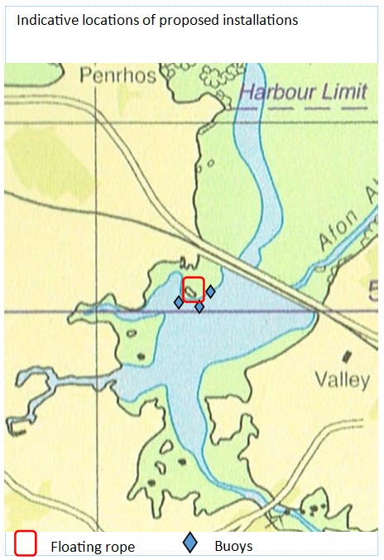
Fig 3: Indicative locations of proposed installations shown on Admiralty Chart 5609_10
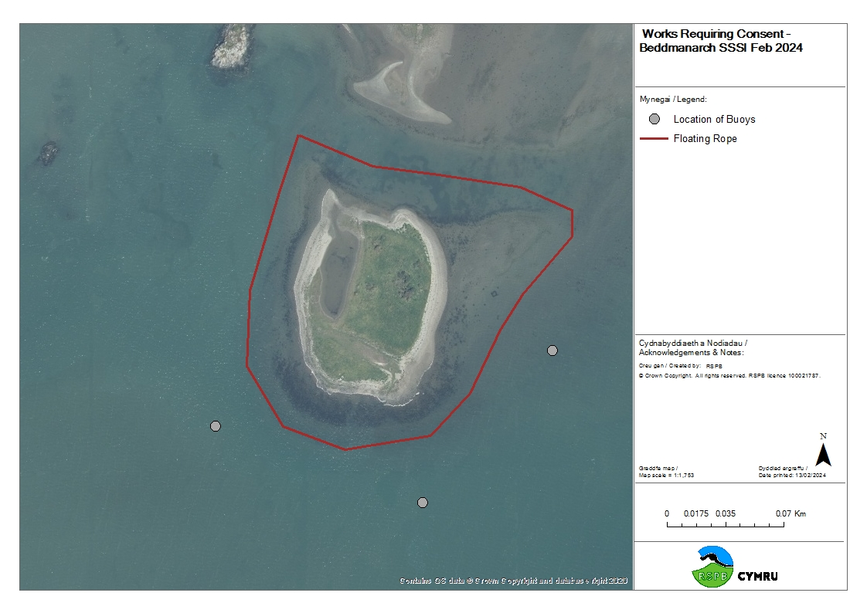
Fig 4: Detailed location of proposed installations
Proposed Installations
Two different works are proposed:
- A c610m floating rope.
- Three small buoys with signage.
Both items would be deployed annually in March and removed in August, such that they are in place during the bird breeding season but are subsequently removed to avoid damage over winter and being an unnecessary obstruction when not needed.
The floating rope surrounds the entire island at a distance of c10m offshore, placed such that it will, as far as possible, remain in water 0.5-1m deep at all times (ie at lowest tides). This should mean that it will be than 20-30m out from High Water Mark except for the North East corner of the site.

Design of rope
Design is based on Ecobarrier Swimming Safety Barrier by Ecocoast:: People Safety Booms - Ecocoast.
The rope fence is made of a minimum 8 mm thick nylon rope, with floats attached at 1m intervals by threading onto the rope.

Figure 3: Red floats and inflatable yellow floats

Red floats @1m centres along the rope, yellow inflatable floats positioned at anchor points every 20 metres.

Fixings & anchorage

- To make the set-up and dismantling of the floating fence as easy as possible the rope is made in 25 - 50 meters pieces joined together with soft shackles.
- Every 20m anchor ropes are attached to the floating rope with either D-ring galvanised shackles or carbines.
- Connecting via 16-20mm nylon anchor ropes (2 tonne breaking strain) to pieces of 20mm galvanised steel heavy chain secured to 25kg concrete blocks, which act as anchors, set every 20m. These would sit on the seabed but not be secured to it. This would aid annual dismantling and removal. Chains will constitute c1/3 of length

Figure 4: Swivel locking stainless steel clip to secure rope, anchor chains and blocks

Figure 5: 20mm galvanised steel short link chain DIN 766
Figure 6: 25kg concrete anchors to secure the rope fence
• The key is to ensure that the anchoring system does not allow a swimming fox to push the rope below the surface.
• A Danish net-maker invented this system, working with the Ministry of Environment and Food of Denmark.

Figure 5: Danish example of floating fox proof fence

The buoys would be placed c80m out from the island in water several metres deep. They would stand approximately 80cm high above water, carrying text requesting people approaching the island to avoid landing. Buoys are proposed to be Smart Buoy Co. :: Marker Buoys or similar.
Hazards resulting from these items are:
- Potential collision with obstructions. Floating items are not large or solid enough to cause significant damage but could cause capsizing of vessels travelling at speed. Concrete weights used will not protrude further than a 20cm from the seabed and should not be more of a hazard than existing rocks and stones in the area.
- Potential snagging. The rope could provide a snag risk, especially if it becomes displaced.
The securing of the rope and buoys follows the recommendation of the suppliers but has not been independently checked. Contractors and the managers of this project have little experience of similar installations. However, the environment is relatively benign, the consequences unlikely to be serious and the installations would be regularly checked and modifications can be made if necessary.
Current Situation
- General situation
The Inland Sea forms a strait between Holy Island and mainland Anglesey whose tides are significantly reduced by the restricted flows through the bridged culverts carrying the A55 & A5 in the North and the B4545 in the South across the inlets. This means that the daily tidal range is only c0.6m, although there is also a monthly cycle with the waterbody filling over a series of spring tides and emptying on neaps. Our own data – though incomplete – has not shown water levels to vary more than 1.5m.
The Inland Sea overall is relatively sheltered with a maximum fetch of 1.5km to the South of the proposed work area, and wooded areas / higher ground to the west.
Water depths vary from less than a metre in much of the Southern Section to a maximum of 8m immediately in front of the main inflow in the North. Detailed water depths around The Spit are not available, but ground levels slope away very gently in the immediate vicinity of the island.
The Western shore adjacent to the island is owned by Land & Lakes and is not at present open to the public at any time.
The island where the works are proposed is a former spit, consisting of low-lying (<1m) grassland and shingle deposits. It is owned by the Welsh Government.
- Vessel traffic
There are no main navigational routes within the Inland Sea.
Restricted access through bridged culverts at either end of this strait, and very shallow waters throughout its Southern end mean that only small craft are able to access these waters.
The Inland Sea is used by small pleasure craft including windsurfers, canoeists, kayakers, paddle-boarders, rowing boats and occasionally small powered fishing craft. Jet skis are very rare.
Most craft use the southern end of the Inland Sea, or the deeper water in the centre of the northern section (eg rod fishing a couple of hundred metres from the inflow / outflow at Stanley Embankment in the North). Very few craft approach the area where work is planned eg one sighting only during wardening period 2024 (April – July inclusive).
There are no significant launch points into the water body. Most craft are launched by hand from the shoreline at the southern end at Four Mile Bridge. There is a jetty on private land on the western side, and a semi-derelict slipway by a private track in the north-east. One or two houses adjacent to the shoreline have small slipways.
There are no moorings or anchorages.
There are no local fishing or boating clubs which are based on the Inland Sea. However, the owners of the jetty to the west (SH26937917, 925m SSW of the Spit) do occasionally host events (eg wedding receptions) which can involve an element of water-based activities in the adjacent bay.
- Designations, Restrictions & bye-laws
The area in question is part of the Beddmanarch – Cymyran SSSI, the Anglesey Terns SPA and the Caernarfon Bay Marine Character Area (MCA11).
It falls outside the jurisdiction of the Holyhead Port Authority.
No specific restrictions are known to be in place, but it is one of the areas included within Anglesey County Council’s ‘Seashore and Seaside Pleasure Boats Byelaws’. Perhaps the most relevant Byelaw is regarding speed restrictions: ‘No person being the navigator of a pleasure boat shall during the months of April to September inclusive cause of suffer such vessel to exceed the speed of eight nautical miles per hour through the water between the hours of 10.00am and 7.00pm.’
Wildfowling is permitted in winter in the Southern section from September 1st, but does not take place within the area of the proposed works.
- Cables & Pipelines
None known or suspected. Crown Estate consent has been requested for these works and will take this into consideration.
- Capability of retrieval
Should the installed items become detached the initially available responses are as follows:
Warden employed more or less coterminous with the deployment; site checked at least weekly and usually every 2-3 days.
Small inflatable boat with petrol outboard motor and/or oars available to contractors who will be installing the items can be on site within 24 hours.
Small rigid boat (2-3 persons max) belonging to RSPB available at all times at our work base on Anglesey (13 miles from site).
Large RiB, licenced for 10 passengers and fully insured, of operator known to and regularly used by RSPB is based in Four Mile Bridge adjacent to the site and could be contracted at short notice subject to availability.
There is no specific maintenance planned for the items whilst they are installed, but they will be periodically checked for issues during the breeding season.
Required Licencing
Organisations consulted / applications made at present are as follows:
- NRW (Environment Team): Section 28 consent received for planned works within SSSI.
- NRW (Marine Licencing): Consulted: Band 2 Marine Licence is required, but application not yet completed.
- Crown Estate: consent under their Small Habitat Activity Licence has been sought and is agreed in principle subject to acceptance of additional documentation (eg this NRA).
- Holyhead Port Authority: not within Port jurisdiction.
- Maritime & Coastguard Agency: advice sought regarding NRA and other requirements (ongoing).
- Trinity House: NRA sent for consideration.

Risk Matrix
Hazards/hazardous events | Who is affected | Typical outcome | Current control measures in place | Risk level  L*H -> RL
Allision (vessel collides with objects) | Public | Immersion in water  Damage to vessel | High visibility colours used  Rope adjacent to dry ground in shallow water  Placed in low-use area | Slight
Fouling in situ (rope becomes tangled with vessel) | Public | Vessel temporarily incapacitated | High visibility colours used  Rope adjacent to dry ground in shallow water  Placed in low-use area | Trivial
Items become detached | Public | Fouling of vessels | Manufacturer recommended methods of securing used.  Installations checked for signs of movement regularly (approx. weekly)  Rapid recovery options available | Slight
Fixings contact cables or pipes | Utility companies | Damage to cables or pipes | Weights used; no invasive fixtures  Installations are not close to other infrastructure | Slight
Additional measures to reduce residual risk:
Ensure Crown Estate checks undertaken for cables and pipes in vicinity. Risk = Trivial

 | Slight Harm | Harmful | Very Harmful
Unlikely | Trivial | Slight | Moderate
Likely | Slight | Moderate | Substantial
Very Likely | Moderate | Substantial | Intolerable
Ian Sims
North Wales Wetlands Warden
September 2024

