PAN-027265 My Map Report:

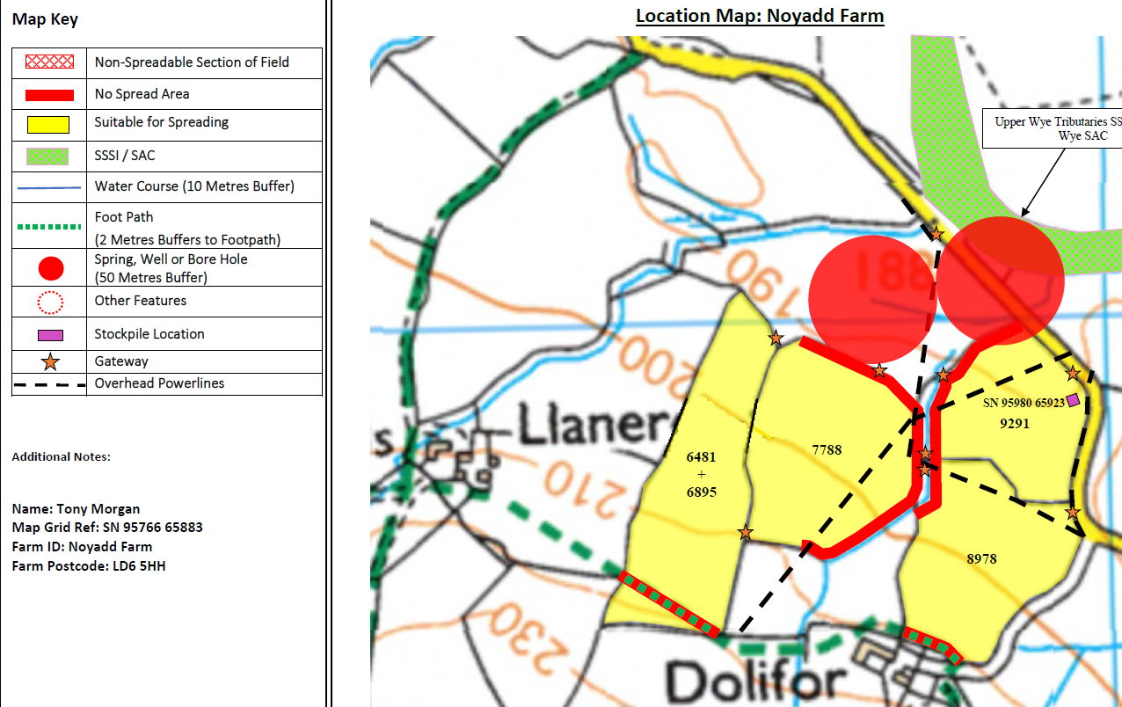
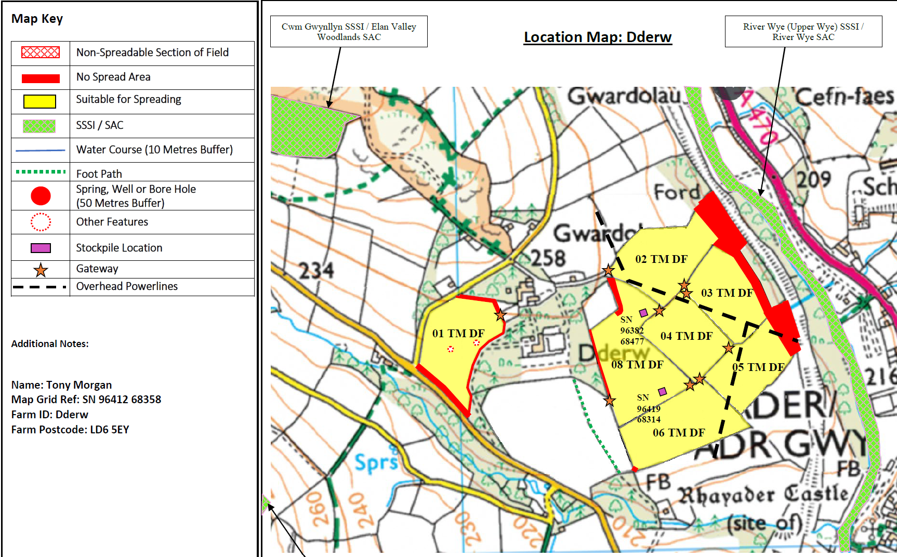

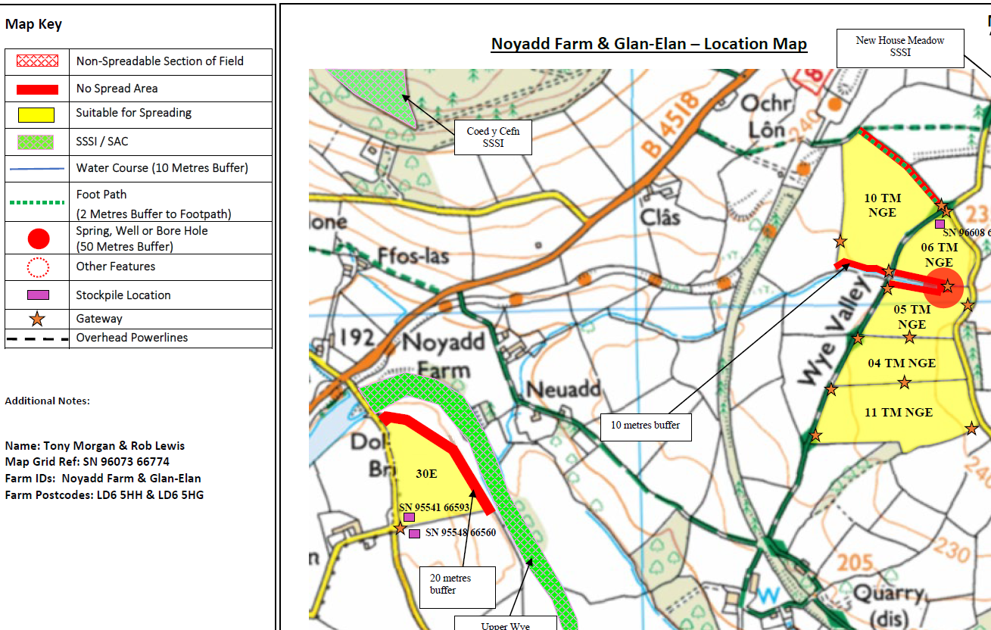

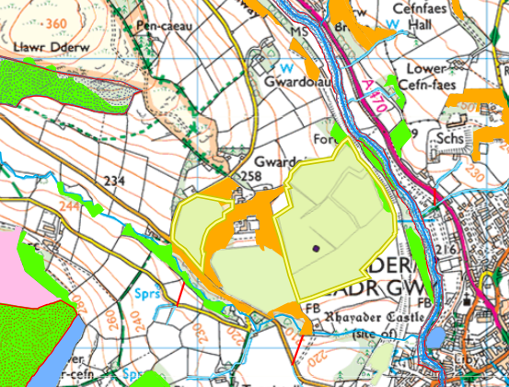

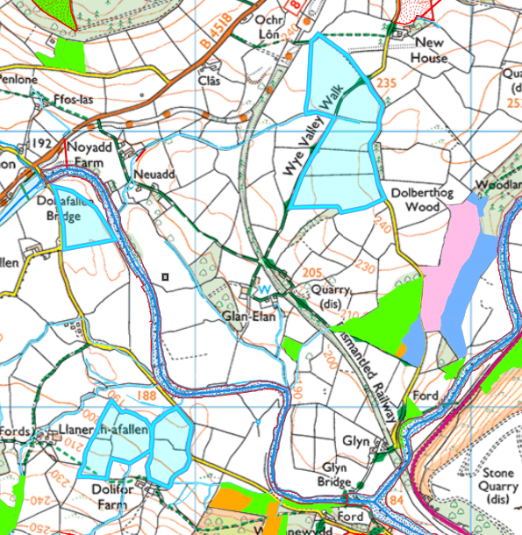

Detailed river network:
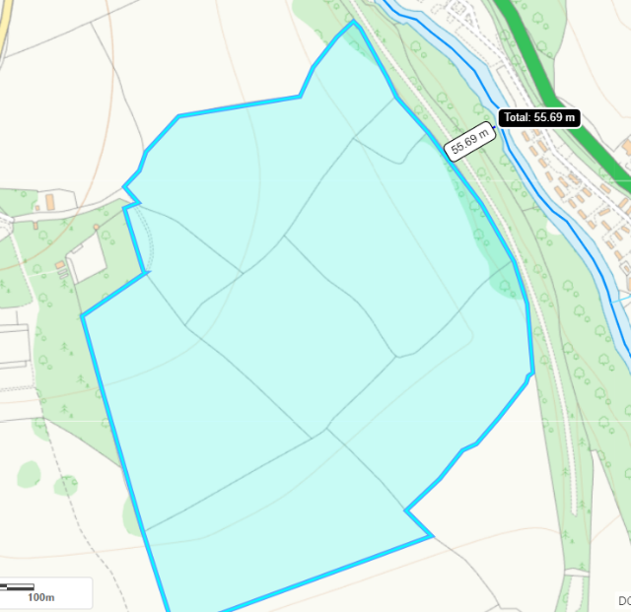
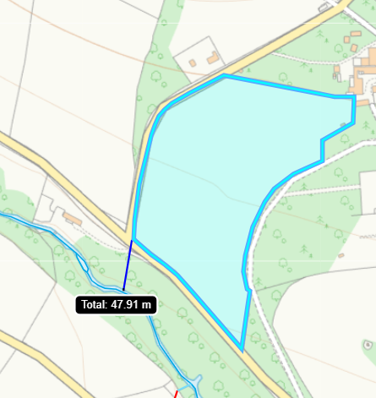
Field 02 TM DF, 03 TM DF and 05 TM DF is located 55 meters from the River Wye. There is a 20 meter no spread buffer zone in place. That minimizes the risk of nutrients entering the watercourse.

Field 01 TM DF is located 48 meters from the River Wye. There is a 10 meter no spread buffer zone in place. That minimises the risk of nutrients entering the watercourse.

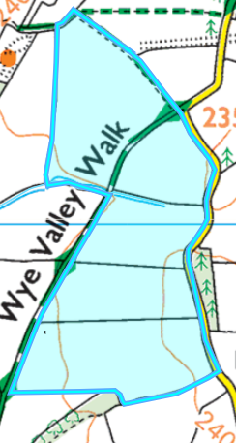
9291
Field 9291 is within 50 meters of a water issue. There is an implemented 50 meter no spread buffer zone in this area.

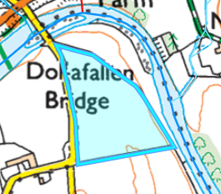
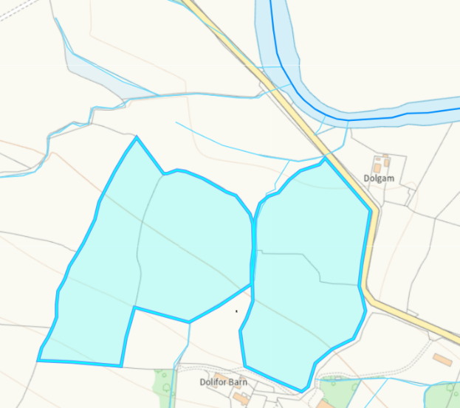
05 TM NGE
Field 05 TM NGE is located within a water issue. A 50 meters no spread buffer zone is in place to minimize risk of nutrients entering the watercourse.

30E
Field 30E is located 6 meters (at its closest point) to the River Wye SAC. There is a 20 meter no spread buffer zone in place to minimize risk of nutrients entering the watercourse.

Groundwater protection zones (source)
None in range.

Wells, springs or boreholes used for the supply of water for human consumption including from a private water supply or supplies
Matches submitted site plan.

any springs wells or boreholes not used to supply water for domestic or food production purposes within 50m

None in range.

European designated sites- Natura 2000 (SPA, pSPA, SAC or cSAC) or Ramsar- or SSSI within 500m

SSSIs
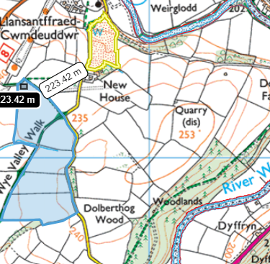
Field 01 TM DF is located within 500m of the following SSSI:
- Coed y Cefn (410 meters).
- Cwm Gwynllyn (377.5 meters).
Field 01 TM DF is located within 500 meters of the following SAC:
- Elan Valley Woodlands (378 meters)

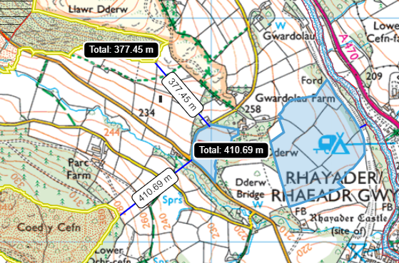

Field 10 TM NGE is located within 500m of the following SSSI:
- New House Meadow (223 meters).

Field 11 TM NGE is located within 500m of the following SSSI:
River Wye (Upper Wye) ( 450 m).

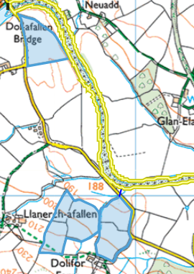
Field 30 E is located 6 meters (at the fields closest point) to the Upper Wye Tributaries SSSI.
Field 9291 is located 41 meters from the Upper Wye Tributaries SSSI.
Field 6481 + 6895 is located 404 meters from the Elenydd – Mallaen SPA .
Field 6481 + 6895 is located 404 meters from the Carn Gafallt SSSI.

9291
30E
Summary of European sites within 500 meters of spreading fields.

SSSI within 500 m of spreading fields | Closest field (meters) | Impact pathway
Cwm Gwynullyn | Field 01 TM DF 377.5 meters. | No due to proximity from spreading fields.
Upper wye tributaries | Field 30 E located 6 meters. | No, due to given distance, waste form (solid), low application 19-24 t/ha rates and additional 30 meter no spread buffer zone.
Carn Gafallt | Field 6481 + 6895 located 404 meters. | No due to proximity from spreading fields.
New house meadow | Field 10 TM NGE located 223 meters. | No due to proximity from spreading fields.
Coed y Cefn | Field 01 TM DF located 410 meters | No due to proximity from spreading fields.
River wye (upper wye) | Field 05 TM DF located 38 meters. | No, due to given distance, the waste form (solid), low application 19-24 t/ha rates and 20 meter no spread buffer zone in place in the field.
SAC
Elan Valley Woodlands | Field 01 TM DF located 378 meters | No due to proximity from spreading fields.
River Wye | Field 30 E located 6 meters. | No, due to given distance, waste form (solid), low application 19-24 t/ha rates and additional 30 meter no spread buffer zone.
SPA
Elenydd – Mallaen | Field 6481 + 6895 located 404 meters. | No due to proximity from spreading fields.

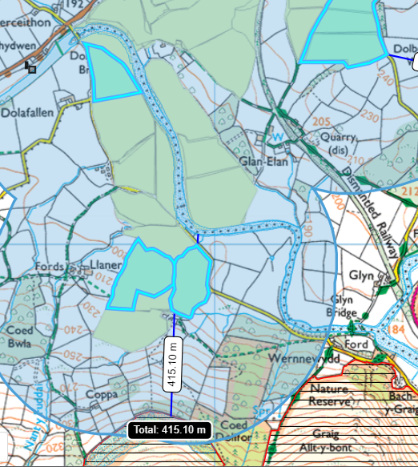
SACS
8978
30E

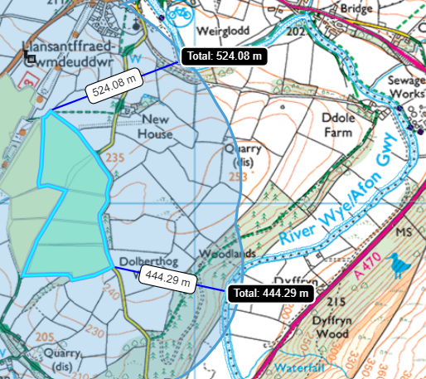
11 TM NGE
10 TM NGE

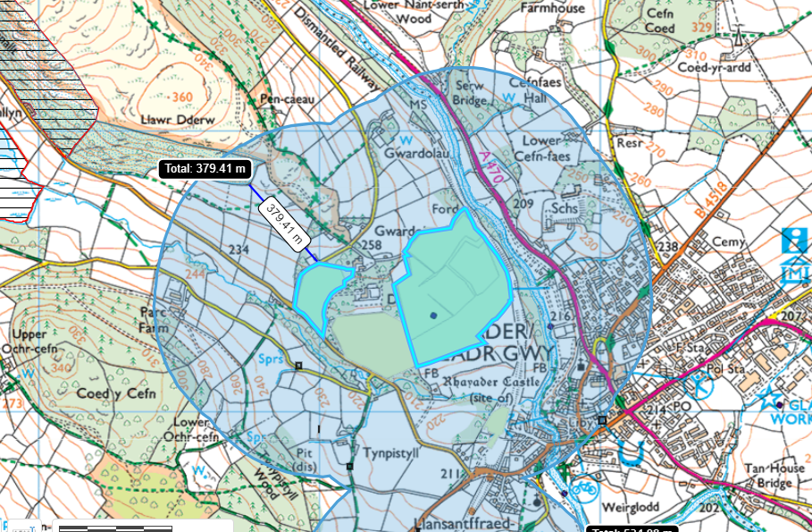
Elan Valley woodlands SAC
01 TM DF

Other protected sites:
- Protected Habitats-
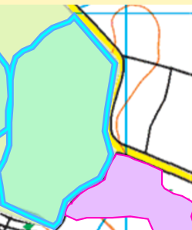
Field 8978 borders an protected habitat: Purple moor grass and rush pastures. No impact pathway has been identified due to a physical barrier separating the field and the protected site.

8978
- Scheduled Ancient Monument- None in range.

- Local Nature Reserve- None in range.

- National Nature Reserve- None in range.

- Ancient Woodlands-
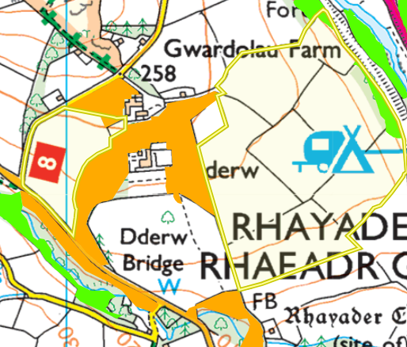
Field 02 TM DF, 03 TM DF and 05 TM DF are located within an ancient woodland: Ancient Semi Natural Woodland. There is an 30 metre no spread buffer zone in place to minimize the risk of nutrients entering the ancient woodland.

- Local Wildlife Sites (SINC)- None in range.

- National Park- None in range.

- Groundwater Safeguard Zone- None in range.

- Hedges- nothing to note.

- Ditches- see slope map.

Flooding
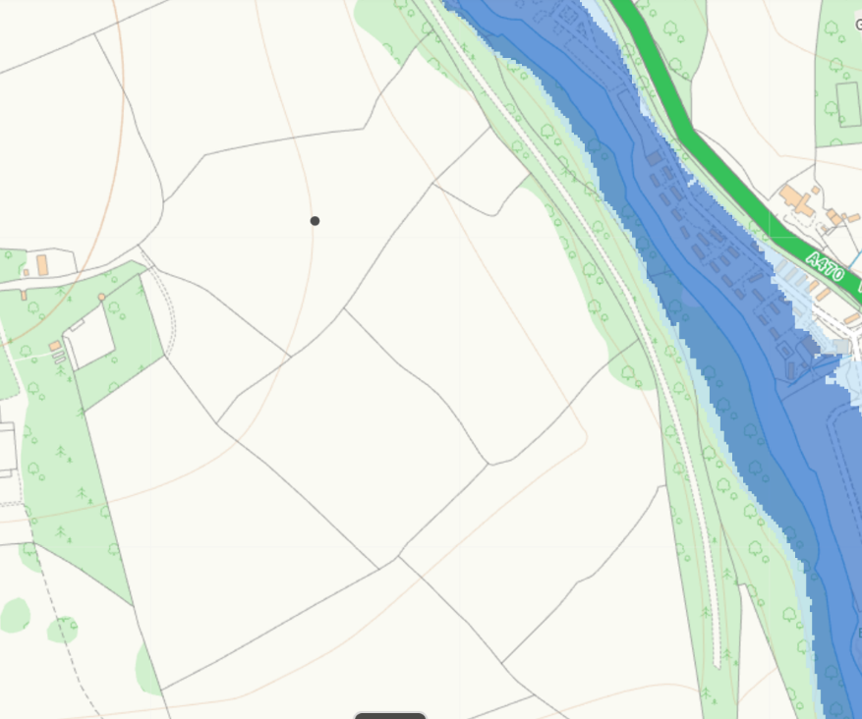
Fields 02 TM DF to 06 TM DF are not within a flood zone.
06 TM DF
02 TM DF

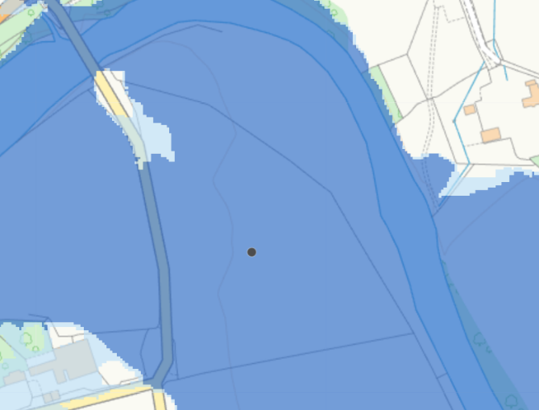
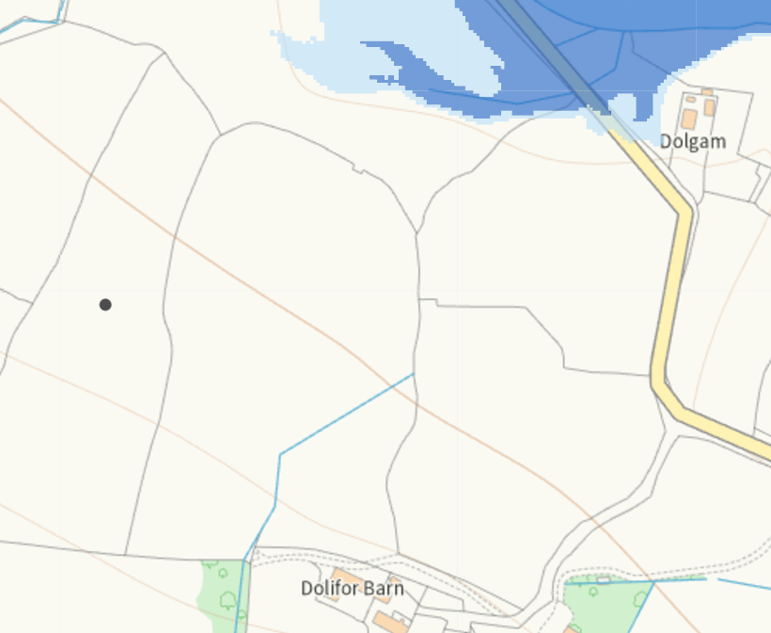
Field 30 E is on a Flood Zone 3. This is defined as an Area with more than 1% (1 in 100) in flooding. Considering this flood zone is from the River Wye SSSI and SAC. Additional information is needed to determine the risk to the SSSI and SAC. The applicant is now applying waste in field 30 E from between April and July to reduce risk of flooding due to the time of year. The field heaps in this area have also been removed from the deployment.

30E
Fields 6481 + 6895, 7788, 8978, 9291 are not located on a flood risk. Field 9291 contains a no spread buffer zone north of the field. To minimize the risk of the flooding that encroaches slightly into field 9291. (Flood Zone 3 Areas with more than 1% (1 in 100) of flooding).

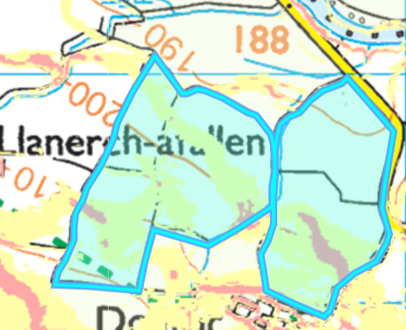
Slope Map
Fields 6481 + 6895, 8978 contain areas of highly sloping land and moderately sloping. The runoff risk has been determined as low due the following reasons:
- The waste being spread is stackable sludges so the run off risk is much lower.
- The application rate of the waste under this deployment is 19/24 tonne per hectare which is low. Reducing the risk of surface runoff.

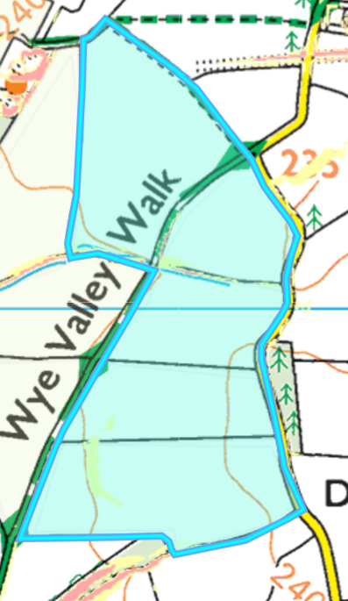
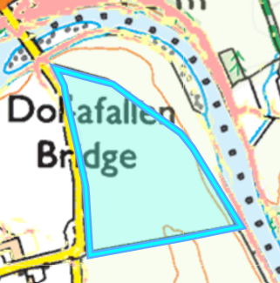
Fields 04 TM NGE to 10 TM NGE contain limited areas of moderately sloping land (7-12º). Due to the limited area which is contained to the spreading area surface runoff has been determined as low.
Field 30E is located on flat to gently sloping land (0-7º). There is no surface runoff risk.
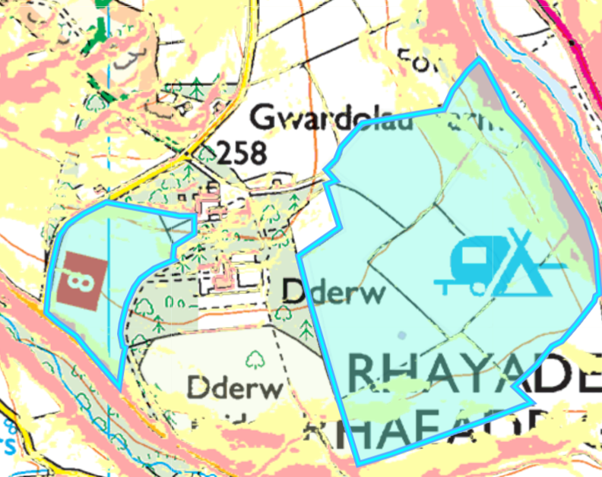
01 TM DF
Field 01 TM DF contains small areas of moderately sloping and high sloping land. There is a 10 meter no spread buffer zones in these areas. No action is required.
Fields 02 TM DF and 03 and 05 contain areas of highly sloping land. These areas have no spread buffer zones to mitigate the risk of surface runoff off no action needed.
These fields also contain moderately sloping land contained within the fields. Therefore run off risk has been determined as low.

