PAN-027141 Mapping assessment
Rights of ways
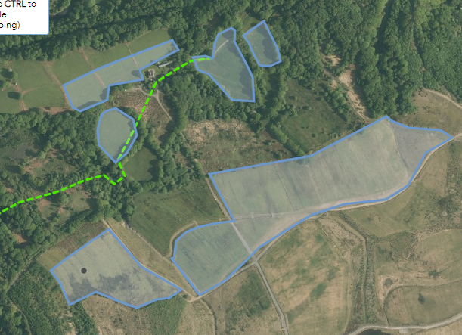
No issues to note, rights of way have been addressed in the app.
Slope map
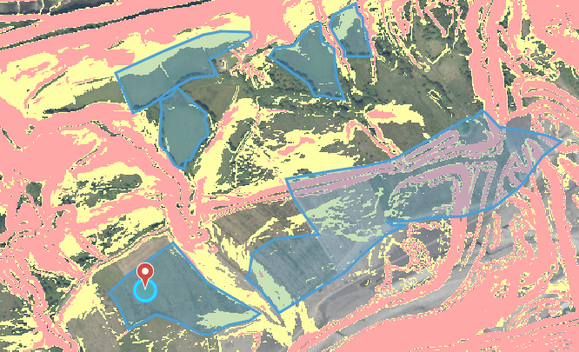
The slopes layers do not appear to be up to date with the current state of these fields. An old quarry or mine has been backfilled at this location. Assessing against this there are no issues.
Flood map
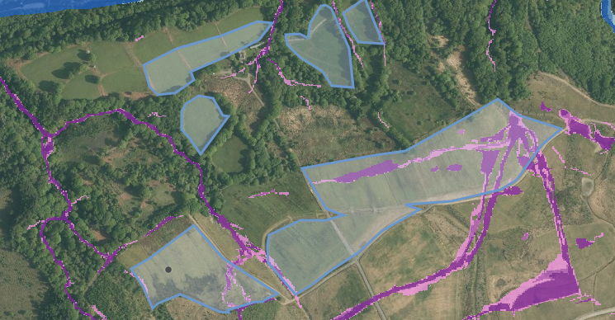
As with sloping layers the flood risk layers do not appear to be up to date with the current geography of the area
Species and Habitat
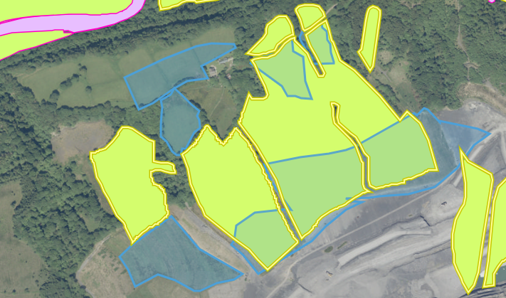
Mapping shows acidic dryland grass habitat covering these fields, this coupled with EIA evidence showing rough grassland in these fields not consistent with agricultural silage grass. This requires an RFI before drawing conclusions.
Designated sites map
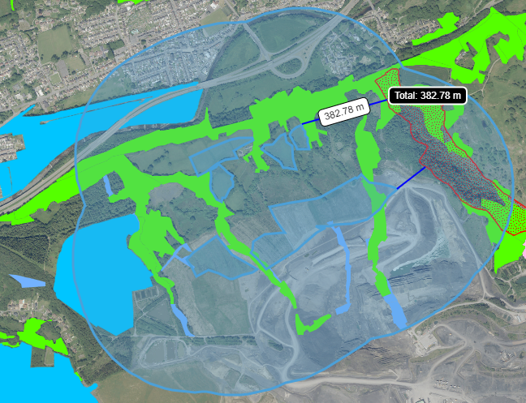
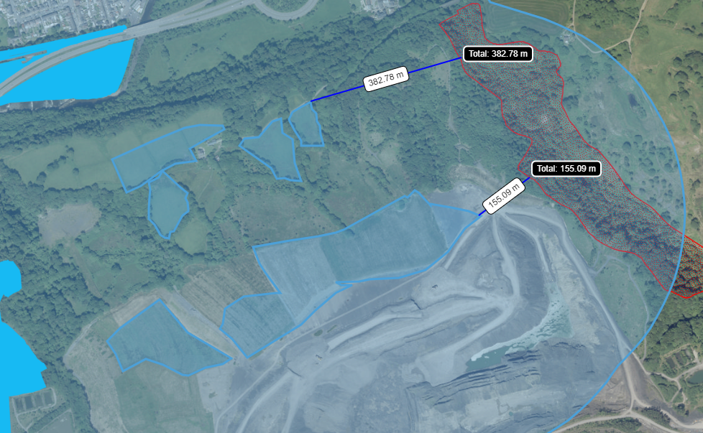
Mapping shows SSSI Cwm Gwrelych and Nant Llyn Fach streams, 155ms from the nearest field. Also shows some areas of forest and SINCs which will be unaffected by spreading.

