

Briton Ferry HWRC

Briton Ferry Industrial Estate,

Briton Ferry,

SA11 2HZ

Fire Prevention Plan
13/03/2018

1. Introduction
This Fire Prevention Plan (FPP) has been written following consultation with the following guidance documents:
- ‘Fire Prevention Plans: environmental permits’ (version 3), the Environment Agency, 29 July 2016
- ‘Reducing Fire Risk at Waste Management Sites’, Waste industry Safety & Health Forum, October 2014
The FPP forms part of the sites management system and sets out the fire prevention measures and procedures in place on ‘the site’. This is a standalone document, however it may be useful to read this in conjunction with the Fire Risk Assessment and Emergency Management Plan.
This FPP and the fire prevention measures specified within it have been designed to meet these three main objectives:
- Minimise the likelihood of a fire happening
- Aim for a fire to be extinguished within 4 hours
- Minimise the spread of a fire within the site and to neighbouring sites
All site staff shall be made aware of the location of this FPP and be able to access it at all times, including during an incident. Site staff and contractors working on site shall be made aware of the contents of the FPP so that they know what they must do:
- To prevent a fire occurring
- During a fire if one breaks out
Regular fire drills are carried out to test how well the plan works and ensure staff understand what to do. These drills will be undertaken 6 monthly as a minimum.

2. Site activities
Briton Ferry HWRC is a civic Amenity Centre. Briton Ferry is a double level facility which accepts waste at the top level and containers are emptied via the bottom level
‘The site’ accepts the following combustible wastes:
Mixed waste (containing any combustible wastes)
- Paper and cardboard
- Plastics
- Rubber (whole tyres, baled tyres, tyre shred, crumb and fibre
- Wood (including planks, boards, sawdust, shavings, logs, firewood or chips, crates, pallets, casts or barrels)
- Rags and textiles
- Scrap metal
- Refuse derived fuel (RDF) and solid derived fuel (SRF)
- Waste electrical and electronic equipment such as fridges, computers and televisions containing combustible materials such as plastic
- Green Waste
- Gas bottles
- Paints

Sensitive receptors within 1 km of the site are identified in Table 1.
Table 1. Key receptors within 1 km of site.
Key receptor | Direction | Distance from facility boundary (metres)
Industrial |  | 100 metres
Residential |  | 100 Metres
M4 |  | 100 Metres
A48 |  | 100 Meters

3. Managing common causes of fire
The possible causes of a fire at ‘the site’ have been identified In the fire risk assessment and measures in place to reduce the risk are detailed below.
3.1 Arson
To prevent or reduce risk of arson, ‘the site’ is fitted with CCTV, Manned security when site is closed and a parimiter fence with locked gates
3.2 Plant and equipment
All plant and equipment is subject to a maintenance and inspection programme. Daily/monthly checks and reguler servicing
Site vehicles / plant are fitted with fire extinguishers and mobile plant is parked away from combustible materials during non-operational hours.
3.3 Electrical faults
Fixed electrics are installed by a qualified electrician certified by NICEIC and are inspected 3 yearly. Portable appliances are tested annually.
3.4 Smoking materials
‘The site’ operates a no smoking policy, has a designated smoking area situated at the side of the main office away from combustible materials to prevent accidental ignition.
3.5 Hot works
Any hot works such as welding or cutting undertaken by staff or contractors are done so with a suitable risk assessment and safe working procedure in place. Hot works undertaken by contractors are done so under a Permit to Work and a fire watch is set for a minimum of 30 minutes after work has been completed with a final check after 60 minutes.
3.6 Industrial heaters
Industrial heaters are kept away from combustible materials, must not be covered and are switched off during non-operational hours. They are regularly maintained and inspected annualy.
3.7 Hot exhausts
A fire watch, consisting of a visual check, is carried out throughout the day to detect signs of a fire caused by dust settling on hot exhaust and engine parts. A final fire watch is carried out at the end of the operational day.
3.8 Other sources of ignition
Sources of ignition, such as naked flames are kept at least 6m away from combustible and flammable materials.
3.9 Batteries
To prevent the risk of a short circuit any batteries disconnected and removed, will be stored appropriatley following the Safe Working Procedures, before they are stockpiled for collection.
3.10 Leaks and spillages of oils and fuels
Site vehicles and plant are subject to regular inspection and maintenance as identified in section 3.2.
Oils and fuels are stored within bunded tanks or on drip trays to prevent spillage, and spill containment equipment is stored adjacent to these areas.
3.11 Build-up of loose combustible waste, dust and fluff
The site is inspected daily for build-up of loose combustible waste, dust and fluff. Cleaning is undertaken daily.
3.12 Reactions between incompatible wastes/materials
All wastes are inspected on arrival at the weighbridge, where possible, or inspected by an operative as they are being tipped. Any identified non-conforming wastes and/or incompatible wastes will be separated and quarantined immediately in an area with sealed drainage where necessary.
3.13 Hot loads
Hot loads identified prior to tipping will be placed within a quarantine area immediately. Any hot loads that have been deposited will either be removed to a quarantine area where safe to do so, or any combustible wastes adjacent to the deposited hot load will be removed to prevent spread.

4. Self-combustion
To minimise the risk of self-combustion storage times, pile volumes and heights, and temperatures of wastes are managed.
4.1 Storage time
All combustible wastes are stored for less than 6 months, see the table in Appendix 1 for storage times of each material.
Stock piles are reulerly turned
The following combustible wastes are stored for more than 3 months:
- Tyres
Extra measures to prevent self-combustion include:
- Fire walls
- Reduced pile sizes (less than maximum recommended)
- Turning
4.2 Temperature control
Heat is controlled to prevent self-combustion by:
- Waste piles / bales will be turned daily/weekly to ensure the waste remains cold and any localised warming is dissipated quickly
5. Waste piles
Pile sizes of combustible wastes are managed to help prevent self-combustion and to limit the scale of a fire if one breaks out. The table in Appendix 1 identifies the combustible waste types accepted at ‘the site’, the average daily tonnage received and how those wastes are stored. All piles are kept to a maximum of 4 metres in height and 20 metres in length/width.
Pile sizes are minimised and wastes are stored in their largest form where possible.

6. Preventing fire spread
Separation distances, fire walls/containers and bays have been used to prevent the risk of a fire spreading. The table in Appendix 1 and Drawing 2 identifies the separation distances between waste piles and/or presence of a fire wall.
6.1 Separation distances
Where separation distances have been specified to prevent fire spread rather than walls, all combustible waste piles are separated
- Other combustible waste piles
- The site perimeter, any buildings, and other combustible / flammable materials (for example gas cylinders, aerosols, flammable chemicals, fuel tanks)

6.2 Fire walls and bays
Fire walls are of a design and construction to resist fire and have a fire resistance period to allow waste to be isolated and help to enable a fire to be extinguished within 4 hours.
- the specification and construction of the walls offer a thermal barrier,
- the calculation of flame height and radiation has been taken into account
Where combustible wastes are stored within bays the following measures are in place:
- Frequent stock rotation - procedure specified within section 4.1
- A quarantine area will be used where necessary as specified below
- Mobile plant is available to allow wastes to be removed from bays quickly and effectively to isolate it during an incident

7. Quarantine area
The quarantine area will be used in the event of a fire to either hold burning wastes or to hold unburnt wastes to isolate and prevent them catching fire. The wastes will be transported with use of the site mobile plant.
A quarantine area will be available at all times, where it has been used to store non-conforming wastes these will be removed as soon as practicable and immediately in the event of a fire. This will either be done with the mobile plant available on site or by use of a suitable contractor to remove the wastes.

8. Detecting and supressing fires
8.1 Detecting fires
Regular checks, end of shift checks, manned security at night, smoke detectors, fire watch when hot works are carried out

8.2 Supressing fires
Fire extinguishers, fire blankets, staff trained

9. Firefighting techniques
The site is designed and operated to allow for active firefighting. Appropriate resources are available to fight a fire including:
- Mobile plant to move waste
- Trained operators
- Water supply
- Finances
Firefighting techniques will include some or all of the following:
- Applying water to cool unburned material and other hazards
- Separating unburned material from the fire using mobile plant
- Separating burning material from the fire to quench it
These actions will be taken under supervision from the fire and rescue service.
This Fire Prevention Plan will be agreed with the local Fire and Rescue Authority (FRA).
FRA contact details: NPT 01639 636107
Safe access for fire and rescue services will be achieved by maintaining routes for fire engines and access points around the site perimeter through good pile layout.

10. Water supplies
The fire hydrant is located outside the main gates.
11. Managing fire water
Fire water will be contained to minimise pollution from fire water as far as reasonably practicable.
The following secondary and tertiary containment facilities for fire water run-off are in place:
- Shut-off valves
- Isolation tanks
- Pollution control equipment such as firewater booms and drain mats

12. During and after an incident
In the event of a fire incoming wastes will be stopped and where required diverted to alternative sites. The alternative sites are:
- Pwllfawatkin
- Cymmer
Residents and businesses that may be affected by a fire will be contacted if considered necessary, contact details are found within the Emergency Management Plan.
Once safe to do so contaminated materials and fire water will be removed from site and disposed of by authorised parties.
The site will then be inspected and all necessary rectifications made to make the site safe prior to any operations commencing. This will be done in agreement with the sites Health and Safety Advisor and Environment Advisor.

Appendix 1 Waste types and storage

Waste type | Daily tonnage received / processed (approx.) | Total stored at any one time (tonnes) | Form |  | Max. storage time (days) | Location | Max. volume of waste pile (m3) | Maximum size of waste pile |  |  | Minimum separation (fire break) (m)
Waste type | Daily tonnage received / processed (approx.) | Total stored at any one time (tonnes) | Unprocessed; shredded; baled | >150mm; 30-150mm; <30mm | Max. storage time (days) | Location | Max. volume of waste pile (m3) | Length (m) | Width (m) | Height(m) | Minimum separation (fire break) (m)
Wood | 4 | 30 | unprocessed |  | 7 | Yard | 40yd container
Hardcore | 10 | 50 | unprocessed |  | 28 | yard | 90 | 10 | 3 | 3 | 1
Plastics | 1 | 20 | unprocessed |  | 7 | yard | 40yd container
Soil | 2 | 50 | unprocessed |  | 28 | yard | 54 | 6 | 3 | 3 | 1
Carpet | 1 | 30 | unprocessed |  | 28 | yard | 54 | 6 | 3 | 3 | 1
Mattress | 1 | 10 | unprocessed |  | 7 | Yard | 40yd container
General | 10 | 40 | unprocessed |  | 7 | yard | 40yd container
Black bags | 10 | 40 | unprocessed |  | 7 | yard | 40yd container
Scrap | 2 | 20 | unprocessed |  | 28 | yard | 40yd container
SDA | 1 | 10 | unprocessed |  | 7 | yard | 40yd container
LDA | 1 | 10 | unprocessed |  | 7 | yard | 40yd container
Batteries | 0.2 | 5 | unprocessed |  | 28 | Top yard | 3
Gas bottles | 0.5 | 5 | unprocessed |  | 14 | Top yard | 6
Fridges | 0.5 | 5 | unprocessed |  | 7 | yard | 10
Paints | 0.2 | 5 | unprocessed |  | 28 | Top yard | 3
Asbestos | 0.1 | 14 | unprocessed |  | 90 | yard | 35yd container
oils | 0.2 | 10 | unprocessed |  | 30 | yard | 1500lt Oil banks
Paper | 1 | 30 | unprocessed |  | 7 | yard | 40 yd container
Card | 1 | 30 | unprocessed |  | 7 | yard | 40 yd container
Textiles | 1 | 10 | unprocessed |  | 7 | Top yard | Clothes banks
UPVC | 1 | 10 | unprocessed |  | 7 | Top yard | 40yd container
Green | 2 | 40 | unprocessed |  | 7 | yard | 40yd container

Drawing 1. Location of sensitive receptors

Key receptor | Direction | Distance from facility boundary (metres)
Industrial |  | 100 metres
Residential |  | 100 Metres
M4 |  | 100 Metres
A48 |  | 100 Meters

Drawing 2. Site plan

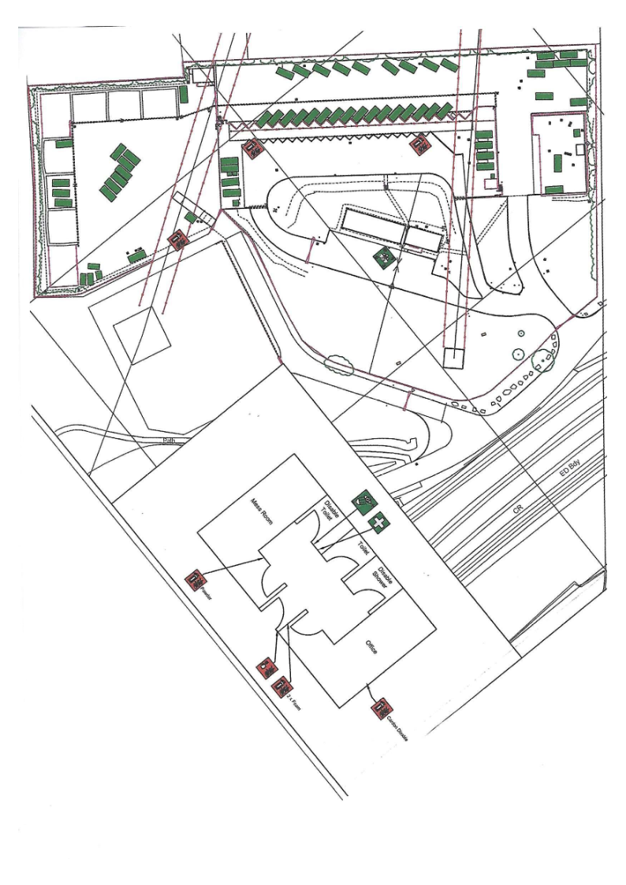

Document Training Record

Number: | IMS-FRM-046 – Fire Prevention Plan
Version:
Site: | Briton Ferry

This table is deemed to be an official training record and must be kept on file.
Please ensure that all relevant employees are made aware of the contents of the document indicated above.
Print employee name | Employee signature | Date | Trained by:

