Notice of variation with introductory note
Environmental Permitting (England & Wales) Regulations 2016

Ammanford Recycling Limited

Ammanford Metal Recycling
Shands Road
Ammanford
SA18 3QU

Variation application number
EPR/RP3098FM/V005

Permit number

EPR/RP3098FM

Ammanford Metal Recycling

Permit number EPR/RP3098FM

Introductory note

This introductory note does not form a part of the notice

The following notice gives notice of the variation of an environmental permit.

Application to vary from bespoke permit to SR2008 No20 – vehicle storage, depollution & dismantling (authorised treatment) facility and SR2008 No21 - metal recycling site.

The schedules specify the changes made to the original permit.

The permit boundary has not been amended, but a site plan has been included in this notice confirm the area that the standard rules permits apply to.

The status log of a permit sets out the permitting history, including any changes to the permit reference number.

Status log of the permit
Description | Date | Comments
Waste Management Licence issued  EAWML 34244 | 30/06/05 | Original Waste Management Licence issued to Mrs Mandy Jane Rowland.
Modification determined | 02/09/10 | The amendment to the operator’s name from Mrs Mandy Jayne Rowland, to Mrs Mandy Jayne Galinsky and also to change the facility name from E and J Autospares to Ammanford Metal Recycling.
Transfer determined EPR/RP3098FM/T003 | 01/11/16 | Full transfer of permit to Ammanford Recycling Limited.
Variation determined EPR/RP3098FM/V004 | 17/12/19 | Varied permit to change registered office address and regulator initiated variation to add in conditions relating to fire risk mitigation issued to Ammanford Recycling Limited.
Application EPR/RP3098FM/V005 | Duly made  19/06/24 | Application to vary from bespoke permit to SR2008 No20 – vehicle storage, depollution & dismantling (authorised treatment) facility and SR2008 No21 - metal recycling site.
Variation determined EPR/RP3098FM | 16/12/24 | Varied permit issued.

End of introductory note

Notice of variation
Environmental Permitting (England and Wales) Regulations 2016

The Natural Resources Body for Wales (“Natural Resources Wales”) in exercise of its powers under regulation 20 of the Environmental Permitting (England and Wales) Regulations 2016 varies

Permit number

EPR/RP3098FM

issued to:

Ammanford Recycling Limited (“the operator”)

whose registered office is

The Old Wagon Works

Shands Road

Ammanford

Wales

SA18 3QU

company registration number 10303550

to operate a regulated facility at

Ammanford Metal Recycling

Shands Road

Ammanford

SA18 3QU

to the extent set out in the schedules.

The notice shall take effect from 16/12/2024

Name | Date
Huw Davies | 16/12/2024

Authorised on behalf of Natural Resources Wales

Schedule 1 – conditions to be deleted

The following conditions are deleted as a result of the application made by the operator:
- All conditions

Schedule 2 – conditions to be amended

None

Schedule 3 – conditions to be added

The following conditions are added as a result of the application made by the operator
- Under regulation 27(2) of the Regulations, standard rules SR2008 No20 and SR2008 No21 are conditions of this permit.

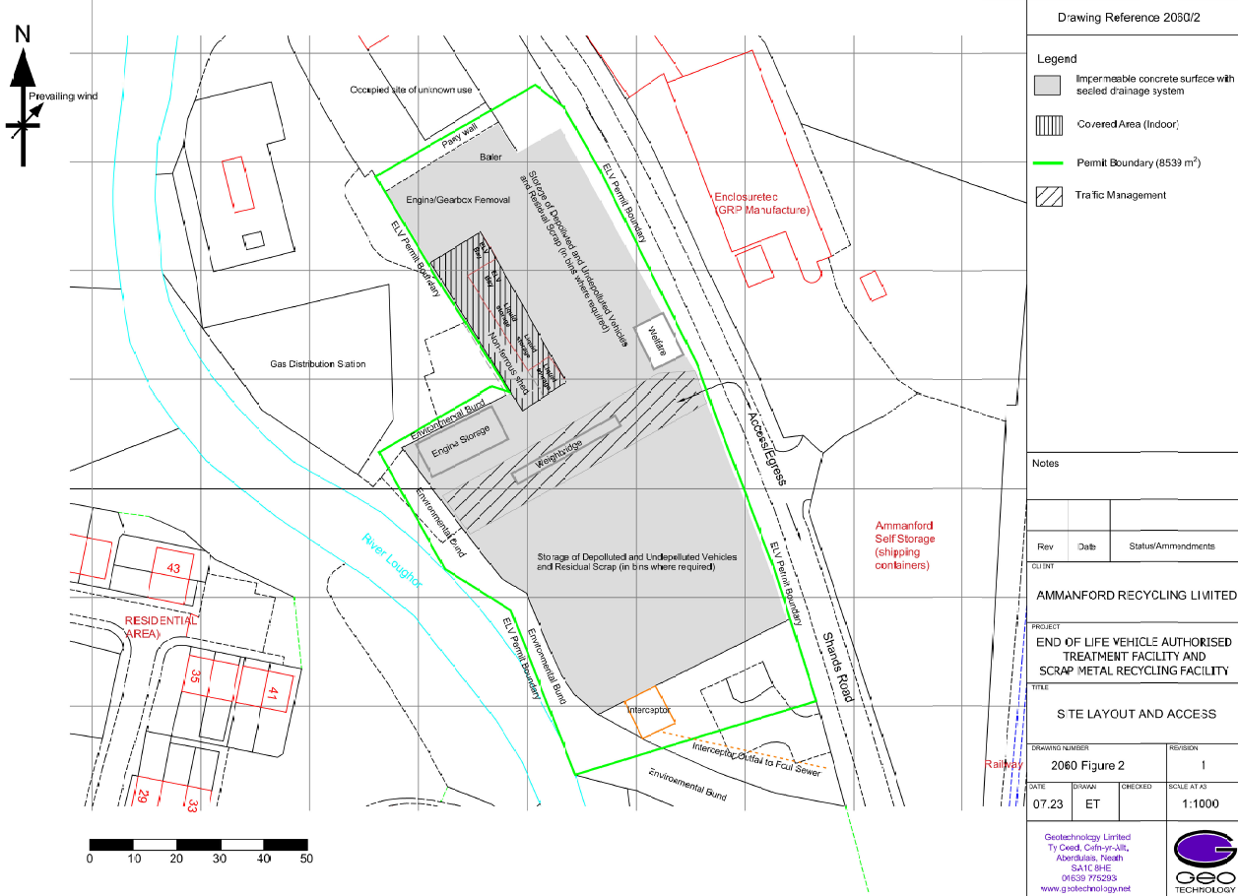
Schedule 4 –plan
© Crown Copyright and database right 2024. Ordnance Survey licence number 100019741.

