Permitting - Waste Recovery Plan assessment form
Date Published: October 2024

Reference number: OGN 222, annex 1
Document Owner: Wales Permitting Service

Version History
Document Version | Date Published | Summary of Changes
1.0 | 10-2024 | Document published
Review Date: 10-2026

Waste Recovery Plan Assessment
Plan details
PPN/PAN reference: | PAN-023949
EPR reference | EPR-BU8819IV
Applicant name: | FCC Waste Services (UK) Ltd
Facility/site name & address:
  Rhydyfro, Pontardawe, SA8 4RX
Waste regulation team: | SW Industry Reg Team
Permitting officer name: | Jennifer McGuire
Date of assessment: | 31/10/2024 (updated 10/12/2024)

Part 1: Evidence to support recovery of waste
The WRP must demonstrate that waste is substituting a non-waste, this can be demonstrated one of three ways.
- Financial benefit by using non-waste
- Funding to use non-waste
- Obligation (specific or general)

Only one of these ways needs to be demonstrated, but we should consider any evidence provided.

Financial gain or other worthwhile benefit by using non-waste materials
Have details of the scheme that will provide financial (or other worthwhile) benefit been included? | NO
Has the expected income or capital gain (or other worthwhile benefit) been included?
Have all the costs of generating this income / capital gain (or other worthwhile benefit) been specified? Including the costs of carrying out the scheme with non-waste and ongoing operating costs.
Does it show that it would be commercially or otherwise worthwhile to complete the scheme using non-waste. E.g. there would be a meaningful financical gain / it is affordable and otherwise worthwhile

Funding to use non-waste materials
Has evidence been included that shows the scheme falls within the applicants area of responsibility / activity? | NO
Has evidence been included that shows the scheme would result in a benefit that is proportionate to the scheme?
Has evidence been provided to show that the applicant has secured the funding needed to cover all the costs of using non-waste, and ongoing operating costs

Obligation to complete the scheme

Specific obligation
Has evidence been supplied to demonstrate there is a specific obligation on the applicant? | YES  Operator is required to restore landfill to complete final landform as required by planning permission ref. P2021/1277.  Copy of consent provided which includes conditions requiring the restoration to be carried out in accordance with specific drawings/plans and a survey to be carried out once complete to ensure conditioned restoration levels have been achieved.
Does this include plan and cross sections that show the proposal matches the obligation? | YES  Planning conditions reference drawings that have been provided within the WRP but the actual drawings associated with the planning conditions have not been provided. I have accessed Neath Port Talbot planning portal to view these. Although some drawings have been updated slightly to correct computer errors and updated topography, the levels of the restored landform are the same in the planning permission and the WRP. See example of comparison below:  Post settlement cross sections (left : WRP, right: planning permission)  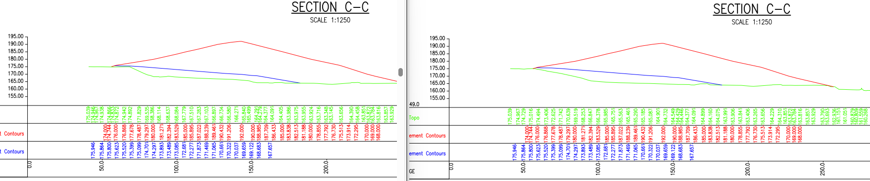

General obligation
Has evidence been supplied to demonstrate there is a general obligation? i.e. an obligation to achieve a certain result but not how. | N/A

Does the WRP demonstrate why the obligation would be met by carrying out the scheme proposed?

Does the WRP show how the proposed scheme meets the obligation?

In the case of a planning condition
Was the local planning authority directly involved in the design of the scheme when planning was granted? | Unknown but not anticipated.
Would the local planning authority be likely to agree anything significantly different? | Reasonable to assume this is unlikely – the planning permission was originally submitted in Dec 2021 and wasn’t issued until April 2024. During this time it would be expected any changes required would have been made. Furthermore the planning conditions are for waste to stop being accepted on site end of October 2024 and for restoration to be completed by end of October 2025.

D. Evidence the waste is suitable
Have the waste types been identified, and the function / use they are fulfilling? | YES  All wastes proposed will be used for capping and restoration. It was confirmed during determination that recovered waste will not be required for the construction of the soil buttress as originally proposed in the application.
Are the waste types and uses included in the list of waste types and typical uses in our guidance? | YES
Does the waste and intended use meet the relevant restriction criteria in the list? | YES  All wastes codes proposed are suitable for landscaping associated with construction work and structural fill for stabilising slopes alongside various other uses. We consider the waste type being added to the permit under the WRP suitable for the intended use.  The operator has confirmed they meet the relevant restriction criteria, this includes confirming to BS3884:2015 where using certain wastes in place of topsoil.

If the waste types and/or uses are not listed in our guidance or it does not meet the relevant criteria:
Has information been provided about the chemical properties of the waste? | N/A – all waste types are listed in our guidance
Has information been provided about the physical properties of the waste? | N/A – all waste types are listed in our guidance

Has information been provided about the engineering properties of the waste?
Does this evidence show that the waste is suitable (in principle) for the intended purpose? | N/A – all waste types are listed in our guidance
Does the evidence show that the waste will not cause pollution? | N/A – all waste types are listed in our guidance
Has the evidence been provided by an appropriately qualified person? | N/A – all waste types are listed in our guidance
Does the WRP show that the specification of the waste is comparable to the non-waste being replaced? | N/A – all waste types are listed in our guidance

Part 2: Other information required unless there is a specific obligation that specifies these details

Purpose of the work
Has evidence been provided to show how the scheme will be carried out and completed? | N/A – there is a specific obligation which specifies these details
Has evidence been provided to show why the scheme is needed? | N/A – there is a specific obligation which specifies these details
Has evidence been provided to show how the scheme will meet that need? | N/A – there is a specific obligation which specifies these details

Quantity of waste used
Has evidence been provided to show that only the amount of waste needed will be used? | N/A – there is a specific obligation which specifies these details
Has evidence been provided to show that alternative proposals that use a smaller amount of waste to achieve the same function have been considered? | N/A – there is a specific obligation which specifies these details
Have plans and cross section been provided showing original and planned final ground levels? These must be to a suitable scale and levels shown relative to ordnance datum. | N/A – there is a specific obligation which specifies these details

Evidence the scheme is sustainable
Has evidence been provided to show how the scheme will be designed and constructed? | N/A – there is a specific obligation which specifies these details
Does the evidence show how the scheme will be fit for purpose? | N/A – there is a specific obligation which specifies these details
Does the WRP demonstrate that the finished scheme will not result in pollution or any other environmental problems, such as soil erosion, increased risk of flooding? | N/A – there is a specific obligation which specifies these details

Decision

Does the WRP demonstrate recovery?
YES

