CRoW Appendix 4 (140_10_SD02)  CRoW Act 2000: Natural Resources Wales application for permission - Formal Notice |  | 
Natural Resources Wales Formal Notice.
Requirements of Section 28I of the Wildlife & Countryside Act 1981 as amended by the Countryside and Rights of Way Act (CRoW) 2000.
Duty in relation to granting any consent, licence or permit for activities likely to damage Sites of Special Scientific Interest (SSSI).
Guide to filling in this form for Natural Resources Wales staff:
To be completed by Permitting Officers for any applications for a permission which the Natural Resources Wales has considered under S28G duties to protect and enhance SSSIs. This applies to all proposed permissions within a SSSI, and to operations outside the SSSI boundary which are likely to damage its special features.
Refer to OI 140_10 ‘Applying the Countryside and Rights of Way (CRoW) Act 2000 to applications for permits with potential for impact on Sites of Special Scientific Interest (SSSI)’, including the flowchart in Appendix 2.
Pink italic text – drafting notes, to be deleted before completion/consultation.
Blue text – examples, to be replaced with permission-specific information.
Ensure you have completed all sections.
- Natural Resources Wales area/region/NPS hub: | West
- Name of SSSI: | Afon Cleddau Gorllewinol/Western Cleddau River
- Type of permission: | SR 2010 No4 under EPR
- Date for Natural Resources Wales permit determination: | 05/12/2024
- Predicted 28 day date for response from NRW conservation/ecology (under S28 I(4)): | N/A
- Natural Resources Wales reference no: | PAN-027465
- National grid reference: | SM 98851 24924
- Description of proposal: | An application to spread a maximum of 7660 tonnes of waste materials over 49.2ha of fields at Hook Farm, SA62 5QX and New House Farm, SA67 8DE. There are 6 waste streams, all under waste code 19 09 02. Spreading is proposed to take place in targeted periods of spreading throughout the year across all fields, please see Agricultural Benefit Statements for in depth details. Wastes to be spread include liquid sludge and sludge cake. Wastes will be spread in accordance with CoGAP.
- Is the proposed activity within (wholly or partially) the SSSI boundary? | NO  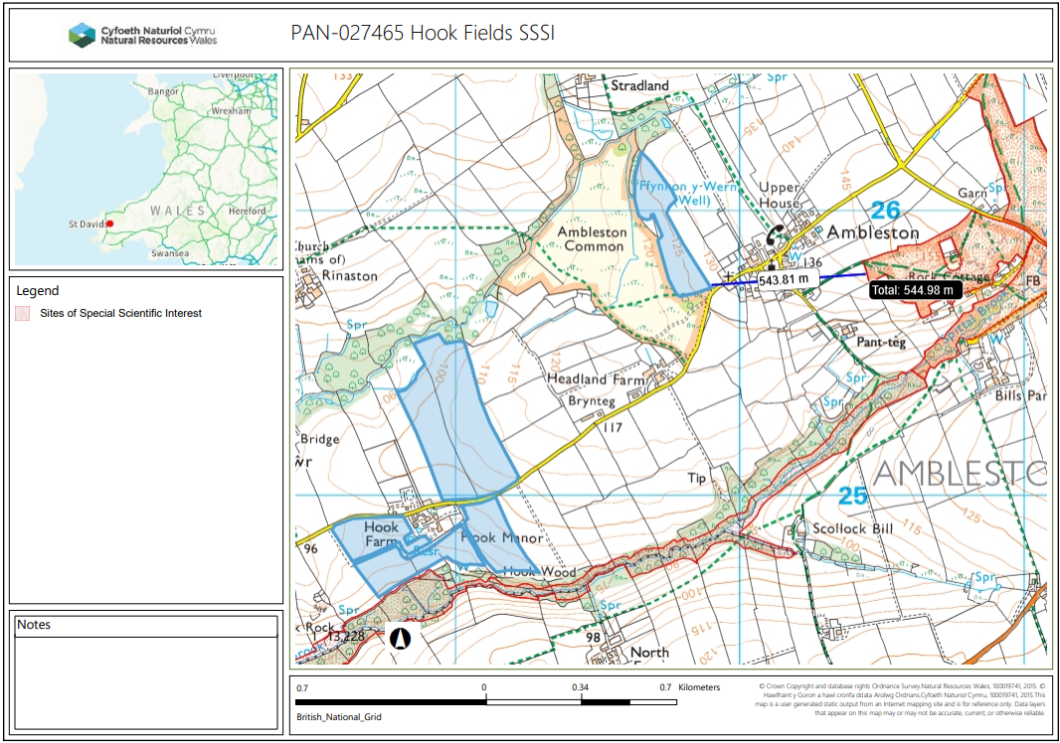  The below fields are also part of the deployment but not near to a SSSI:  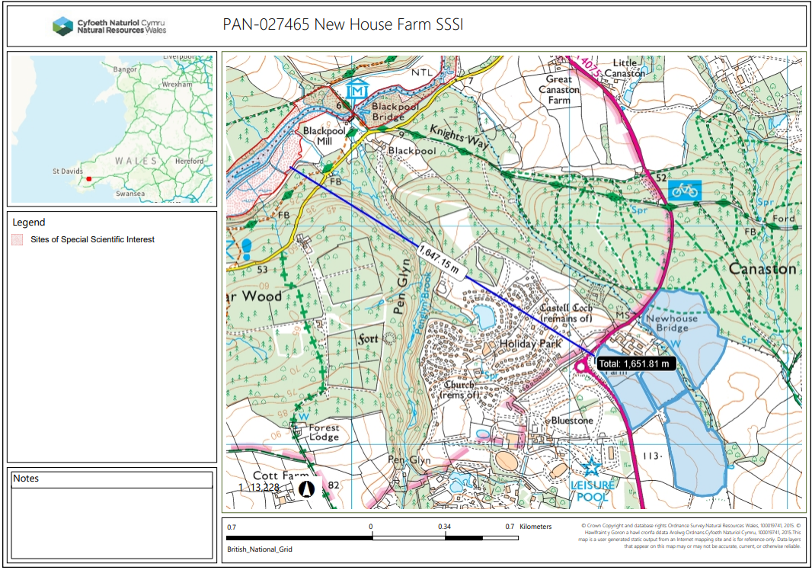
- Has there been any pre-application discussion or correspondence with NRW conservation/ecology | NO  Previous deployment PAN-019621 issued in 2022 covers the fields of concern.
- What aspect(s) of the proposed permission may damage the features which are of special interest for the SSSI?
The following ‘Operations Requiring Consent’ (or other activities associated with the permission) that may cause damage) are relevant to the proposed permission.
5. Application of manure, slurry, silage liquor, fertilisers and lime.
7. Dumping, spreading or discharging of any materials.
26. Use of vehicles or craft that are likely to damage the special features of the site.

The following SSSI features and mechanisms of impact have been considered to assess the likelihood of damage:
- River habitats including water crowfoot habitat
- Associated riverside habitats (including semi-natural broadleaved woodland, scrub, marshy grassland, swamp and mire)
- Otter
- Fish (bullhead, brook lamprey, river lamprey, sea lamprey)

- Decision
i) The proposed permission is not likely to damage any of the flora, fauna or geological or physiological features which are of special interest.
- 20m no spreading area between fields and SSSI
- Liquid sludges will be spread using trailing shoe/hose or dribble bar to reduce spray. Spreading machinery will be turned off prior to turning at the end of each field.
- Solid wastes will be spread using conventional rear discharge spreader. 20m no spread zone will ensure none of the solid waste reaches the SSSI.
- CoGAP will be followed throughout the duration of the deployment.
- SSRA has been written to take the SSSI into account.
- All spillages will be immediately reported to NRW.
- No machinery turns in buffer strips.
- All waste deliveries to fields and stores will be done under supervision.
- Contingency plans will be in place for machinery issues, staffing, and adverse weather conditions.

Natural Resources Wales is minded to:
Issue the permission

- Name and job title of Natural Resources Wales officer: | Rhiannon Smith  Permitting Officer
- Date form sent to NRW conservation/ecology | N/A
For Natural Resources Wales use only, once NRW conservation/ecology response received
- NRW conservation/ecology comment on assessment: | i) NRW conservation/ecology advise the operation can go ahead  ii) NRW conservation/ecology advise the operation can go ahead with conditions  iii) NRW conservation/ecology advise against permitting the operation  Please ensure that the NRW conservation/ecology response is attached to this Formal Notice.
- Name and job title of NRW conservation/ecology officer:
- Date of receipt of NRW conservation/ecology response:

