PAN-027358 My Map Report:
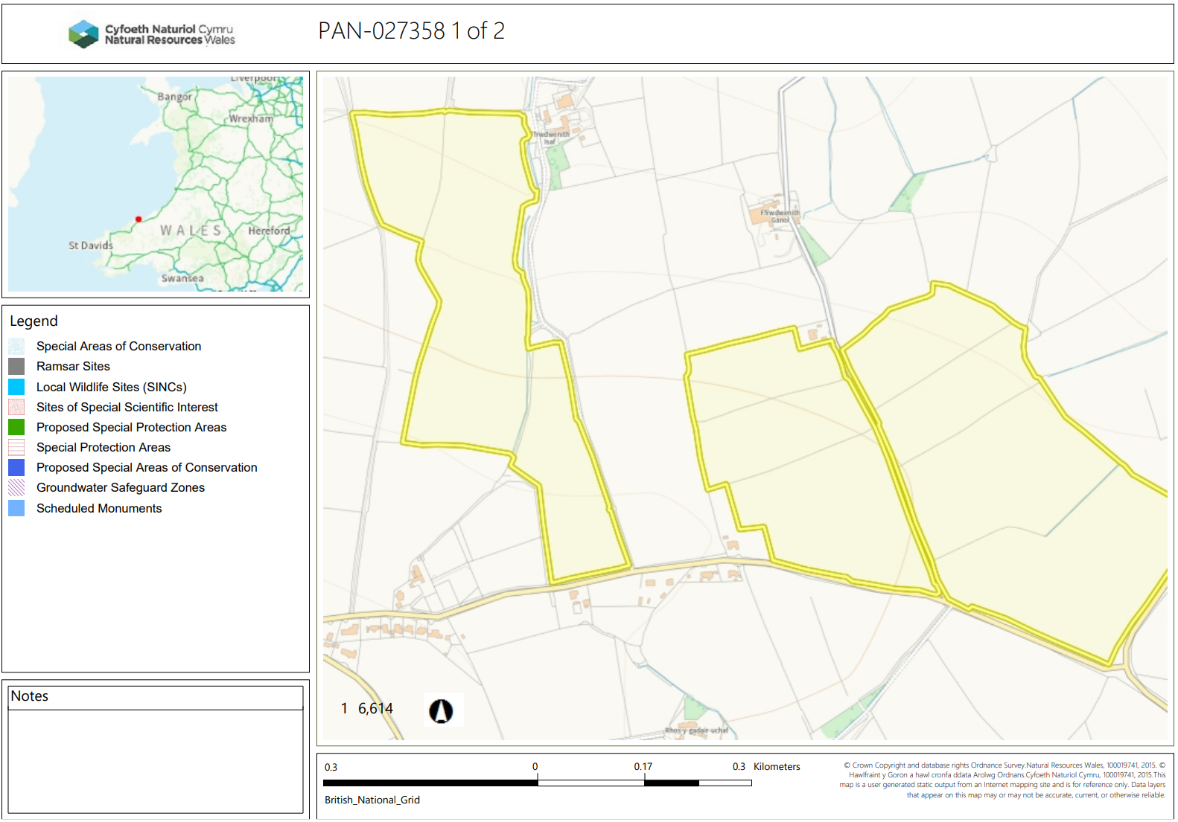
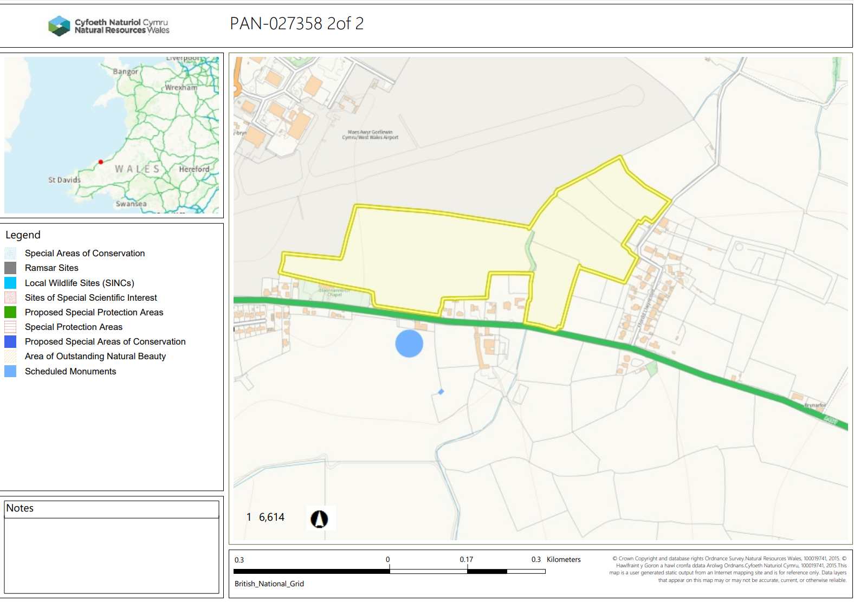
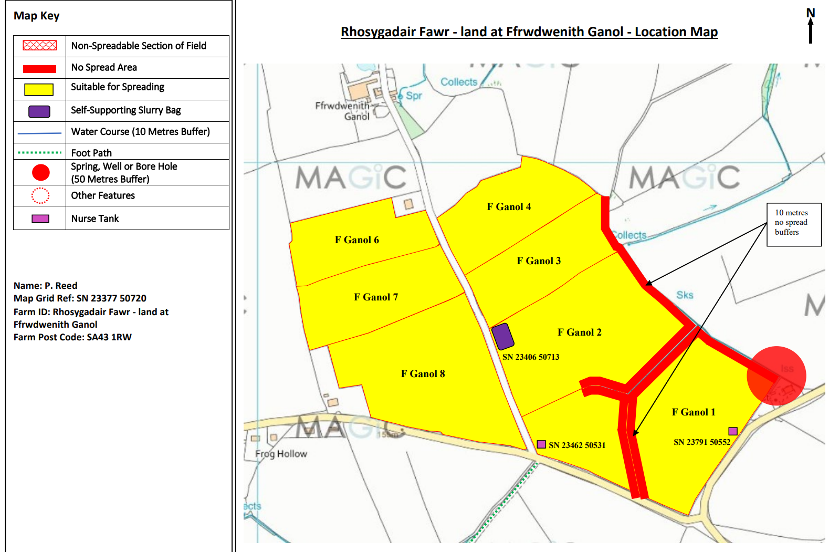
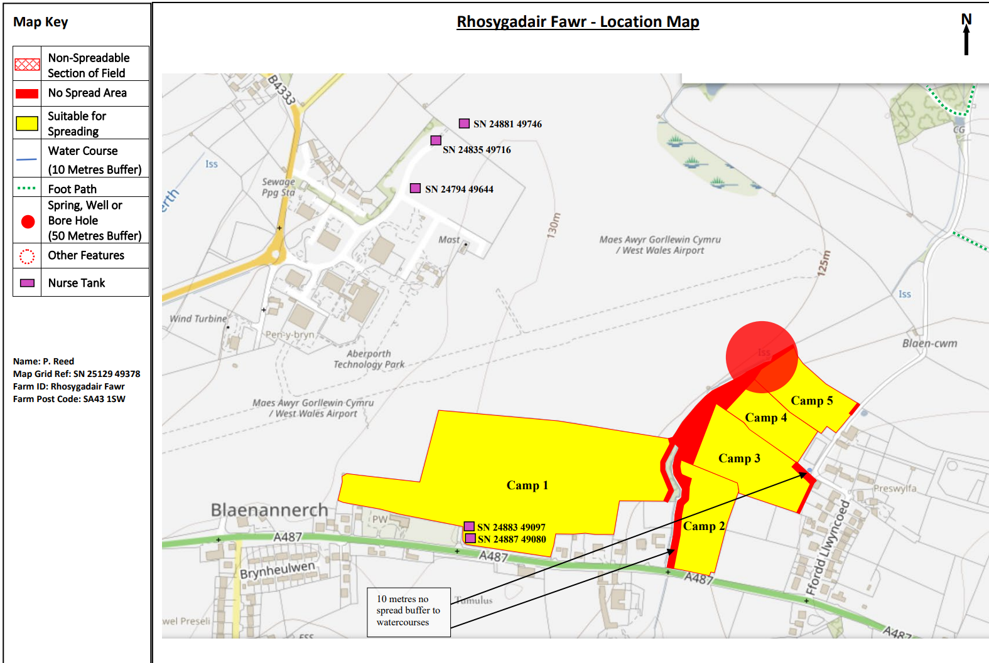
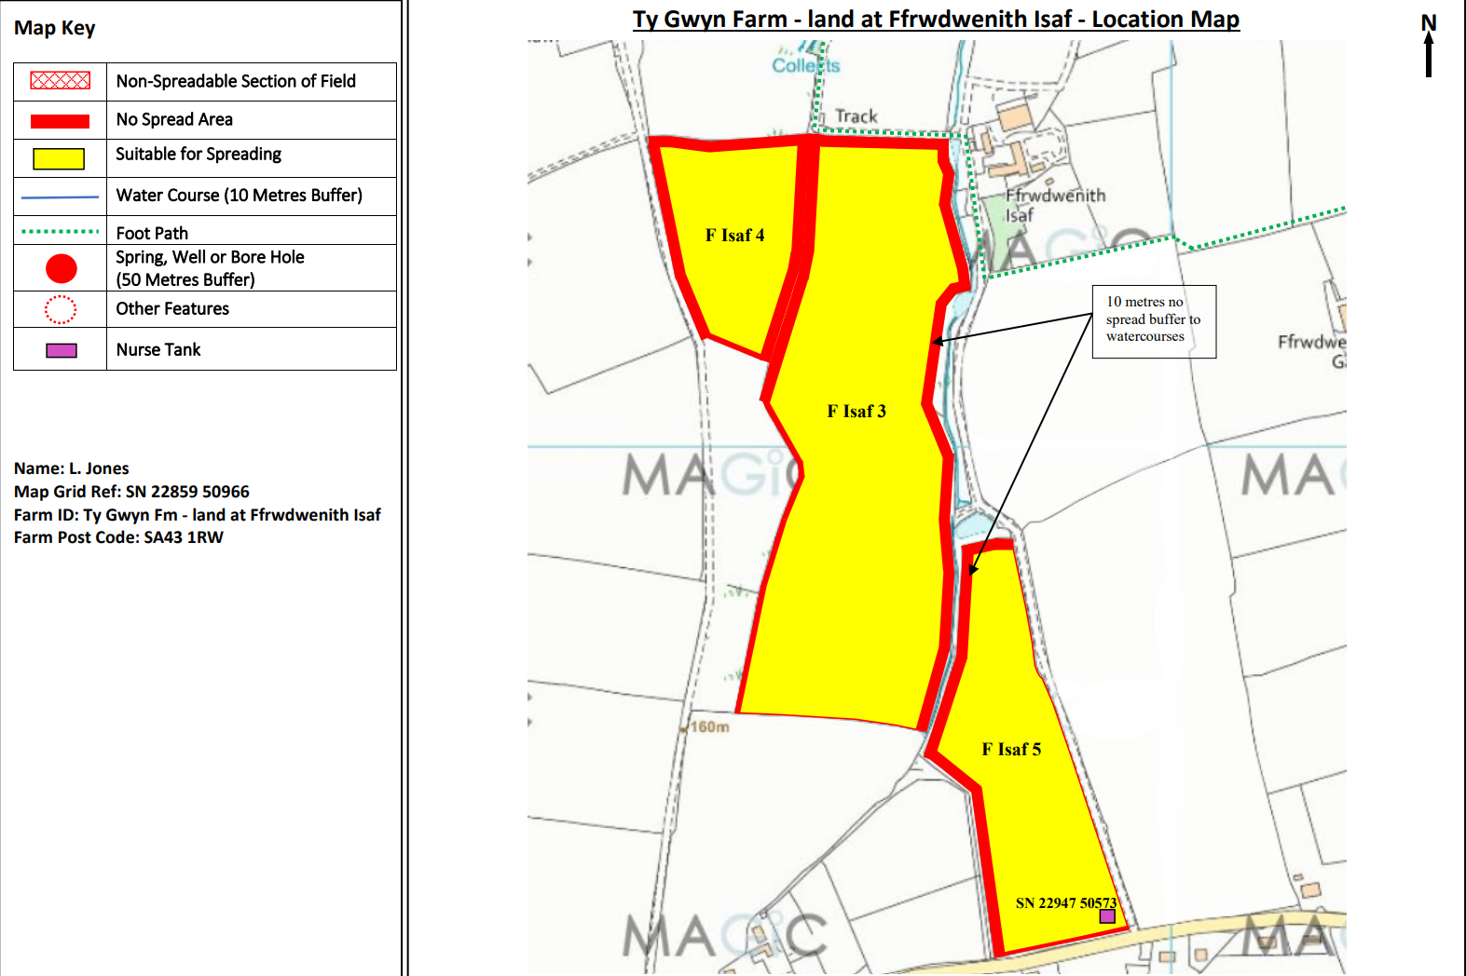
Detailed river network:
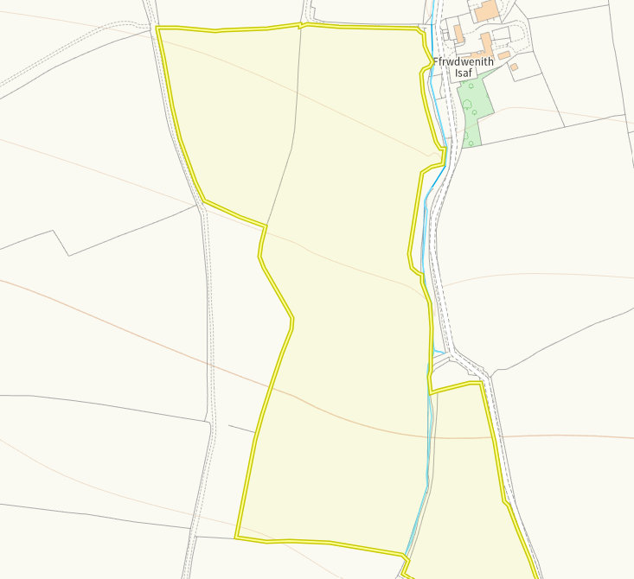
Watercourse runs parallel to F Isaf 3 and F isaf 5. A separation between field 3 and 5 as well as a 10m no spread buffer on both borders is sufficient. No action required.

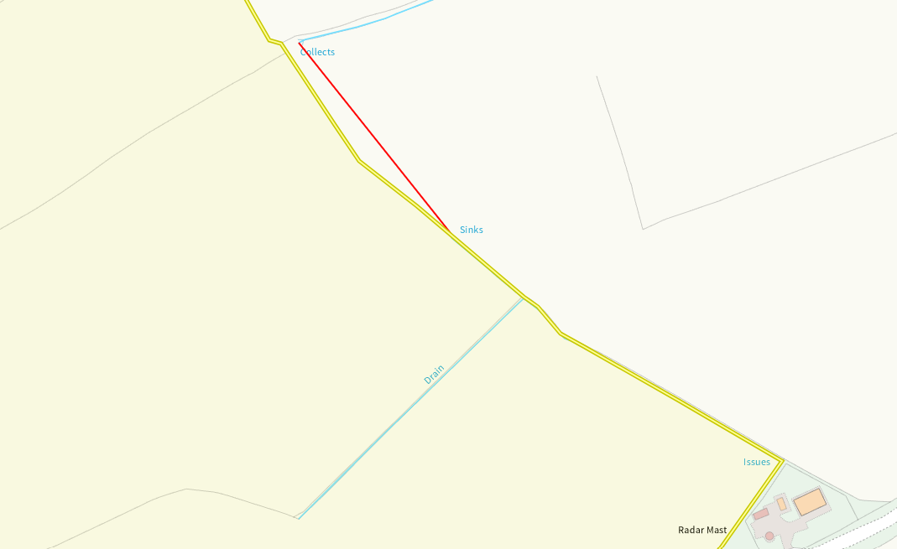
Watercourse runs alongside F Ganol 2 and a drain into F Ganol 1. Both have been buffered appropriately. No action required.
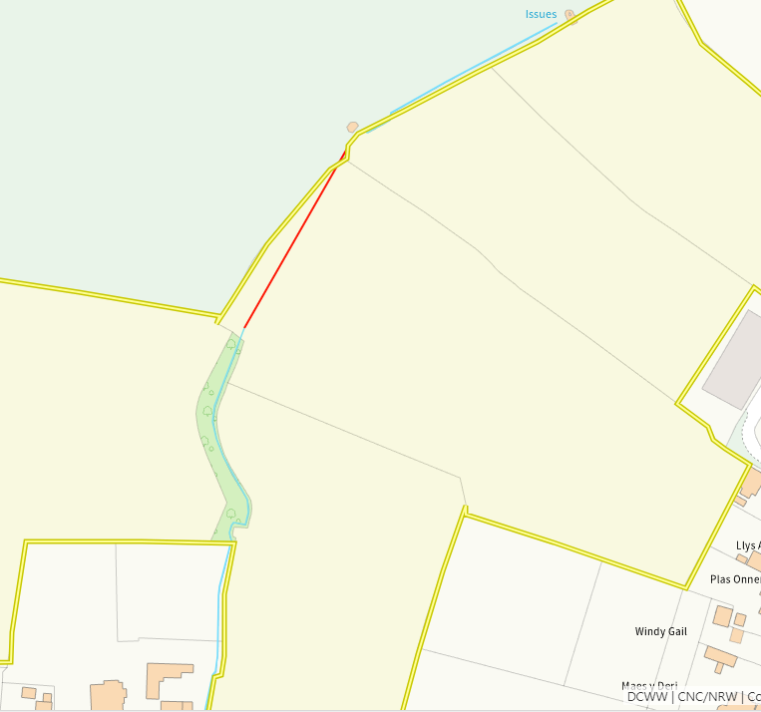
A watercourse runs along the edge of Camp 1, 2, 3 and 4. A 10m no spread buffer zone has been implemented on all borders. No action required.
Groundwater protection zones (source)
None in range
any well, spring (or issue) or borehole used for the supply of water for human consumption including from a private water supply or supplies
None in range

any well, spring (or issue) or borehole not used to supply water for domestic or food production purposes within 50m

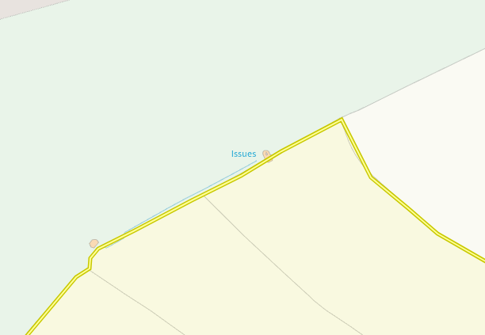

An issue is at the corner of Camp 5. This has been identified and appropriately buffered.

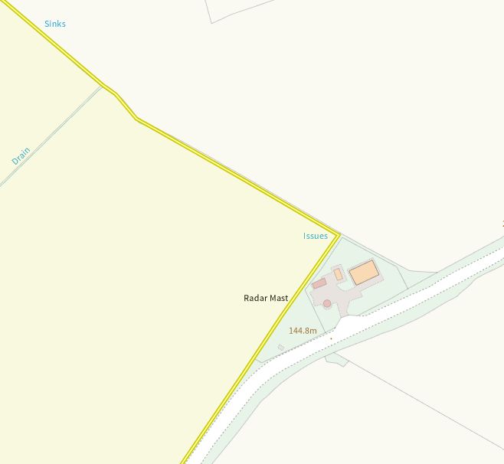

An issue is at the corner of F Ganol 1. This has been identified and appropriately buffered.

European designated sites- Natura 2000 (SPA, pSPA, SAC or cSAC) or Ramsar- or SSSI within 500m

None in range
Other protected sites:
- Protected Habitats-
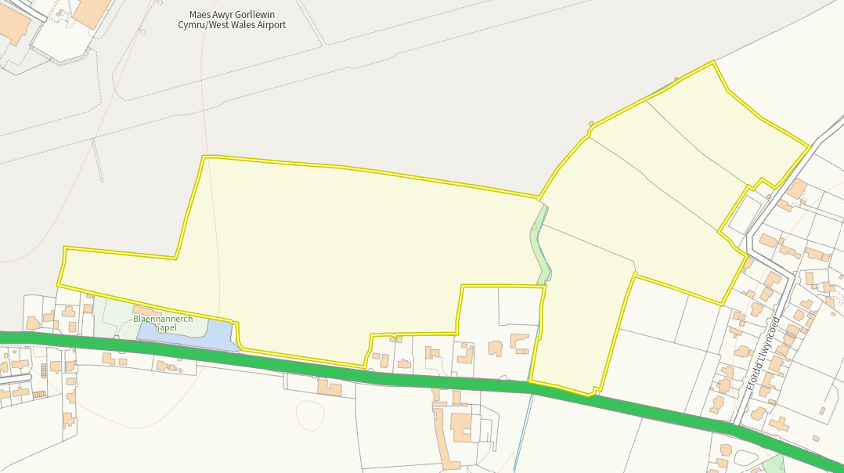

An area of Lowland dry acid grassland and Lowland calcareous grassland is at the border of Camp 1. Ariel images show this area is a graveyard and as such the habitat is no longer present.

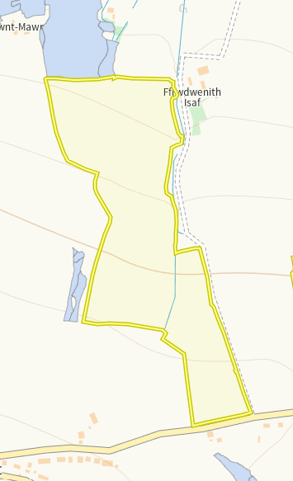
Lowland dry acid grassland and Lowland calcareous grassland, Purple moor grass and rush pastures are seen at the north of F isaf 3 and 4. There are 10m no spread buffers implemted on borders, no run off risk.

- Protected Species-
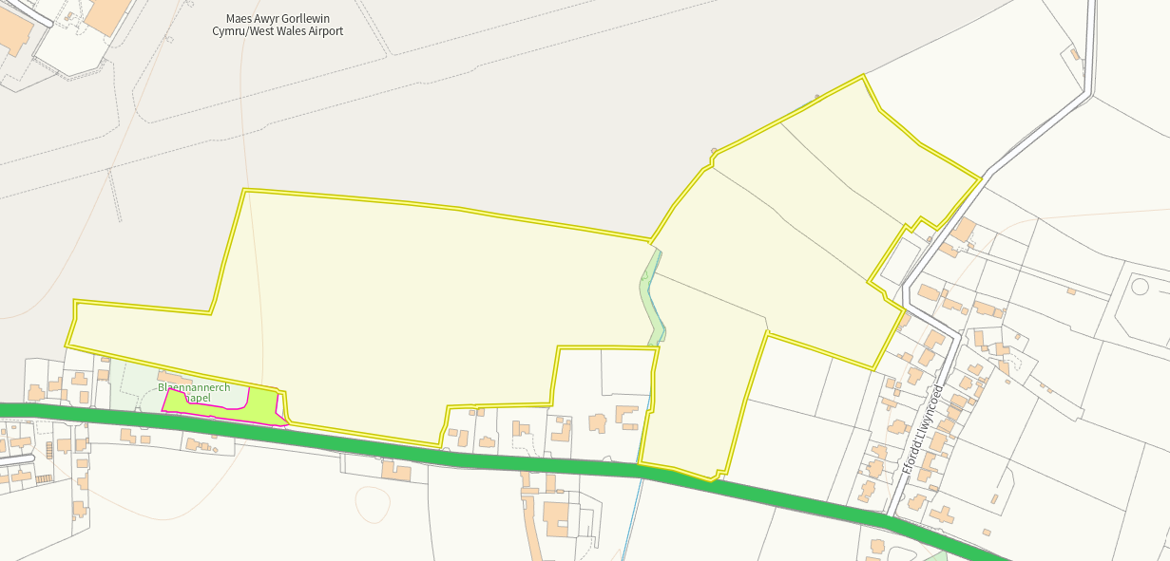
An area of Lowland dry acid grassland and Lowland calcareous grassland is at the border of Camp 1. Ariel images show this area is a graveyard and as such the habitat is no longer present.

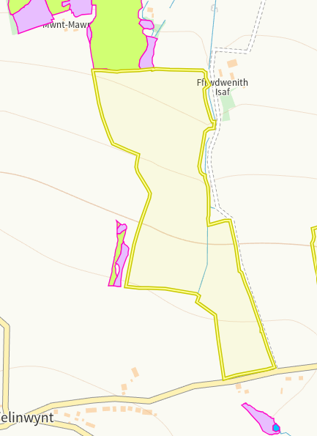
Lowland dry acid grassland and Lowland calcareous grassland, Purple moor grass and rush pastures are seen at the north of F isaf 3 and 4. There are 10m no spread buffers implemted on borders, no run off risk.
- Scheduled Ancient Monument-
None in range
- Local Nature Reserve-
None in range
- National Nature Reserve-
None in range
- Ancient Woodlands-
None in range
- Local Wildlife Sites (SINC)-
None in range
- National Park-
None in range
- Nitrate Vulnerable Zone (NVZ)-
None in range
- Groundwater Safeguard Zone-
None in range
- ANOBs
None in range
- Heritage coast
None in range
- World Heritage Sites
None in range
- Hedges, Ditches, Local residents, Housing, schools, Workplaces, Recreational facilities
Nothing of concern

Slope Map
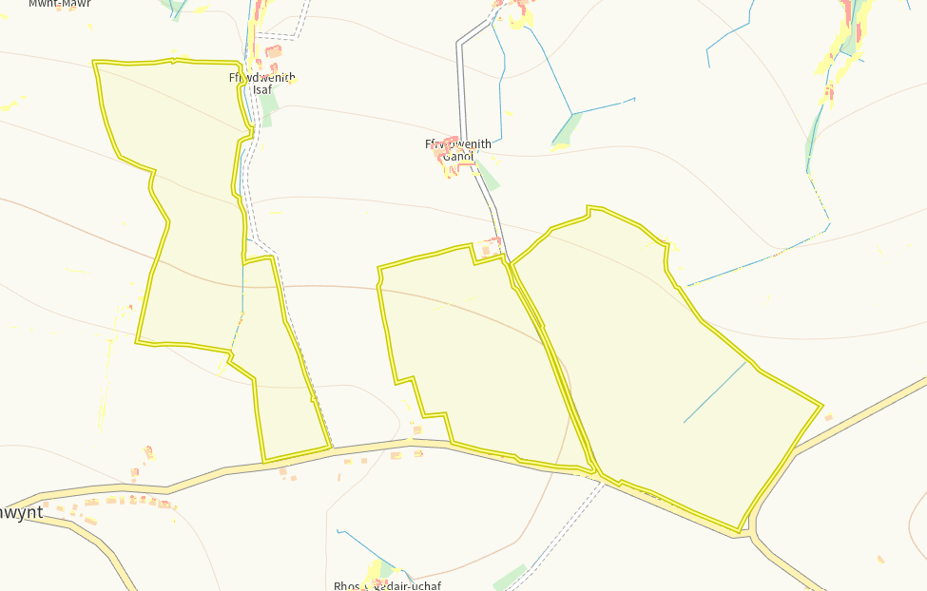
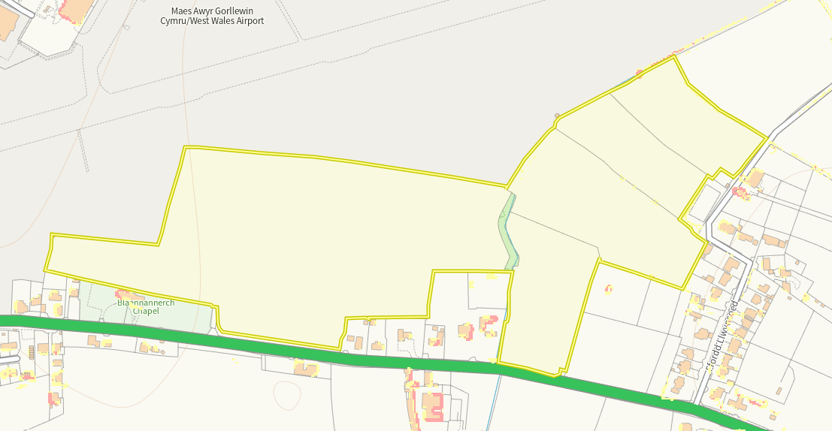

No slopes associated with the fields.

