Permit
The Environmental Permitting (England & Wales) Regulations 2016

Plan B Management Solutions Limited

Seawall Waste Transfer Station
Unit 82 Seawall Road
Cardiff
CF24 5TH

Permit number

EPR/DB3395CG

Permit
The Environmental Permitting (England and Wales) Regulations 2016
Permit number

EPR/DB3395CG

The Natural Resources Body for Wales (“Natural Resources Wales”) authorises, under regulation 13 of the Environmental Permitting (England and Wales) Regulations 2016

Plan B Management Solutions Limited “the operator”,

whose registered office is

Suite 2e

The Courtyard

Main Cross Road

Great Yarmouth

Norfolk

United Kingdom

NR30 3NZ

company registration number 05873377

to operate waste operations at

Seawall Waste Transfer Station

Unit 82 Seawall Road

Cardiff

CF24 5TH

to the extent authorised by and subject to the conditions of this permit.

Under regulation 27(2) of the Regulations, standard rules SR2008 No03 are conditions of this permit.

Name | Date
Huw Davies | 06/01/2025

Authorised on behalf of Natural Resources Wales

Schedule 1 - Site plan

This is the plan referred to in the standard rules SR2008 No03
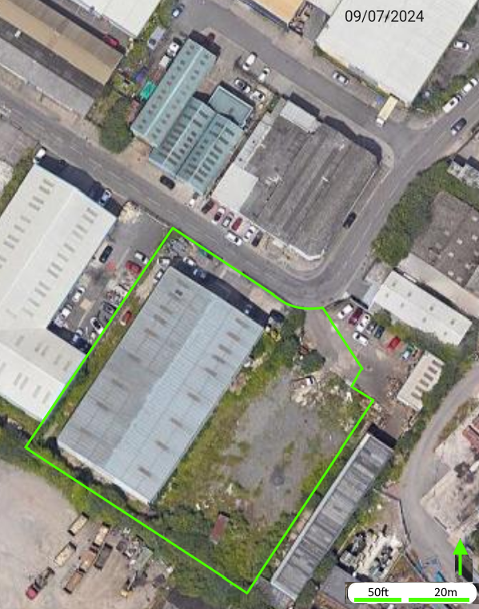

END OF PERMIT

