Annex (iv) – SSSI Assessment Form
SSSI Assessment for permit/licence and deployment applications | 
To be completed by Permitting Officers for any applications for a permission which Natural Resources Wales has considered under S28I duty to notify SNCB and take their advice into account. This applies to all proposed permissions within a SSSI, and to operations outside the SSSI boundary which are likely to damage its special features.
NRW as a Section 28G authority has, when exercising its functions, a general duty to take reasonable steps, consistent with the proper exercise of its functions, to further the conservation and enhancement of the flora, fauna or geological or physiological features by reason of which the site is of special interest’

Part 1 – SSSI Assessment
Part 2 – Formal notification to SNCB (to be completed if part 1 assessment concludes likely damage, not likely to damage because of conditions or you cannot conclude no likely damage)
Part 3 – Decision
Pink text – drafting notes, to be deleted before completion/consultation.
Blue text – examples, to be replaced with permission-specific information and text turned to black.

Part 1 – SSSI Assessment

- Permitting officer/team | Bryan Burn
- Permit application reference and site name | PAN-027531  Land at Fferam Bailey, Trefdaerth. LL62 5ET
- a. SSSI name(s)  b. location  c. NRW Operational Area/Environment Team | a. Malltraeth Marsh / Cors Ddyga  b. Anglesey  c. NW
- Brief description of proposal | Land spreading deployment under standard rules permit SR 2010 No4 Mobile plant for land spreading.  Farm location: SH 41064 70701  Fields: only field 19 is in range  8 SH 41062 71235  9 SH 40897 70995  10 SH 40974 70819  11 SH 41191 71085  12 SH 41327 70916  18 SH 41153 70422  19 SH 41325 70206  No Storage  The activity is not wholly or partly within the SSSI.  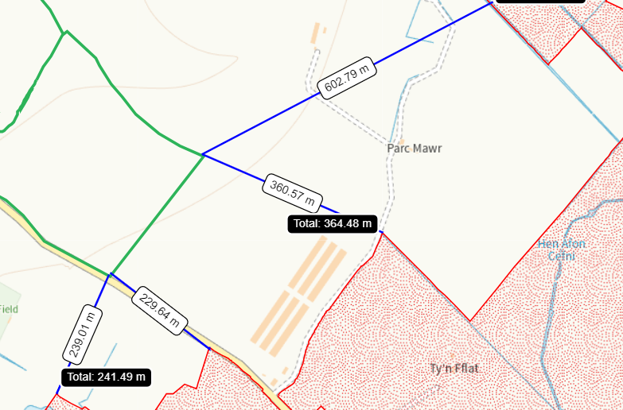  The proposed landspreading activity is to spread 4 waste streams (EWC 020501 x3 and 020502  x1) onto fields in grass rotation on 4 occasions in 2025 – February, April, June, August. Application rates are 100t/ha for 020502 and 250t/ha for 020501.  The material will be applied in multiple applications after each silage cut, by trailing shoe applicator. The elements are fitted with a self-sharpening share which parts the plant leaves allowing sludge to be  delivered to the soil surface via a rubber injection cone, which is positioned directly behind the share. The trailing shoe applies sludge at the soil surface minimising sward contamination and root disturbance.  The application rates have been calculated to ensure crop requirement/nutrient replacement is not exceeded and that no more than 250 kg total N/ha is applied within any 12-month period. No more than 50t/ha per application.  The waste spread under this deployment are composed of non-stackable liquid wastes and will be spread on delivery.  The fields are sloping 0-7 degrees.  Documents relating to the deployment, PAN-027531, can be found at DMS
- What aspects of the proposed permission are likely to damage the SSSI features of special interest?

The following activities are likely to cause damage:

7. Dumping, spreading or discharging of any materials, excluding manure or fertilizers.

The following SSSI(s) features and potential impacts have been considered to assess the likelihood of damage:

• Open water associated with the lowland grazing marsh ditch system and former river meanders with associated plants and animals such as reed canary, grass, water-plantain and branched bur-reed. Club-rush, and reed sweet-grass Submerged plants such as spiked water-milfoil, blunt-leaved pondweed, horned pondweed and uncommon plants such as flowering-rush, water-violet and marsh stitchwort.
• Pillwort – an aquatic fern
• Variable dragonfly
• Water beetle
• Wintering shoveler
• An assemblage of breeding birds of lowland damp grassland such as lapwing, curlew, redshank and snipe.
• An assemblage of breeding birds of open water such as teal, gadwall, and pochard.
• Water vole

Fertilisers: Increased plant-nutrient levels in ditches lead to excessive growth of competitive species such as float grass at the expense of more valued species. Application of fertilisers or any other materials such as creamery waste should avoid a 10 metre wide strip alongside every watercourse and ditch to avoid nutrient pollution.

- Summary of any informal advice received from internal experts (if required and including pre-app advice) | none
- Recommendation  . | The proposed permission is not likely to damage any of the flora, fauna or geological or physiological features which are of special interest  - The sludges are of low dry matter and will infiltrate readily into the soil surface following application minimising potential impact.  - The land is flat with only a gentle slope (0-7degrees).  - All waste deliveries to the field will be made during the working day and applied directly. No storage.  - All application machinery is calibrated and regularly checked to ensure the stated application rates are maintained.  - Buffer strips will not be used as headlands.  - 10m buffer zone adjacent to surface water features, including dry ditches.  - Spreading operations and spreading will cease if conditions are deemed unsuitable.  - No spread buffers are in place at the boundary of the feilds and for all watercourses, springs, wells and issues within range of all fields in the deployment.  - The land spreading activity will comply with the Code of Good Agricultural Practice guidelines (COGAP).
- Signature and date assessment made | Bryan Burn 06/01/2025
- Officers name and job title | Bryan Burn  Waste Permitting Officer


Permitting
Formal Notification under Section 28I of the Wildlife and Countryside Act 1981

Part 2 Formal notification under S28I – To be completed for all permit applications assessed as: not likely to damage because of conditions, likely to damage SSSI and those where we are unable to conclude no likely damage.

- Date Notice of intention to permit activity likely to damage SSSI sent to NRW (SCNB)  If you assess activity as being likely to damage even if you think this can be mitigated by conditioning you need to formally notify SNCB send them a copy of this notice with part 1 of this form. Environment teams have 28 days to respond.  Environment teams please complete question 11 and 12 using the information in questions 1-9 | Insert date  We have assessed that [permit ref/name of site] is likely to damage [insert name of SSSI] and request your formal advice. We have assessed that this damage could be mitigated by including conditions[remove if not applicable].  Or  We are unable to conclude that [permit ref/name of site] is not likely to damage [insert name of SSSI] and request your formal advice.  Information on the permit application can be found in Part 1 of this form and [include link to DMS documents if required]
- Advice received from NRW (SNCB)

Environment Teams and Marine Area Management and Advice Teams are expected to log and issue formal statutory advice through our CAMS system. The advice letter generated can simply by attached/appended here. ET/MAAMT can just refer to that here or write a summary of advice here too.

To be completed by environment officers.
Within 28 days of receiving notice from a permitting/licensing regime, you should advise whether the operation:
• Should be allowed to proceed.
• Should be allowed to proceed with certain conditions.
• Should not proceed.

Please ensure all advice provided is evidenced and comprehensive. Advice provided may be scrutinised as part of a formal appeal.

- Name and job title of conservation/marine officer (sign and date)
Part 3 – To record NRW decision following SNCB Advice
- DECISION  Provide reasoning for your decision and how you have considered advice from NRW(SNCB) in the box opposite and delete text in blue that is not relevant. This might be the same as the info and decision in part 1 of the form  Large amounts of supporting information can be appended to this form. | The proposed permission is not likely to damage any of the flora, fauna or geological or physiological features which are of special interest  The permission is not likely to damage any of the flora, fauna or geological or physiological features which are of special interest because of conditions  The permission is likely to damage
- Natural Resources Wales (Section 28G Authority) (permitting service) is minded to  Delete as appropriate  If this decision is not in line with advice received from NRW(SNCB) please outline your reasoning (please note that you should try to resolve any differences in opinion) | Issue the permission  Issue the permission with conditions to ensure no damage to SSSI  Refuse the permission due to likely damage to SSSI
- Is decision in line with advice from SNCB  If your decision is not in line with the recommendations from SNCB you must formally notify them using the appropriate online form or letter.  Record the date the notice/letter was sent opposite and save a link. The permitted operation cannot commence for 21 days following service of this notice. | Yes/No  If No record date notice was sent to SNCB
- Signature and date assessment completed
- Officers name and job title



