PAN-023797 My Map Report:
Application map
The activities shall not extend beyond the site, being the land shown edged in green on the site plan attached to the permit.
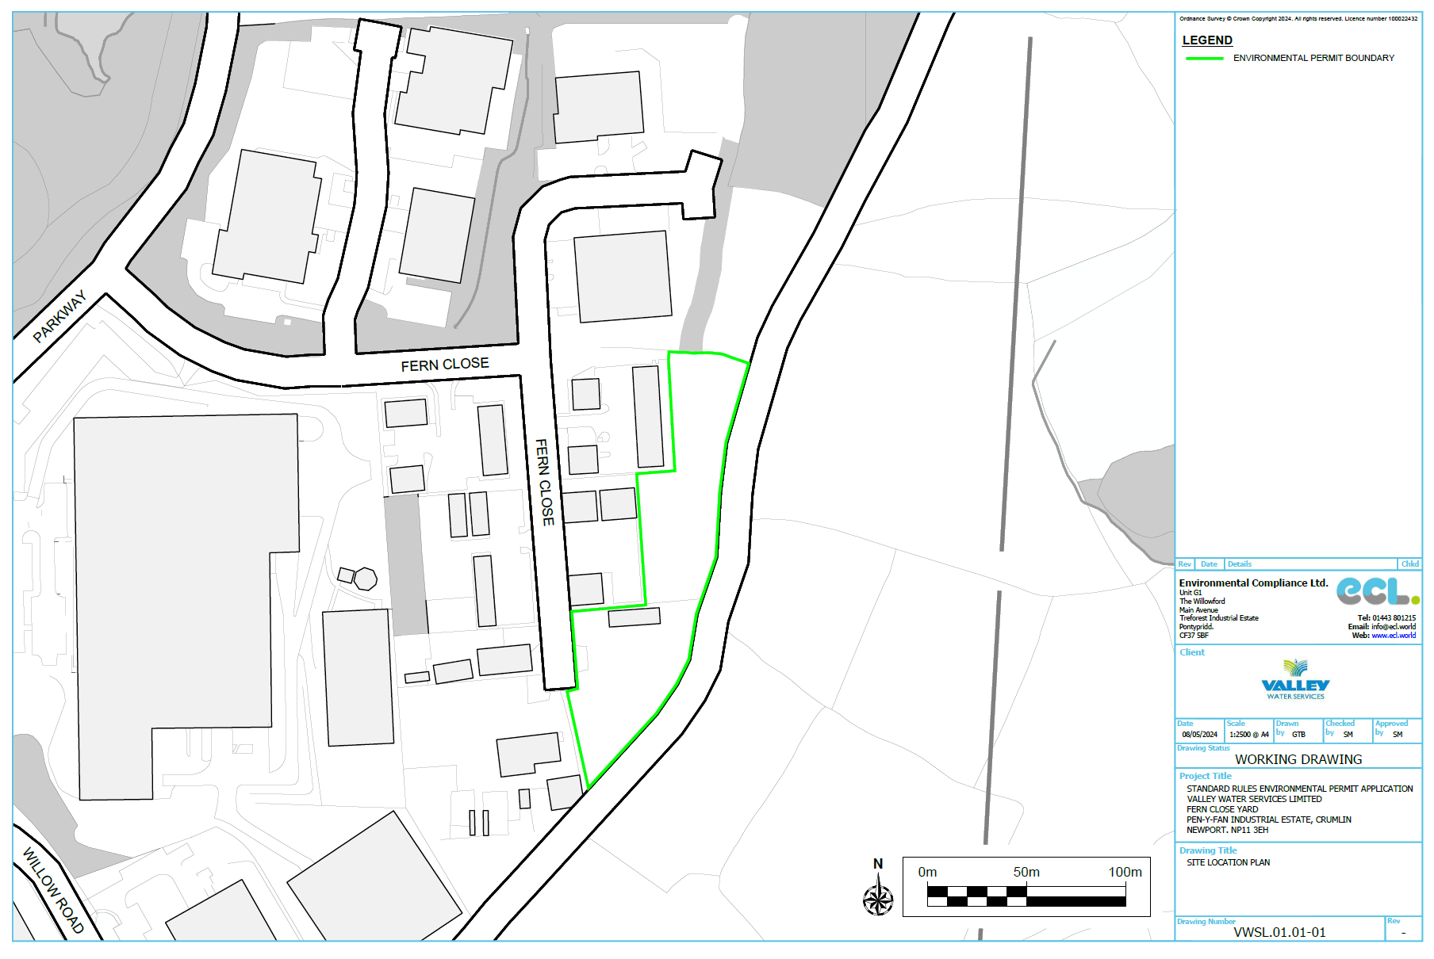
The activities shall not be carried out within:
500 metres of a European Site or Site of Special Scientific Interest (SSSI);
none
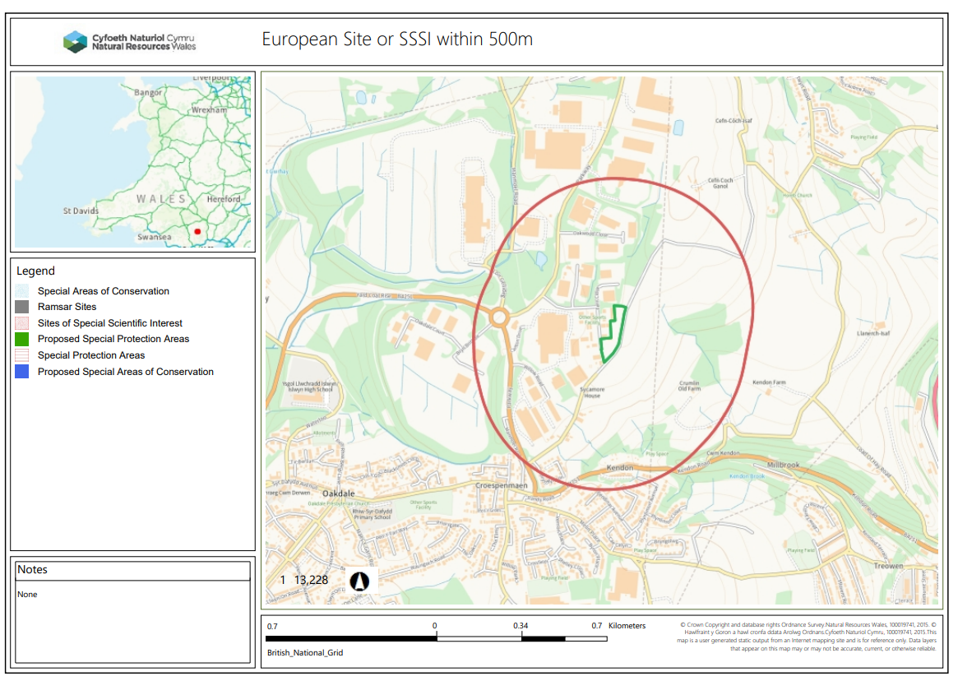
10 metres of any watercourse;
None
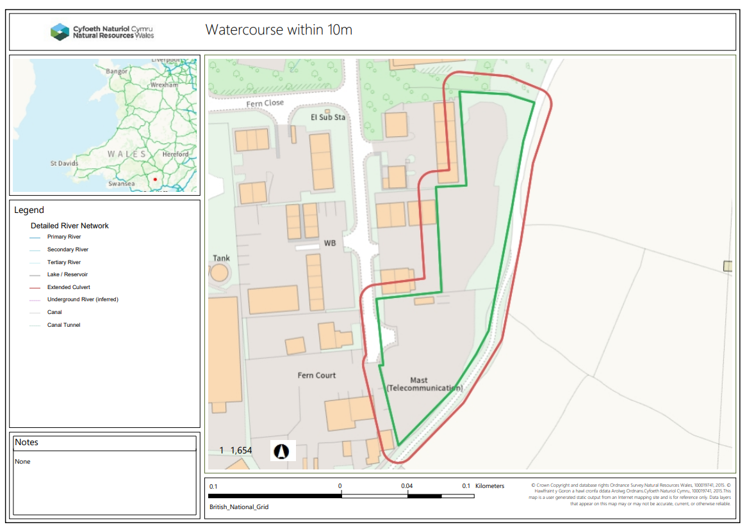
50 metres of any spring or well, or any borehole not used to supply water for domestic or food production purposes;
None
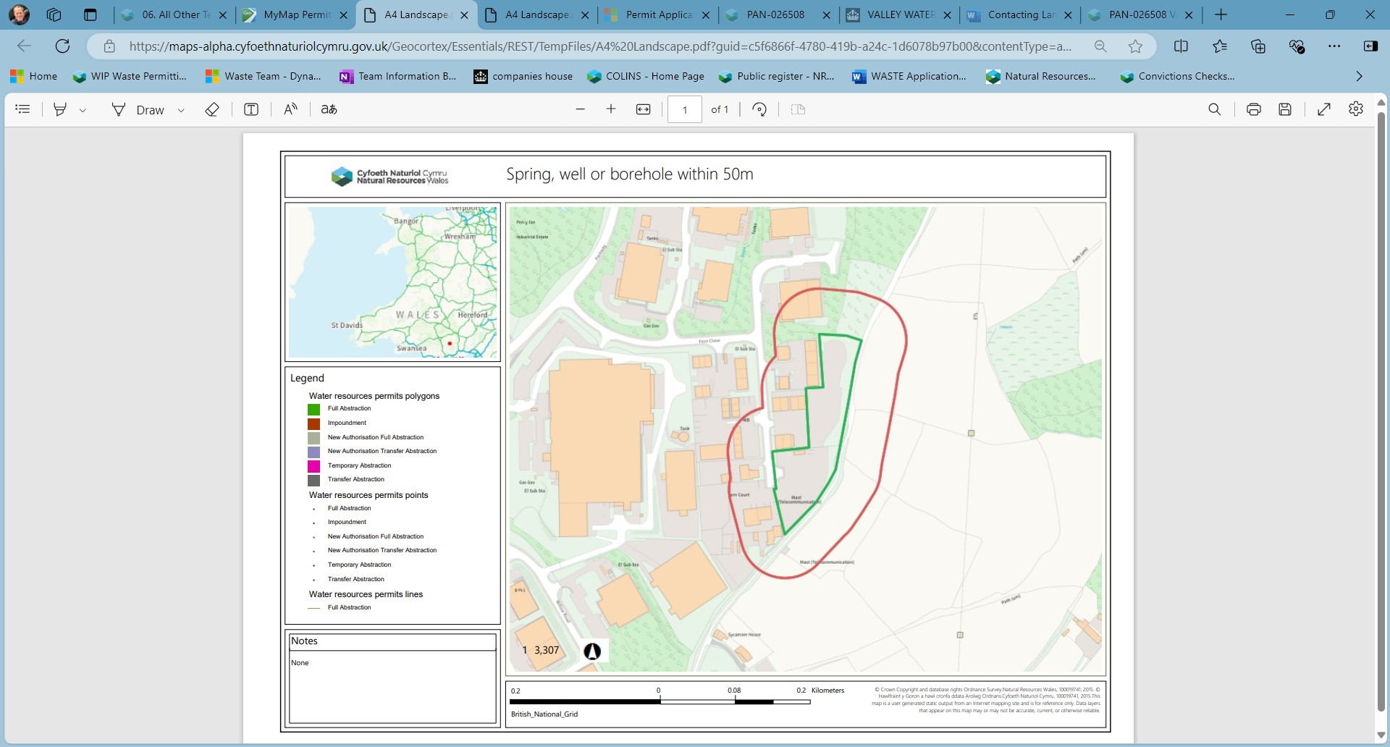
a specified AQMA;
none
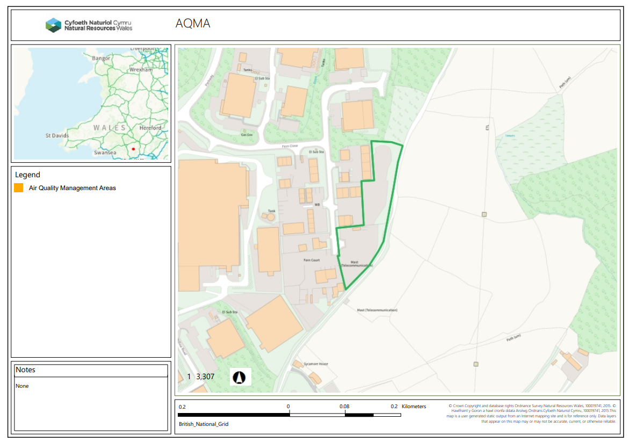

50 metres from any well, spring or from any borehole used for the supply of water for human consumption. This must include private water supplies.
None

250metres within the presence of Great Crested Newts where it is linked to the breeding ponds of the newts by good habitat;
None
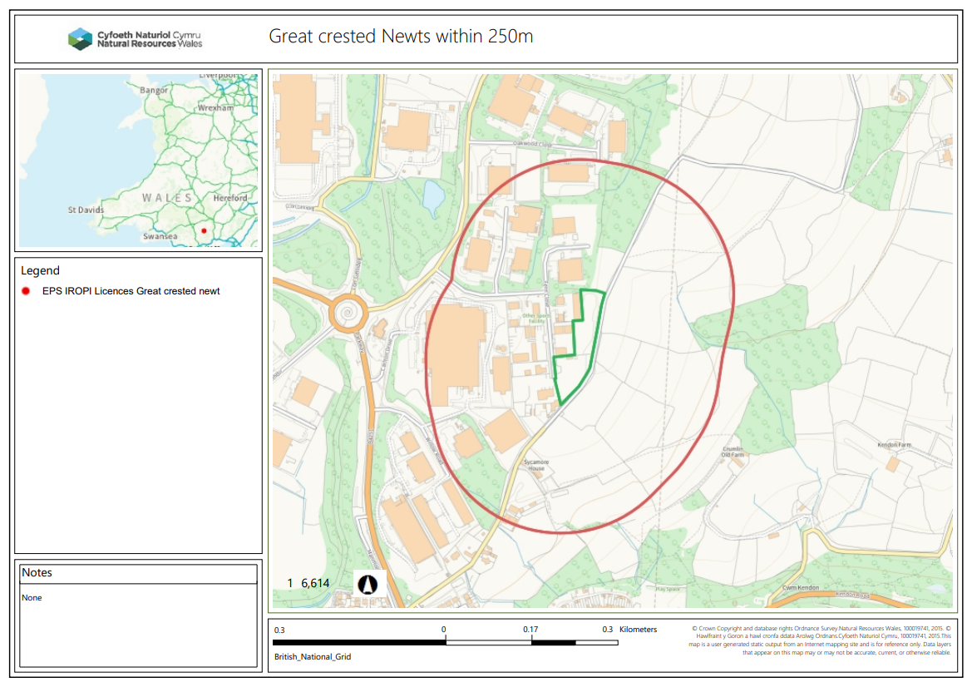

50 metres of a site that has species or habitats protected under the Biodiversity Action Plan that Natural Resources Wales considers at risk to this activity;
Lowland dry acid grassland and Lowland calcareous grassland appeared to be adjacent to the N of and within the site. However the aerial image shows the area N to be populated by substantial tree growth and the area within has been laid to hardstanding.
Local Environmental team contacted for clarification, response from Kerry Murton dated 07/01/25 as below.
‘I can see on ArcGIS that the grassland was picked up in the Phase 1 habitat surveys undertaken in the 1990s and marked as semi improved. It may not have been calcareous grassland at time of designation or now-but was marked as semi improved so it was viewed to be better grassland habitat than the improved (more nutrient high) grassland in that area.
CCW/NRW have not been back to check on the grassland since the surveys, as far as I’m aware. I can see like you stated in email- the area to south is now developed on but the area to the north remains. I can see the area north (outside the application boundary) has had trafficking across the field by aerial images so would likely have declined since the surveys.
I can see on ArcGIS that the land adjacent to the north section of the ‘grassland’ is a SINC (Local Authority designated) called Pen-y-Fan Industrial Estate Woodland, Oakdale.
Although im aware that waste activities can create dust, this waste application is not for depositing materials on the grassland so I do not think there would be an issue proceeding with this permit’.
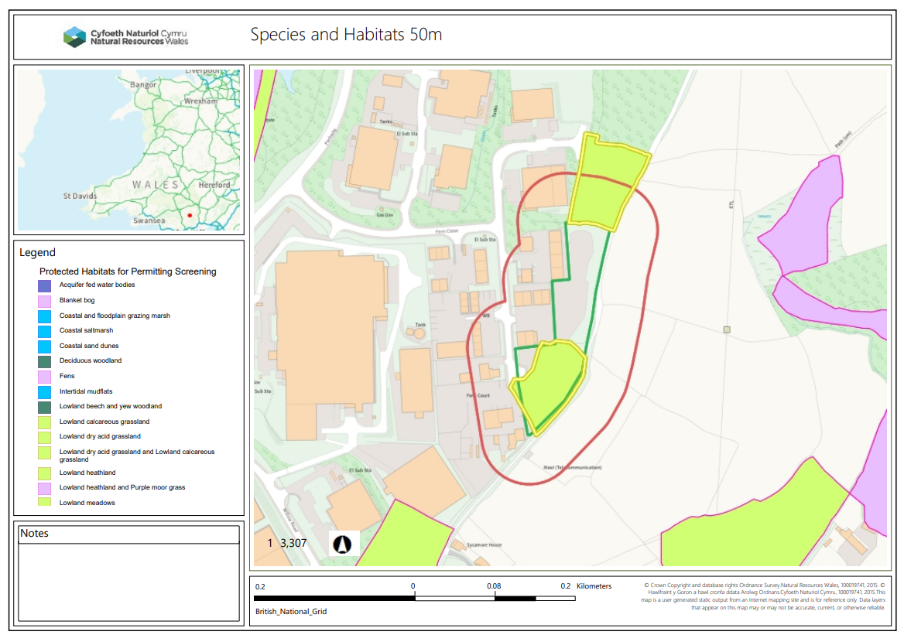
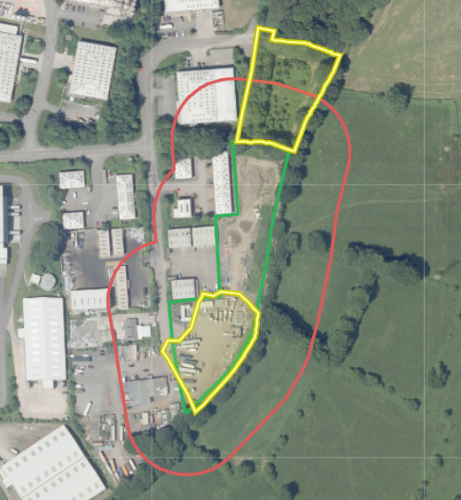

Section 7 species – none, nearest noted at approx. 310m (2017)
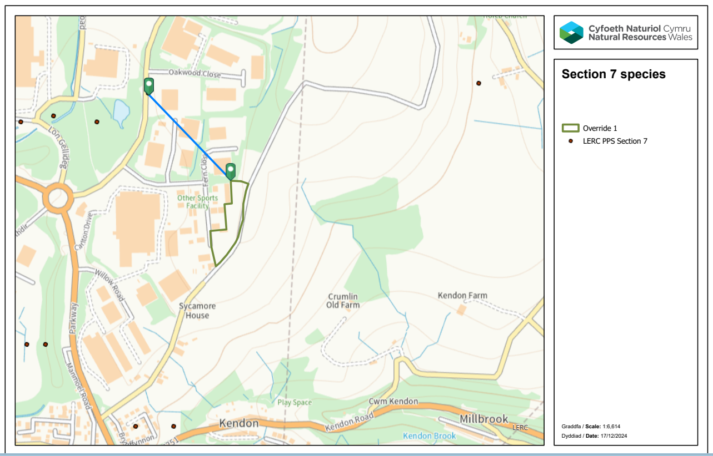
50 metres of a National Nature Reserve (NNR), Local Nature Reserves (LNR), Local Wildlife Site (LWS), Ancient woodland or Scheduled Ancient Monument.
None
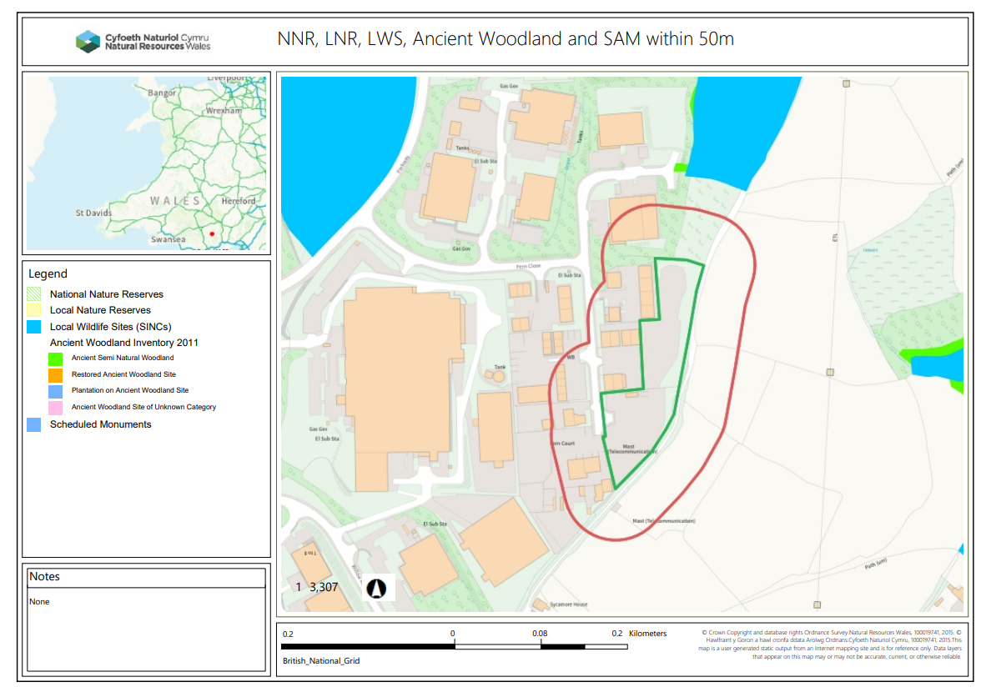
END

