Permit
The Environmental Permitting (England & Wales) Regulations 2016

Valley Water Services Limited

Valley Water Services Waste Treatment Facility
Fern Close
Pen-y-Fan Industrial Estate
Crumlin
Newport
NP11 3EH

Permit number

EPR/DB3398ZC

Permit
The Environmental Permitting (England and Wales) Regulations 2016
Permit number

EPR/DB3398ZC

The Natural Resources Body for Wales (“Natural Resources Wales”) authorises, under regulation 13 of the Environmental Permitting (England and Wales) Regulations 2016

Valley Water Services Limited (“the operator”),

whose registered office is

6 Bramblewood Court

Pengam

Blackwood

NP12 3QW

company registration number 07973937

to operate waste operations at

Valley Water Services Waste Treatment Facility

Fern Close

Pen-y-Fan Industrial Estate

Crumlin

Newport

NP11 3EH

to the extent authorised by and subject to the conditions of this permit.

Under regulation 27(2) of the Regulations, standard rules SR2010 No12 are conditions of this permit.

Name | Date
Huw Davies | 22/01/2025

Authorised on behalf of Natural Resources Wales

Schedule 1 - Site plan

This is the plan referred to in the standard rules SR2010 No12

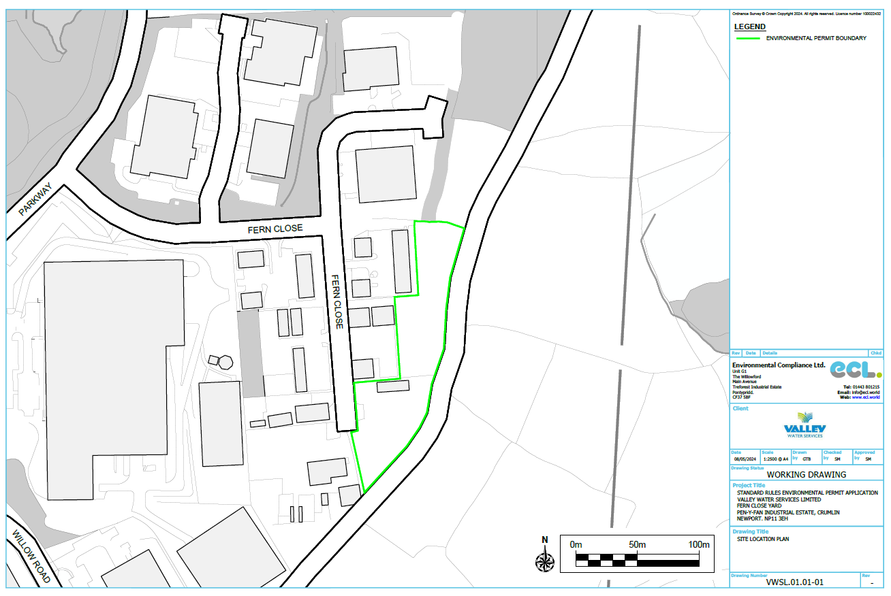

END OF PERMIT

